==================================================================================

GRADED LAB 4

=================================================================================

Create database e_comm ;

1. You are required to create tables for **supplier,customer,category,product,supplier_pricing,order,rating** to store the data for the E-commerce with the schema definition given below.

create table supplier(

SUPP_ID INT Primary key,

SUPP_NAME varchar(50) NOT NULL,

SUPP_CITY varchar(50) NOT NULL,

SUPP_PHONE varchar(50) NOT NULL

);

create table customer(

CUS_ID INT Primary key,

CUS_NAME VARCHAR(20) NOT NULL,

CUS_PHONE VARCHAR(10) NOT NULL,

CUS_CITY VARCHAR(30) NOT NULL,

CUS_GENDER CHAR

);

create table category

(

CAT_ID INT primary key ,

CAT_NAME VARCHAR(20) NOT NULL

);

create table product

(PRO_ID INT Primary key,

PRO_NAME VARCHAR(20) NOT NULL DEFAULT "Dummy",

PRO_DESC VARCHAR(60),

CAT_ID INT ,

Foreign key(Cat_id) references category(CAT_ID)

);

create table supplier_pricing

(PRICING_ID INT primary key,

PRO_ID INT ,

SUPP_ID INT ,

SUPP_PRICE INT DEFAULT 0,

Foreign key(PRO_ID) references product(PRO_ID),

Foreign key(SUPP_ID) references supplier(SUPP_ID)

);

create table e_comm.order

(

ORD_ID INT primary key,

ORD_AMOUNT INT NOT NULL,

ORD_DATE DATE NOT NULL,

CUS_ID INT ,

PRICING_ID INT ,

Foreign key(CUS_ID) references customer(CUS_ID),

Foreign key(PRICING_ID) references supplier_pricing(PRICING_ID)

);

create table rating

(

RAT_ID INT primary key,

ORD_ID INT ,

RAT_RATSTARS INT NOT NULL,

foreign key(ORD_ID) references e_comm.order(ORD_ID)

);

1. **Insert the following data in the table created above**

**Supplier**

INSERT INTO Supplier (`SUPP_ID`,`SUPP_NAME`,`SUPP_CITY`,`SUPP_PHONE`) VALUES (1,'Rajesh Retails','Delhi','1234567890');

INSERT INTO Supplier (`SUPP_ID`,`SUPP_NAME`,`SUPP_CITY`,`SUPP_PHONE`) VALUES (2,'Appario Ltd.','Mumbai','2589631470');

INSERT INTO Supplier (`SUPP_ID`,`SUPP_NAME`,`SUPP_CITY`,`SUPP_PHONE`) VALUES (3,'Knome products','Banglore','9785462315');

INSERT INTO Supplier (`SUPP_ID`,`SUPP_NAME`,`SUPP_CITY`,`SUPP_PHONE`) VALUES (4,'Bansal Retails','Kochi','8975463285');

INSERT INTO Supplier (`SUPP_ID`,`SUPP_NAME`,`SUPP_CITY`,`SUPP_PHONE`) VALUES (5,'Mittal Ltd.','Lucknow','7898456532');

**Customer**

INSERT INTO Customer(`CUS_ID`,`CUS_NAME`,`CUS_PHONE`,`CUS_CITY`,`CUS_GENDER`) VALUES (1,'AAKASH','9999999999','DELHI','M');

INSERT INTO Customer (`CUS_ID`,`CUS_NAME`,`CUS_PHONE`,`CUS_CITY`,`CUS_GENDER`) VALUES (2,'AMAN','9785463215','NOIDA','M');

INSERT INTO Customer (`CUS_ID`,`CUS_NAME`,`CUS_PHONE`,`CUS_CITY`,`CUS_GENDER`) VALUES (3,'NEHA','9999999999','MUMBAI','F');

INSERT INTO Customer (`CUS_ID`,`CUS_NAME`,`CUS_PHONE`,`CUS_CITY`,`CUS_GENDER`) VALUES (4,'MEGHA','9994562399','KOLKATA','F');

INSERT INTO Customer (`CUS_ID`,`CUS_NAME`,`CUS_PHONE`,`CUS_CITY`,`CUS_GENDER`) VALUES (5,'PULKIT','7895999999','LUCKNOW','M');

**Category**

INSERT INTO Category (`CAT_ID`,`CAT_NAME`) VALUES (1,'BOOKS');

INSERT INTO Category (`CAT_ID`,`CAT_NAME`) VALUES (2,'GAMES');

INSERT INTO Category (`CAT_ID`,`CAT_NAME`) VALUES (3,'GROCERIES');

INSERT INTO Category (`CAT_ID`,`CAT_NAME`) VALUES (4,'ELECTRONICS');

INSERT INTO Category (`CAT_ID`,`CAT_NAME`) VALUES (5,'CLOTHES');

**Product**

INSERT INTO Product (`PRO_ID`,`PRO_NAME`,`PRO_DESC`,`CAT_ID`) VALUES (1,'GTA V','Windows 7 and above with i5 processor and 8GB RAM',2);

INSERT INTO Product (`PRO_ID`,`PRO_NAME`,`PRO_DESC`,`CAT_ID`) VALUES (2,'TSHIRT','SIZE-L with Black, Blue and White variations',5);

INSERT INTO Product (`PRO_ID`,`PRO_NAME`,`PRO_DESC`,`CAT_ID`) VALUES (3,'ROG LAPTOP','Windows 10 with 15inch screen, i7 processor, 1TB SSD',4);

INSERT INTO Product (`PRO_ID`,`PRO_NAME`,`PRO_DESC`,`CAT_ID`) VALUES (4,'OATS','Highly Nutritious from Nestle',3);

INSERT INTO Product (`PRO_ID`,`PRO_NAME`,`PRO_DESC`,`CAT_ID`) VALUES (5,'HARRY POTTER','Best Collection of all time by J.K Rowling',1);

INSERT INTO Product (`PRO_ID`,`PRO_NAME`,`PRO_DESC`,`CAT_ID`) VALUES (6,'MILK','1L Toned MIlk',3);

INSERT INTO Product (`PRO_ID`,`PRO_NAME`,`PRO_DESC`,`CAT_ID`) VALUES (7,'Boat Earphones','1.5Meter long Dolby Atmos',4);

INSERT INTO Product (`PRO_ID`,`PRO_NAME`,`PRO_DESC`,`CAT_ID`) VALUES (8,'Jeans','Stretchable Denim Jeans with various sizes and color',5);

INSERT INTO Product (`PRO_ID`,`PRO_NAME`,`PRO_DESC`,`CAT_ID`) VALUES (9,'Project IGI','compatible with windows 7 and above',2);

INSERT INTO Product (`PRO_ID`,`PRO_NAME`,`PRO_DESC`,`CAT_ID`) VALUES (10,'Hoodie','Black GUCCI for 13 yrs and above',5);

INSERT INTO Product (`PRO_ID`,`PRO_NAME`,`PRO_DESC`,`CAT_ID`) VALUES (11,'Rich Dad Poor Dad','Written by RObert Kiyosaki',1);

INSERT INTO Product (`PRO_ID`,`PRO_NAME`,`PRO_DESC`,`CAT_ID`) VALUES (12,'Train Your Brain','By Shireen Stephen',1);

**Supplier_pricing**

INSERT INTO Supplier_pricing (`PRICING_ID`,`PRO_ID`,`SUPP_ID`,`SUPP_PRICE`) VALUES (1,1,2,1500);

INSERT INTO Supplier_pricing (`PRICING_ID`,`PRO_ID`,`SUPP_ID`,`SUPP_PRICE`) VALUES (2,3,5,30000);

INSERT INTO Supplier_pricing (`PRICING_ID`,`PRO_ID`,`SUPP_ID`,`SUPP_PRICE`) VALUES (3,5,1,3000);

INSERT INTO Supplier_pricing (`PRICING_ID`,`PRO_ID`,`SUPP_ID`,`SUPP_PRICE`) VALUES (4,2,3,2500);

INSERT INTO Supplier_pricing (`PRICING_ID`,`PRO_ID`,`SUPP_ID`,`SUPP_PRICE`) VALUES (5,4,1,1000);

**Order**

INSERT INTO Order(`ORD_ID`,`ORD_AMOUNT`,`ORD_DATE`,`CUS_ID`,`PRICING_ID`) VALUES (101,1500,'2021-10-06',2,1);

INSERT INTO Order(`ORD_ID`,`ORD_AMOUNT`,`ORD_DATE`,`CUS_ID`,`PRICING_ID`) VALUES (102,1000,'2021-10-12',3,5);

INSERT INTO Order(`ORD_ID`,`ORD_AMOUNT`,`ORD_DATE`,`CUS_ID`,`PRICING_ID`) VALUES (103,30000,'2021-09-16',5,2);

INSERT INTO Order(`ORD_ID`,`ORD_AMOUNT`,`ORD_DATE`,`CUS_ID`,`PRICING_ID`) VALUES (104,1500,'2021-10-05',1,1);

INSERT INTO Order(`ORD_ID`,`ORD_AMOUNT`,`ORD_DATE`,`CUS_ID`,`PRICING_ID`) VALUES (105,3000,'2021-08-16',4,3);

INSERT INTO Order(`ORD_ID`,`ORD_AMOUNT`,`ORD_DATE`,`CUS_ID`,`PRICING_ID`) VALUES (109,3000,'2021-00-10',5,3);

INSERT INTO Order(`ORD_ID`,`ORD_AMOUNT`,`ORD_DATE`,`CUS_ID`,`PRICING_ID`) VALUES (110,2500,'2021-09-10',2,4);

INSERT INTO Order(`ORD_ID`,`ORD_AMOUNT`,`ORD_DATE`,`CUS_ID`,`PRICING_ID`) VALUES (111,1000,'2021-09-15',4,5);

INSERT INTO Order(`ORD_ID`,`ORD_AMOUNT`,`ORD_DATE`,`CUS_ID`,`PRICING_ID`) VALUES (114,1000,'2021-09-16',3,5);

INSERT INTO Order(`ORD_ID`,`ORD_AMOUNT`,`ORD_DATE`,`CUS_ID`,`PRICING_ID`) VALUES (115,3000,'2021-09-16',5,3);

**Rating**

INSERT INTO Rating(`RAT_ID`,`ORD_ID`,`RAT_RATSTARS`) VALUES (1,101,4);

INSERT INTO Rating(`RAT_ID`,`ORD_ID`,`RAT_RATSTARS`) VALUES (2,102,3);

INSERT INTO Rating(`RAT_ID`,`ORD_ID`,`RAT_RATSTARS`) VALUES (3,103,1);

INSERT INTO Rating(`RAT_ID`,`ORD_ID`,`RAT_RATSTARS`) VALUES (4,104,2);

INSERT INTO Rating(`RAT_ID`,`ORD_ID`,`RAT_RATSTARS`) VALUES (5,105,4);

INSERT INTO Rating(`RAT_ID`,`ORD_ID`,`RAT_RATSTARS`) VALUES (9,109,3);

INSERT INTO Rating(`RAT_ID`,`ORD_ID`,`RAT_RATSTARS`) VALUES (10,110,5);

INSERT INTO Rating(`RAT_ID`,`ORD_ID`,`RAT_RATSTARS`) VALUES (11,111,3);

INSERT INTO Rating(`RAT_ID`,`ORD_ID`,`RAT_RATSTARS`) VALUES (14,114,1);

INSERT INTO Rating(`RAT_ID`,`ORD_ID`,`RAT_RATSTARS`) VALUES (15,115,1);

1. **Display the total number of customers based on gender who have placed orders of worth at least Rs.3000.**

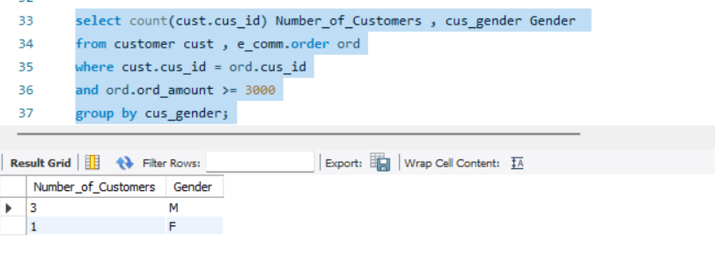

1. **Display all the orders along with product name ordered by a customer having Customer_Id=2**

**select**

**ord.* ,prd.PRO_DESC**

**from supplier_pricing sp ,**

**e_comm.order ord , product prd**

**where sp.PRO_ID = prd.PRO_ID**

**and ord.PRICING_ID = sp.PRICING_ID**

**and ord.CUS_ID =2**

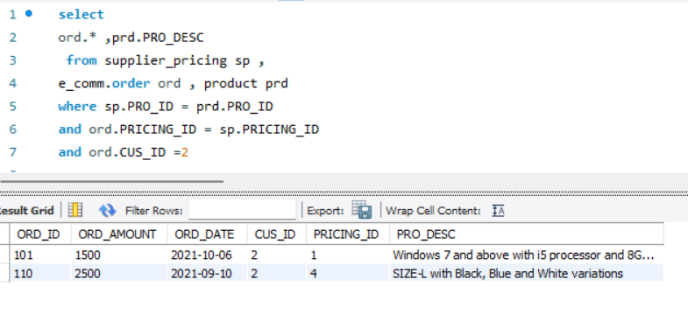

1. **Display the Supplier details who can supply more than one product.**

select supp_mst.* from supplier supp_mst,

(

select SUPP_ID ,count(PRO_ID)

from supplier_pricing

group by SUPP_ID

having count(PRO_ID) > 1

) supp_ord

where supp_mst.SUPP_ID = supp_ord.SUPP_ID ;

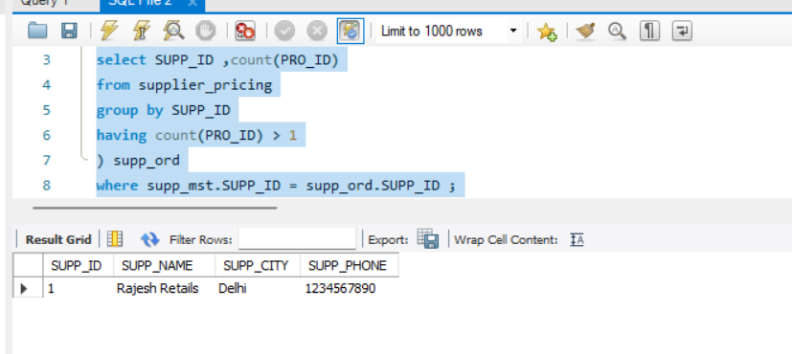

1. Find the least expensive product from each category and print the table with category id, name, product name and price of the product

select

prd.CAT_ID , sup_prc.SUPP_PRICE,sup_prc.PRO_ID,prd.PRO_DESC

,rank() over(partition by prd.CAT_ID order by sup_prc.SUPP_PRICE) rnk

from supplier_pricing sup_prc ,

product prd

where prd.PRO_ID = sup_prc.PRO_ID;

5)5)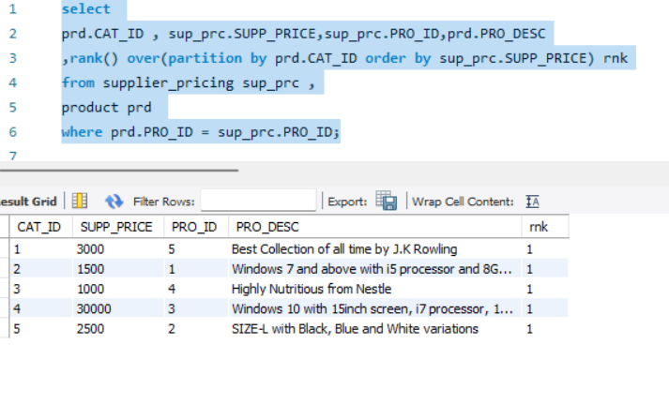

1. Display the Id and Name of the Product ordered after “2021-10-05”.

SELECT

prc.PRO_ID, prc.PRO_DESC

FROM

product prc,

e_comm.order ord,

supplier_pricing supp_prc

WHERE

supp_prc.PRICING_ID = ord.PRICING_ID

AND prc.PRO_ID = supp_prc.PRO_ID

AND ord.ORD_DATE >= '2021-10-05';

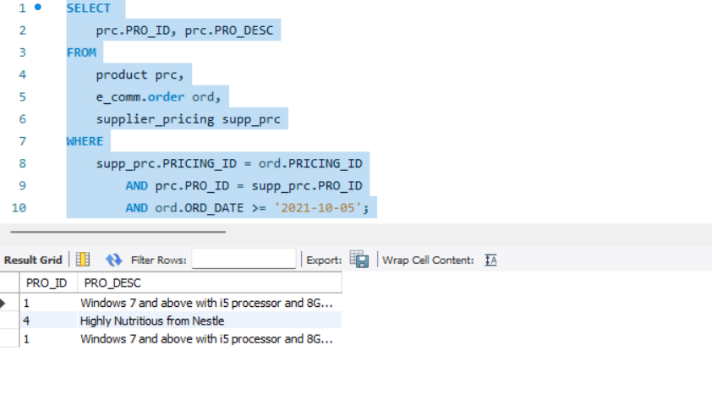

1. Display customer name and gender whose names start or end with character 'A'.

SELECT

c.CUS_NAME, c.CUS_GENDER

FROM

customer c

WHERE

c.CUS_NAME LIKE 'A%'

OR c.CUS_NAME LIKE '%A'

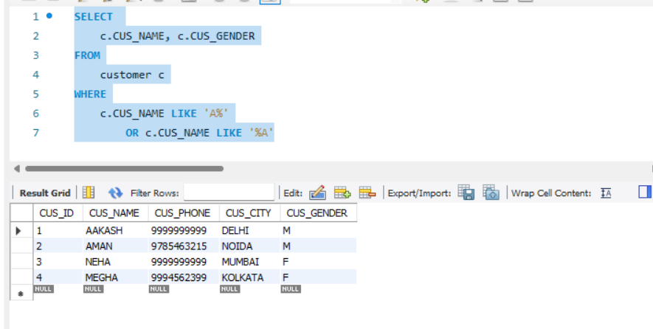

1. Create a stored procedure to display supplier id, name, rating and Tyx`pe_of_Service. For Type_of_Service, If rating =5, print “Excellent Service”,If rating >4 print “Good Service”, If rating >2 print “Average Service” else print “Poor Service”.

Delimiter //

CREATE PROCEDURE PriceOfCurrentMonth()

Begin

select supp.SUPP_ID,supp.SUPP_NAME ,avg(rtng.RAT_RATSTARS) rating ,

case when avg(rtng.RAT_RATSTARS) = 5 then 'Excellent Service'

when avg(rtng.RAT_RATSTARS) > 4 then 'Good Service'

when avg(rtng.RAT_RATSTARS) > 2 then 'Average Service'

else 'Poor Service' end Type_of_Service

from rating rtng ,supplier supp,

e_comm.order ord , supplier_pricing sprc

where ord.PRICING_ID = sprc.PRICING_ID

and sprc.SUPP_ID = supp.SUPP_ID

and rtng.ORD_ID = ord.ORD_ID

group by supp.SUPP_ID,supp.SUPP_NAME

order by rating desc ;

End //

