1. they returns the value for every single row, unlike aggregate functions.
2. use of OVER() clause.
3. window functions provides the output on the basis of a particular window.
4. Wherever you find partition-by , always take it like – issi particular group mein ,like partition by id means – create partition on the basis of id only , no other factor.
4. we can easily use window functions with aggregate functions using partition ( basically like group by in aggregate functions)

- avg()
if we want to find the avg grade of the student based on department , but also don't want to lose any individual rows.
eg-
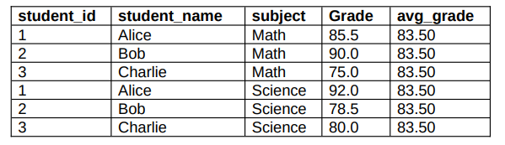
Query -
select student_id, student_name,subject,grade, avg(grade) over (partition by subject) as avg_grade from student_grades
So here basically , we grouped the grades on the basis of subjects and then did the average, we could have done it on basis of names as well
We can do all other operations using this as well like MIN,MAX,SUM,COUNT
- Min() and max()

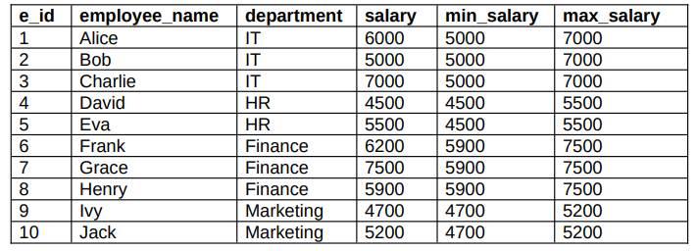

Query –
Select e_id, employee_name,department,salary , min(salary) over (partition by department) as min_salary , max(salary) over (partition by department) as max_salary from employee_table;

- Count()
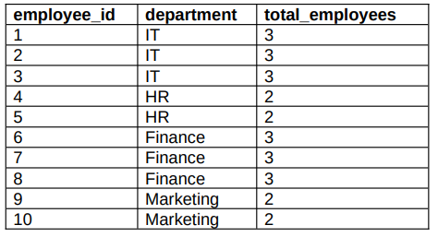
Query
Select employee_id, department, count(*) over (partition by department) as total_department from Employee;

5. RANK function – we have already wrote about Ranking using OVER clause , but what if we need to do ranking on a particular window? On a particular partition , we then will use partition by in RANK as well
a. RANK() – will give rank on the basis of given column with order by clause , but if we want the partition within a column then we will use the same.
Here , if 2 rows have same rank then next rank will be skipped on the tie rank , and will be started in increasing order sequence only.
Eg-
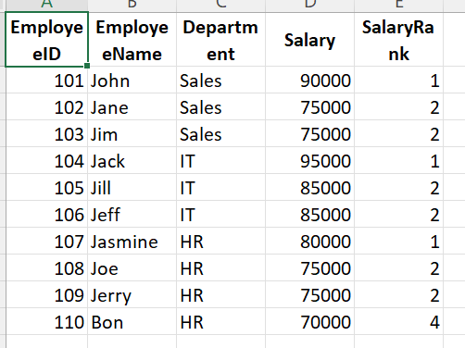
Here we are giving ranks on the basis of salary but within each department only , hence
Query – select , employeeID, employeeName, Department, Salary , RANK() over(PARTITION BY DEPARTMENT order by SALARY DESC) as SalaryRank from Employee;
b. DENSE_RANK() – will be used when we don’t want to skip ranks even if there are ties, it gives same rank to tied rows but does not leave any rank gaps in the sequence.
Eg-
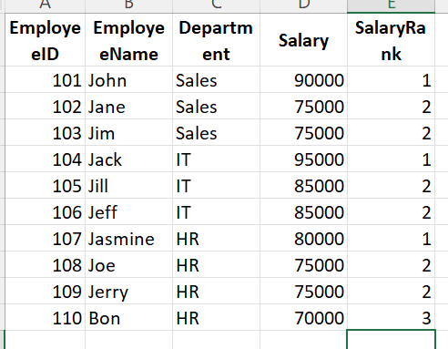
Query – select , employeeID, employeeName, Department, Salary , DENSE_RANK() over(PARTITION BY DEPARTMENT order by SALARY DESC) as SalaryRank from Employee;

