Hospital Management System

19-19-2024 Thursday 02:33:35 ~ Basic rough layout

__________________________________________________________________________________

**LOGIN PAGE**

* Patient
* Doctor
* Receptionist

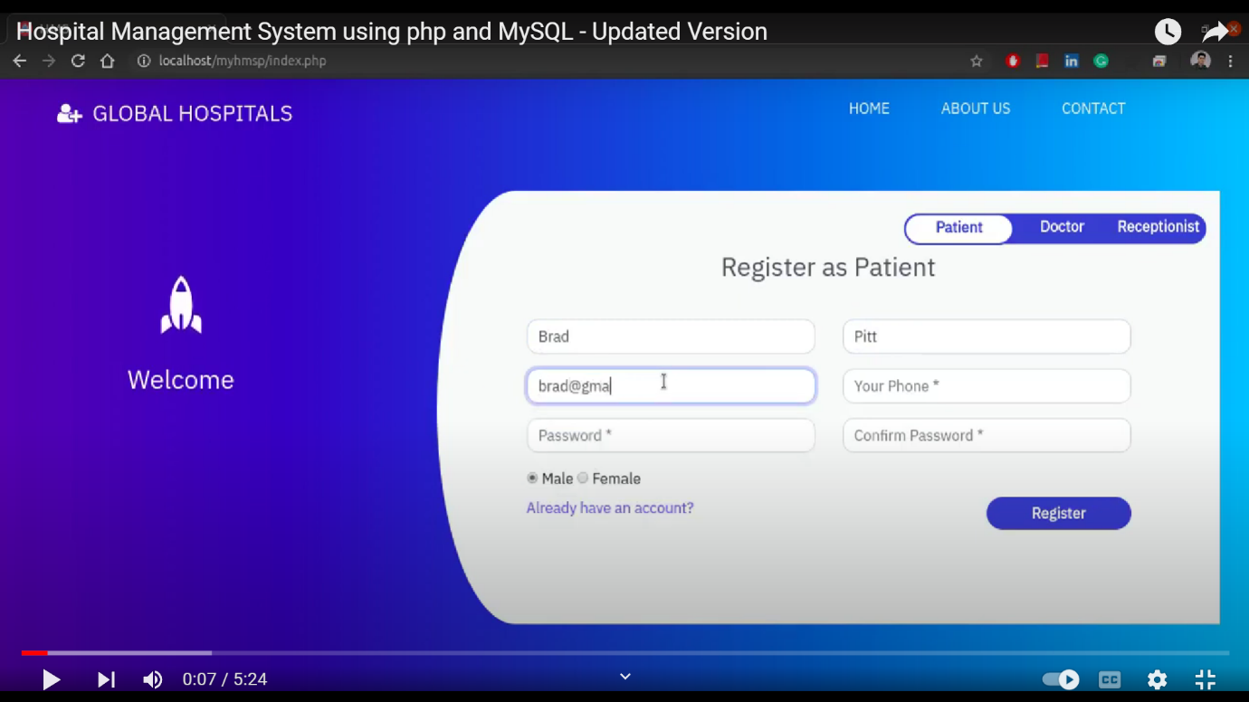



Ticked one IMP! [Already have an account *means login page just : (****email , password****)* ***-> login****]*

--------------------------------------------------------------------------------------------------------------------------------------

PATIENT MODULE

1. Find Doctor based on filter
2. Specialisation

Lists all doctors in grid format with data

1. Name
2. Experience
3. Fees
4. Rating
5. Availability filter
6. ~~Time Slot~~ filter
7. Prescription

* Lists Appointment history

|  |  |  |  |  |  |  |  |
| --- | --- | --- | --- | --- | --- | --- | --- |
| Appointment ID | Date + Day | Reason | Scheduled / Completed / Cancelled | Prescription  **  (None if cancelled)  (pending id scheduled) | Test Reports | Bill ***  (None if cancelled)  (pending id scheduled) | Remark on cancellation  (Reason sent by doctor for cancellation) |

OPTIONAL



DOCTOR MODULE

1. **Profile** Display

* Name
* Rating
* Education
* Specialisation

1. Pending Appointment to Approve or reject

* Sends short reason to patient

1. Handling of Patient

* Retrieves info of Patient through patient ID

( Some field will be pre-filled as that will be done by receptionist at the OPD when patient encounters for registration after taking online appointment

Like – patient id, name, age ,blood group and all necessary attributes to identify a patient

)

[Doctor just need to fill prescription **:

* Symptoms
* Cause
* Lab Test required
* Medical drugs suggested (Dosage time and quantity)
* Need of hospitalisation [YES/NO] [ICU/ General Ward / Surgery]
* If Surgery needed [Date+Time+Advice] [Immediate ?? assign doctor { patient kins goes to OPD to get allotted a room and surgery } ]



* Precautions / Remark



* Digitally Signed with Doctor ]
* Upload and updates prescription **

RECEPTIONIST MODULE :

1. Patient Registration

* Includes Fill of general info of patient [uploaded on dashboard; the empty prescription with general details filled]
* Money deposition (updated in ***table transactions*** with appointment id; all money time to time deposited )

[Bill *** page updated at all times tracking what money deposited at what, where by patient]

1. Handle Doctor feedback [ if doctor has urgent work between requested hour slot , cancel those appointments or allot another free doctor from of time slot from same field ]

{Refund of Money if registration happened at hospital}

{Simply Cancel and report to patient via SMS}

1. Bill *** generation :

* Pdf uploaded with final stamp handed to patient after all pending payments cleared !

1. Room allotment :

* Allot vacant room (ICU / general ward as prescribed by doctor)

1. Medicinal System :

* Add extra medicine bill copy with bill *** (depends on availability of drug)

1. Feedback System

* Reviews on doctor [necessary for rating star update of doctor ]

1. Tests :

* Test fee adds in ***transaction table*** with same appointment ID
* Test reports uploaded
* Test fee page attached with bills

1. **SETTINGS :**

Admin access (authenticate)!

* ALTER DOCTOR’s Data
* Fees
* delete doctor
* add doctor
* TEST Price change

___________________________________________________________________________

NOTE :

* ~~Crossed attributes~~ are optional : Well and good if implemented : later part
* “***Asterisks used on words” and “**bold and underlined** ”mean *related to each other* …..refers to same context {Ponder on its count 😊}