**PIZZA SALES SQL QUERY**

**A. KPI’s  
1. Total Revenue:**



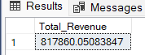

**2. Average Order Value**:

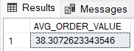

**3 . Total Pizza Sold**



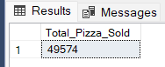

**4. Total_Orders**



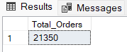

**5. Average Pizzas Per Order**

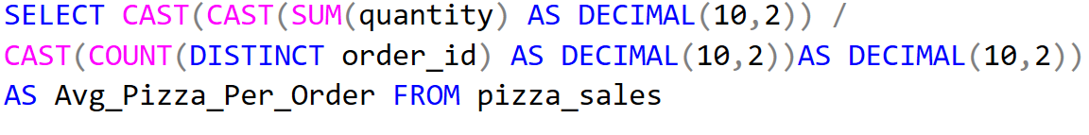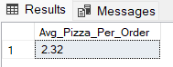

**B.DAILY TREND FOR TOTAL ORDERS**

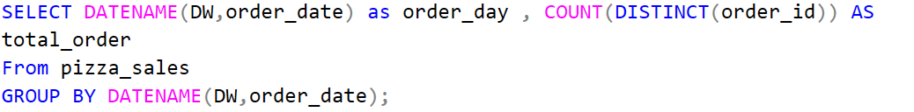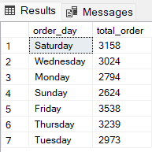

**C.MONTHY TREND FOR ORDERS**

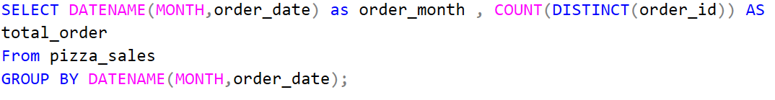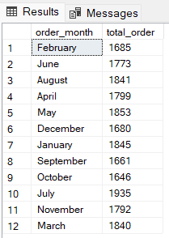

**D.% OF SALES BY PIZZA_CATEGORY**



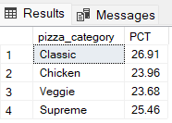

**E.% OF SALES BY PIZZA SIZE**



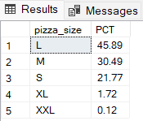

**F.TOP 5 PIZZAS BY REVENUE**

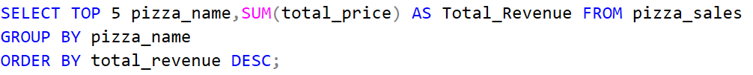

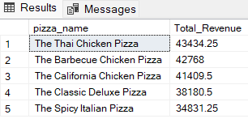

**G.BOTTOM 5 PIZZAS BY REVENUE**

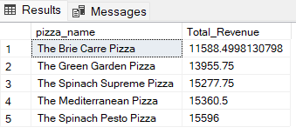

**H. TOP 5 PIZZAS BY QUANTITY**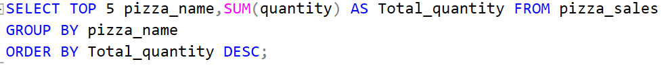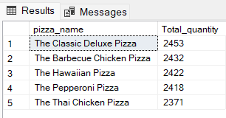

1. **TOP 5 PIZZAS BY TOTAL ORDERS**

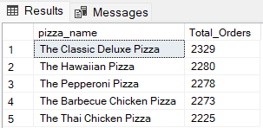

**J.BOTTOM 5 PIZZAS BY TOTAL ORDERS**

