- Search the Web for Cumani colour edge detector and write a report on it. Analyse how it may be better than doing Sobel edge detection three times on an RGB image.
Ans.

- Implement colour ranging operation in RGB space on colour images.

Ans. The implementation is given in file 2.rangingRGB.py.

Sample Input: orchid.ppm

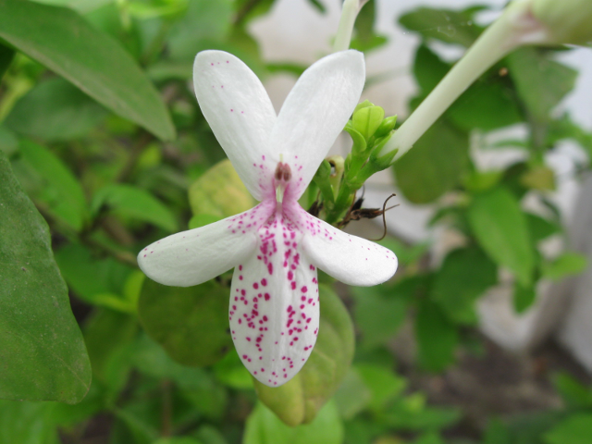

Output:
Removed all G component using ranging operation. Hence producing RB representaion of the input.

- Implement colour ranging operation in HSV space on colour images.

Ans. Code is given in 3.rangingHSV.py

Sample Input: makaw-bad.ppm
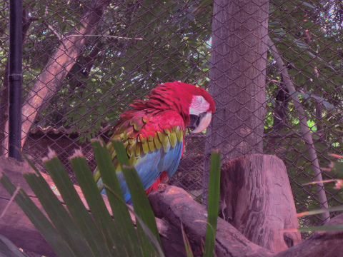

Output: (h_c = 0, h_bw = 22, s_c = 150, v_c = 50)

- Implement vector median filter and any one of the basic vector edge detectors. Show example images to demonstrate that these are better than the grayscale versions for colour images.
Ans.

