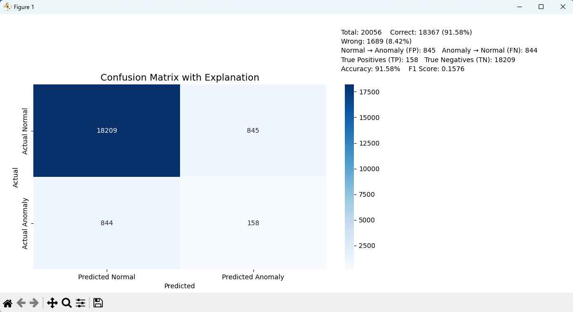

|  |  |  |  |  |  |  |  |  |  |  |  |  |
| --- | --- | --- | --- | --- | --- | --- | --- | --- | --- | --- | --- | --- |
| |  |  | **Predicted Normal (0)** | **Predicted Anomaly (1)** | | --- | --- | --- | --- | | **Actual Normal (0)** |  | **TN** (True Negative) | **FP** (False Positive) | | **Actual Anomaly (1)** |  | **FN** (False Negative) | **TP** (True Positive) | |

In matrix:

* **TP = 158**
* **FP = 845**
* **FN = 844**
* **TN = 18209**
* **Total samples = TP + TN + FP + FN = 20056**

**✅ Key Metric Equations:**

