E-Commerce Customer Churn Analysis
MySQL Module-End Assignment — Project Documentation

1. Data Cleaning

1.1 Mean Imputation

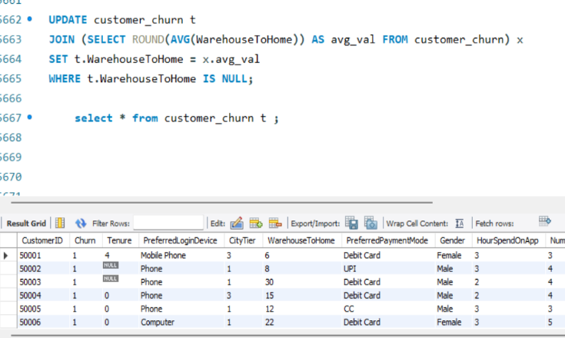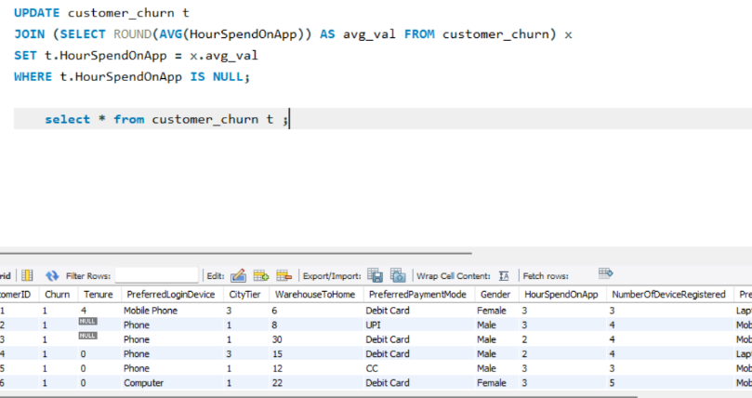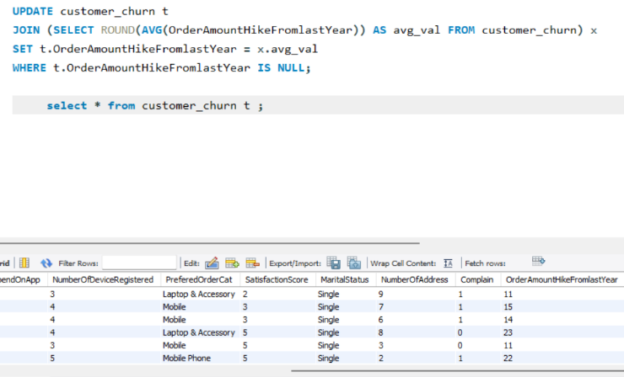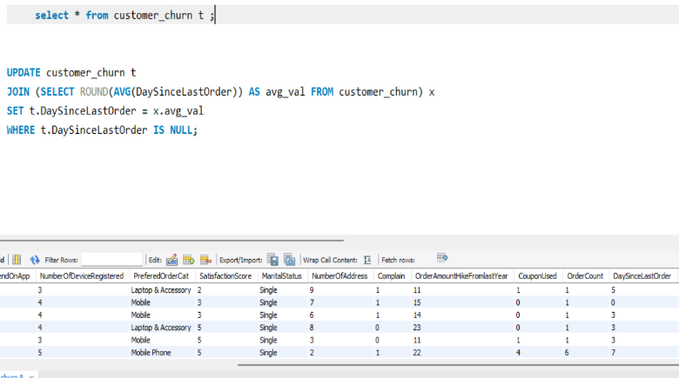

1.2 Mode Imputation

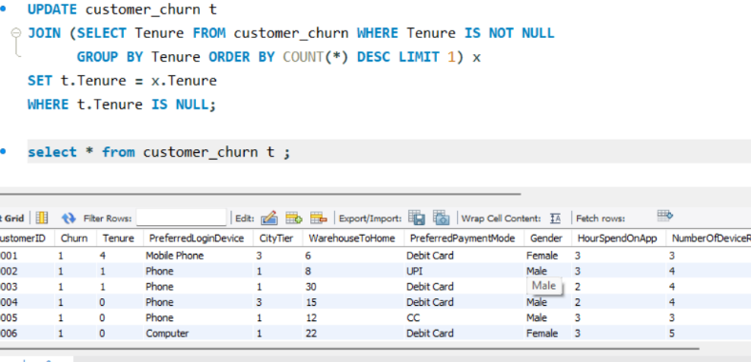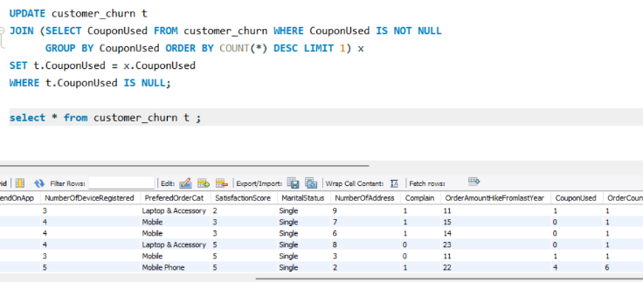

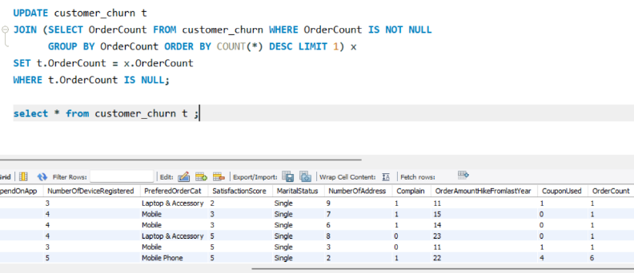

1.3 Outlier Removal

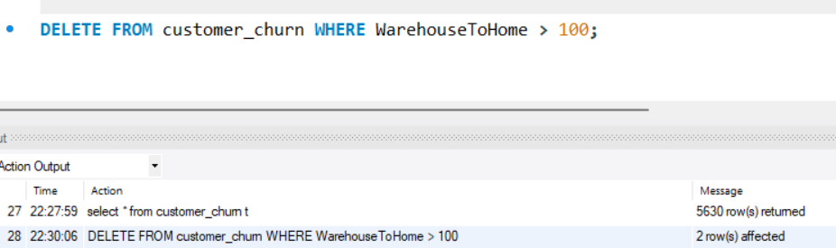

1.4 Fixing Inconsistent Category Labels

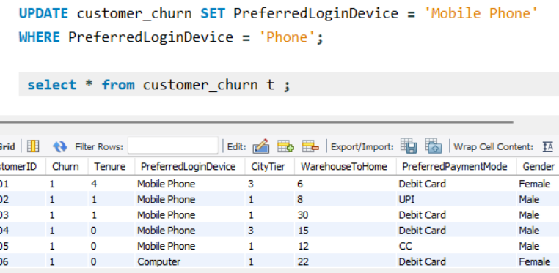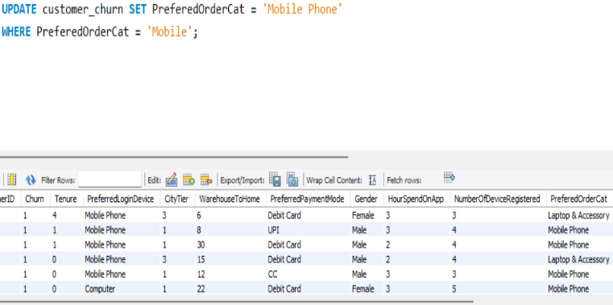

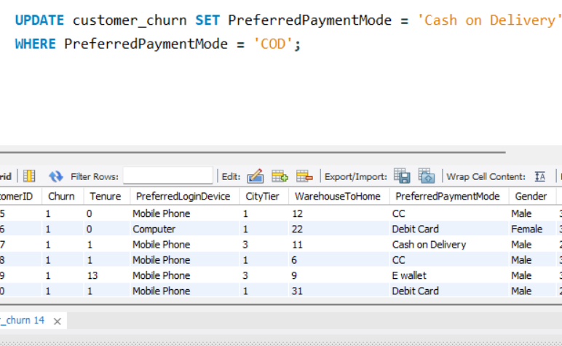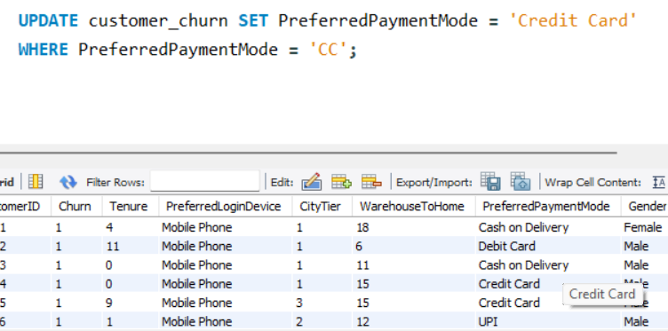

2. Data Transformation

2.1 Renaming Columns

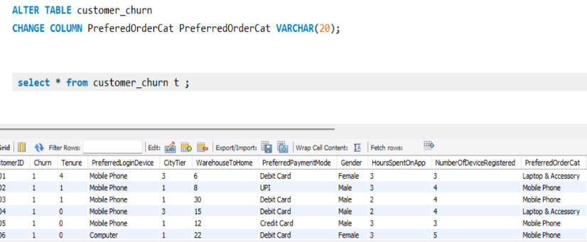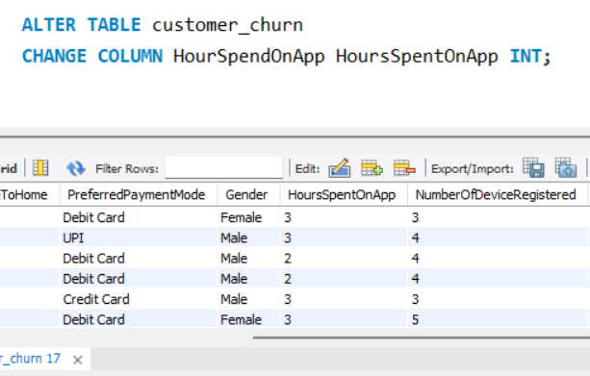

2.2 Creating New Columns

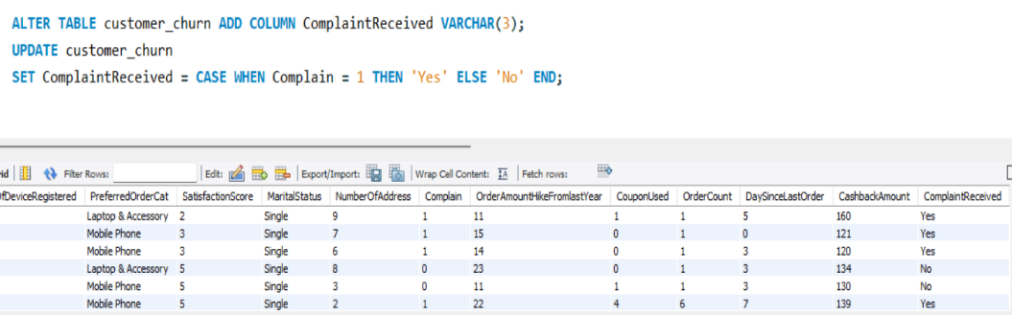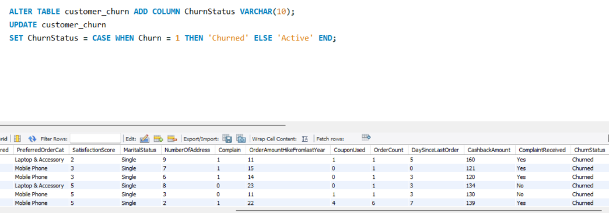

2.3 Dropping Old Columns

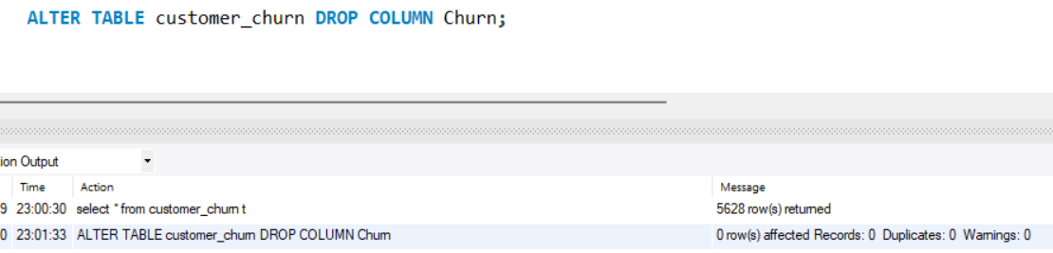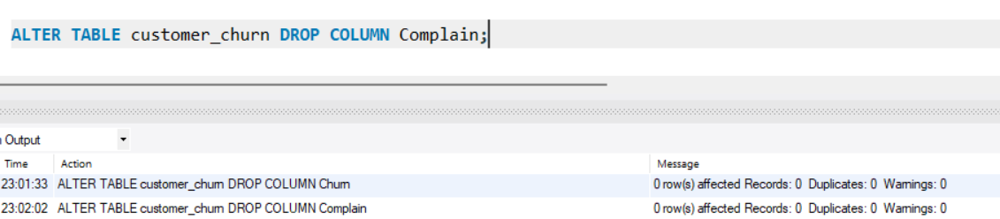

3. Data Exploration and Analysis

Q1. Count of churned

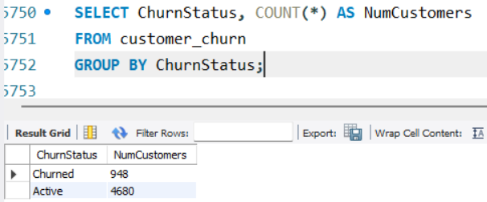

Q2. Average tenure and total cashback of churned customers

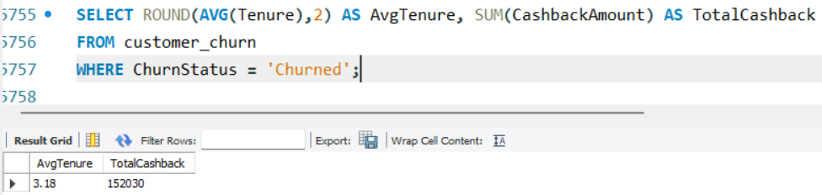

Q3. Percentage of churned customers who complained
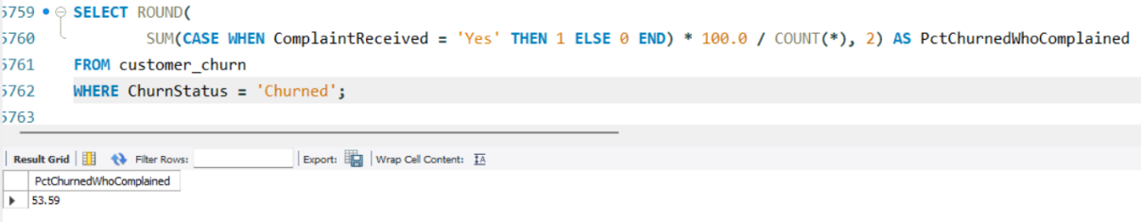

Q4. City tier with most churned customers preferring Laptop & Accessory
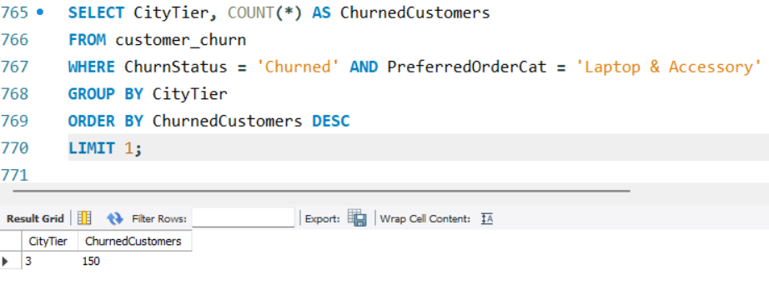

Q5. Most preferred payment mode among active customers
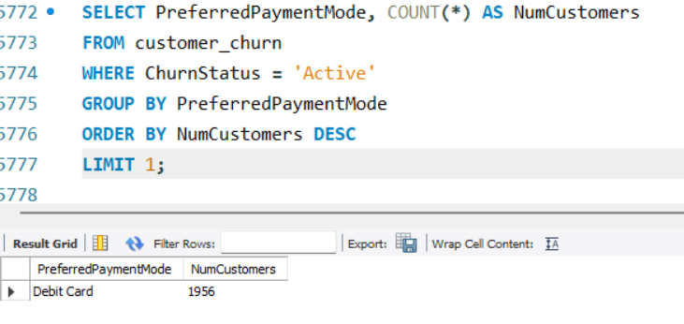

Q6. Total order amount hike for single, mobile-ordering customers

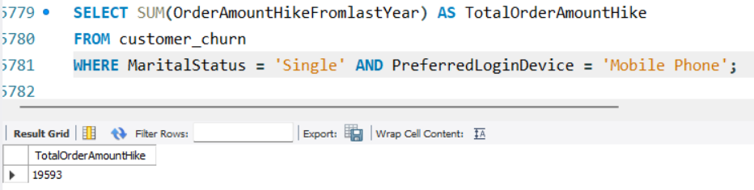

Q7. Average devices registered among UPI users
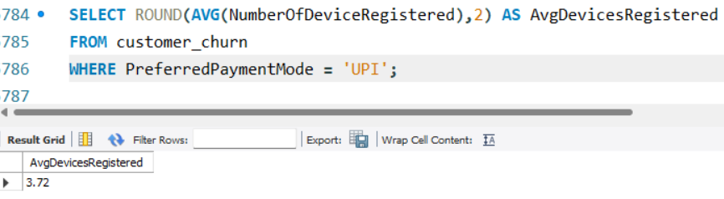

Q8. City tier with the highest number of customers overall
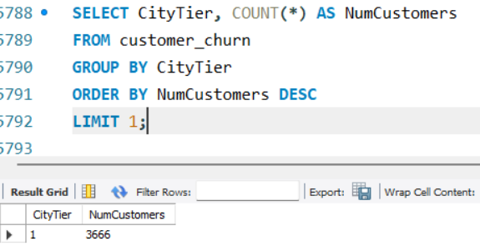

Q9. Gender that used the highest number of coupons

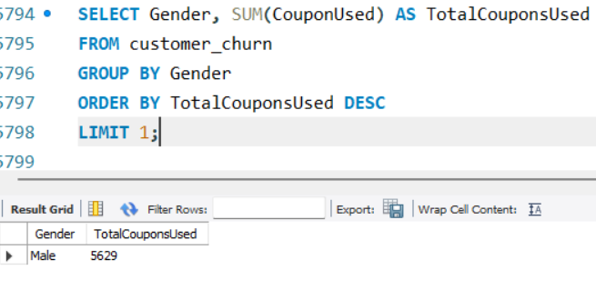

Q10. Customers and max app hours per preferred order category
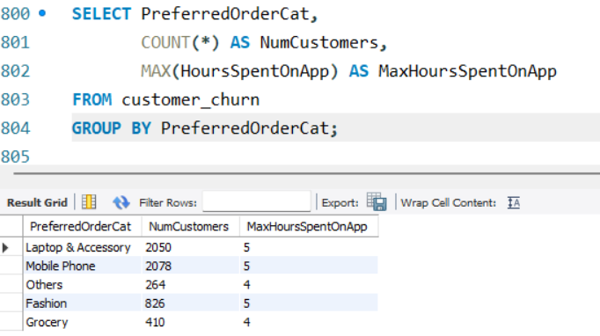

Q11. Total order count for top-satisfaction credit-card customers
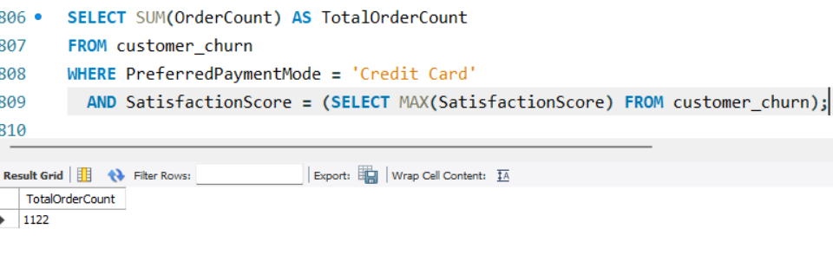

Q12. Average satisfaction score of customers who complained

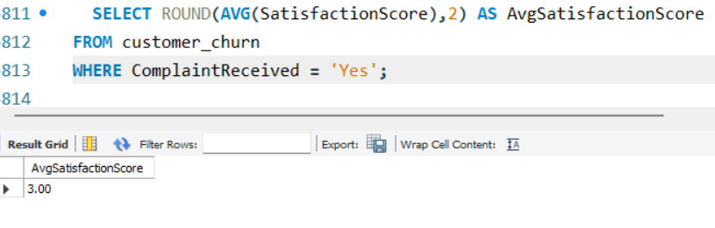

Q13. Preferred order category among customers who used more than 5 coupons
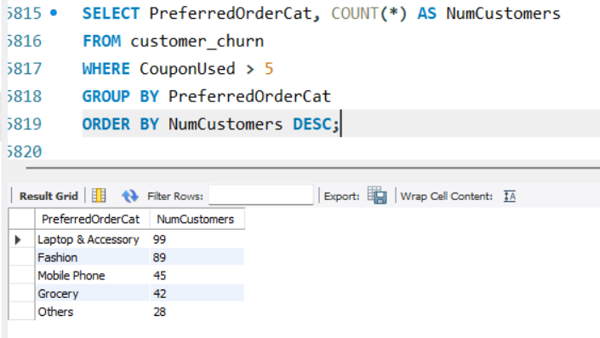

Q14. Top 3 preferred order categories by average cashback amount
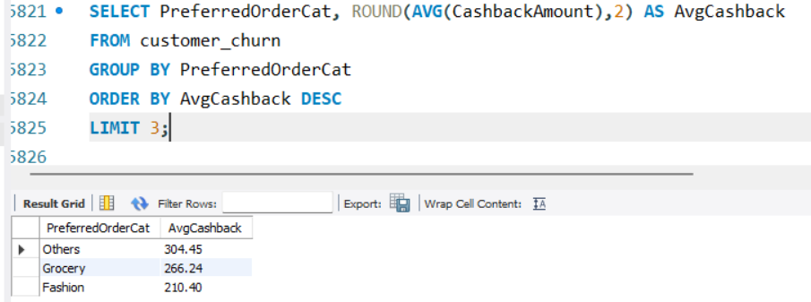

Q15. Payment modes with 10-month average tenure and 500+ total orders
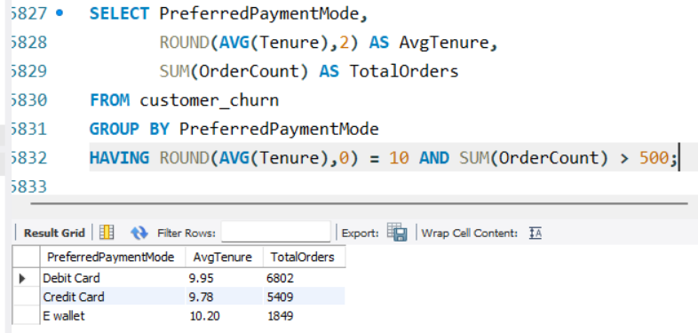

Q16. Distance-based churn breakdown
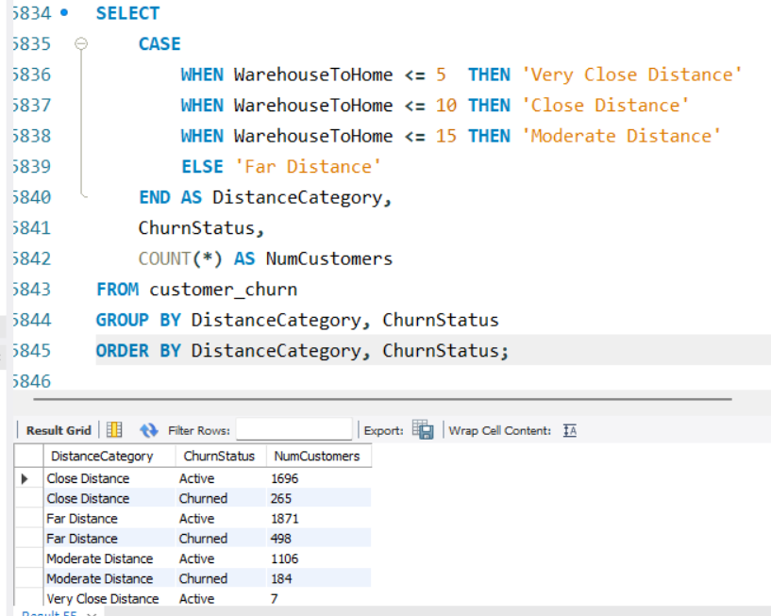

Q17. Married, City Tier-1 customers ordering above the overall average
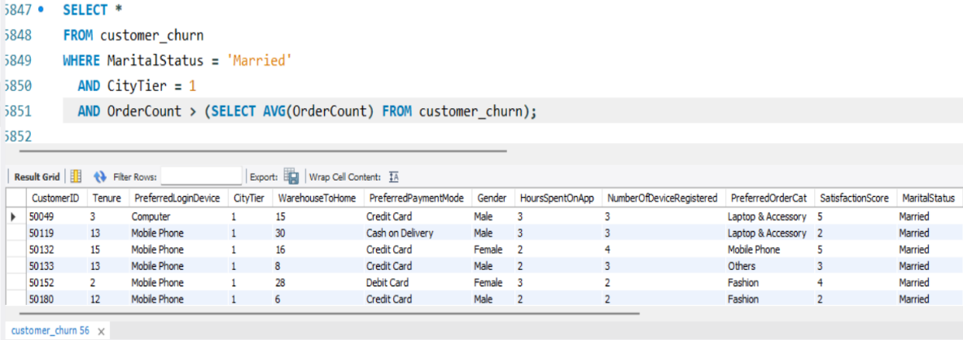

4. Customer Returns Table

4.1 Creating and Populating customer_returns

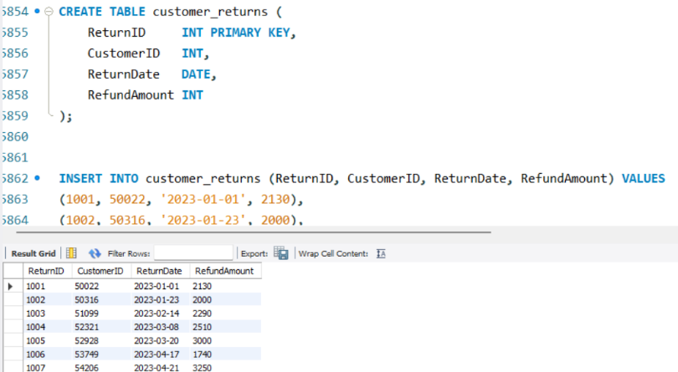

4.2 Returns from Churned, Complaining Customers

