1. AIM-

To Print the Multiplication Table of 10.

Source Code-

print "Multiplication Table of 10"

n=input("Enter Number")

for i in range(1,n+1):

print 10,"*",i,"=",10*i

Output-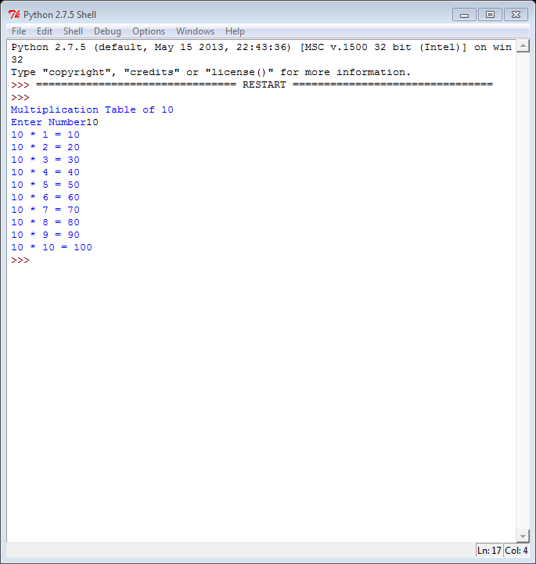

1. AIM-

To Check whether a given Date is valid or not.

Source Code-

print "Valid or Invalid Date"

x=raw_input("enter date in DD/MM/YYYY : ")

if (len(x)!=10):

print "enter in DD/MM/YYYY format"

else:

d1=x[0]

d2=x[1]

date=10*int(d1)+int(d2)

m1=x[3]

m2=x[4]

month=10*int(m1)+int(m2)

y1=x[6]

y2=x[7]

y3=x[8]

y4=x[9]

year=1000*int(y1)+100*int(y2)+10*int(y3)+int(y4)

a=[1,3,5,7,8,10,12]

b=[4,6,9,11]

if (month<=12 and month>=1):

if (month in a):

if (date>=1 and date<=31):

print "Valid Date"

else:

print "Invalid Date"

elif (month in b):

if (date>=1 and date <=30):

print "Valid Date"

else:

print "Invalid Date"

elif (month==2):

if (year%4==0 and date>=1 and date<=29):

print "Valid Date"

elif (year%4!=0 and date>=1 and date<=28):

print "The date is valid."

else:

print "Invalid Date"

else:

print "Invalid Date"

Output-

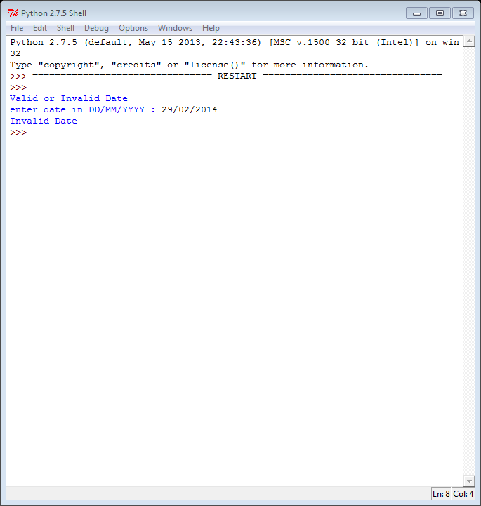

1. AIM-

To Print First n Fibonacci Numbers using while loop.

Source Code-

print "Fibonacci Sequence"

x=0

y=1

n=input("Enter range")

print x

while (x<=n):

y=x+y

x=y-x

if (x<=n):

print x

Output-

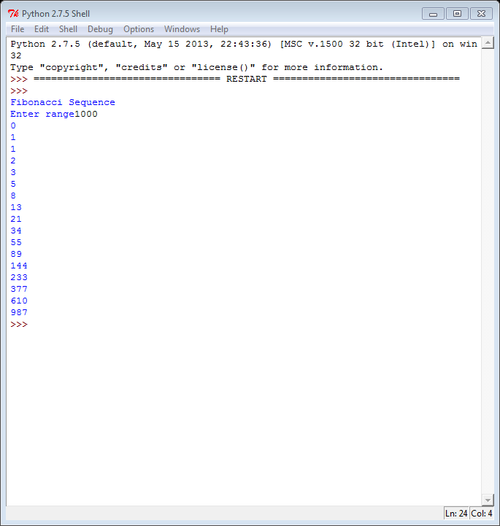

1. AIM-

To Print sum of Series 1+x2+x3+...+n terms.

Source Code-

print "Sum of Series 1+x2+x3+...+n terms"

x=input("Enter base")

y=input("Enter number of terms")

z=1

for i in range(2,y+1):

z+=(x**i)

print "The sum is", z

Output-

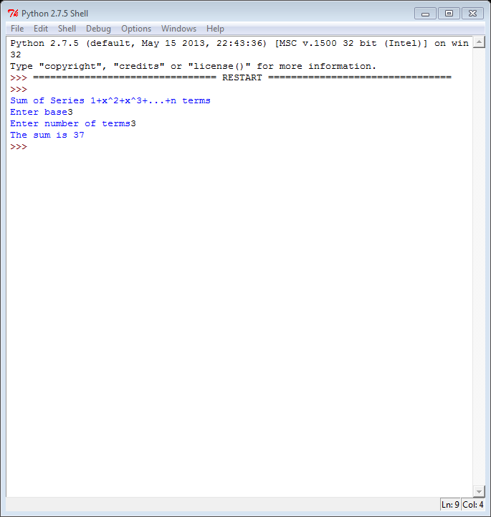

1. AIM-

To Print Sum of Series x-(x2)/3!+(x3)/5!-(x4)/7!+(x5)/9!+..+n terms.

Source Code-

print "Sum of Series x-(x2)/3!+(x3)/5!-(x4)/7!+(x5)/9!+..+n terms"

s=0

a=1

x=input("Enter number")

n=input("Enter number of terms")

for i in range(1,n+1):

k=1

for j in range(1,i+a):

k=k*j

if (i%2==0):

s=s-(float(x**i)/k)

else:

s=s+(float(x**i)/k)

a+=1

print "The sum is",s

Output-

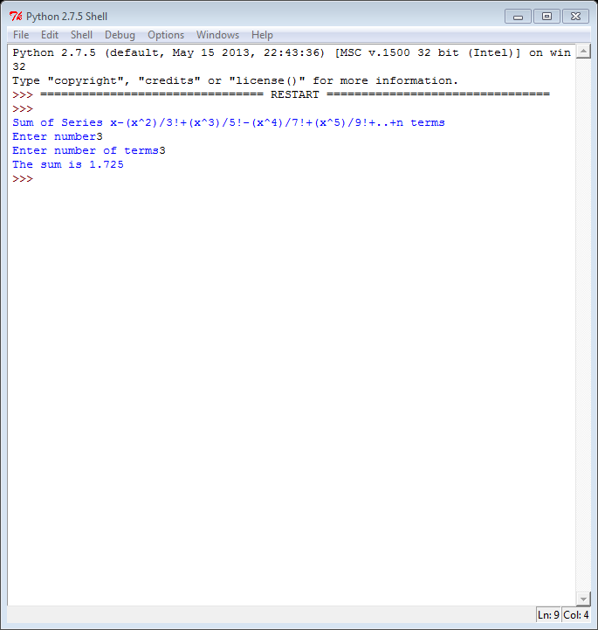

1. AIM-

To Print Factorial of a Number.

Source Code-

print "Factorial of a Number"

x=input("Enter Number")

fact=1

for i in range(1,x+1):

fact=fact*i

print "The product is",fact

Output-

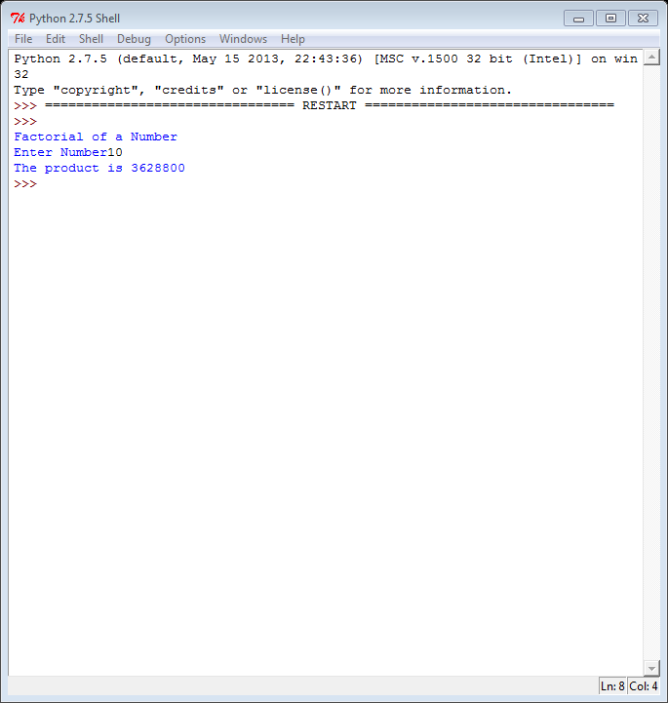

1. AIM-

To Print Sum of Digits.

Source Code-

print "Sum of Digits"

x=input("Enter the number")

s=0

while x>=1:

k=x%10

s+=k

x=x/10

print "The sum of digits is",s

Output-

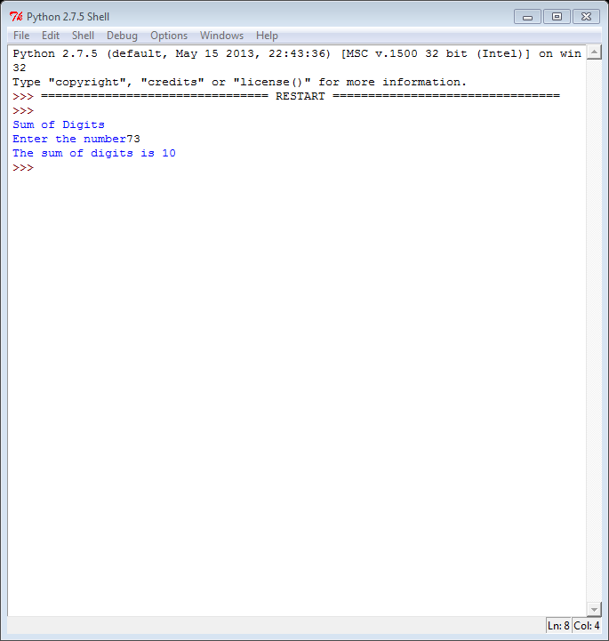

1. AIM-

To Check whether a Number is Palindrome or not.

Source Code-

print "Palindrome"

n=input("Enter number")

s=0

new=n

k=0

while(n>=1):

r=n%10

s=(s*10)+r

n=n/10

k+=1

if (s==new) and (k%2==1):

print "It is a palindrome"

else:

print "It is not a palindrome"

Output-

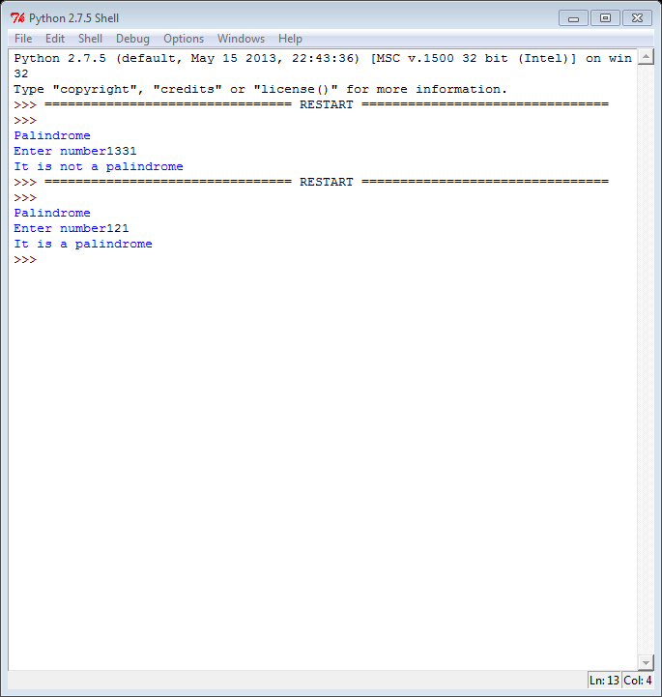

1. AIM-

To Check whether a Number is an Armstrong Number.

Source Code-

print "Armstrong Number"

n=input("Enter number")

s=0

new=n

while(n>=1):

r=n%10

s=s+(r**3)

n=n/10

if (s==new):

print "It is an armstrong number"

else:

print "It is not an armstrong number"

Output-

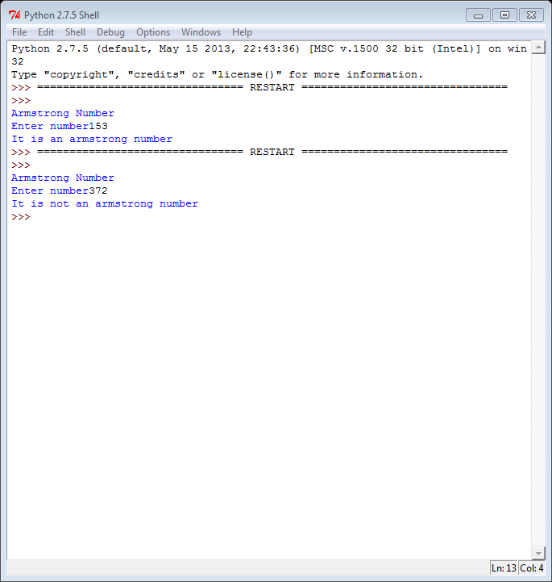

1. AIM-

Decimal to Binary Conversion.

Source Code-

print "Decimal to Binary Conversion"

n=input("Enter Decimal data type")

bn=0

k=0

while(n>0):

r=n%2

n=n/2

bn=bn+(r*(10**k))

k=k+1

print bn

Output-

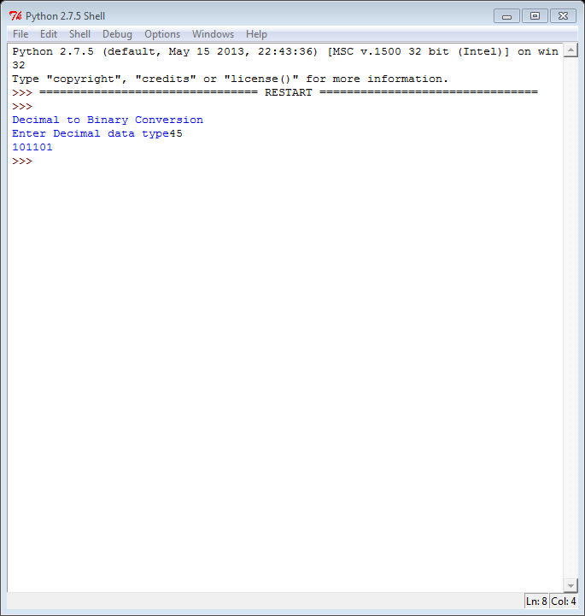

1. AIM-

To Check whether a Number is prime or not.

Source Code-

print "Prime or Composite"

n=input("Enter the number")

for i in range(2,n):

if (n%i==0):

print “The number is composite”

break

else:

print “The number is prime”

Output-

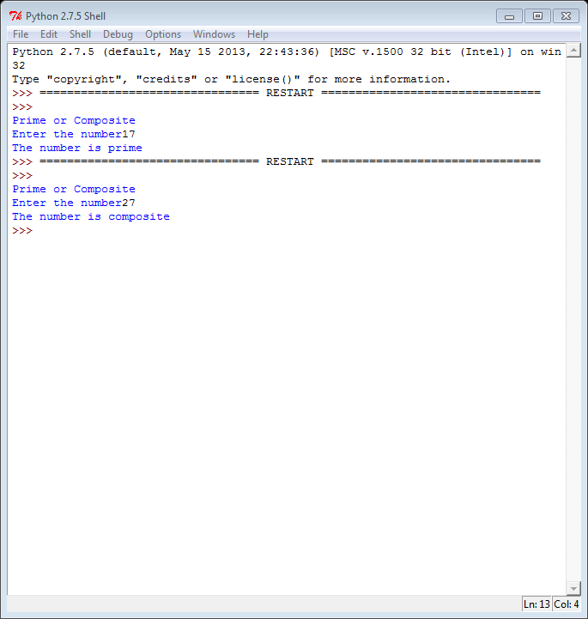

1. AIM-

To Print a Number Pyramid.

Source Code-

print "Number Pyramid"

n=input("Enter range")

for i in range(1,n+1):

for j in range(1,i+1):

print i,

print

Output-

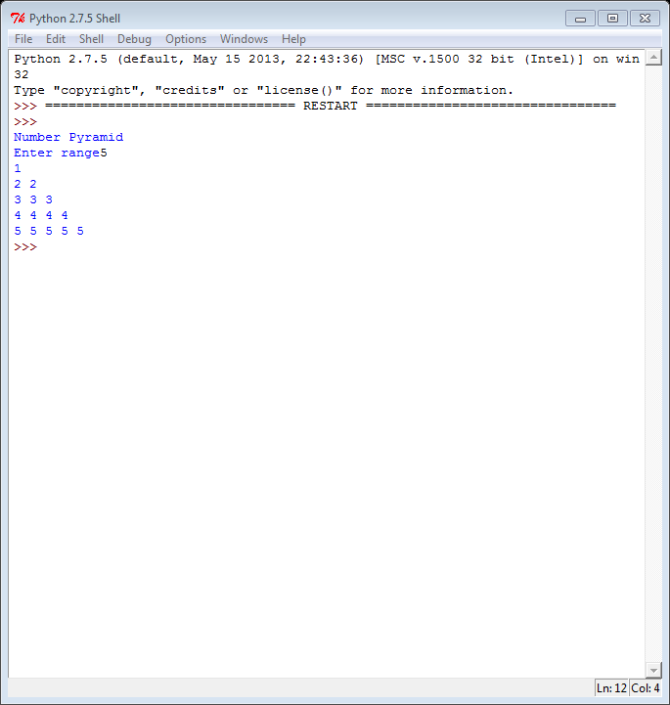

1. AIM-

To Calculate the Sum & Average of Odd & even Natural Numbers using user defined functions.

Source Code-

def sumavg(n):

sumn=0

even=0

odd=0

x=0

o=0

e=0

for i in range(0,n+1):

sumn=sumn+i

x=x+1

if(i%2==0):

even=even+i

e+=1

if(i%2==1):

odd=odd+i

o+=1

avg=sumn/x

eavg=even/e

oavg=odd/o

print "Natural no.s sum",sumn,"and average",avg

print "Odd no.s sum",odd,"and average",o

print "Even no.s sum",even,"and average",e

n=input("Enter range")

sumavg(n)

Output-

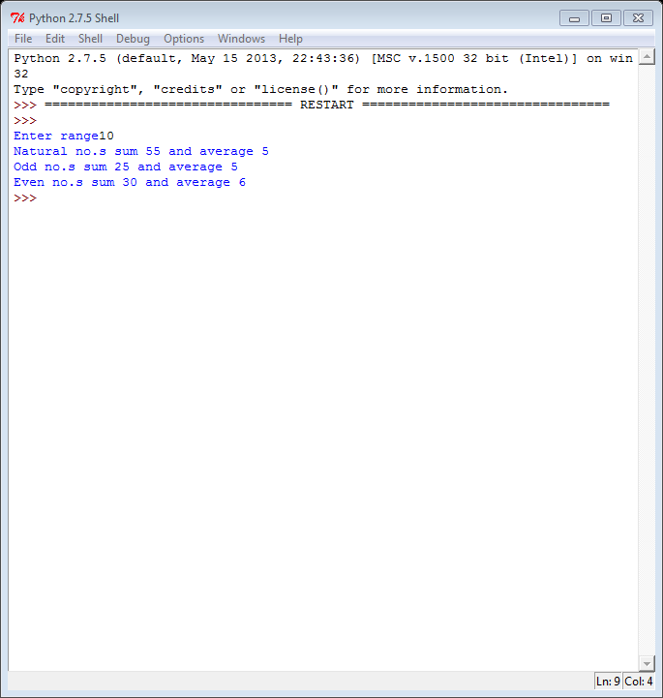

1. AIM-

Function to find the sum of prime numbers between two ranges.

Source Code-

def prime(x,y):

n=0

for i in range(x+1,y):

for j in range(2,i):

if (i%j==0):

break

else:

print i,"is a prime no"

n+=i

print "The sum is",n

x=input("Enter initial value ")

y=input("Enter final value ")

prime(x,y)

Output-

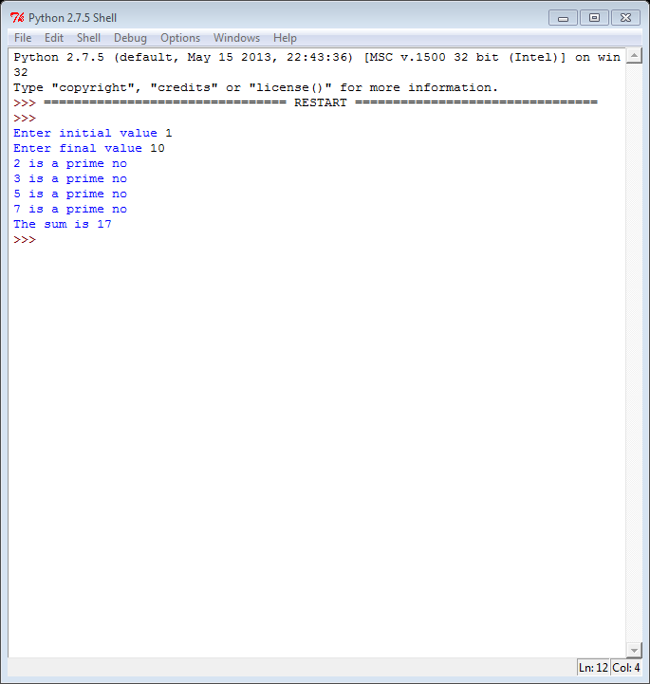

1. AIM-

Function to find the roots of a Quadratic Equation.

Source Code-

def quadroots(a,b,c):

import math

D=(b**2)-4*(a)*(c)

root1=(-1*b+math.sqrt(D))/2*a

root2=(-1*b-math.sqrt(D))/2*a

return root1,root2

x=input("Enter the coefficient of x^2:")

y=input("Enter the coefficient of x:")

z=input("Enter the constant:")

print 'The roots are',quadroots(x,y,z)

Output-

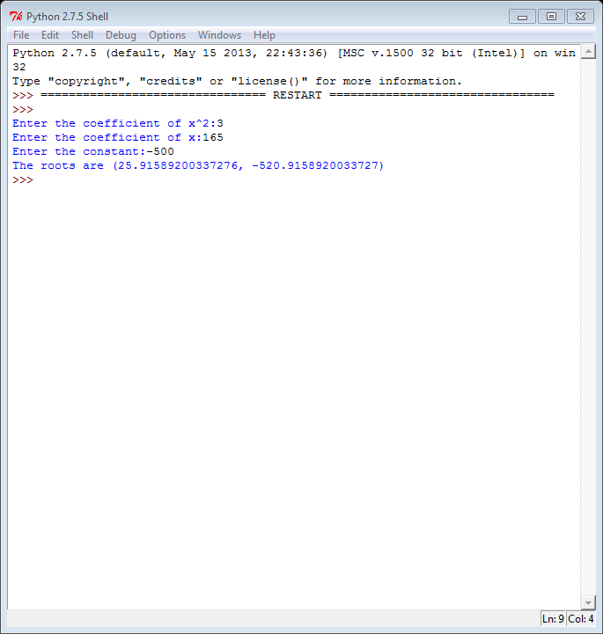

1. AIM-

To Print Reverse of a String.

Source Code-

def reverse(x):

s=''

for i in range(len(x)-1,-1,-1):

s=s+x[i]

return s

x=raw_input("Enter the word")

print reverse(x)

Output-

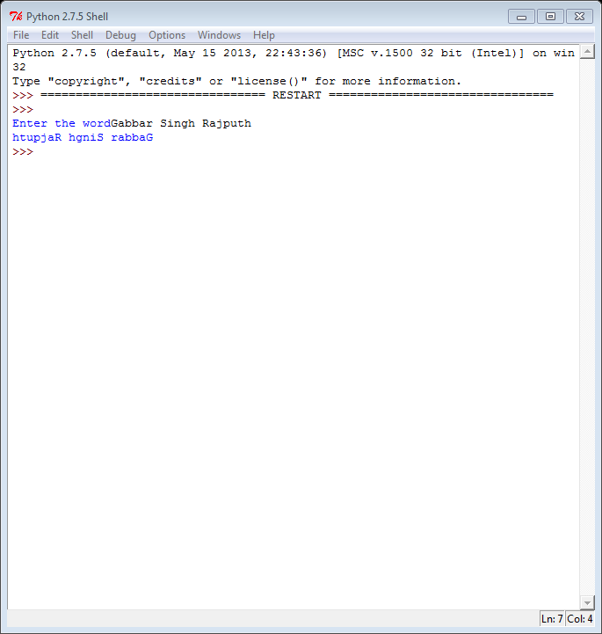

1. AIM-

To Check if a given string is palindrome or not.

Source Code-

def stringpalindrome(x):

s=''

for i in range(len(x)-1,-1,-1):

s=s+x[i]

if (s==x and (len(x)%2==1)):

print "It is a palindrome"

else:

print "It is not a palindrome"

x=raw_input("Enter the word")

stringpalindrome(x)

Output-

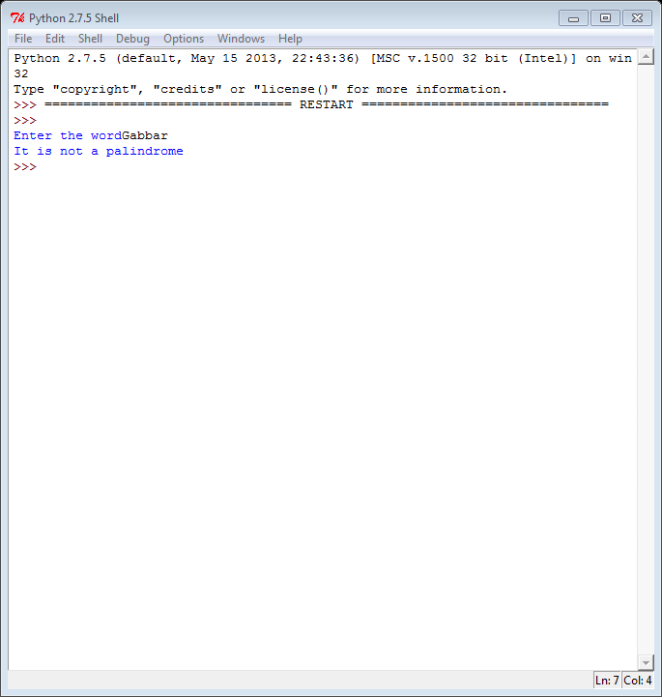

1. AIM-

To Count the Number of Vowels, uppercase letters, lowercase letters and spaces in a given string.

Source Code-

def alphabet(x):

v,u,l,s=0,0,0,0

for i in x:

if (i in "aeiou"):

v+=1

if i.isupper():

u+=1

if i.islower():

l+=1

if i.isspace():

s+=1

print "No.of vowels is ",v

print "No.of uppercase letters is ",u

print "No.of lowercase letters is ",l

print "No.of spaces is ",s

x=raw_input("Enter string: ")

alphabet(x)

Output-

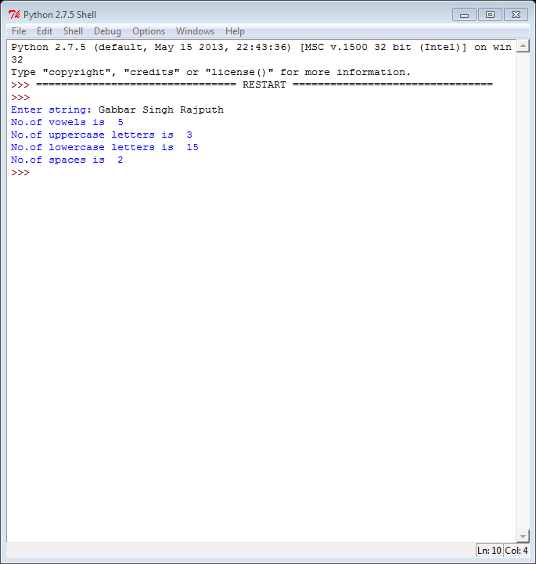

1. AIM-

To Search an element using Linear Search.

Source Code-

n=list(input("Enter list"))

x=input("Find number")

for i in range(0,len(n)):

if (x==n[i]):

print "Found in position",i+1,"of list"

Output-

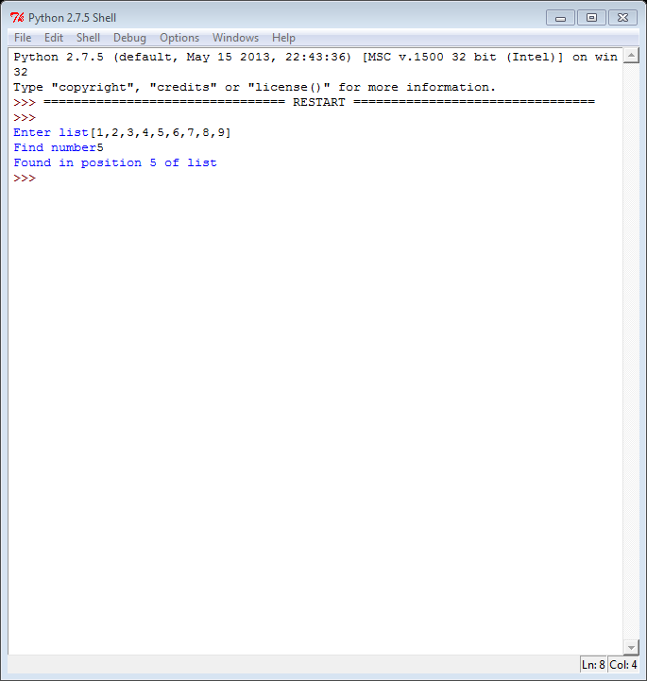

1. AIM-

To Search an element using Binary Search.

Source Code-

n=list(input("Enter list"))

l=len(n)

for i in range(0,l):

for j in range(0,l-1):

if(n[j]>n[j+1]):

n[j],n[j+1]=n[j+1],n[j]

print n

x=input("Enter item to be searched")

b=0

e=len(n)-1

while(b<=e):

m=(b+e)/2

if (n[m]==x):

print "Found",x,"in location",m+1

break

elif(x>n[m]):

b=m+1

else:

e=m-1

if(b>e):

print "Not found"

Output-

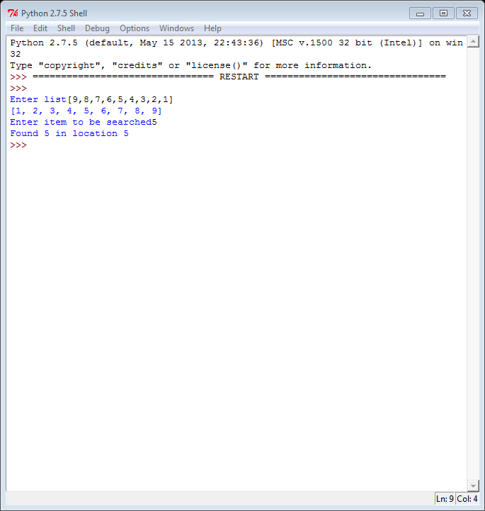

1. AIM-

To Sort an element using Selection Sort.

Source Code-

x=list(input("Enter list"))

for i in range(0,len(x)):

for j in range(i+1,len(x)):

if (x[i]>x[j]):

x[i],x[j]=x[j],x[i]

print x

Output-

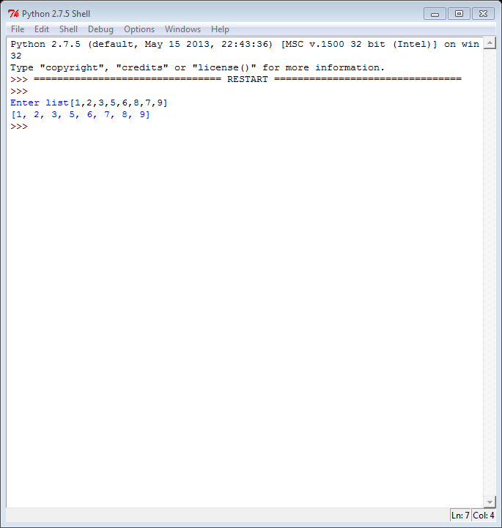

1. AIM-

To Sort an element using Bubble Sort.

Source Code-

print "Bubble Sort"

x=list(input("Enter list"))

n=len(x)

for i in range(0,n-1):

for j in range(0,n-i-1):

if(x[j]>x[j+1]):

x[j],x[j+1]=x[j+1],x[j]

print x

Output-

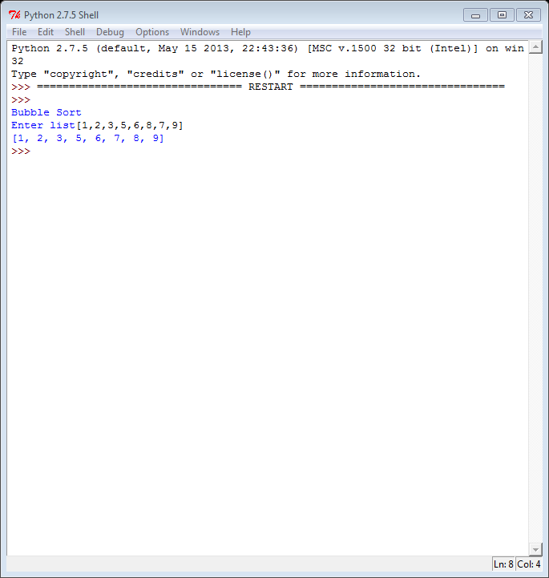

1. AIM-

To find the smallest and largest element in a list.

Source Code-

print "Largest & Smallest Element"

x=list(input("Enter list"))

for i in range(0,len(x)):

for j in range(i+1,len(x)):

if (x[i]>x[j]):

x[i],x[j]=x[j],x[i]

print "The smallest number is",x[0]

print "The largest number is",x[len(x)-1]

Output-

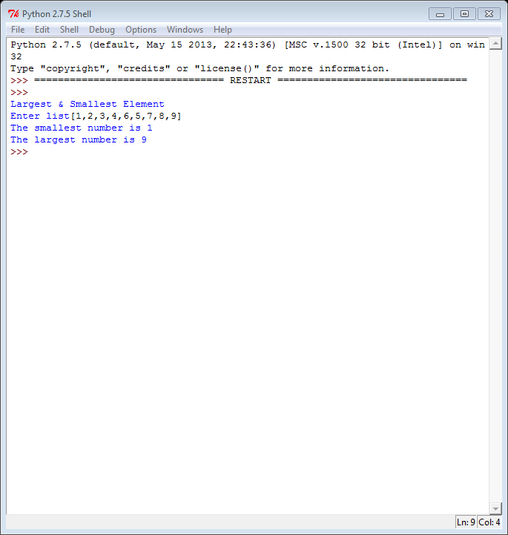

1. AIM-

To Merge two lists.

Source Code-

print "Merge two lists"

x=list(input("Enter list1"))

y=list(input("Enter list2"))

for i in range(0,len(y)):

x.append(y[i])

print x

Output-

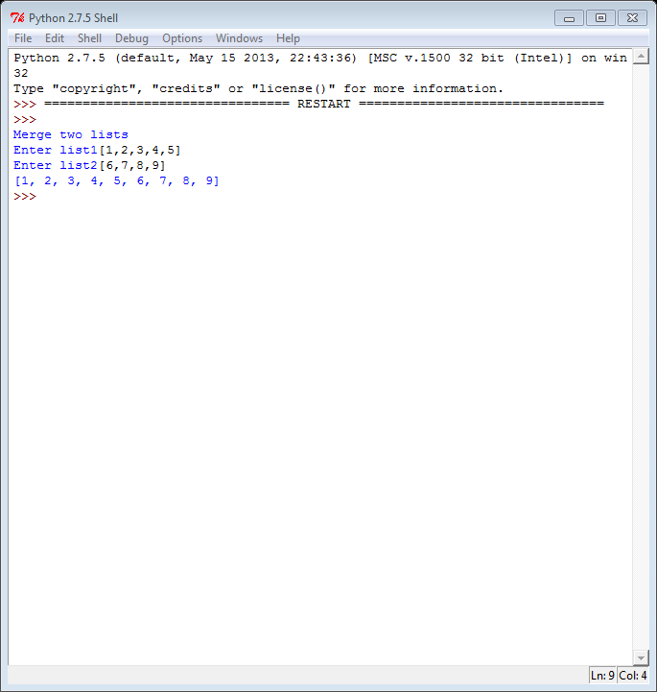

1. AIM-

To Transpose a Matrix.

Source Code-

print "Transpose of a Matrix"

a=list(input("Enter list"))

for i in range(0,len(a)):

for j in range(0,len(a[i])):

print a[j][i],

print

Output-

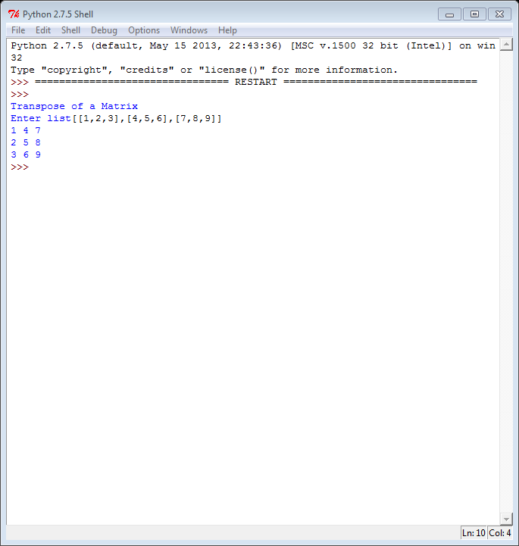

1. AIM-

To Find the Sum of both Diagonals.

Source Code-

n=list(input("Enter the list "))

x,y=0,0

for i in range(0,len(n)):

for j in range(0,len(n[i])):

if (i==j):

x+=n[i][j]

if (i+j==(len(n)-1)):

y+=n[i][j]

print "The sum of left to right diagonal is",x

print "The sum of right to left diagonal is",y

Output-

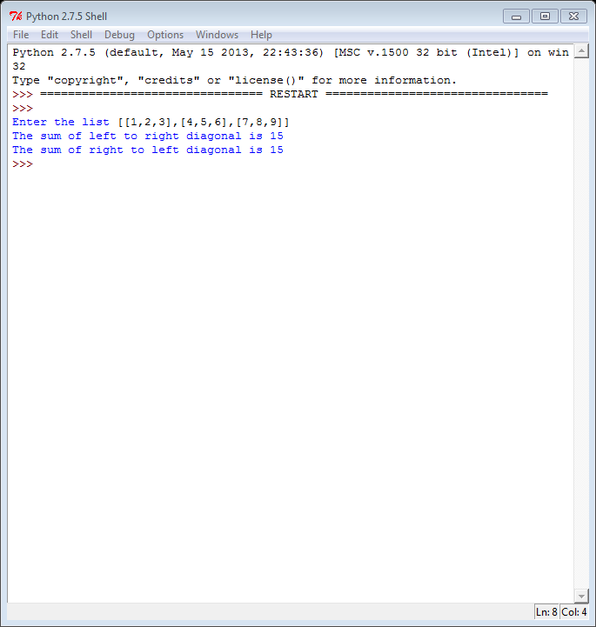

1. AIM-

To Find the Sum of two Matrices.

Source Code-

x=[input("Enter the first list ")]

y=[input("Enter the second list ")]

for i in range (0,len(x)):

for j in range(0,len(x[i])):

x[i][j]+=y[i][j]

for i in range(0,len(x)):

for j in range(0,len(x[i])):

print x[i][j],

print

Output-

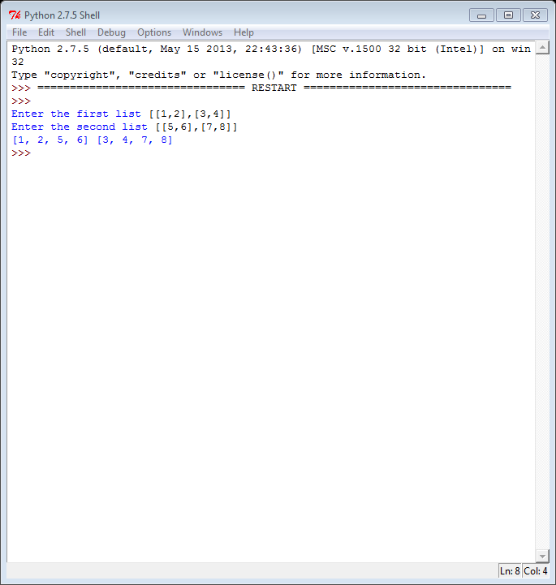

1. AIM-

To Print the Upper Triangle and Lower Triangle.

Source Code-

n=list(input("Enter nested list: "))

for i in range(0,len(n)):

for j in range(0,len(n[i])):

if(i<=j):

print n[i][j],

else:

print " ",

print

for i in range(0,len(n)):

for j in range(0,len(n[i])):

if(i>=j):

print n[i][j],

else:

print " ",

print

Output-

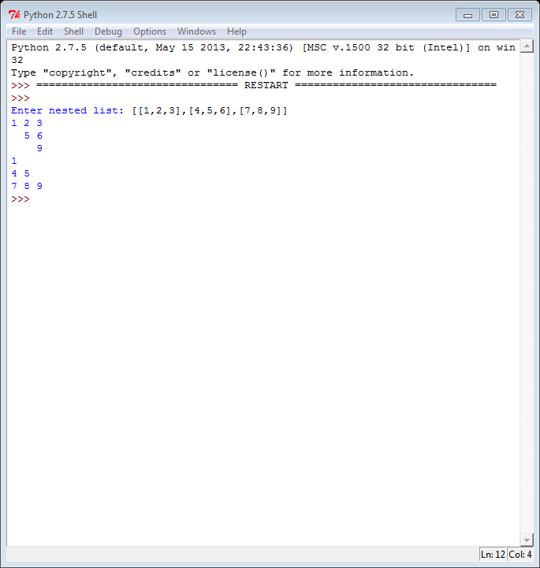

1. AIM-

To Find the largest element in the Matrix.

Source Code-

x=list(input("Enter the nested list: "))

a=x[0][0]

for i in range(0,len(x)):

for j in range(0,len(x[i])):

if (x[i][j]>a):

a=x[i][j]

print "The greatest number is",a

Output-

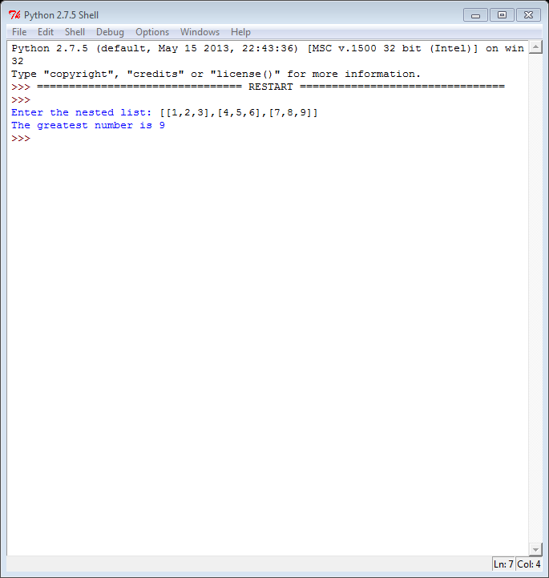

1. AIM-

To Find the sum of rows and columns of a Matrix.

Source Code-

n=list(input("Enter the nested list: "))

for i in range(0,len(n)):

for j in range(0,len(n[i])):

print n[i][j],

print

for i in range(0,len(n)):

print "Sum of row",i+1,"is",sum(n[i])

for j in range (0,len(n)):

s=0

for k in range(0,len(n[i])):

s+=n[k][j]

print "Sum of column",j+1,"is",s

Output-

