LINUX BASICS ASSIGNMENT
DEVOPS | TUTEDUDE
Student Name: Mridul Sharma
Course: DevOps
Assignment: Linux Basics
Operating System: Ubuntu Linux

1. Creating and Renaming Files/Directories

Task 1: Create a Directory
Command:
mkdir test_dir
Explanation:
The mkdir command is used to create a new directory. This command creates a directory named test_dir.
Screenshot:
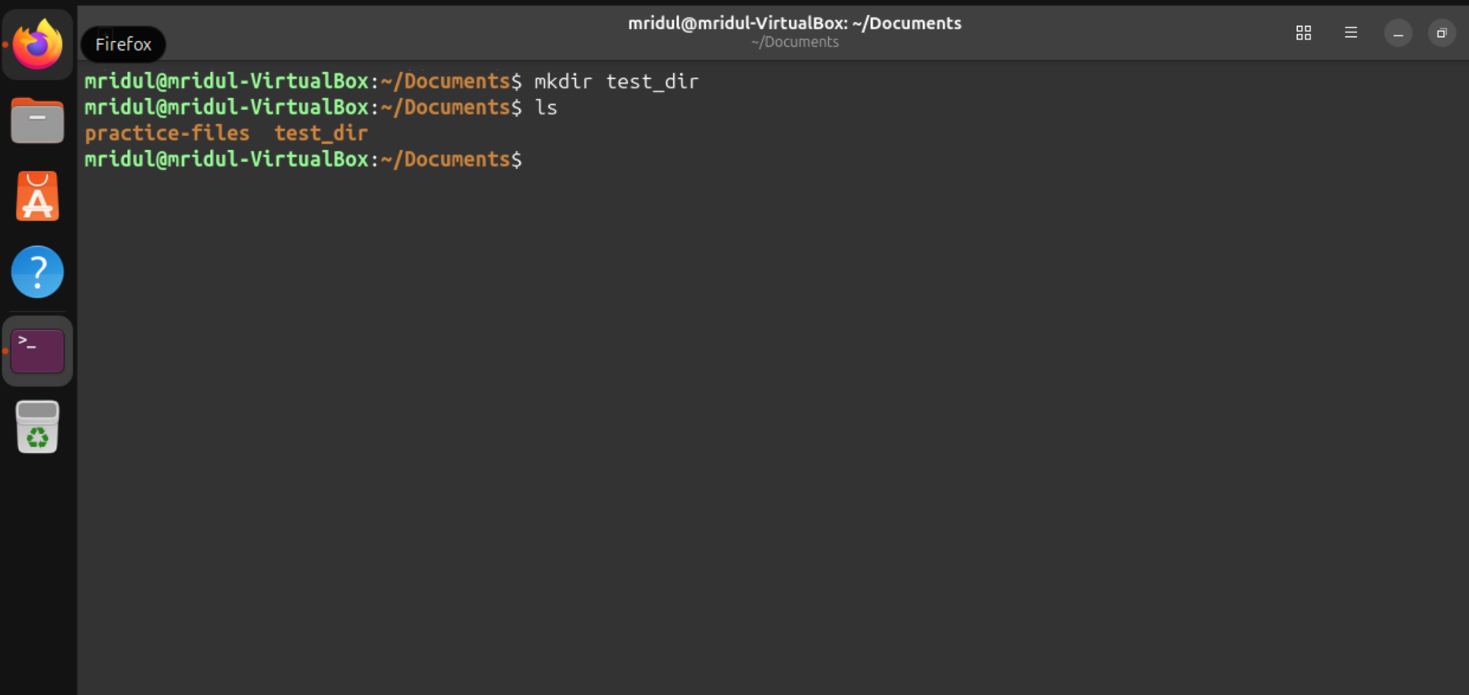

Task 2: Create an Empty File
Command:
touch test_dir/example.txt
Explanation:
The touch command is used to create an empty file. Here, it creates example.txt inside the test_dir directory.
Screenshot:
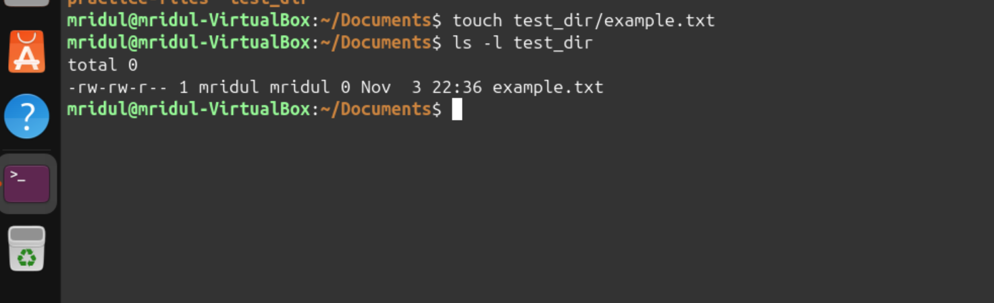

Task 3: Rename a File
Command:
mv test_dir/example.txt test_dir/renamed_example.txt
Explanation:
The mv command is used to move or rename files and directories. Here, it renames example.txt to renamed_example.txt.
Screenshot:
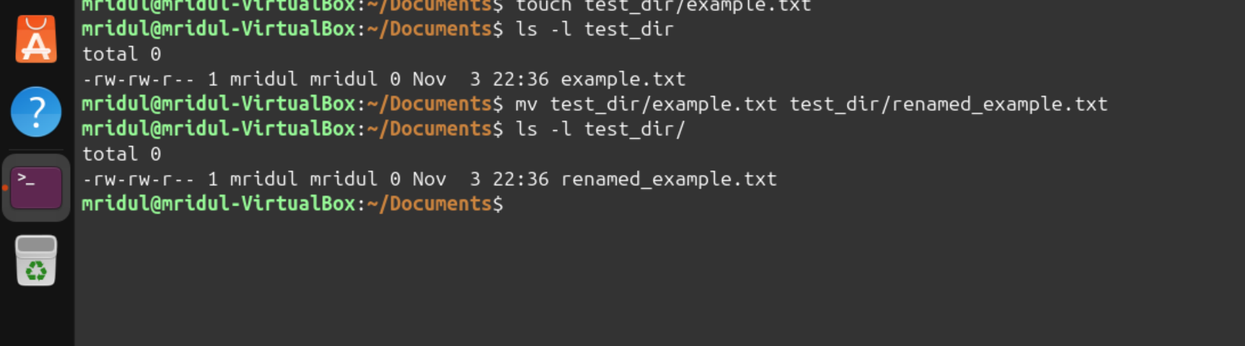

2. Viewing File Contents

Task 4: Display File Contents Using cat
Command:
cat /etc/passwd
Explanation:
The cat command is used to display the contents of a file. Here, it displays the contents of /etc/passwd.
Screenshot:
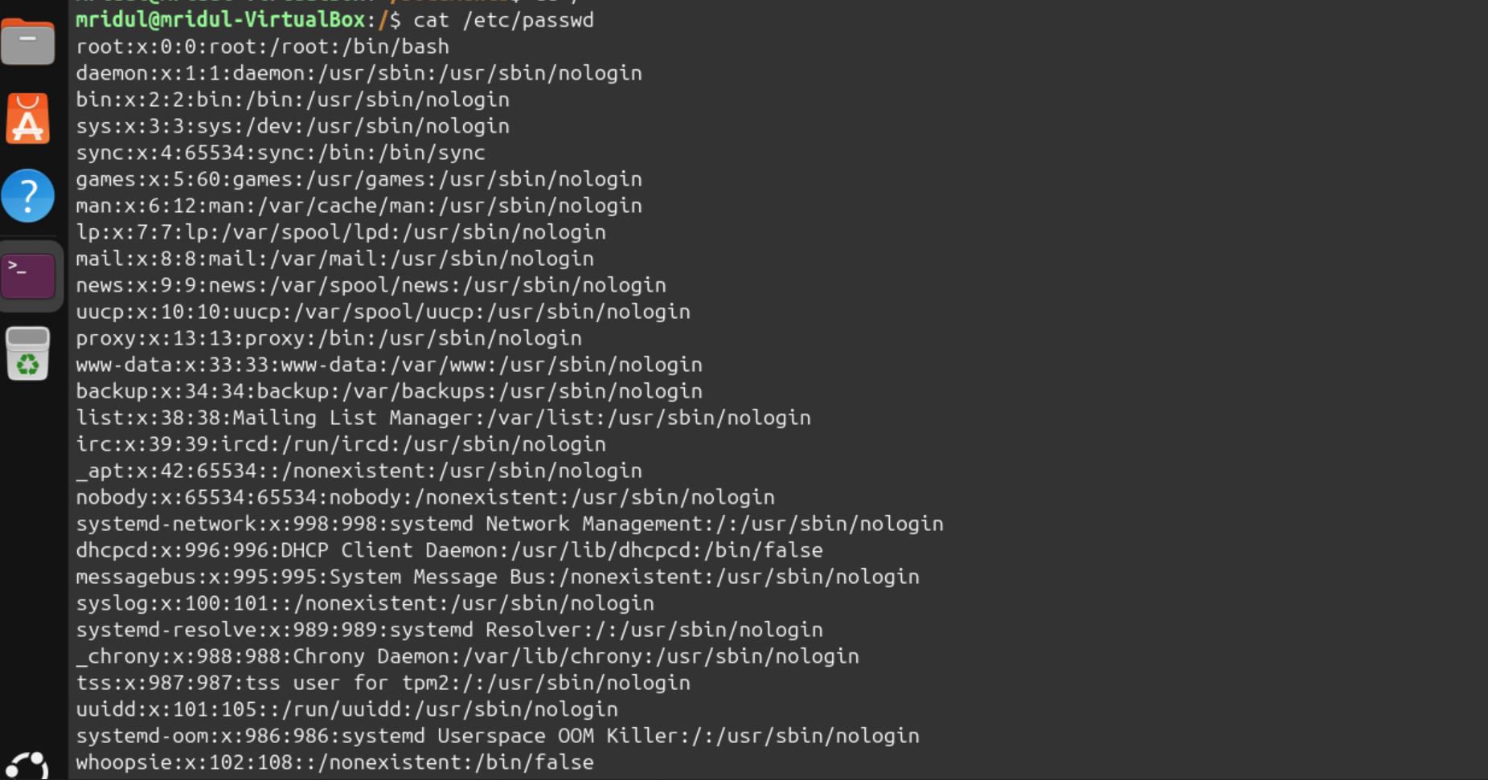

Task 5: Display First 5 Lines Using head
Command:
head -n 5 /etc/passwd
Explanation:
The head command displays the beginning of a file. The -n 5 option displays only the first five lines.
Screenshot:
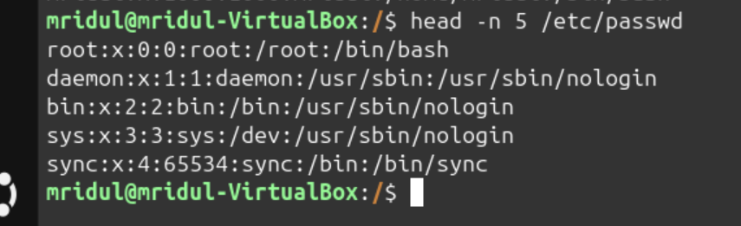

Task 6: Display Last 5 Lines Using tail
Command:
tail -n 5 /etc/passwd
Explanation:
The tail command displays the ending lines of a file. The -n 5 option displays only the last five lines.
Screenshot:
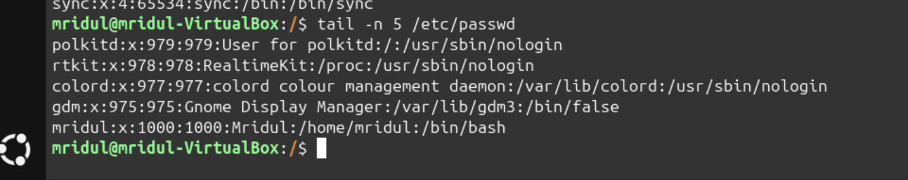

3. Searching for Patterns

Task 7: Search for the Word root Using grep
Command:
grep "root" /etc/passwd
Explanation:
The grep command is used to search for specific words or patterns in a file. Here, it displays all lines containing the word root in /etc/passwd.
Screenshot:
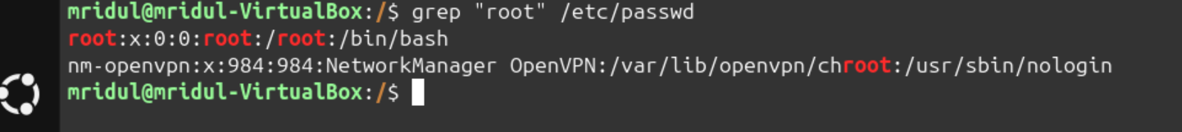

4. Zipping and Unzipping

Task 8: Compress a Directory Using zip
Command:
zip -r test_dir.zip test_dir
Explanation:
The zip command is used to compress files and directories. The -r option includes all files and subdirectories inside the directory.
Screenshot:
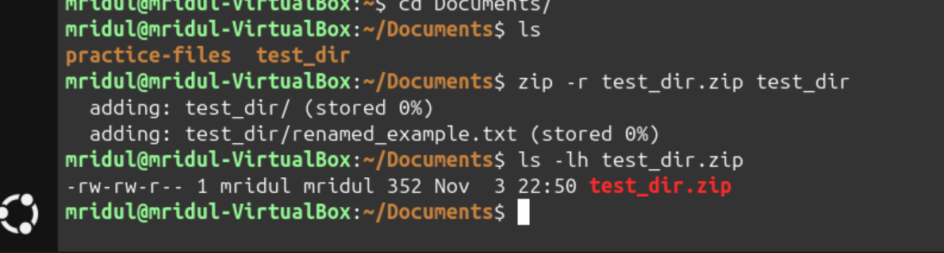

Task 9: Extract a ZIP File Using unzip
Commands:
mkdir unzipped_dir
unzip test_dir.zip -d unzipped_dir
Explanation:
The unzip command is used to extract files from a ZIP archive. The -d option specifies the destination directory.
Screenshot:
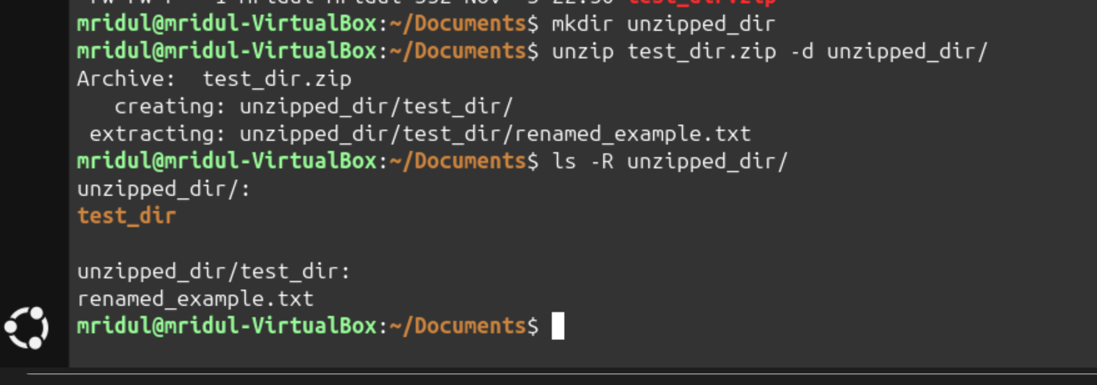

5. Downloading Files

Task 10: Download a File Using wget
Command:
wget https://raw.githubusercontent.com/git/git/master/README.md
Explanation:
The wget command is used to download files from the internet using a URL. Here, it downloads the README.md file.
Screenshot:
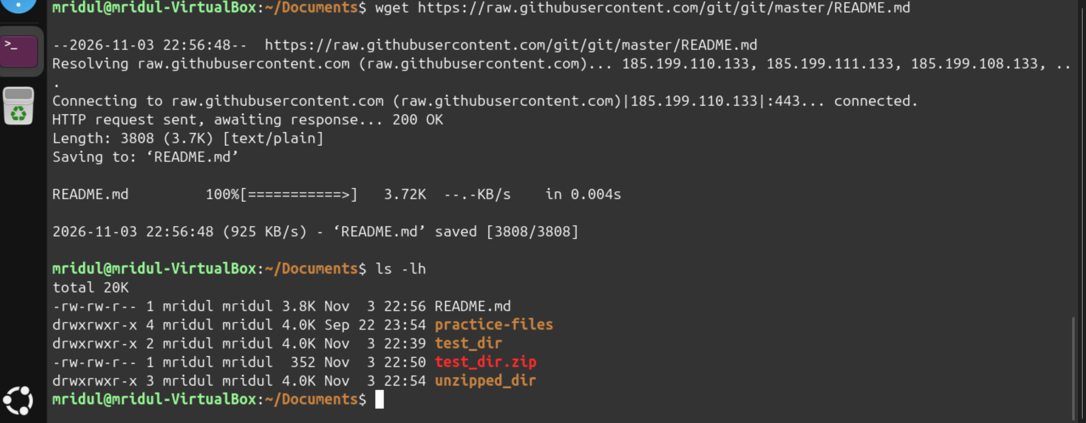

6. Changing Permissions

Task 11: Change File Permissions Using chmod
Commands:
touch secure.txt
chmod 444 secure.txt
ls -l secure.txt
Explanation:
The chmod command is used to change file permissions. The permission value 444 gives read permission to the owner, group, and others, while removing write and execute permissions.
Screenshot:
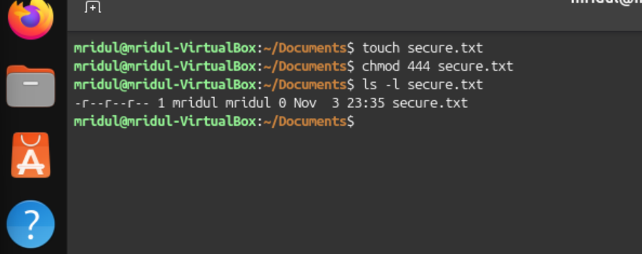

7. Working with Environment Variables

Task 12: Create an Environment Variable Using export
Commands:
export MY_VAR="Hello, Linux!"
echo "$MY_VAR"
Explanation:
The export command is used to create an environment variable. Here, it creates a variable named MY_VAR with the value Hello, Linux!.
The echo command displays the value stored in the variable.
Screenshot:
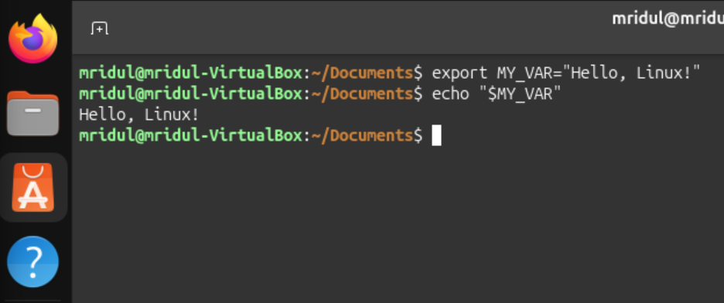

GitHub Repository
GitHub Repository Link:

https://github.com/mridulsharma5712-ui/Linux-Basics-Assignment.git


END OF ASSIGNMENT

