**LABs**

LAB – 1 – Create a Web Service (.Net core 3.1 / Windows) and app service plan (use SKU - D1 or B1)

LAB -  2 – Continuous deployment - Create a Git Project. Create new .Net Core project. Publish to Azure. Make changes and verify those changes have been pushed.

LAB – 3 – Create another App service in existing plan. Use VS 2019 to create an app and publish / deploy the code.

LAB – 4 -  Create a VM, enable RDP and Port 80. Enable IIS. Verify that you can access the default web app by using VM public IP.

Here are steps for LAB # 2 –

Deploying Continuously from GitHub ->

* Go to github
* Create new repo – e.g.  myFirstAzWebAppIr
* Md \AZ-204\Demo-app
* Cd  \AZ-204\Demo-app

Git clone <https://github.com/pkatiris/myFirstAzWebAppIr-.git>

* Cd <folder>
* Dotnet –version
* <<3,1>>
* Dotnet new web or webapp (for razor view)
* Dir
* Dotnet run
* Open app on local browser
* Git status
* Git add .
* Git status // it will be green
* Git commit . –m “initial commit”
* Git push origin master
* Check code on github portal (browser)
* Go to azure portal
* go to Web App -> Deployment -> Deployment Center
* select Github
* Select Azure Pipelines
* Configure pipeline..wait for build to start and refresh app page
* Go back to folder
* Code // Open project in VS Code or any other IDE
* //make change in .cshtml… change some text
* Git status
* Git commit . –m “changes made”
* Git status
* Git push origin master
* // This will push the code to App Service

Lab-5 – Create App Service and create Scale-out rule. Use CPU or other metrices to create rules to add / remove instances. If possible try generating traffic, may be posting multiple requests to web app.

Lab-6 – Create App Service and explore following features –

* Scale Up / Scale Out
* Custom Domain
* SSL
* Enabling / Log; Log Stream

Lab -7 – Create a Web Job – create simple PS or Batch file. Run and check output.

Lab – 8 – Create an API-M instance. Use swagger to define API or add API manually. Define APIs, Product and subscription key. Explore various policies.

**UN:** [Mridul@irissoftware1.onmicrosoft.com](mailto:Mridul@irissoftware1.onmicrosoft.com)

**Exercise LAB**

**Lab-1:**

Web-App: advi

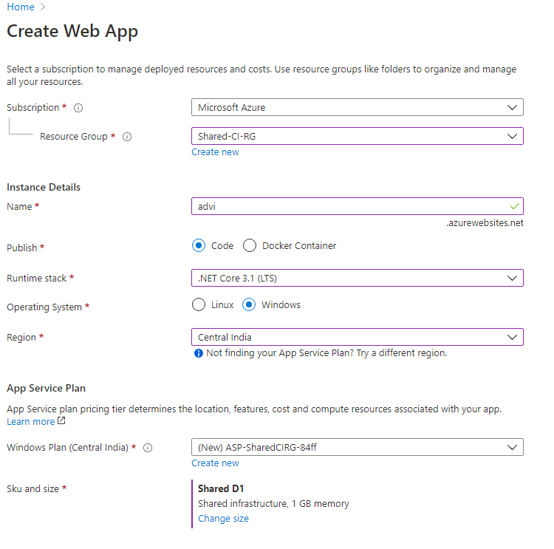

Running Application (https://advi.azurewebsites.net/)

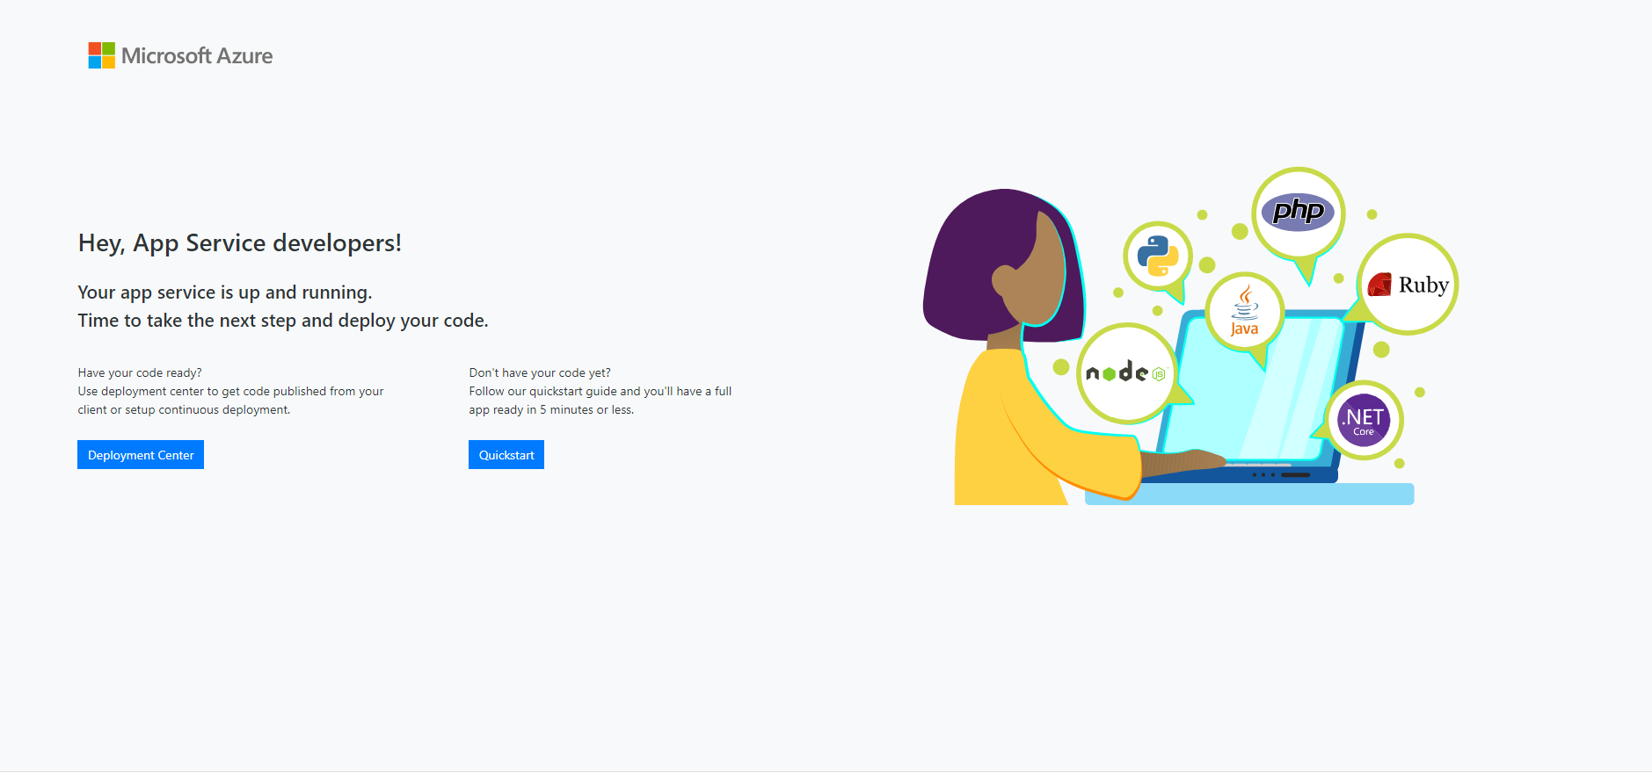

1st App service with Application insight.

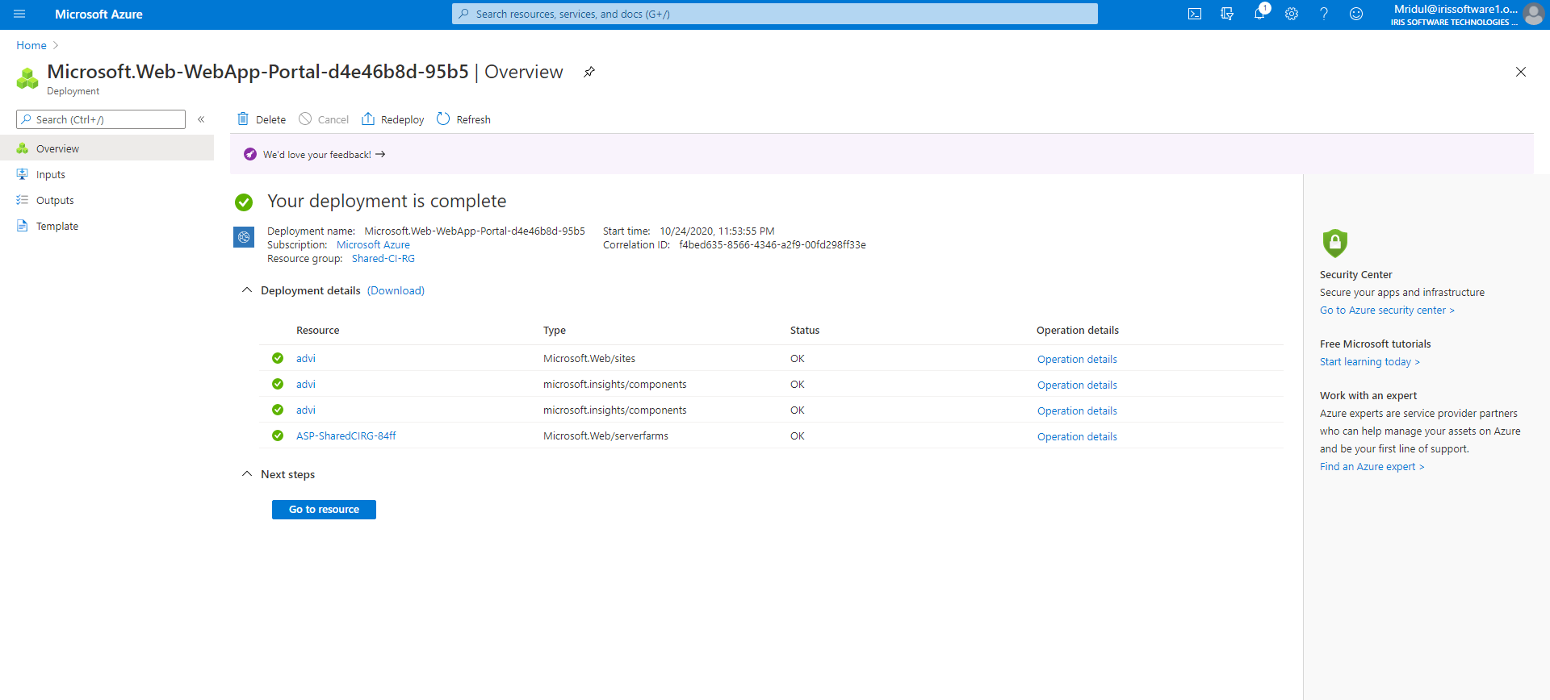

List of App Services:

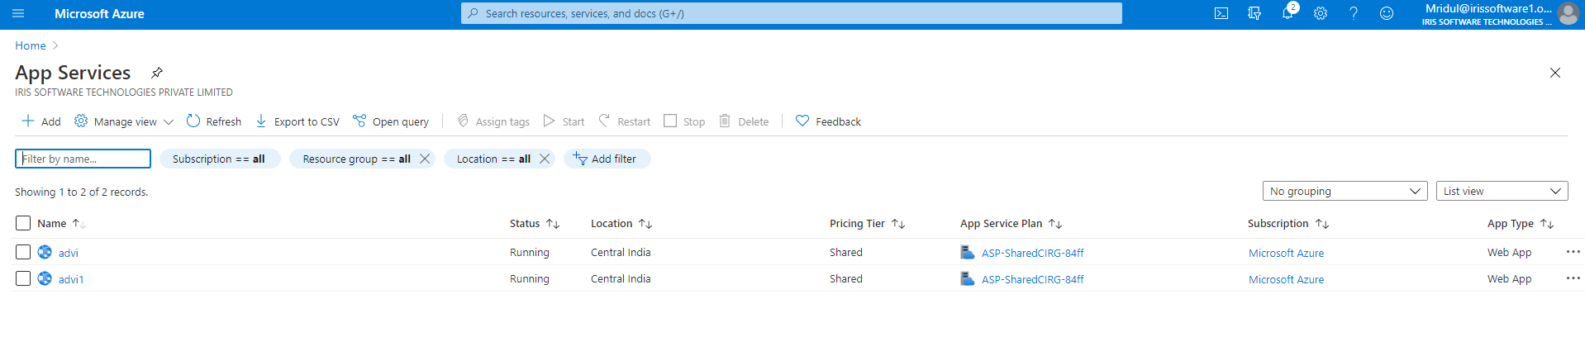

Publish 2nd app using VS Code

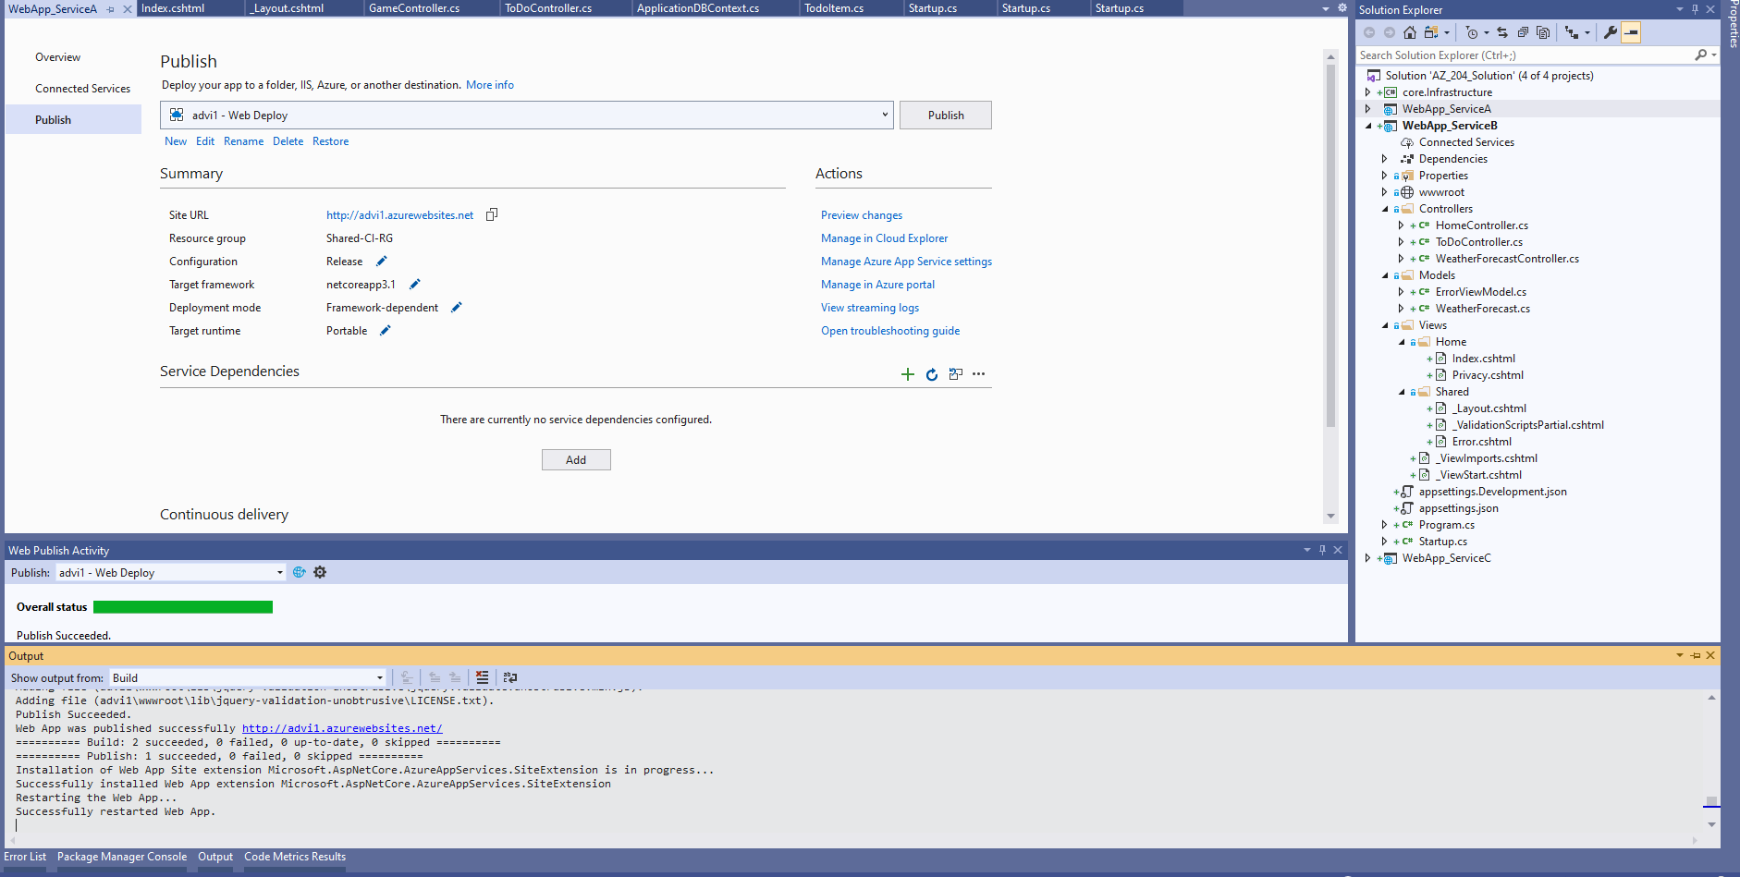

Deployed Application on azure

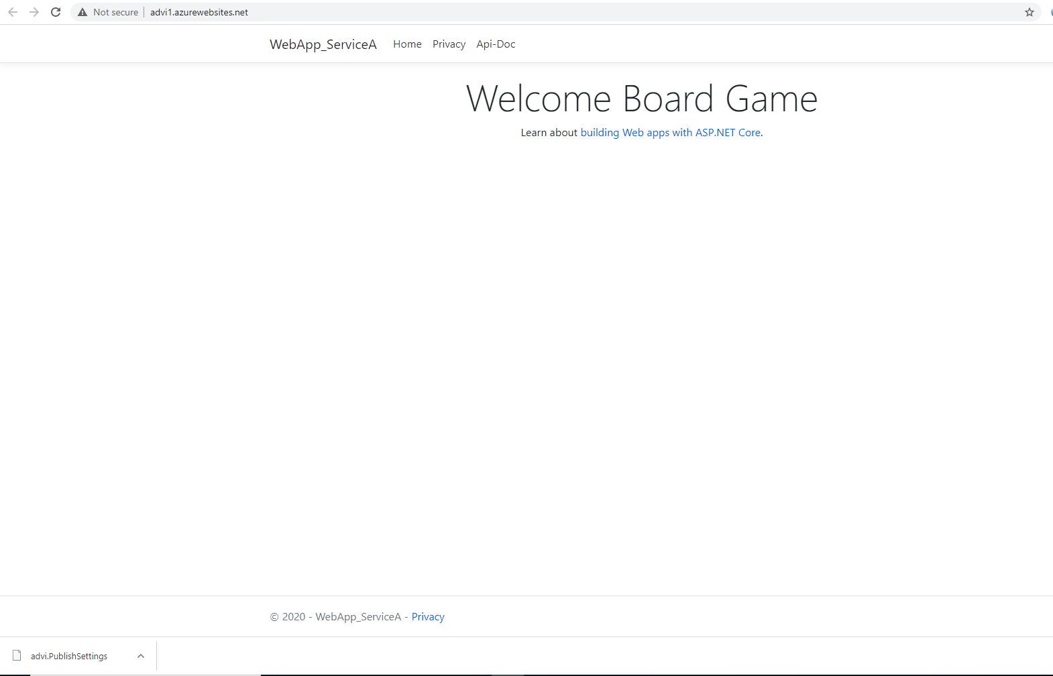

Application API Doc using Swagger

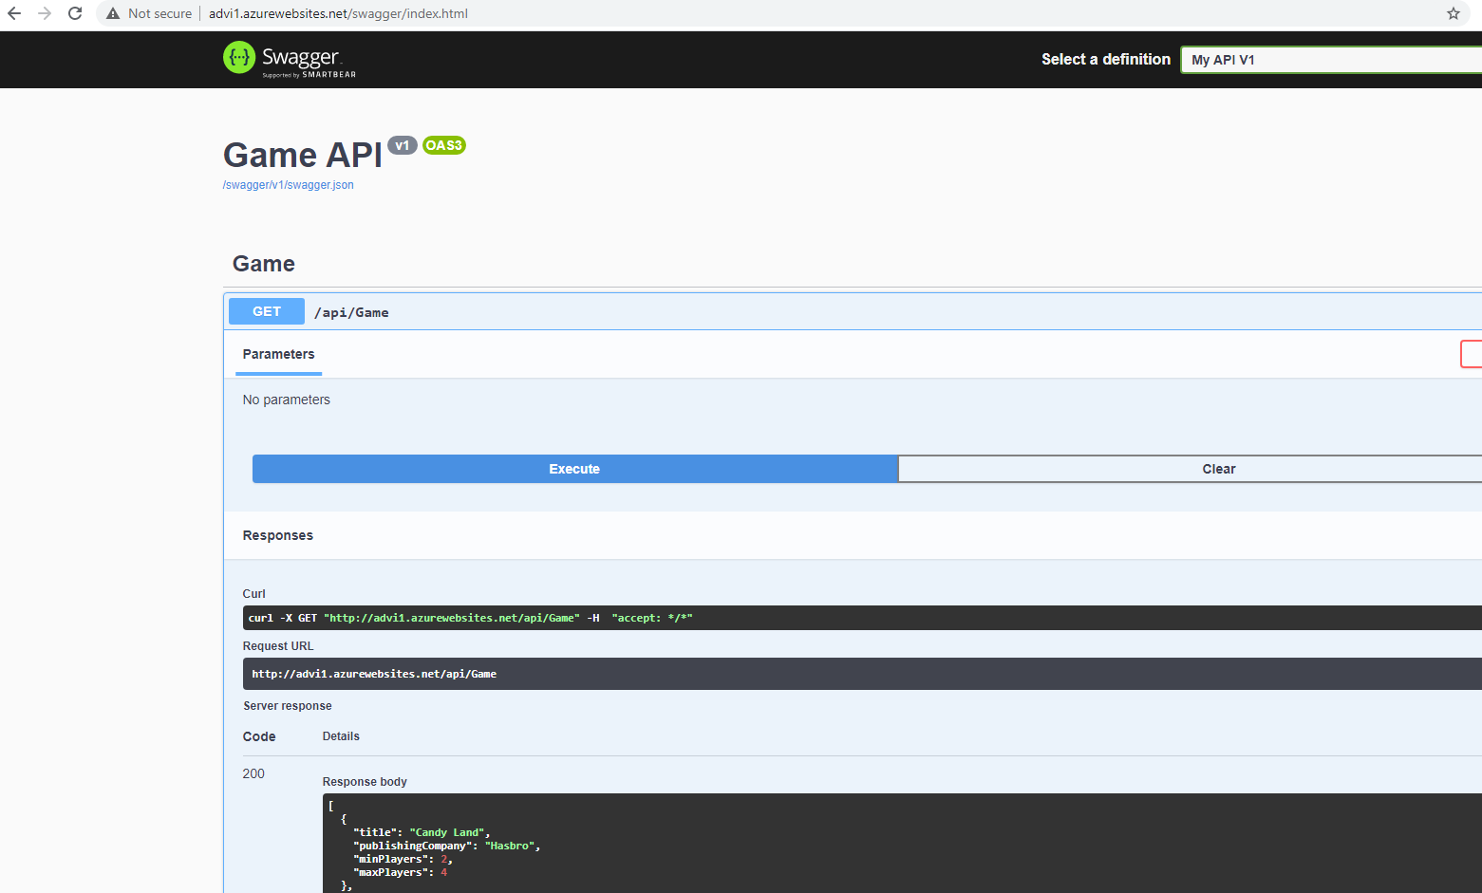

2nd Application deployed and its API docs

