1. Understanding of project:

In this project we will demonstrate about custom visual recognition classifier for analyzing vehicle damage. In traditional insurance company when a car owner has an accident and claims for the damage to the respective insurance company then a person from the insurance company will come and take photos of the damaged vehicle which may take some time for the process and there is a high chance of corruption as it is in the hands of the insurance person to reject to manipulate the data. By using our project there is high chances of eliminating the corruption and it can be accessed by the car owner/driver and claim his insurance for the damage vehicle which will be beneficial for the society in terms of running the process smoothly. In our project we have used different types of datasets to analyze different parts of the damaged vehicle (front bumper, windshield and flat tire) to do so we have taken datasets of damaged and undamaged. By using the IBM Watson Visual Recognition to check the genuity of the damaged imaged vehicle that have been uploaded by the car owner/driver. Image classification is a growing requirement for all kinds of organizations, including insurance companies.

Classifying images gets easier with the IBM Watson Visual Recognition service. We will create a web application using Node.js, and Watson Visual Recognition. The application sends the images of accidents vehicle issues to be analyzed by a server application using Watson Visual Recognition. The server application uses the images to train Watson Visual Recognition to identify various classes of issues, for example, flat tire, a broken windshield, a vehicle accident. We can leverage this to create our own custom Watson Visual Recognition classifiers.

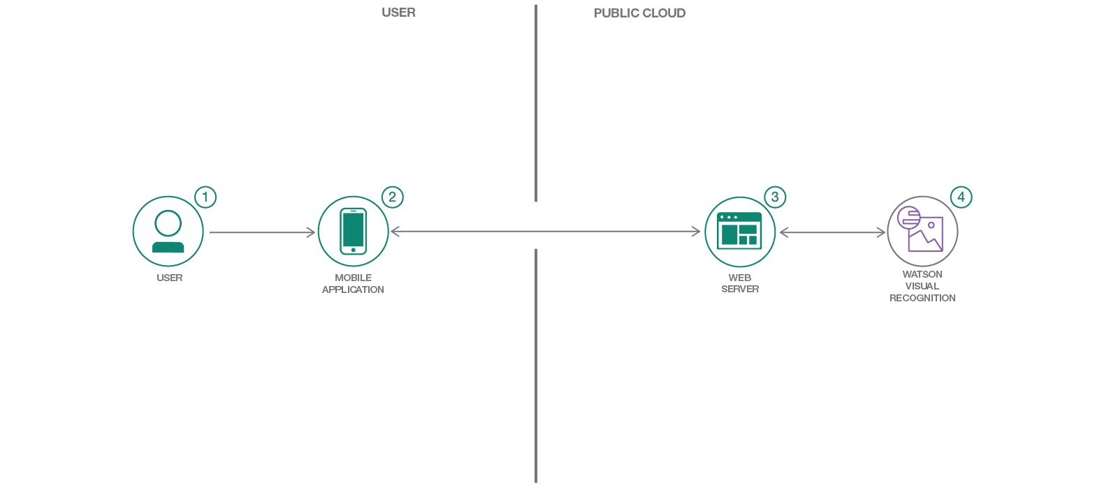The flow of our project is as follows:

2. Technology Stack – Application Development Architecture:

a. HTML, CSS, BOOTSTRAP: HTML, CSS, Bootstrap are used for user interface part. Hypertext Markup Language (HTML) is the standard markup language for documents designed to be displayed in a web browser.

Cascading Style Sheets (CSS) is a stylesheet language used to describe the presentation of a document written in HTML or XML. CSS describes how elements should be rendered on screen, on paper, in speech, or on other media.

Bootstrap is an open source toolkit for developing with HTML, CSS, and JS. Quickly prototype your ideas or build your entire app with our Sass variables and mixins, responsive grid system, extensive prebuilt components, and powerful plugins built on jQuery.

b. Watson visual studio with Watson visual recognition as the API.

c. Node js for backend.

d. JSON (Java script object notation).

e. npm (node package manger), cloud foundry cli.

f. IBM cloud for the deployment of project.

3. Datasets:

We have collected our dataset from:

kagle.com

The size of our datasets is 9.8MB

4. Scalability Scope of the Project:

If we need to scale our project we would like to capture the images using drone as the initial price may be high for the drones but it would be helpful in capturing the images for genuity.

We would also like to create an apk so that we can access it from any IOS/android phones so that it can be easily accessed by the car owner/driver as now days everyone has a smart phone.

We would also like to create a registration and login form for the users and an administrator who has the records and can accept or decline the insurance claims for a given percentage of the damaged car.

We would also like to create a service so that anyone who met with an accident and claims the insurance at instant it will have an additional option to opt to tow service to their current location using api of goggle map to tow their damaged car to a nearby garage to prevent the car owner/driver from any further inconvenience.