Python Project
My Book Shelf
-By Mrigank Singh(161B124)

Submitted to: Dr. Mahesh Kumar

My Book Shelf is a mini python project created by Mrigank singh (161B124). This project has two features :
1.Your personal book shelf which can keep record of the Books that you own.
2.Your own personal dictionary, in which you can save your word of the day with their meaning to enhance your vocabulary.
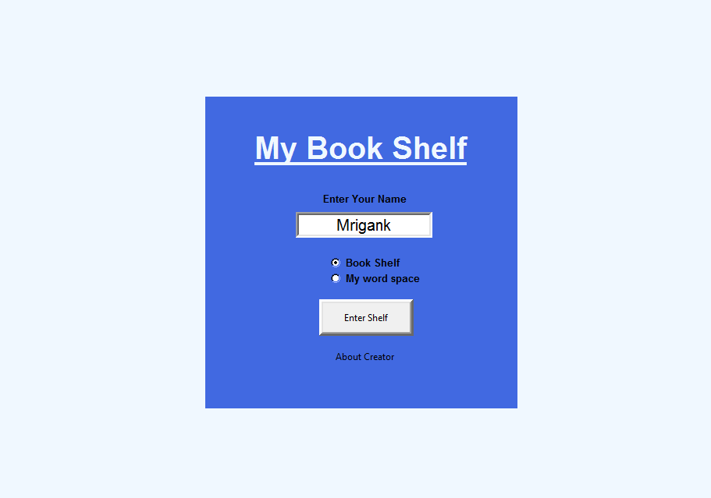
The First Screen you see is the login screen which contains an Entry box. You have to enter your name in that box which accepts String type entry to give your page a personalised touch. If you leave this box empy then the program will throw an error box.

Since this project has two parts therefore there are two Radiobuttons through which you can select your choice. If you'll not select any option then the program again throws an error box.

After you've entered your name and marked your choice, you have to click on 'Enter Shelf Button', which will redirect you to your desired screen. There is one more button on the first screen saying 'About Creator', Pressing this button will open a info box which will show my name and enrollment number.

Option 1: First option in the Radiobutton is Book Shelf. Selecting this option will open a screen which contains four entry boxes and five buttons. This screen will have your name as the title, welcoming you.

In this screen we can enter the details of the books which we own to keep the record of them.

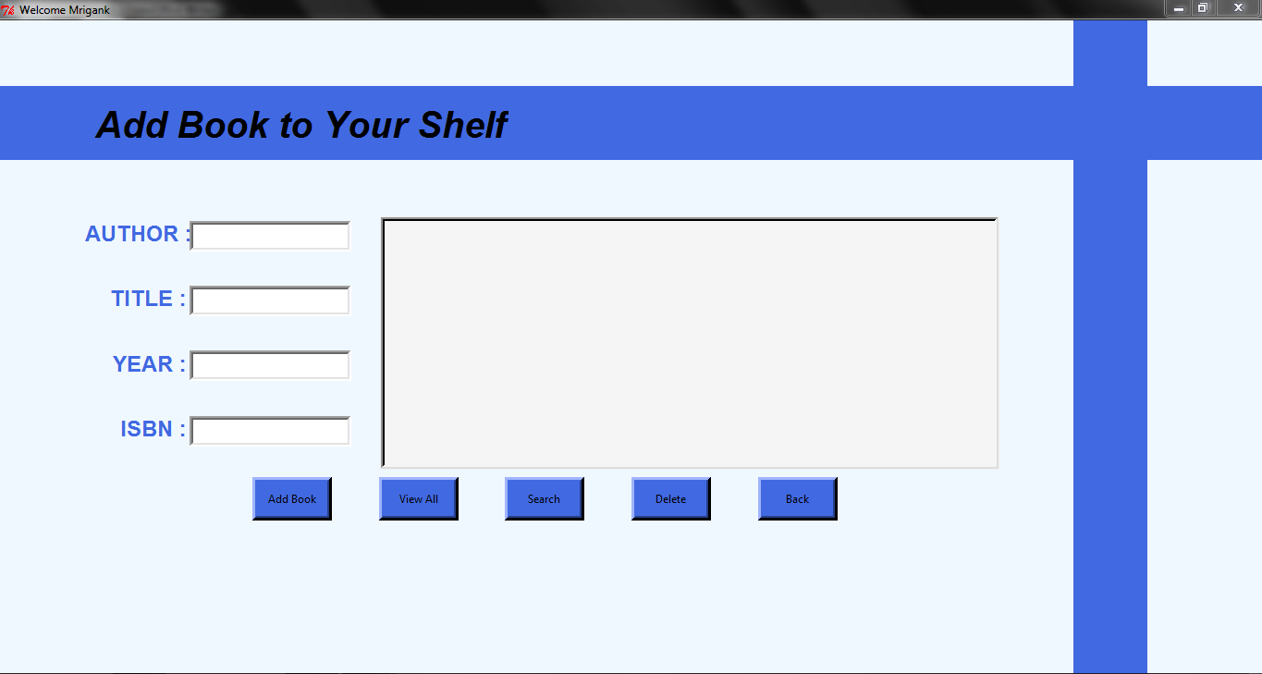
Elements on the screen:
Entry Boxes-
1.In first entry box you have to enter the name of the Author of the book which takes String type entry.
2.Second entry box will take the title of the book.
3.Third entry box will save the year when the book was published. It will take an integer as the entry.
4.Last box will save ISBN of the book which is also be an integer.

Buttons-
Add Book: This button will add the details of your book into the database If you leave any or all the feild empty then information box will be shown saying 'fill all the entries'. This will also check the duplicate entry in the database on the basis of ISBN or Title.
View All: This button will show all the books that you have saved in your database on the List Window. If your database is empty then an information box will appear.
Search: You can search any book in your database either by entering its ISBN or Title. If the book is present in your database then it will appear on the Listbox.
Delete: You can delete any book from your database by selecting it from the ListBox.
Back: This button will close the shelf and you'll be on the first screen again.

Option 2: Second option id 'My Word Space'. Chosing this option will lead you to a window which contains three button.
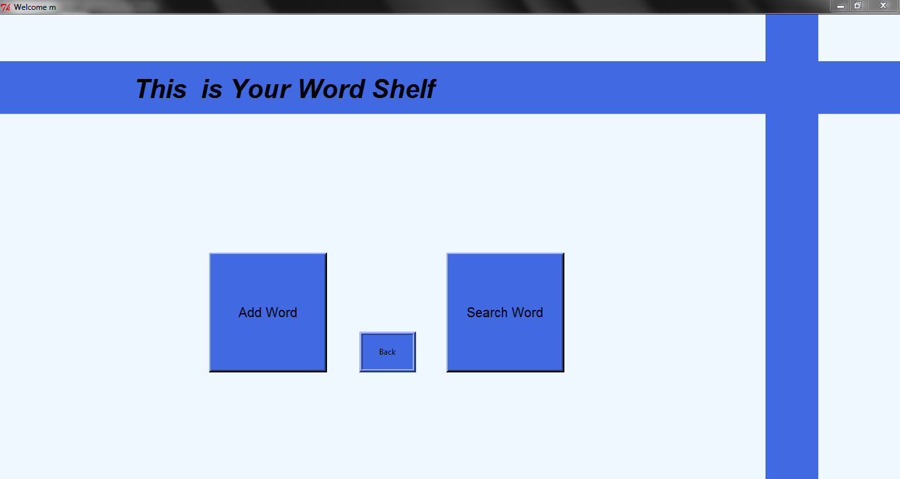
Buttons:
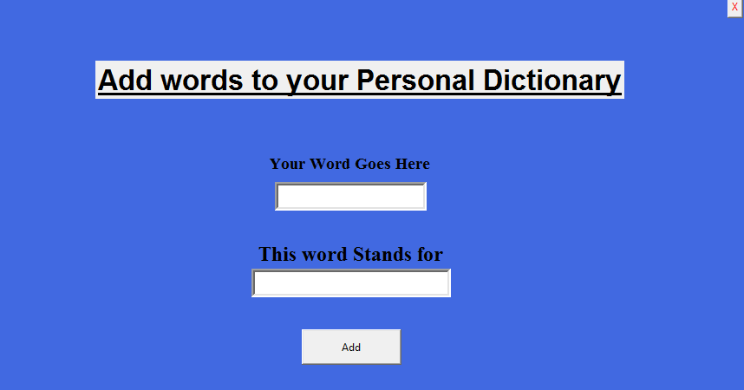
Add Word- This will change the frame of the screen and you'll see the following screen.

This screen has two entry boxes and two button. In first Entry box you'll type your word of the day
and second will hold the meaning of that word.

Add button will save your word of the into the database with its meaning. Second button is on the top right corner of the frame there is another button 'X' which will close this frame and you will get the screen with three buttons again.

Search Word- this button will again change the frame. A frame with one entry and two button will appear.
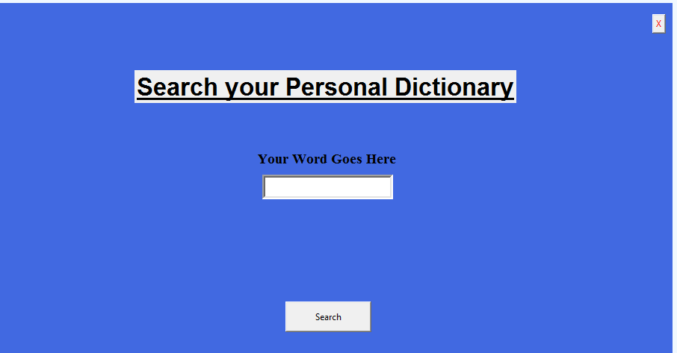
This is the search portion of your entry. In entry box you can type a word which you want to find. Clicking the search button will open a information box which will display the desired message. If your word is in the database then it will show its meaning, if it is not then it will show 'Not Found'. Again at top right corner there is a button 'X' which will close this frame and you will be on the screen having three button.

Back- This button will close this window and you'll be redirected to the First Screen.

This is all about my project. Thank You.

