**­­­­­**

**“K&M 70”**

**ALY6980 Capstone**

**Instructor Name: Thomas Dadmun**

**Team Members**

**Mrigankshankar Singh**

**Komal Rawat**

**Approach**

We have selected 70 stocks from Estimize estimate by using **Random Sampling** method. We have named our ‘K&M 70’

We have observed 2019 Q3 earning releases. We have fetched the market cap and sector from the Pricing_Reference file .

**Assumptions**

We have two assumptions as follows:

1. We have assumed the Fiscal Year 2019 and Fiscal quarter as Q3
2. For release date, we have considered October 1 to October 30, 2019 as per first assumption applied, we cannot have the release dates which are before October 1st, 2019 as it does not make sense to consider the actual eps releases by the companies in the previous quarters.

**Insights**

**Part A**

**Companies that have already reported 2019-Q3 earning**

**There are 53 companies that have reported Q3 earnings which are 75.71% in all**

1. **% and number that had upside suprises > 5% and > 10%**

There are **10 companies** having **upside suprises > 5%** and they are **18.86%** out of the total 53 companies belonging to **6 Large cap** and **4 Mega Cap** and **50%** being from **Finance sector**.

|  |  |  |  |
| --- | --- | --- | --- |
| symbol | upside surprise (5%) | market cap | sector |
| SLB | 5.70% | Mega Cap | Health Tech |
| UTX | 5.83% | Mega Cap | Health Tech |
| PYPL | 6.05% | Large Cap | Finance |
| RTN | 6.28% | Large Cap | E Technology |
| MET | 6.31% | Mega Cap | Health Tech |
| FB | 6.35% | Large Cap | Finance |
| BK | 6.69% | Large Cap | Finance |
| JPM | 7.50% | Large Cap | Health Tech |
| LMT | 9.19% | Mega Cap | Finance |
| GE | 9.80% | Large Cap | Finance |

|  |  |  |  |
| --- | --- | --- | --- |
| symbol | upside surprise (10%) | market cap | sector |
| INTC | 10.62% | Large Cap | Health Tech |
| COF | 11.27% | Large Cap | Finance |
| SO | 13.50% | Large Cap | Finance |
| PFE | 14.12% | Large Cap | E Technology |
| MRK | 15.23% | Mega Cap | Health Tech |
| F | 17.63% | Large Cap | Finance |
| GM | 26.77% | Large Cap | E Technology |
| NFLX | 27.46% | Mega Cap | Finance |

There are **8 companies** having **upside suprises > 10%** and they are **15.09%** out of the total 53 companies belonging to **6 large cap** and **2 to mega cap** and **50%** belonging to **Finance sector.**

1. **% and number that had downside suprises > 5% and > 10%**

Only **2 companies** with **downside suprises > 5%** and only with **1 Large cap and 1 Mega cap** of **Health Tech and Finance** respectively

|  |  |  |  |
| --- | --- | --- | --- |
| symbol | downside surprise (5%) | market cap | sector |
| CAT | -7.11% | Large Cap | Health Tech |
| MCD | -5.79% | Mega Cap | Finance |

Only **3 companies** with **downside suprises > 10%** and only with **2 Large cap and 1 Mega cap** of **E- Technology, Finance and Health Technology** respectively

|  |  |  |  |
| --- | --- | --- | --- |
| symbol | downside surprise (10%) | market cap | sector |
| BA | -51.74% | Large Cap | E Technology |
| GOOGL | -28.52% | Large Cap | Finance |
| WFC | -14.25% | Mega Cap | Health Tech |

1. Blended average EPS increase or decrease. In total, by market-cap and by sector

Blended average EPS Increase is shown (which means EPS has increased)

1. **Mid** cap is **5.83%** (only 1 company in our sample which might not reflect the general trend)
2. **Large** cap is **2.48%**
3. **Mega** cap is **1.42%**

Blended average EPS Increase is shown (which means EPS has increased)

1. **Health** Sector is **3.77%** (only 1 company in our sample which might not reflect the general trend)
2. **Finance Sector** is **2.07%**
3. **E Technology** is **1.99%**

**Part B**

**Companies that have not reported 2019-Q3 earning**

**There are 17 companies that have not reported Q3 earnings which are 24.28% in all**

1. **Summary of companies by market-cap and sector**

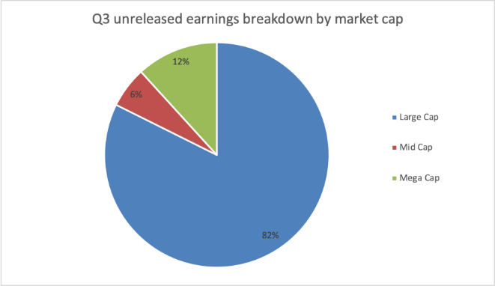

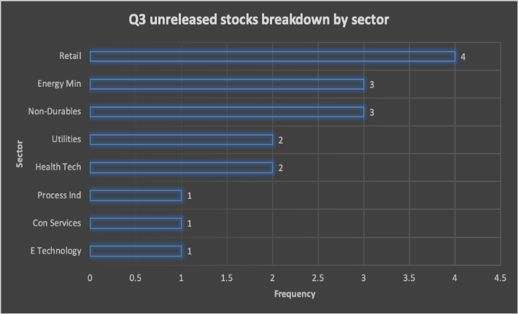

82% of companies belong to large cap while 6% belong to Mid cap. Retail sector has the maximum unreleased stocks followed by Energy Minerals sector in 2019-Q3.

1. **Blended average EPS increase or decrease from prior quarter (2019-Q2 vs. Q1)**

By Market cap,

The blended average for

* Large cap is 0.95
* Mid cap is 0.31
* mega cap is 0.52

By Sector,

The blended average for

* Retail is 0.57
* Energy Min is 0.27
* Non-durables is -0.58

1. **Blended average EPS increase or decrease for prior year quarter (2019-Q2 vs 2018-Q2)**

By Market Cap,

The blended average for

* Large cap is 0.16
* Mid cap is 0.7
* mega cap is 0.05

By Sector,

The blended average for

* Retail is 0.13
* Energy Min is -0.07
* Non-durables are at -0.1­

**We can compare 2019 Q2 with 2018 Q4 to evaluate whether there is a constant trend of increase or decrease in the blended averages of companies releases in “K&M70” portfolio**