Issue: Adding New columns to a dataframe in Python has an issue of indexing. When added without resetting the index, values may not be added. Here is an Example to better explain

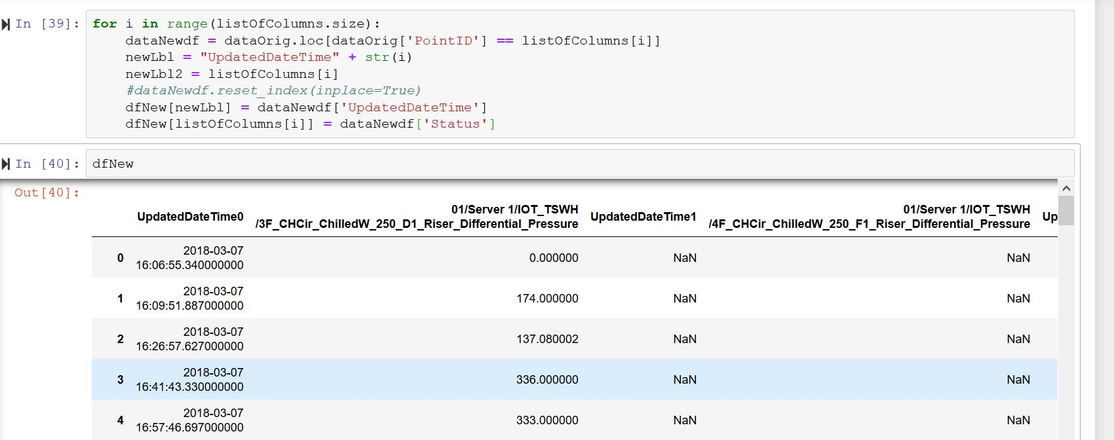

We Can see that many columns have NaN as values are not properly Added. This can be solved by resetting the index of dataFrame from which we need to add columns to a new df.

