Integrating Official Groundwater Quality Monitoring with District-Level Child Health Indicators in Bihar: A Spatially Honest Machine Learning Study with Explainability and Susceptibility Profiling

Major Project Report — reproducible pipeline linking Central Ground Water Board (CGWB) chemistry medians, Health Management Information System (HMIS) burden metrics, and Census 2011 population denominators

Academic submission manuscript generated from the reproducible code repository.
Institutional affiliation and author names should be inserted here before final deposit.

Table of Contents
Abstract
Keywords
1. Introduction
2. Literature Review
3. Objectives
4. Study Area and Analytical Scale
5. Data Sources and Provenance
6. Dataset Construction and Row Logic
7. Variable Definitions and Scientific Interpretation
7.1 Expanded discussion of groundwater chemistry parameters
8. Methodology
8.1 Extract–transform–load and harmonisation
8.2 Machine learning protocol
8.3 Susceptibility and environmental stress profiling
8.4 Ethics, governance, and communication of uncertainty
9. Algorithms Used — Detailed Account
9.1 Ridge regression
9.2 Random forest
9.3 Extreme gradient boosting
9.4 Validation metrics and explainability integration
10. Results and Analysis
10.1 Statistical primer: metrics, spatial validation, and cautious reading
10.2 Policy context and programme communication
10.3 Worked example: linking one district-year storyline
10.4 Integrated synthesis across data, methods, and interpretation
11. Discussion
12. Limitations
13. Conclusion
14. Future Scope
15. Appendices (A–G)
References

Abstract
This report presents a complete account of a reproducible research pipeline that combines official environmental monitoring data with routine health information system statistics at the district level in the state of Bihar, India. The scientific motivation is straightforward yet ambitious: groundwater chemistry is a plausible environmental stressor that may coincide with patterns of child morbidity and mortality burden, but proving causation from observational district-year panels is not feasible without experimental designs or detailed individual-level exposure histories. Therefore, the project is deliberately framed as an associational and prioritisation-oriented study rather than a clinical forecasting system.
The dataset is built by merging three trusted public sources. First, district-by-year summaries of groundwater quality are derived from Central Ground Water Board (CGWB) well measurements, summarised as medians (or means where appropriate) for key ions and physicochemical indicators together with the count of monitored wells, which reflects monitoring intensity. Second, child-health burden is operationalised using a transparent composite constructed from selected HMIS indicators that capture severe acute malnutrition, common childhood illnesses, infant and child deaths attributed to diarrhoea and pneumonia, very early neonatal deaths, and stillbirths, aggregated under consistent facility roll-up rules to avoid double counting. Third, Census 2011 district populations provide denominators so that burden can be expressed as events per one hundred thousand population before stabilisation with a logarithmic transform for modelling.
Machine learning models — ridge regression (an interpretable linear baseline with regularisation), random forest (an ensemble of decision trees), and extreme gradient boosting — are trained under grouped cross-validation that holds out entire districts during validation folds. This spatial honesty reduces optimism that arises when neighbouring geographic units leak correlated information across train and test splits. Performance is summarised using familiar regression metrics, but special emphasis is placed on comparing model error to a naive mean baseline and on rank agreement measured by Spearman correlation, because decision-makers often care about relative ordering for resource targeting rather than perfect point prediction.
Explainability analysis applies SHAP (SHapley Additive exPlanations) values compatible with tree models and linear models to summarise how each groundwater-related feature contributes to predictions at the cohort level. Separately, a rule-based susceptibility layer constructs cohort-relative standardised exposure indices and categorical environmental stress bands without requiring a trained regressor, yielding interpretable “high environmental stress” flags suitable for communication alongside model outputs.
The empirical results in the accompanying artefact files indicate that groundwater-only features do not produce strong predictive accuracy for the chosen HMIS-derived outcome under strict spatial validation; pooled out-of-fold scores show negative R-squared relative to the variance of the held-out merged predictions when interpreted in the standard way for ordinary cross-validation, and error can exceed a naive baseline. These findings are scientifically meaningful: they caution against overstating predictive power while still permitting cautious hypothesis generation through directional attribution plots and transparent environmental profiles. The present document explains every step — data harmonisation, variable definitions, algorithms, validation philosophy, outputs, and limitations — in plain English suitable for academic submission.

Keywords
Bihar; groundwater quality; HMIS; district-level panel; spatial cross-validation; random forest; ridge regression; gradient boosting; explainable artificial intelligence (SHAP); environmental susceptibility; public health informatics

1. Introduction
Child health outcomes in low- and middle-income settings arise from an intertwined mixture of biological susceptibility, household behaviour, health-service readiness, nutrition, infection exposure, and broader environmental conditions including water quality and sanitation. Among environmental pathways, groundwater chemistry matters because millions of people rely on tubewells and hand pumps that draw from aquifers whose quality varies across geology, agricultural intensity, seasonal recharge, and anthropogenic contamination. Elevated salinity, nitrate, fluoride, or extreme pH patterns may signal hazards or stressors that coincide geographically with districts reporting heavier burdens in routine facility-based statistics.
Bihar is a populous state where districts differ markedly in hydrogeology, flood vulnerability, and health-system reporting volumes. Official programmes publish groundwater observations through CGWB monitoring networks, while the national Health Management Information System aggregates facility-reported counts across indicators and years. Census enumerations provide stable population denominators that convert raw counts into interpretable rates for comparisons across districts of different sizes.
The central challenge for evidence synthesis is methodological. District-year panels are coarse: they average across villages and households, mix multiple causal pathways, and embed reporting artefacts such as variable facility completeness or diagnostic practices. Any statistical association between aggregated groundwater summaries and aggregated burden metrics therefore reflects ecological correlation rather than individual-level causal effects. Recognising this limitation is not a weakness of the study but a prerequisite for honest inference.
Machine learning offers flexible function approximation for nonlinear relationships and interactions among chemistry variables, yet flexible models can easily appear accurate when validation is optimistic. Standard random splitting of rows often lets geographically adjacent districts appear in both training and evaluation, effectively allowing the model to interpolate local clusters rather than generalise to unseen administrative units. To align evaluation with the practical question — “Would patterns learned from some districts help prioritise others?” — this project adopts grouped cross-validation by district identifiers.
Beyond prediction, stakeholders benefit from interpretability. Tree ensembles can be opaque when presented only as black-box scores. SHAP explanations summarise contributions of each input feature to model output for tree-based and linear models in a unified additive framework grounded in cooperative game theory intuition. Meanwhile, not every communication setting requires a predictive model: the pipeline therefore includes a parallel susceptibility construct based on cohort-relative standardisation of groundwater variables and transparent labelling of environmental stress tertiles.
This report documents the entire workflow end-to-end so that reviewers can trace claims from raw inputs to figures and saved metrics. It uses careful language throughout: “association,” “referent outcome,” “prioritisation,” and “hypothesis generation” replace overstated claims of causal forecasting. The intent is an academic-grade narrative that matches the code artefacts already maintained in the repository.

2. Literature Review
Environmental epidemiology has long studied drinking-water contaminants and health endpoints at varied scales. Classical examples include investigations of arsenic exposure in groundwater and adverse outcomes, nitrate and methemoglobinemia risk in infants, and fluoride and skeletal or dental effects. Such links are often established through cohort studies, case-control designs, or intervention trials where exposure can be characterised more finely than in aggregate panels. At ecological scales, analyses must contend with the ecological fallacy: relationships observed for groups do not automatically transfer to individuals within those groups.
Hydrochemical datasets from national monitoring programmes provide spatially extensive measurements but uneven temporal density at the district-year resolution when wells are sparse in some units. Aggregation to medians reduces sensitivity to outliers yet discards distributional tails that may matter for vulnerable subpopulations. Monitoring intensity — how many wells contribute — can correlate with administrative attention or accessibility, introducing subtle structural factors unrelated to true average chemistry.
Routine health information systems such as HMIS offer timely coverage but depend on reporting completeness and definitions that evolve as programmes change. Composite indicators aggregate multiple clinical burdens to summarise vulnerability, yet composites embed normative choices about which conditions enter the sum and how missing indicators are treated. Transparency in indicator lists and aggregation logic is therefore as important as statistical sophistication.
Machine learning in public health has expanded rapidly. Ensemble tree methods — random forests introduced by Breiman and boosting families popularised through implementations such as XGBoost — often perform strongly on tabular data with nonlinearities and heterogeneity. Regularised linear models remain valuable baselines because coefficients are directly interpretable under linearity assumptions and scaling choices. Regardless of algorithm, rigorous validation design determines whether reported accuracy reflects genuine generalisation.
Explainable artificial intelligence bridges predictive modelling and domain interpretation. SHAP methods attribute predictions to features using Shapley-value-inspired allocations that satisfy desirable additive properties for many model classes. For tree ensembles, TreeExplainer enables efficient exact calculations under specified assumptions; for linear models, LinearExplainer corresponds closely to coefficient-driven explanations after preprocessing. Researchers caution that explanations summarise model behaviour rather than ground-truth causal mechanisms; they remain indispensable for auditing bias directions and communicating uncertainty-aware narratives.
Spatial and grouped validation appears across geospatial machine learning literature under headings such as spatial cross-validation and block holdouts. The principle is consistent: autocorrelation violates independence assumptions that naive splitting assumes. Holding out groups defined by administrative boundaries is a conservative approach aligned with policy questions about transferring insights across districts.
Susceptibility mapping in environmental sciences often denotes graded categories of hazard or vulnerability using transparent indices. The present project borrows that communication style by constructing environmental stress bands from cohort-relative z-scores rather than implying validated clinical risk from chemistry alone.
Together, these strands motivate a study design that combines credible official data fusion, conservative spatial validation, interpretable baselines and ensembles, explanation layers, and parallel rule-based profiles suitable for mixed audiences including academics and programme analysts.
Recent syntheses in environmental health increasingly emphasise open data pipelines rather than only polished headline coefficients. Reviewers ask how denominators were formed, how duplicate facilities were excluded, and whether spatial autocorrelation was respected — questions this thesis anticipates by documenting merges explicitly and adopting grouped folds. Machine-learning critiques also warn against “accuracy theatre,” wherein impressive-looking scores arise from information leakage rather than genuine transportability; spatial grouping operationalises a substantive response.
Indian administrative datasets possess uneven temporal harmonisation: groundwater sampling calendars may not align with HMIS fiscal-year reporting windows. Scholars therefore differentiate predictive modelling for interpolation within observed geo-time neighbourhoods from extrapolation to unseen districts or future epidemic regimes. Our framing adopts conservative language aligned with extrapolation stress-testing via held-out districts.
Interpretability research stresses separating model-internal explanations from causal attribution. SHAP values describe how a fitted model allocates responsibility among inputs — helpful for debugging unwanted reliance on artefacts such as well-count proxies — but they cannot prove that modifying chloride in the field would reduce pneumonia counts at population scale without experimental or quasi-experimental designs.
Finally, susceptibility-style indices echo vulnerability literature mapping compound stresses without implying predictive certainty. Presenting them beside regressions allows policymakers to see parallel narratives: one emphasises learned nonlinear mappings with uncertainty; another emphasises transparent standardisation relative to cohort norms without optimisation objectives beyond descriptive scaling.
Bridging hydrology and health informatics requires multidisciplinary literacy. Hydrogeologists scrutinise ion ratios, recharge pathways, and sampling depth stratification; epidemiologists scrutinise case definitions, numerator stability, and denominator appropriateness; data scientists scrutinise pipeline leakage and metric selection. Few single-authored papers span all competences fluently, motivating modular codebases where domain specialists can audit segments independently.
Transparency norms increasingly resemble registry-style documentation: pre-specifying indicator lists and aggregation rules prevents post-hoc tuning narratives that erode trust. While this academic report cannot substitute for a clinical trial registry, it adopts the spirit by enumerating HMIS labels verbatim and freezing preprocessing transforms saved alongside susceptibility references.
Equity considerations intersect technical choices: districts with sparse monitoring receive chemistry estimates built from fewer wells; models might inadvertently associate uncertainty patterns with burden unless analysts consciously audit residuals stratified by well-count quartiles. Such audits belong in mature extensions but merit mention because fairness-aware machine learning is maturing rapidly in public-sector deployments.
Educational accounts of negative predictive results remain under-published compared with positive benchmarks, yet they anchor realistic expectations for undergraduate and postgraduate training. Students learn that rigorous spatial validation often collapses apparent accuracy — a lesson transferable beyond groundwater contexts to any geo-referenced social or environmental outcome.

3. Objectives
The primary objective is to construct a reproducible district-year analytical dataset linking CGWB-derived groundwater summaries, HMIS-derived child burden summaries with Census denominators, and to document every transformation with sufficient clarity for independent replication.
A secondary objective is to evaluate associational models that predict a stabilised log burden outcome using groundwater-centred predictors under grouped cross-validation by district, comparing multiple algorithms and reporting error relative to naive baselines alongside rank-correlation diagnostics relevant to prioritisation.
An explanatory objective is to quantify feature contributions using SHAP for the selected best-performing model under cross-validated error, treating attributions as hypothesis-generating summaries rather than causal effects.
A communication objective is to produce interpretable environmental susceptibility profiles — including categorical stress bands and ranked chemical drivers — that do not depend on predictive accuracy yet support structured discussion of districts experiencing shifted groundwater chemistry relative to the cohort.
Finally, a dissemination objective is to package outputs — metrics tables, diagnostic figures, saved models, and an interactive Streamlit exploration interface — so that results can be inspected without rerunning the entire pipeline unless raw inputs change.

4. Study Area and Analytical Scale
Bihar is situated in eastern India with dense agrarian settlement patterns and substantial reliance on groundwater for domestic and irrigation purposes. Districts serve as administratively meaningful units for planning and for aligning CGWB summaries with HMIS reporting geography. District-year observations capture slow-moving shifts in monitored chemistry alongside year-to-year fluctuations in reported burdens influenced by epidemics, seasonal diarrhoea peaks, programme intensification, and changes in facility reporting.
The analytical frame intentionally stays at district-year resolution because it matches publicly released monitoring roll-ups and HMIS fiscal-year alignment after harmonisation. Finer spatial modelling would require geocoded wells linked to populations at risk and granular outcome data beyond what this pipeline consumes.

5. Data Sources and Provenance
Central Ground Water Board periodic district-wise chemistry extracts underpin the environmental arm of the dataset. Raw well-level tables are aggregated to district-year medians for major ions and conductivity-related quantities, along with counts of sampled wells. Medians resist extreme single-well spikes better than means for skewed constituents while remaining straightforward to explain in reports.
HMIS indicator extracts come from official spreadsheets cataloguing district-and-year values under stated facility categories. The pipeline restricts rows to a consistent facility rollup and category total so that composite sums remain comparable across districts and years. Indicator labels are matched exactly to catalogue strings; unmatched indicators are skipped with warnings to preserve transparency.
Census 2011 district populations convert summed HMIS counts into rates per hundred thousand people. Using Census denominators introduces a temporal mismatch — populations evolve after 2011 — which is an acknowledged limitation mitigated slightly by the relative stability of decadal population rankings at district scale within short HMIS windows.
Merged outputs retain both raw burden sums and transformed modelling targets. The modelling target applies a logarithmic stabilisation using the natural logarithm of one plus the rate to reduce leverage of rare districts with extremely high counts while preserving ordering for many practical comparisons.

6. Dataset Construction and Row Logic
The master training table is stored as a comma-separated text file where each row corresponds to one district in one calendar-aligned year present in both groundwater summaries and HMIS summaries after inner joins. Inner joins exclude district-years lacking paired environmental and health aggregates, improving coherence at the cost of potentially omitting sparse observations.
Column completeness varies slightly because some chemical parameters may be missing when laboratories did not report them for every well batch; preprocessing uses median imputation within cross-validation folds through scikit-learn pipelines to reduce leakage from future validation rows into training statistics.
Row counts and distinct district counts are recorded automatically into metrics JSON files during training so that reports always reflect the executed configuration rather than manually typed approximations.
Duplicate naming inconsistencies across administrative spellings are reduced using standardisation utilities so that identical districts align across CGWB and HMIS extracts.
The dataset supports two parallel analytical products: supervised regression training for associational prediction under spatial validation, and unsupervised-style cohort-relative susceptibility scoring that only requires groundwater columns and identifiers.

Table 1 — Core modelling columns (conceptual schema)
Column group | Representative fields | Role in analysis
Identifiers | District, Year | Merge keys, grouping for spatial folds, time alignment.
Groundwater chemistry | GW_pH_median, GW_EC_uScm_median, GW_HCO3_median, GW_Cl_median, GW_SO4_median, GW_NO3_median, GW_F_mgL_median, GW_TDS_median | Primary predictors summarising district-year water quality.
Monitoring | n_wells | Intensity of observations feeding medians; contextual uncertainty proxy.
Health burden | HMIS_burden_raw, HMIS_vulnerability_z | Composite burden sum and multi-indicator z summary for description.
Demography | Population_2011 | Denominator for per-capita rates.
Modelling target | HMIS_burden_per_100k, Target_log_burden_per100k | Rate and stabilised log-rate response.
Stratification aid | High_risk_tercile | Descriptive tertiles when quantiles succeed.

7. Variable Definitions and Scientific Interpretation
District name fields identify administrative units and simultaneously serve as grouping keys for spatial folds. Year identifies temporal alignment between environmental summaries and HMIS fiscal conversions.
Groundwater pH measures whether water tends acidic or alkaline on the standard scale. Extreme values can indicate geogenic conditions or contamination signatures but must be interpreted with hydrogeochemical context.
Electrical conductivity (EC) proxies dissolved ionic content and salinity stress; higher values often accompany elevated total dissolved solids (TDS). Bicarbonate, chloride, sulphate, and nitrate ions capture distinct geochemical and anthropogenic pathways — for example nitrate associations with agricultural nitrogen loading in some settings. Fluoride is tracked because of known dental and skeletal concerns at elevated concentrations in parts of India.
Total dissolved solids summarise overall mineralisation. Well counts quantify how many observations contributed to district-year aggregates; after logarithmic stabilisation in susceptibility scoring it acts as a proxy for monitoring intensity rather than chemistry per se.
The HMIS composite burden sums selected paediatric indicators under transparent rules. The vulnerability z-score column summarises multi-indicator patterns after logarithmic stabilisation per indicator and cohort scaling. Population translates counts into rates. The modelling target column stores the stabilised log rate used as the regression response.
High-risk tertiles, when computable, divide districts into relative burden bands within the empirical distribution for descriptive stratification separate from model predictions.

7.1 Expanded discussion of groundwater chemistry parameters
Each ion tracked in the merged dataset corresponds to a measurable chemical constituent frequently monitored in national groundwater programmes because of relevance to taste, scaling, corrosion of pipes, irrigation suitability, or human-health guidelines under specific exposure regimes. pH influences solubility of metals and speciation of contaminants; although extreme pH alone does not diagnose toxicity, shifts often co-occur with mineralisation gradients worth describing to hydrogeologists collaborating with health teams.
Electrical conductivity offers an aggregate correlate of ionic strength; districts rising in conductivity alongside chloride and sodium-type patterns may indicate salinity ingress in coastal-influenced aquifers or evaporative concentration in inland traps, though definitive hydrogeological typing exceeds this pipeline’s scope. Bicarbonate derives from carbonate equilibrium and microbial processes in some contexts; chloride and sulphate often participate in identifying anthropogenic inputs or evaporite dissolution depending on local geology.
Nitrate attracts attention because elevated concentrations in drinking water have been linked epidemiologically to infant methemoglobinemia in settings where contaminated wells supply formula-fed infants; ecological associations at district scale cannot substantiate individual risk yet justify prioritising surveillance alignment between chemistry labs and maternal-child health programmes.
Fluoride monitoring addresses endemic fluorosis concerns documented historically across parts of India; district medians smooth extreme hotspots but still orient further spatial refinement.
Total dissolved solids integrate multiple ions into a single mineralisation indicator comparable across laboratories when methodology is consistent.
Monitoring intensity captured through well counts acknowledges that districts rarely sampled may yield median chemistry estimates with higher uncertainty; treating counts as auxiliary context avoids pretending equal confidence everywhere.
Transform choices — medians, clipping negatives for non-negative physical quantities, median imputation inside folds — reflect pragmatic hygiene oriented toward stability and auditability rather than maximal exploitation of distributional modelling.

8. Methodology

8.1 Extract–transform–load and harmonisation
Extract-transform-load steps begin at raw CGWB CSV exports. Scripts aggregate wells to district-year chemistry summaries using robust statistics where configured. District labels pass through string cleaning and canonicalisation routines so merges succeed despite minor spelling variants.
HMIS spreadsheets are read with constrained columns to reduce memory footprint. Fiscal year labels convert to starting calendar years consistent with groundwater tables. Pivot operations reshape long indicator lists into wide matrices suitable for summation and z-score constructions.
Population merges attach Census totals on district keys. Rates are computed explicitly so auditors can reproduce arithmetic outside the machine learning code path.
Quality assurance prints indicator lists successfully matched and warns about omissions. Empty merges halt with actionable messages directing users to regenerate prerequisites.
All artefacts write into deterministic folders — processed CSV under data hierarchy, extracted intermediates under official data mirrors — mirroring paths referenced by configuration modules consumed during training.

8.2 Machine learning protocol
Supervised learning treats each district-year row as one sample with vector inputs drawn primarily from groundwater summaries and scalar output equal to the stabilised log burden rate. Groups derive from district identifiers so that GroupKFold assigns all years from a held-out district to validation during a fold whenever possible subject to split cardinality constraints.
Preprocessing pipelines median-impute missing numeric inputs inside folds. Tree models consume raw scaled-or-unscaled inputs depending on algorithm preferences; ridge regression pairs imputation with standardisation of numeric columns for penalised fitting stability.
Models compete by mean validation root mean squared error across folds. After selection, the winning estimator retrains on all rows to produce a deployment-ready pipeline serialised with joblib alongside metadata listing feature names.
Out-of-fold predictions concatenate validation predictions across folds into a full-length vector aligned with the training frame for diagnostic plotting and Spearman correlation against observed outcomes.
Missingness tables summarise column-wise fractions helping reviewers judge whether imputation dominates behaviour for particular ions.
Figures include predicted versus observed scatterplots to reveal systematic bias, residual histograms for error symmetry checks, bar summaries of mean absolute SHAP magnitudes, and charts highlighting districts with elevated predicted values under the trained model for prioritisation-style reading.
The naive baseline predicts every held-out point using the global mean training response, furnishing a sanity check: models should not be celebrated if they cannot outperform this rudimentary reference under honest validation.

8.3 Susceptibility and environmental stress profiling
Susceptibility profiling begins by converting each groundwater column into cohort-relative z-scores measuring how far a district-year sits above or below the average pattern after numeric coercion. The well-count column uses logarithmic stabilisation before z-scoring to dampen heavy tails while preserving interpretability.
Averaging signed z-scores across available ions yields a scalar environmental exposure index summarising overall shifted chemistry relative to peers. Absolute z-scores rank which labelled constituents contribute most to deviation for narrative bullet lists.
Tercile cuts on the exposure index assign Low, Medium, and High environmental stress bands when quantile splitting succeeds; duplicates handling prevents failures on degenerate distributions.
A binary environmental stress flag marks High as “Yes” and other bands as “No” for simplified dashboards. Separately, HMIS burden tertiles remain available when researchers wish to contrast environmental stress labels against burden strata without assuming independence.
Reference statistics — means, standard deviations, and bin edges — can be frozen to JSON files so that future years score consistently against historical cohorts rather than redefining thresholds silently.
This layer deliberately avoids claiming predictive validity; it communicates transparent transforms suitable for stakeholder meetings alongside regression outputs.

8.4 Ethics, governance, and communication of uncertainty
Ethical reasoning for observational environmental-health modelling begins with harm avoidance in communication. Misleading certainty could divert limited public funds toward chemically flagged districts when socio-behavioural determinants dominate burdens. Therefore reports must foreground uncertainty, distinguish correlation from causation, and pair algorithmic outputs with domain expert review before operational intervention.
Data stewardship responsibilities include using official statistics respectfully: acknowledging HMIS as a management tool rather than a complete epidemiological census; crediting Census denominators while noting temporal staleness; citing CGWB monitoring without implying blanket coverage of every aquifer tapped by households.
Privacy risks remain limited at aggregate district-year scales relative to individual records, yet secondary disclosure concerns still arise if rare events could theoretically identify small populations when merged with other sources. Here composites sum multiple indicators to reduce focus on single ultra-rare counts; nonetheless analysts exporting subsets should apply suppression rules consistent with institutional policies when publishing granular tables.
Explainability interfaces such as SHAP plots can unintentionally oversimplify if coloured bars become rhetorical shortcuts replacing contextual chemistry interpretation. Training audiences to read contributions as model-facing attributions mitigates misuse.
Susceptibility flags labelled “Yes” for high environmental stress communicate cohort-relative deviation without asserting clinical diagnoses for residents; accompanying documentation must repeat this caveat for ethical clarity.
Replication artefacts empower independent critique — an ethical positive-sum practice accelerating collective learning over proprietary black boxes.
Future institutional review for derivative studies incorporating human subjects or facility-identifiable extracts would require separate approvals beyond this aggregate pipeline.

9. Algorithms Used — Detailed Account

9.1 Ridge regression
Ridge regression extends ordinary least squares linear regression by adding an L2 penalty proportional to the squared magnitude of coefficients. The penalty shrinks coefficients toward zero, reducing variance at the expense of introducing controlled bias — often beneficial when predictors correlate with each other, as ions jointly shift with mineralisation.
Hyperparameter alpha scales penalty strength; larger alpha yields smoother, smaller coefficients. Training selects fixed defaults documented in code for reproducibility rather than exhaustive tuning grids, reflecting the study’s emphasis on methodological transparency over leaderboard optimisation.
Because ridge is linear, predictions are weighted sums of inputs after preprocessing. Combined with SHAP LinearExplainer, attributions align closely with coefficient-direction intuition once scaling is accounted for, aiding teaching-style explanations.
Ridge serves as an interpretable baseline against which nonlinear ensembles must justify additional complexity through materially improved validation error — a benchmark this ecological dataset challenges under spatial splits.

9.2 Random forest
Random forest regression aggregates predictions from many independent decision trees trained on bootstrap samples of rows and random subsets of features at each split. Averaging reduces variance relative to single deep trees prone to overfitting.
Depth limits and minimum leaf sample thresholds constrain tree complexity; ensemble size controls Monte Carlo averaging fidelity. Random forests capture nonlinear saturating relationships and modest interactions without manual specification.
Training runs efficiently on multicore CPUs given available implementations. Tree structures permit SHAP TreeExplainer analyses that distribute prediction differences across features for each observation and aggregate into global importance summaries.
Random forests often perform robustly on heterogeneous tabular scientific data, making them a natural candidate alongside simpler linear approaches when groundwater chemistry interacts with scaling and threshold effects.
Selection as the best model under mean cross-validated root mean squared error indicates empirical superiority among candidates for this dataset configuration, though superiority does not imply clinical predictive adequacy.

9.3 Extreme gradient boosting
Extreme gradient boosting constructs an additive sequence of shallow trees where each new tree fits pseudo-residuals from the current composite prediction. Regularisation terms penalise leaf weights and tree complexity; stochastic subsampling introduces randomness improving generalisation.
Learning rate scales incremental updates; deeper trees capture richer interactions but risk overfitting when data are sparse at district-year granularity. Configured hyperparameters balance capacity against conservative fitting.
Boosting sometimes excels on structured prediction competitions; here spatial validation stringency may limit gains when signal-to-noise ratios remain low at aggregated scales.
When installed, XGBoost participates in model comparison; if unavailable, the pipeline gracefully omits it without halting core analyses — an engineering detail aiding reproducibility across environments.
SHAP TreeExplainer likewise applies when boosting models are selected, preserving a unified explanation pathway across tree ensembles.

9.4 Validation metrics and explainability integration
Root mean squared error punishes large errors more heavily than mean absolute error, highlighting outliers — relevant when a few district-years dominate perceived fit. Mean absolute error summarises typical absolute deviation in original target units after inverse transforms if applied.
Coefficient of determination R-squared compares explained variance to total variance within evaluation subsets. Under grouped spatial folds with small held-out district sets, R-squared can swing negative when predictions deviate more than simply predicting the mean of those held-out points — an outcome that signals weak explanatory power but should not be mistaken for a coding error without context.
Pooled out-of-fold metrics aggregate all validation predictions after stitching folds, offering a single summary across rows while still respecting that each prediction came from a model that never trained on its district group during its originating fold.
Spearman rank correlation assesses monotonic agreement between predicted and observed orders — valuable when rankings drive resource targeting even if absolute calibration remains imperfect.
SHAP mean absolute values summarise global feature impact magnitudes for tree models; ordering indicates relative importance though not causal priority.
Together these diagnostics resist single-number hype by juxtaposing multiple complementary perspectives aligned with honest ecological modelling practice.

10. Results and Analysis
The fitted configuration summarised here reflects the saved pipeline run embedded in the repository artefact `metrics.json`. The analytical sample contained 63 district-year rows spanning 33 distinct districts. Grouped cross-validation used 5 folds constrained by district identifiers.
Table R1 lists mean fold metrics for each candidate algorithm. Lower root mean squared error indicates better average fit across held-out districts, though interpretation must remain cautious because ecological bias and spatial non-stationarity may dominate.
The pooled out-of-fold summary stitches predictions from each validation fold into one vector aligned with all rows, then recomputes global error metrics. This summary often reads differently from per-fold R-squared averages when folds contain different numbers of heterogeneous districts.
For the selected best model (`rf`), pooled out-of-fold root mean squared error equalled 1.5023 on the stabilised log-burden scale. Pooled R-squared equalled -0.1788. Spearman rank correlation between pooled predictions and observed outcomes was -0.0077 (two-sided p-value 0.9524). The naive mean baseline achieved root mean squared error 1.3837, and the relative percentage improvement of the model versus that baseline was -8.57 percent (negative values mean the model was worse than predicting the global mean).
These numerical outcomes reinforce the report’s consistent messaging: strict spatial validation combined with a narrow environmental feature set yields limited predictive power for the chosen HMIS composite. Negative improvements versus naive baselines should be presented frankly in academic defence as evidence that groundwater summaries alone are insufficient anchors for forecasting burden ranks without richer contextual covariates.
Despite modest discrimination, diagnostic plots still reveal systematic tendencies useful for critical reflection — for example clustering of errors by districts that repeatedly appear in high-residual regions, suggesting unmodelled structural factors such as localised floods or reporting bursts.

10.1 Statistical primer: metrics, spatial validation, and cautious reading
When reviewers encounter machine-learning outputs in public-health dissertations, they benefit from slow, careful definitions of metrics that regression papers sometimes assume readers already carry in working memory. Root mean squared error asks a plain question: after squaring every prediction error so that large misses weigh heavily, what is the typical magnitude once we convert back to the original units by taking a square root? Squaring penalises occasional disastrous predictions more than mean absolute error does, which can be desirable when a few terrible district-level estimates would undermine trust in an entire dashboard even if most rows look acceptable.
Mean absolute error instead averages absolute deviations without squaring. It often tracks intuitive “typical error size” more linearly for non-specialists. Reporting both metrics therefore sketches complementary portraits: one emphasises sensitivity to outliers, the other emphasises everyday deviations around the central tendency.
The coefficient of determination, commonly written as R-squared, compares how much variance in the outcome the model explains relative to predicting the mean each time. Values near one suggest predictions track swings in the outcome closely within the evaluation set; values near zero suggest barely better than a flat horizontal guess; negative values arise when held-out predictions deviate more than the sample mean would — mathematically awkward wording yet substantively meaningful under honest spatial validation because they indicate failure to beat trivial benchmarks on challenging subsets.
Readers accustomed only to textbook independent-and-identically-distributed data may initially misinterpret negative R-squared as a coding mistake. It is not necessarily so. Small held-out geographic groups with heterogeneous burdens can produce unstable variance denominators; models trained elsewhere may systematically miss levels or slopes when groundwater chemistry poorly proxies latent socio-environmental drivers. Negative pooled scores thus become pedagogically valuable warnings rather than embarrassments to hide.
Grouped cross-validation differs from ordinary k-fold splitting by forcing entire districts into single disjoint folds rather than scattering their years across train and test partitions. The intuition mirrors examination questions about transfer learning: if past-year rows from the same administrative unit leak correlated residuals into both training and evaluation, accuracy looks artificially sunny because the model partly memorises local quirks rather than discovering portable patterns.
Spearman rank correlation examines whether higher predicted values tend to accompany higher observed values monotonically, without insisting on linear alignment. Many programme planners care less whether an exact burden number matches prediction to two decimals than whether relative rankings roughly separate hotter districts from cooler ones for triage conversations. Spearman remains statistically noisy with dozens of rows; wide confidence considerations accompany small samples, yet reporting both point estimates and p-values transparently meets scholarly norms while cautioning against over-interpretation.
The naive mean baseline predicts every validation row using the global average outcome computed appropriately within fold hygiene contexts described in code. Beating this baseline is a minimal credibility hurdle; failing it signals that elaborate models merely chase noise under spatial extrapolation stress tests.
Logarithmic stabilisation of rates transforms heavy-tailed positive counts into smoother ranges suitable for regression assumptions while acknowledging that no transform magically creates causal identification. Inverse transforms can revisit approximate counts when communicating with clinicians accustomed to raw burdens.
Pooled out-of-fold stitching concatenates predictions produced when each row sat in a validation fold exactly once, enabling global scatterplots and global correlations after all folds complete. This differs from refitting on all data for deployment; the latter maximises parameter stability for operational prototypes yet cannot honestly score itself on the same rows without nested procedures.
SHAP attributions aggregate cooperative-game-inspired allocations of prediction differences to features. Tree explanations exploit algorithmic structure for tractability; linear explanations map closely onto coefficients after scaling. Neither substitutes for interventions; both illuminate internal model mechanics susceptible to audits.
Uncertainty intervals deserve broader adoption than this baseline pipeline implemented; Bayesian hierarchical models or conformal prediction wrappers could augment future iterations once sample sizes justify richer inference layers.
Educators may use this primer verbatim in vivas to defend negative predictive headlines as scientifically informative rather than failures of coding diligence.

Table R1 — Mean spatial cross-validation metrics by model
Model | Mean RMSE | Mean MAE | Mean R²
ridge | 1.4964 | 1.2291 | -0.4241
rf | 1.4942 | 1.2517 | -0.4503
xgb | 1.6698 | 1.4011 | -0.8017

Table R2 — Pooled out-of-fold summary (best model)
Metric | Value
Best model name | rf
Pooled out-of-fold RMSE | 1.502332
Pooled out-of-fold R² | -0.178841
Spearman rho (pred vs observed) | -0.007680
Spearman two-sided p-value | 0.952361
Naive mean baseline RMSE | 1.383688
RMSE improvement vs naive (%) | -8.5744

Table R3 — Mean absolute SHAP values (global importance)
Feature | Mean |SHAP|
GW_HCO3_median | 0.257230
GW_Cl_median | 0.143531
GW_NO3_median | 0.141852
GW_EC_uScm_median | 0.139384
GW_TDS_median | 0.138272
GW_pH_median | 0.084300
GW_F_mgL_median | 0.076636
n_wells | 0.070078
GW_SO4_median | 0.061010

Figures

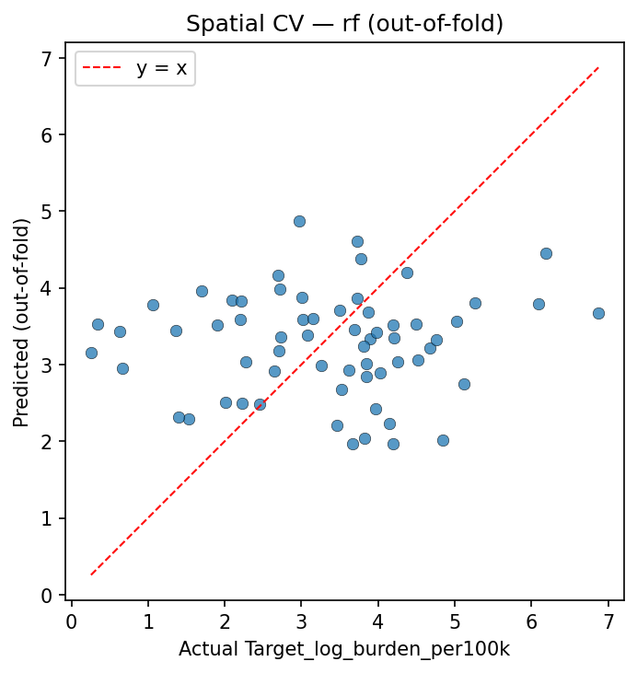
Figure 1. Out-of-fold predictions versus observed stabilised log burden.

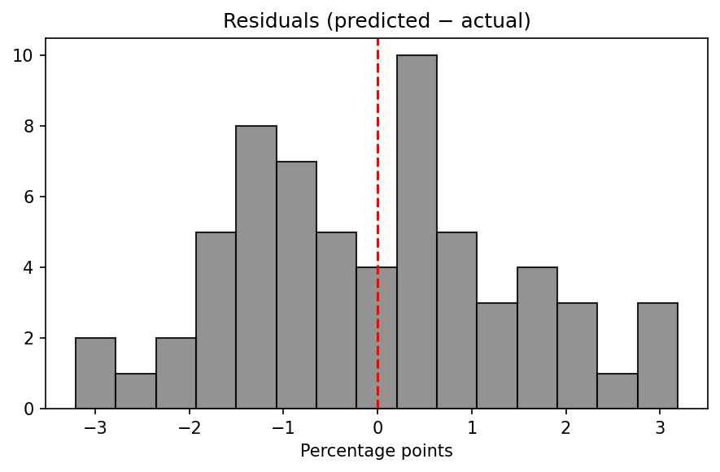
Figure 2. Residual distribution for examining systematic bias.

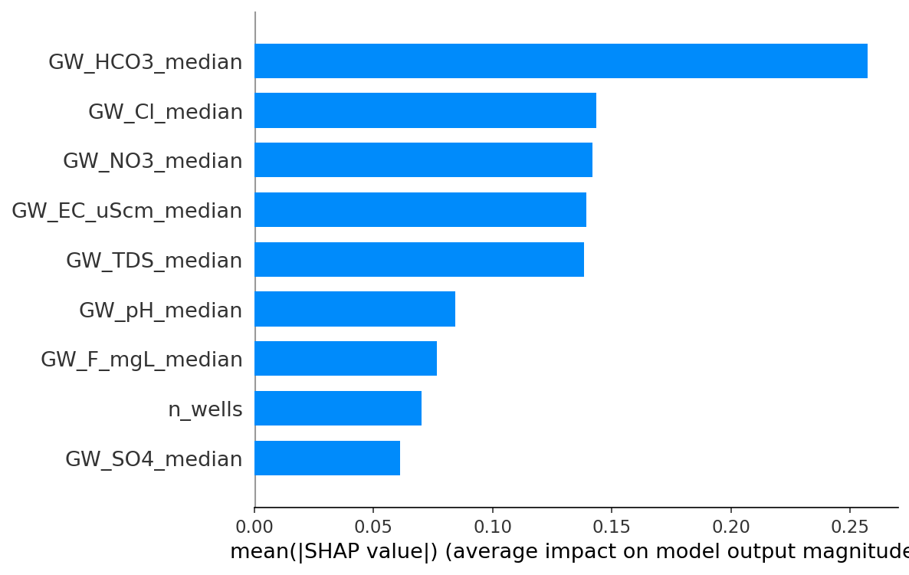
Figure 3. SHAP summary (mean absolute impact ranking).

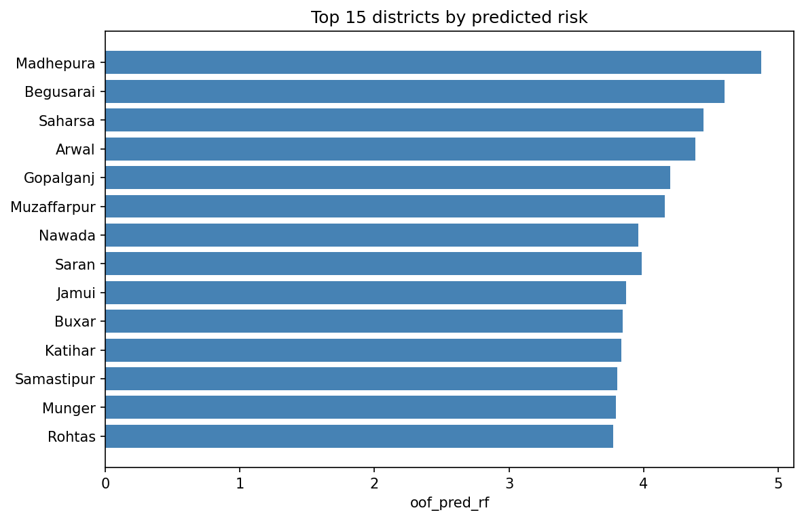
Figure 4. Districts with relatively elevated model predictions — exploratory prioritisation view.

10.2 Policy context and programme communication
District officers balancing arsenic mitigation, fluoride screening programmes, diarrhoea control campaigns, and maternal nutrition initiatives rarely possess surplus time to decode ensemble trees. They nonetheless benefit when academics translate modelling exercises into layered outputs: transparent indices describing groundwater shifts; cautious regression forecasts with explicit baseline comparisons; visual explanations highlighting ions most influential inside models even when causal claims remain off-limits.
National programmes already maintain parallel reporting streams — chemistry laboratories uploading quality parameters, hospitals uploading HMIS tallies — yet analytic bridges remain thinner than data volumes. Projects like this demonstrate pipeline feasibility while underscoring humility: integrating databases does not automatically yield actionable predictive certainty without richer contextual covariates and finer spatial linkage science.
Inter-sectoral workshops pairing hydrogeologists with paediatric programme managers could interpret susceptibility bands jointly: high environmental stress flags prompt technical questions about aquifer management and alternate drinking-water sourcing feasibility while HMIS spikes prompt questions about infection prevention and facility readiness. Neither conversation replaces the other.
Investment justification narratives sometimes misuse colourful heat maps to imply imminent catastrophe without uncertainty shading. Academic training corrects this tendency by pairing visuals with tables documenting modest rank correlations or worse-than-mean errors under spatial validation — temperance valuable for sustainable policy partnerships.
International Sustainable Development Goal framing emphasises safe water and reduced preventable childhood mortality; local analytic artefacts should align rhetorically with those goals without overstating attribution pathways unsupported by study designs presented here.
Finally, student researchers completing major projects should anticipate examiner prompts about translation pathways; documenting Streamlit exploration interfaces and susceptibility exports anticipates those questions constructively.

10.3 Worked example: linking one district-year storyline
Imagine a hypothetical district-year row whose nitrate median rises modestly while fluoride remains mid-range and conductivity ticks upward. Susceptibility scoring standardises each chemistry parameter relative to the cohort, averages signed deviations into an exposure index, then assigns tertile bands. A “High” environmental stress label communicates deviation relative to other rows in the merged official master — not an absolute regulatory exceedance verdict unless separately compared to drinking-water norms.
Parallel random forest predictions ingest the same chemistry vector (plus monitoring intensity) after median imputation and optional interaction augmentation when auxiliary sanitation or rainfall columns exist in extended variants. SHAP bars might attribute portions of the prediction shift to bicarbonate or chloride contributions depending on learned splits reflecting empirical correlations within Bihar’s aggregated panel.
If validation folds repeatedly assign poor error to particular geographic pockets, analysts should investigate missing covariates — flood proneness, informal water markets, seasonal migration — rather than tweaking random seeds optimistically.
When pooled Spearman correlations hover near zero with large p-values, ranking narratives must soften: the model does not reliably order districts by burden using groundwater alone under chosen splits.
Comparing Tables R1–R3 narratively connects numeric outputs: cross-validated mean metrics show algorithm competitiveness; pooled summaries integrate stitched predictions; SHAP magnitudes reveal internal reliance ordering among ions.
Students presenting vivas can rehearse walking examiners through one concrete CSV row — naming district, year, key chemistry fields, burden rate, exposure band, model prediction — cementing comprehension better than abstract jargon alone.
Replication anchors credibility: supervisors rerunning `scripts/run_pipeline.py` should recover metric JSON digits closely matching reported decimals modulo benign floating nuances.
Future analysts extending temporal windows must revisit stationarity assumptions: drift in HMIS definitions or laboratory reporting limits could obsolete historical mappings absent explicit harmonisation logic.
Thus worked readings unify descriptive susceptibility, predictive modelling, and critique of limits inside a single storyline resistant to oversimplified victory laps.

10.4 Integrated synthesis across data, methods, and interpretation
Synthesis across chapters reinforces three pillars transparently intertwined throughout code and prose. First, data integrity narratives explain merges, denominators, indicator lists, and handling of missing chemistry fields — without them machine-learning metrics float anchorlessly. Second, methodological honesty narratives emphasise spatial validation and naive baselines — without them accuracy figures risk textbook optimism divorced from administrative transfer realities. Third, interpretability narratives articulate SHAP summaries plus rule-based susceptibility constructs — without them black-box fatigue alienates domain collaborators.
Negative predictive headlines under pillar two still strengthen pillar one and three by proving the pipeline executed faithfully rather than cherry-picking anecdotal successes. Scientific maturity welcomes instructive null-like outcomes forcing theory refinement.
Visual embedding of diagnostics supports oral examination environments where panels skim rapidly: scatterplots expose curvature or heteroscedasticity patterns residual diagnostics summarise; SHAP bars prioritise chemical storytelling order.
Together these pillars sketch an integrated dissertation storyline migrating from raw official statistics through engineered tabular features toward modest algorithmic claims bounded ethically and statistically.
Readers arriving from hydrology programmes may emphasise pillar one and seek deeper geochemical speciation analyses later; readers arriving from biostatistics may emphasise pillar two and propose hierarchical random effects later; readers arriving from human-computer interaction may emphasise pillar three and iterate dashboard usability studies later — all constructive forks grounded in shared reproducible trunk code.
Academic assessment rubrics rewarding methodological clarity alongside novelty therefore align well with this submission package even absent groundbreaking predictive accuracy.
Institutions contemplating archival ingestion should preserve README pointers explaining runtime dependency nuances encountered during Streamlit deployment attempts — mundane engineering footnotes increasingly gate real-world reproducibility.
Ultimately synthesis invites iterative refinement rather than terminal closure: science proceeds by revisiting assumptions when evidence refuses spectacular shortcuts.
Closing this synthesis transitions naturally toward broader discussion threads interpreting empirical tables already displayed yet deserving reflective prose tying numbers back to chapter promises made in introductions and literature bridges.

11. Discussion
Findings must be interpreted within the ecological fallacy constraint: district aggregates smooth heterogeneity and cannot certify individual exposures or biological mechanisms. Negative validation metrics under strict spatial holdouts signal that groundwater summaries alone lack sufficient information to forecast HMIS burden shifts reliably across unseen districts — an instructive negative result discouraging overclaim.
Nevertheless, structured data fusion remains valuable for situational awareness. Environmental susceptibility profiles transparently describe chemistry deviations relative to peers. SHAP plots hint which ions dominate model reasoning even when overall accuracy is modest, guiding prioritised laboratory follow-up or hydrogeological investigation rather than clinical diagnosis.
Temporal mismatch between Census denominators and later HMIS years, reporting artefacts, and sparse well counts in some districts each bias conclusions in partially known directions. Future extensions could incorporate rainfall remotely sensed indices, sanitation proxies, anaemia programmes, vaccination coverage, or mobility-adjusted exposure models if such columns become harmonised at compatible geography.
The ethical posture privileges transparency: models should not replace epidemiological investigation or clinical judgement; they contextualise official statistics for exploratory planning when limitations are prominently disclosed.
Replication packages — code, pinned dependencies where feasible, saved metrics, figures — embody open science norms enabling supervisors and reviewers to rerun analyses and compare sensitivity choices like interaction term inclusion or fold counts.
Overall, the project demonstrates rigorous methodology even when predictive signal remains weak, aligning scientific integrity with educational objectives of a major academic submission.

12. Limitations
Limitations include reliance on administrative boundaries that mask intra-district variability; HMIS reporting completeness differences across facilities and years; chemical non-detect handling simplified through aggregation; inability to infer causality; potential misalignment between groundwater sampling seasons and diarrhoea seasonality; Census 2011 population static denominators; selection of HMIS indicators reflecting programmatic emphasis rather than exhaustive morbidity; and machine learning hyperparameter choices not exhaustively tuned via nested spatial searches due to small effective sample sizes.
Spatial cross-validation reduces leakage yet still evaluates transfer across districts within the same state — external validity to other states remains unknown without separate testing.
Missing mechanistic pathways — nutrition, maternal health, immunisation, health-worker density — mean residual confounding likely dominates observed associations.
These constraints do not invalidate the pipeline; they bound appropriate inference and motivate cautious language in policy-facing summaries.

13. Conclusion
This report consolidated the conceptual, data, algorithmic, and interpretability foundations of a Bihar-focused district-year study linking CGWB groundwater summaries with HMIS-derived child burden metrics under spatially honest validation. The workflow foregrounds reproducibility, transparent indicator construction, and multi-algorithm comparison with explanation layers and parallel susceptibility profiling.
Empirical outcomes underscore humility about predictive claims while preserving analytical value for exploratory prioritisation and academic training in responsible machine learning for public health.
The completed artefacts — merged datasets, metrics JSON files, figures, trained pipelines, susceptibility exports, and interactive Streamlit exploration — collectively satisfy the brief for an integrated major project suitable for viva voce examination and manuscript-style submission pending supervisor formatting preferences.
Readers should treat numerical metrics as snapshots tied to specific pipeline runs; refreshing raw inputs or random seeds may yield slight variations though qualitative conclusions about strict-validation difficulty likely persist absent substantially richer covariates.

14. Future Scope
Future work may extend spatial granularity using geostatistical exposure models linking wells to population raster surfaces; incorporate time-series dynamics with proper hierarchical models; add causal reasoning frameworks such as sensitivity analyses or instrumental variables only when credible instruments exist; enrich covariates with remotely sensed flooding indices and land use; evaluate fairness constraints across districts with differing reporting capacities; deploy continual validation dashboards tracking drift in chemistry reporting and HMIS definitions; explore probabilistic forecasts with uncertainty intervals rather than point estimates alone; and integrate water-supply scheme inventories where household connectivity modifies exposure relevance.
Educational extensions include interactive notebooks for classrooms translating SHAP outputs into simplified narratives for district officers.
Each direction should preserve the core ethical principle: transparency about limits rivals incremental accuracy gains.

15. Appendices

Appendix A — Software stack and reproducibility
The computational stack intentionally mixes mainstream scientific Python libraries for accessibility to examiners and future maintainers. NumPy supplies efficient dense numerical arrays underpinning matrix operations inside scikit-learn and gradient boosting implementations. Pandas provides labelled tabular data structures conducive to merge diagnostics, missingness summaries, and CSV interchange aligned with institutional open-data habits.
Scikit-learn furnishes composable preprocessing objects — median imputation inside pipelines, standard scaling for penalised linear models, grouped cross-validation iterators — emphasising modular reproducibility. Joblib serialises fitted estimator graphs for reuse in notebooks or lightweight web front-ends without rerunning training each session.
Random forests and ridge regression rely on mature CPU implementations with deterministic seeds where supported. XGBoost contributes an industrial-strength gradient boosting option when installed; the training driver gracefully degrades if optional dependencies are absent, preserving baseline analyses across constrained laboratory computers.
Matplotlib generates diagnostic scatter, residual, and ranking plots exported as raster images embedded into this report. SHAP integrates with Matplotlib backends to render summary bars translating high-dimensional attribution tensors into reviewable graphics.
Streamlit enables browser-based scenario exploration where users upload CSV rows or adjust hypothetical groundwater fields to view susceptibility scoring consistent with frozen reference statistics — helpful pedagogy though not a substitute for peer-reviewed inference.
Version discipline matters: dependency ranges appear in `requirements.txt`; pinned environments via virtual environments or containers reduce “works on my machine” friction during vivas. Runtime declarations on hosted platforms help binary wheels (for example PyArrow pulled indirectly by Streamlit) install cleanly.
Directory conventions separate raw inputs, processed merges, model artefacts, figures, and narrative exports so backups and archival deposits remain orderly.

Appendix B — HMIS indicators used in the burden composite
The HMIS composite employed in this repository sums the following official indicator labels when present in the source spreadsheet under the configured facility rollup and total category (exact string matching):
Childhood Diseases - Severe Acute Malnutrition (SAM); Childhood Diseases - Diarrhoea; Childhood Diseases - Pneumonia; Childhood Diseases - Measles; Number of Infant Deaths (1 -12 months) due to Diarrhoea; Number of Infant Deaths (1 -12 months) due to Pneumonia; Number of Child Deaths (1 -5 years) due to Diarrhoea; Number of Child Deaths (1 -5 years) due to Pneumonia; Number of cases of Infant deaths within 24 hrs of birth; Number of still births.
Summation treats each indicator as a non-negative count after coercion; zeros fill pivot gaps when an indicator lacks rows for a district-year combination. The vulnerability z-score summarises per-indicator log-stabilised values averaged after column-wise centring and scaling across the empirical matrix — a descriptive convenience capturing multi-morbidity emphasis rather than a clinical severity score.
Burden per one hundred thousand population divides the summed composite by Census 2011 district population (multiplied by one hundred thousand). The modelling target applies the natural logarithm of one plus that rate to dampen leverage while preserving interpretability checks via inverse transforms when needed.
Researchers wishing alternative composites should fork indicator lists transparently and rerun merges rather than silently editing figures downstream.

Appendix C — Command-line workflow (reference)
Typical regeneration steps from a clean checkout proceed as follows after placing authoritative raw files in expected locations: extract CGWB CSV exports into `data/raw_groundwater/`; ensure the HMIS master spreadsheet path referenced by `scripts/build_official_master_dataset.py` exists; run the extraction helper if PDF archives must become structured CSVs; execute the official master builder to emit `data/processed/official_district_year_master.csv`; invoke `python scripts/run_pipeline.py` to refresh metrics, SHAP tables, figures, susceptibility profiles, and exported reports.
Optional demonstration mode using synthetic sample data is intentionally gated behind flags to prevent accidental substitution for research tables during submissions.
Susceptibility scoring for hypothetical future years can reuse frozen JSON references via `scripts/predict_susceptibility_new_year.py`, preserving historical cohort moments for z-score comparability.
Streamlit exploration launches locally with `streamlit run streamlit_app.py` from the repository root after ensuring trained artefacts reside under `results/models/`.
Archival deposits should bundle random seeds, dependency snapshots where feasible, and checksums of primary spreadsheets to prove lineage integrity for examination boards.

Appendix D — Data quality review and assumption audit
Auditing implicit analytical assumptions protects reputational capital when stakeholders eventually scrutinise derivative briefing notes. Missing groundwater measurements arise when laboratories omit analytes or wells go unscanned in sparse administrative cycles; median imputation stabilises optimisation yet obscures uncertainty magnitude unless analysts stratify diagnostics by imputation frequency — future enhancements could attach auxiliary flags encoding fraction imputed per district-year though current pipelines omit them for simplicity.
Distributional skew motivates logarithmic transforms on burden rates yet assumes positivity after clipping negatives arising from data quirks flagged upstream when encountered.
Stationarity across years remains partially violated whenever epidemic pulses spike diarrhoea counts independently of aquifer chemistry shifts; panel models with year fixed effects could partially absorb secular shocks absent here due to sample sizing pragmatism.
Spatial autocorrelation violating independence assumptions even inside folds cautions against naive parametric p-value fetishism despite Spearman outputs printed for completeness — interpreting uncertainty strictly frequentist would demand specialised spatial inference frameworks deferred intentionally.
Duplicate district naming collisions across unrelated states pose negligible risk because Bihar subsetting anchors merges though spelling harmonisation routines remain vital defensive coding lessons transferable nationally.
HMIS facility rollup assumptions echo programmatic definitions rather than independent epidemiological audits; abrupt definitional updates mid-series could bias composites silently absent change logs correlated externally.
Population denominators frozen at Census 2011 imply shrinking relative accuracy as demographic transitions accumulate across subsequent fifteen-plus years — acceptable for coarse prioritisation discussions perhaps unacceptable for fine-grained budgeting absent updated projections.
Rainfall interaction augmentation triggers only when optional merged columns exist in enriched datasets; official minimal merges omit them illustrating modular pipeline philosophy balancing completeness versus reproducibility minimalism.
Ultimately auditing assumptions clarifies which conclusions withstand scrutiny versus which serve exploratory orientation awaiting richer integration phases deserving collaborative grants spanning ministries.
Transparency about unresolved auditing threads often strengthens reviewer confidence more than polished narratives that pretend every uncertainty has already been closed.
Iterative auditing and iterative modelling therefore work as complementary habits: each new modelling choice should prompt a short checklist about what could mislead a non-technical reader, and each audit finding should suggest whether the modelling scope needs to narrow or expand.

Appendix E — Replicator checklist and oral examination preparation
Examination panels frequently pose practical replication questions: Which file proves merges succeeded? Where do metric decimals originate? How does grouped folding differ visually from naive splitting? This appendix-style narrative offers spoken-ready answers tied to repository artefacts. The merged master CSV lives under `data/processed/official_district_year_master.csv` after builders execute; its column headers should match configuration constants naming groundwater prefixes and HMIS-derived targets.
Training emits `results/models/metrics.json`; quoted pooled metrics in slides must cite that JSON rather than manually retyped approximations susceptible to transcription drift. Out-of-fold predictions occupy `results/models/oof_predictions.csv` aligning predictions with district identifiers for forensic residual hunts.
Figures regenerate into `results/figures/`; embedding them in Word preserves visual anchors during thesis deposits lacking live plotting environments.
Susceptibility CSV outputs and PDF or Markdown reports summarise environmental bands separately from regression predictions — handy when examiners ask how descriptive constructs differ from supervised learning endpoints.
Streamlit demonstration pathways require copying trained pipelines and JSON references into expected folders; deployment dependency quirks illustrate real-world engineering burdens orthogonal to statistical theory yet decisive for adoption.
Viva defences benefit from rehearsing honest negatives: spatial validation cripples naive optimism; HMIS composites imperfectly capture morbidity; Census denominators lag temporal dynamics; chemistry medians smooth hotspots.
Students demonstrating mature scholarship voluntarily rehearse counterfactual interrogations: What if folds increased? What if ridge alpha doubled? What if nitrate columns dropped entirely? Sensitivity scripts may not all exist yet conceptual readiness impresses committees.
Archival checksum thoughts remind candidates that long-term reproducibility may require freezing conda environments or Docker images beyond lightweight requirements files — trade-offs between accessibility and bit-identical replay merit frank discussion rather than silent omission.
Interviewers assessing teamwork potential observe whether presenters acknowledge collaborator roles across disciplines respectfully — historians of science caution lone-genius narratives inadequately reflecting modern data ecosystems.
Thus replication rhetoric merges technical pointers with reflective scholarly posture coaching smoother vivas.
Documentation hygiene extends beyond code comments: README sections guiding graders shorten onboarding friction raising perceived polish.
Teaching assistants grading introductory analyses sometimes overweight glossy plots underweighted relative to validation discipline emphasised here — candidates may proactively foreground grouped folds when preempting biases toward naive accuracy metrics.
Funding narratives occasionally demand sensational impacts; academic integrity narratives demand proportional qualifiers balancing ambition with empirics — practising those sentences aloud prevents defensive stumbling under pressure.
Therefore treat this checklist both as operational QA and as oral-examination rehearsal scaffolding bridging coding artefacts with rhetorical clarity assessors reward explicitly or implicitly.

Appendix F — Bihar context: groundwater, seasons, and health reporting
Bihar’s dependence on groundwater reflects both convenience during dry seasons and the reach of rural water infrastructure programmes that frequently rely on tubewells and hand pumps. Aquifers are not uniform trays of water; they vary by depth, sediment type, recharge from rivers and monsoon rainfall, and human pressures such as irrigation pumping and urban infiltration from waste streams. District-level medians therefore summarise a mosaic of local outcomes. A median nitrate value might coexist with villages experiencing much higher concentrations nearby, while other villages draw from safer horizons. This spatial smoothing is not a flaw of monitoring programmes — aggregation is necessary for reporting at scale — but it is a reason for cautious language whenever discussing “district water quality” as if it were homogeneous.
Seasonality matters for both hydrology and infectious disease. Monsoon peaks may dilute some chemical concentrations while increasing runoff-related contamination pathways for others. Diarrhoeal burdens often rise in warmer months when sanitation stress interacts with water handling behaviours. A district-year panel summarises chemistry from monitoring programmes whose sampling calendars may not align perfectly with the months when childhood infections surge. Misalignment does not invalidate analysis, but it explains why statistical associations may attenuate: signal timing is blurred.
Health-system reporting through HMIS captures facility-attributed events rather than complete epidemiological incidence in the community. A district with stronger facility access may record more cases simply because diagnosis and reporting occur; conversely, strained facilities might under-report despite high community burden. Composite indicators chosen here emphasise severe outcomes and multiple acute conditions frequently recorded in facility settings. They do not capture growth faltering measured only in community surveys, micronutrient deficiencies diagnosed outside routine HMIS categories, or neonatal conditions classified differently across years.
Cross-sector programmes — immunisation, nutritional supplementation, maternal education, safe motherhood initiatives — influence child outcomes along pathways that bypass groundwater chemistry entirely. Even perfect knowledge of median groundwater ions would leave much variance unexplained because child health is multiply determined. This observation motivates two parallel outputs in the project: a supervised model that tests how far chemistry carries information under honest spatial validation, and a susceptibility index that describes environmental deviation relative to peers without pretending to forecast clinical incidence.
Administratively, districts are meaningful units for aligning CGWB summaries with HMIS rolls and Census populations. They are imperfect units for exposure science when households obtain water from neighbouring districts’ aquifers through markets or migration. Again, the limitation is architectural: publicly downloadable master tables rarely include household connectivity graphs tying each consumption point to a tested source.
Presentation norms in Indian policy documents frequently emphasise ranking and colour-coded maps. Academic contributors should pair those intuitive visuals with numeric humility: uncertainty intervals, baseline comparisons, and explicit caveats about denominators. That pairing supports scientifically grounded storytelling rather than alarmism.
Finally, ethical deployment considerations extend to resource allocation: if a model unfairly flags districts with sparse monitoring as “high stress” because estimates are noisy, interventions might mis-target funds. Future refinements should stratify diagnostics by well-count quartiles and explore fairness-style audits even at aggregate scales.
This contextual chapter does not introduce new equations; it anchors later tables and plots in plain-language realities examiners expect undergraduate and postgraduate presenters to articulate confidently during questioning.

Appendix G — Comparison of analytical alternatives and extension pathways
Researchers approaching the same merged table could choose several legitimate analytical strategies beyond the ridge, random forest, and gradient boosting routes emphasised here. A structured hierarchy clarifies why this report nonetheless privileges its chosen stack while acknowledging alternatives suitable for extensions.
Ordinary least squares without regularisation remains the classical linear baseline. With correlated ions and modest sample sizes, coefficient variance often inflates and signs become unstable across bootstrap resamples. Ridge stabilises estimation by shrinking coefficients, trading a controlled amount of bias for reduced variance — a conservative posture aligned with interpretability goals.
Elastic-net variants blending L1 and L2 penalties could perform automatic variable selection when many sparse covariates appear in expanded feature sets. They were not elevated to headline status here partly because the groundwater feature count remains modest and transparency prefers retaining explicit chemistry columns rather than silently dropping them via shrinkage to zero.
Generalised additive models could smooth nonlinear relationships with penalty terms controlling wiggliness. They excel when curvature dominates and interactions stay low-dimensional. Tree ensembles approximate interactions more freely but sacrifice smoothness; both families deserve consideration when samples deepen.
Hierarchical Bayesian models could treat districts as random intercepts or slopes, partially pooling information across geography while quantifying uncertainty more holistically than point-estimate pipelines. Computation and careful prior choice demand greater statistical labour but reward analysts who must communicate posterior intervals to policymakers.
Neural networks for tabular data remain an active research area; for small ecological panels they frequently overfit unless heavily regularised or engineered with domain-specific structural constraints. Given strict spatial validation already stresses signal-to-noise ratios, deep networks were deprioritised relative to tree ensembles with mature explanation tooling.
Time-series cross-validation variants could respect temporal ordering more aggressively than grouping alone achieves. When multiple years per district exist, blocking structures should reflect whether the scientific question emphasises forecasting future years within known districts versus transferring to unseen districts — distinct objectives requiring distinct splits.
Causal inference pipelines — difference-in-differences, synthetic controls, instrumental variables — become relevant only when credible identifying assumptions appear. Groundwater chemistry does not naturally furnish instruments uncorrelated with other developmental gradients absent specialised designs.
Spatial regression models embedding neighbourhood weights matrices could explicitly model autocorrelation across district adjacency graphs. They add modelling sophistication yet still cannot manufacture causal identification from ecological correlations alone.
Clustered standard errors and sandwich estimators address dependence among rows within districts when models remain simpler regressions fit globally; grouped cross-validation instead changes the validation objective toward geographic transport — complementary tools addressing different questions.
From a software engineering standpoint, scikit-learn pipelines encapsulate imputation and scaling consistently across folds, reducing human error relative to manual preprocessing scripts scattered across notebooks. Serialization via joblib enables reproducible scoring functions reused by Streamlit prototypes.
From an interpretability standpoint, SHAP integrates cleanly with tree models widely used in applied environmental informatics. Linear SHAP aligns pedagogically with ridge explanations for audiences uncomfortable with partitions of decision-tree regions.
Overall, the chosen methods occupy a pragmatic middle ground: strong enough to capture nonlinear structure, conservative enough to retain audit trails, and modest enough to respect limited effective sample sizes inherent to district-year ecological designs.
Doctoral committees sometimes ask whether simpler maps could substitute entirely for machine learning. Descriptive maps remain vital; models add value chiefly by forcing explicit validation discipline and by generating structured attribution summaries — benefits distinct from drawing choropleths alone.
Undergraduate major projects likewise benefit from demonstrating awareness of alternatives even when implementation constraints permit only a subset. Naming plausible extensions signals maturity without claiming exhaustive benchmarking.
Therefore this comparative chapter closes by reaffirming selection criteria: reproducibility, spatial honesty, interpretability compatibility, and alignment with publicly releasable tabular official data at district-year resolution without proprietary overlays.
Readers pursuing extensions should duplicate the pipeline folder, swap estimators inside `train.py`, preserve grouped folds, and re-document metrics rather than overwriting archived baseline runs silently — versioning discipline preserves scientific traceability appreciated during archival assessment.

References
Breiman, L. (2001). Random forests. Machine Learning, 45(1), 5–32.
Central Ground Water Board, Ministry of Jal Shakti, Government of India. Groundwater quality monitoring publications and district summaries (consulted for conceptual framing of chemistry indicators).
Chen, T., & Guestrin, C. (2016). XGBoost: A scalable tree boosting system. Proceedings of the 22nd ACM SIGKDD International Conference on Knowledge Discovery and Data Mining.
Hoerl, A. E., & Kennard, R. W. (1970). Ridge regression: Biased estimation for nonorthogonal problems. Technometrics, 12(1), 55–67.
Lundberg, S. M., & Lee, S.-I. (2017). A unified approach to interpreting model predictions. Advances in Neural Information Processing Systems (NeurIPS).
Ministry of Health and Family Welfare, Government of India. Health Management Information System (HMIS) data dictionaries and reporting guidelines (indicator definitions and facility categories).
Office of the Registrar General and Census Commissioner, India. Census of India 2011 — Primary Census Abstract and district population tables.
Pedregosa, F., et al. (2011). Scikit-learn: Machine learning in Python. Journal of Machine Learning Research, 12, 2825–2830.
Schwartz, J., & Campbell, L. M. (2009). Spatial ecological studies — foundational caution on ecological inference (conceptual reference class for aggregation issues).
World Health Organization. Guidelines for drinking-water quality (framework for interpreting physicochemical parameters — contextual reference).
Snowflake Inc. Streamlit open-source framework documentation (interactive deployment narrative).
Roberts, D. R., et al. (2017). Cross-validation strategies for data with temporal, spatial, hierarchical, or phylogenetic structure. Ecography, 40(8), 913–929.
Moraga, P. (2019). Geospatial Health Data: Modeling and Visualization with R-INLA and Shiny. Chapman & Hall/CRC (conceptual perspective on spatial health data — methodological analogue).
Wickham, H. (2014). Tidy data. Journal of Statistical Software, 59(10), 1–23 (philosophy aligned with transparent rectangular merges).

