We are an official Wayne State Student Organization with the goal of building a robot for the annual Intelligent Ground Vehicle Competition held in the early part of June. Our team is currently composed of students from the Electrical and Computer Engineering department but students from Computer Science, Engineering Technology, Physics, and Mechanical Engineering have expressed interest in joining. We accept students without any previous experience with robotics as long as they are possess a strong work ethic and are willing to put time in every week working on the project. Our robot, WAVE (Warrior’s Autonomous VEhicle), is shown in Figure 1:

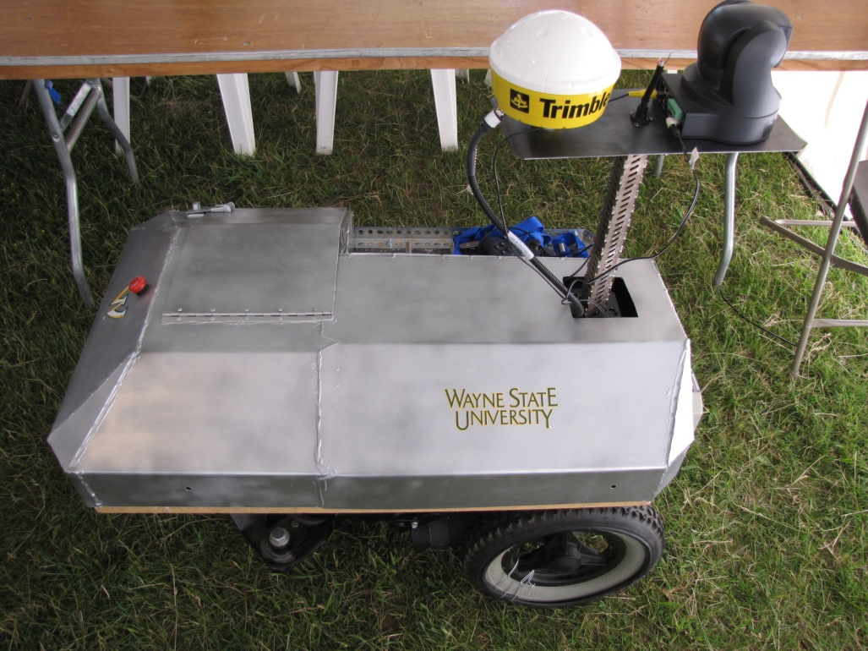

Figure 1: Wayne State's robot at the 2009 IGVC

Our team’s faculty mentor is Dr. R. Darin Ellis, from Industrial Engineering. Dr. Abhilash Pandya, from Electrical and Computer Engineering, also assists in advising the team. Both professors have an extensive background in robotics. This same platform is also being used in the research of two doctoral students on the team.

This team would not have been possible without the generosity of Dr. Gary Witus, alumni of Wayne State, and local small business owner. The platform, a modified wheelchair base, along with many electronics was donated to Dr. Ellis’s lab. Although we have a good start on 2010’s competition, we are still in need of funding to be able to participate.

Table 1 summarizes what we perceive to be our needs for the 2010 competition, in order of precedence. The first is the registration fee that is due in February 2010. The next items are additional hardware that we would like to buy to make our computer processing more efficient. One our team members designed an electronics board that reduces the amount of hardware we have to use underneath the hood but in order to use it, we have to buy a programmer to write code to the board. He was able to use resources at his employer to make the board but in order for us to use it, we need to buy the same hardware. Next, is a Mac Mini which will increase our processing power and reduce the amount of space taken up by the electronics. The other items on the list would be nice to have but have a lower priority.

|  |  |
| --- | --- |
| **Item** | **Cost** |
| 2010 Registration Fee | $ 200.00 |
| Microchip PIC Programmer | $ 80.00 |
| Mac Mini | $ 600.00 |
| Battery charger | $ 50.00 |
| Canopy | $ 150.00 |
| Hardware to make a pole for GPS | $ 100.00 |
| Transportation costs for 4-7 June 2010 | $ 300.00 |
| Food during competition | $ 200.00 |
| Team T-shirts | $ 150.00 |
|  |  |
| Total | $ 1,830.00 |

Table 1: Our wish list for 2010

We have space on the robot’s cover to acknowledge our sponsors by affixing their logo. We will also acknowledge our sponsors in the written report that every team has to submit to IGVC and in the presentation that every team has to give to the IGVC judges, detailing their system design.

Thank you for your consideration. If there are any questions, Dr. Ellis may be reached at rdellis@wayne.edu.