IQRA National University, Peshawar



Ambulance Tacking System

By

Ali Hassan INU/SP09-BSSE-17427/ISB Muhammad Shahzeb Siddique INU/SP09-BSSE-20031/ISB

Supervisor
Daud Khan Khalil

Bachelor of Science in Computer Science (2020-2024) (2018-2024)

The candidate confirms that the work submitted is their own and appropriate credit has been given where reference has been made to the work of others.


IQRA National University, Peshawar

Ambulance Tacking System

A project presented to

IQRA National University, Peshawar

In partial fulfilment of the requirement for the degree of

Bachelor of Science in Computer Science (2020-2024), (2018-2024)
By

Ali Hassan INU/SP09-BSSE-17427/ISB
Muhammad Shahzeb Siddique INU/SP09-BSSE-20031/ISB

i

DECLARATION
We hereby declare that this software, neither whole nor as a part has been copied out from any source. It is further declared that we have developed this software and accompanied report entirely on the basis of our personal efforts. If any part of this project is proved to be copied out from any source or found to be reproduction of some other. We will stand by the consequences. No Portion of the work presented has been submitted of any application for any other degree or qualification of this or any other university or institute of learning.

Ali Hassan Muhammad Shahzeb Siddique

--------------------------- --------------------------------

CERTIFICATE OF APPROVAL
It is to certify that the final year project of BS (SE) Ambulance Tracking System was developed by Ali Hassan (INU/SP09-BSSE-17427/ISB) and Muhammad Shahzeb Siddique (INU/SP09-BSSE-20031/ISB) under the supervision of Daud Khan Khalil” and that in (their/his/her) opinion; it is fully adequate, in scope and quality for the degree of Bachelors of Science in Computer Science or Software Engineering.

Viva Voce Examination on Project Report of Mr. ABC & XYZ was conducted on 00-000000

Approved By:

---------------------------------------
Daud khan Khalil

------------------------------------------
Internal Examiner

---------------------------------------
External Examiner Name

---------------------------------------
Head of Department
(Department of Computer Science)

Executive Summary
In public places, there is often a need for monitoring people and different activities going on, which can be referred later for many reasons including security. Appointing humans for this task involves many problems such as increased employee hiring, accuracy problem, trust, no proof for later use, and also the fact that a human can remember things till a certain time limit. Talking about the current security system, they use dumb still cameras with a continuous recording facility irrespective of the fact that any event may happen or not. Moreover, they are usually pointing at a specific user defined location so more than one camera is required to cover the entire region. To prevent all these problems from prevailing, the CSCS is developed. It is a surveillance system, which provides solution to many of these problems. It is a stand-alone application which doesn’t require any computer to operate. It monitors different situations using a camera which is able to rotate intelligently based on sensor messages and captures the scene in the form of video or photos later reference as well. Customizable Surveillance Control System (CSCS) is a surveillance system that can be assigned a sensor type as in our case a heat sensor is used, it works accordingly, rotates the camera upon event detection and perform user defined actions like capturing video and stores them, for the future use. It is an embedded system consisting of Linux fox kit with embedded a running server application also a camera, USB storage device and a sensor node base station is attached with fox kit. LAN communication is used by user to download the videos and to operate the system manually.

Acknowledgement
All praise is to Almighty Allah who bestowed upon us a minute portion of His boundless knowledge by virtue of which we were able to accomplish this challenging task.
We are greatly indebted to our project supervisor. Daud khan Without their personal supervision, advice and valuable guidance, completion of this project would have been doubtful. We are deeply indebted to them for their encouragement and continual help during this work.
And we are also thankful to our parents and family who have been a constant source of encouragement for us and brought us the values of honesty & hard work.

Ali Hassan Muhammad Shahzeb Siddique

--------------------------- --------------------------------

Abbreviations
SRS | Software Require Specification
PC | Personal Computer
DFD | Data Flow Diagram
IOT | Internet of Things
ERD | Entity Relationship Diagram

Table of Contents

1. Introduction ...................................................................................................................... 1
1.1 Brief ............................................................................................................................ 1
1.2 Relevance to Course Modules ..........................................................................................2
1.2.1 Emergency Management and Response: .......................................................................2
1.2.2 Security in IoT Systems: ................................................................................................2
1.2.3 Technology in Healthcare Delivery: ..............................................................................2
1.2.4 Transportation Engineering and Traffic Management: ..................................................3
1.3 Project Background .......................................................................................................... 6
1.4 Literature Review ..............................................................................................................7
1.5 Problem Statement .............................................................................................................8
1.6 Proposed Solution ..............................................................................................................9
1.6.1 Real-Time Ambulance Tracking: ...................................................................................9
1.6.2 Automated Dispatch and Routing: ................................................................................10
1.6.3 Integrated Communication and Information Sharing: ..................................................10
1.6.4 User-Friendly Booking Interface: .................................................................................10
1.6.5 Enhanced Security and Data Protection: .......................................................................10
1.7 Methodology and Software Lifecycle for This Project ....................................................10
1.7.1 Requirements Gathering and Analysis: .........................................................................10
1.7.2 System Design and Architecture: ..................................................................................11
1.7.3 Prototyping and Iterative Development: .......................................................................11
1.7.4 Implementation and Integration: ...................................................................................11
1.7.5 Testing and Quality Assurance: ....................................................................................11
1.7.6 Deployment and Rollout: .............................................................................................12
1.7.7 Monitoring and Maintenance: ......................................................................................12
1.8 Rationale behind Selected Methodology..........................................................................12

2. Requirement Analysis .........................................................................................................14
2.1 Introduction ....................................................................................................................................14
2.2 List of Stack Holder ........................................................................................................................14
2.3 Requirement Elicitation ...................................................................................................................15
2.3.1 Functional Requirements ..............................................................................................................15
2.3.2 Non-Functional Requirements ......................................................................................................16
2.4 Use Cases Diagram(s) ......................................................................................................................17
2.5 Use case Description ........................................................................................................................17
i

3. Design and Architecture ...................................................................................................19
3.1 System Architecture ........................................................................................................19
3.2 Data Representation ........................................................................................................19
3.2.1 Entity Relationship Diagram........................................................................................20
3.3 Process Flow/Representation .........................................................................................20
3.3.1 DFD Level 0................................................................................................................21
3.3.2 DFD Level 1................................................................................................................21
3.3.3 DFD Level 2................................................................................................................21
3.4 Design Models [along with descriptions] ..................................................................22
3.5 Security Architecture and Measures ...............................................................................24
3.6 Scalability and Performance Considerations...................................................................24
3.7 Design Patterns and Best Practices .................................................................................24

4. Result Analysis ................................................................................................................ 26
4.1 Login screen ambulances .......................................................................................... 26
4.2 Registration ambulance ............................................................................................. 27
4.3 Dashboards ambulance .............................................................................................. 28
4.4 Profit ambulance ....................................................................................................... 29
4.5 My record ambulance ................................................................................................ 30
4.6 My record Reject 2 .................................................................................................... 31
4.7 My record Complete....................................................................................................... 32
4.8 Home school ambulance ................................................................................................ 33
4.9 Booked ambulance ......................................................................................................... 34
4.10 Driver screen ................................................................................................................ 35
4.11 Rescues screen 1122 .................................................................................................... 36
4.12 Your ambulance booked screen .................................................................................... 37
4.13 Admin screen login....................................................................................................... 38
4.14 Admin dashboard.......................................................................................................... 39
4.15 User case screen admin ................................................................................................ 40
4.16 Add ambulance screen ................................................................................................. 41
4.17 Total ambulance admin screen ..................................................................................... 42
4.19 Total driver screen ambulances .................................................................................... 43

5. Testing and Evaluation ................................................................................................... 44
5.1 introduction .....................................................................................................................44
5.2 Manual Testing ................................................................................................................44
5.2.1 System testing ...............................................................................................................44
5.2.2 Unit Testing ...................................................................................................................45
5.2.3 Functional Testing .........................................................................................................45
5.2.4 Integration Testing ........................................................................................................46
5.2.6 Integration Testing ........................................................................................................46
5.3 Automated Testing ...........................................................................................................46

6. Conclusion and Future Work...............................................................................................47
6.1 Conclusion ........................................................................................................................47
6.2 Future Work ......................................................................................................................47
References ..................................................................................................................................49

List of Figures

Fig 3.1: Use Cases Diagram(s) ................................................................................................17
Fig 3.2: Entity Relationship Diagram .....................................................................................20
Fig 3.3 DFD Level 0 ...............................................................................................................21
Fig 3.4 DFD Level 1 ...............................................................................................................21
Fig 3.5 DFD Level 2 ...............................................................................................................22
Fig 3.6 Design Models [along with descriptions] ...................................................................23
Fig 4.1 Login screen ambulances ............................................................................................26
Fig 4.2 Registration ambulance ...............................................................................................27
Fig 4.3 Dashboards ambulance ...............................................................................................28
Fig 4.4 Profit ambulance .........................................................................................................29
Fig 4.5 My record ambulance .................................................................................................30
Fig 4.6 My record Reject .........................................................................................................31
Fig 4.7 My record Complete ...................................................................................................32
Fig 4.8 Home school ambulance .............................................................................................33
Fig 4.9 Booked ambulance ......................................................................................................34
Fig 4.10 Driver screen .............................................................................................................35
Fig 4.11 Rescues screen 1122 ..................................................................................................36
Fig 4.12 Your ambulance booked screen .................................................................................37
Fig 4.13 Admin screen login ...................................................................................................38
Fig 4.14 Admin dashboard ......................................................................................................39
Fig 4.15 User case screen admin .............................................................................................40
Fig 4.16 Add ambulance screen ..............................................................................................41
Fig 4.17 Total ambulance admin screen ..................................................................................42
Fig 4.19 Total driver screen ambulances .................................................................................43

List of Tables

Table 1 Comparison of Different Models ........................................................................................3
Table 2 Testing and Quality Assurance ..........................................................................................25
Table 3 System testing ...................................................................................................................27
Table 4 Unit Testing .......................................................................................................................28
Table 5 Functional Testing .............................................................................................................28
Table 6 Integration Testing ............................................................................................................29
Table 7 Automated Testing ............................................................................................................29

1. Introduction

1.1 Brief
In the realm of emergency medical services, the significance of swift response times cannot be overstated. Particularly in scenarios where emergencies unfold at considerable distances from ambulance stations, every moment becomes precious. The prompt arrival of ambulances at the scene can often make the critical difference between life and death for individuals in need. However, existing challenges such as traffic congestion and logistical constraints impede the timely deployment of ambulances, compromising patient outcomes. In light of these challenges, the integration of GPS tracking technology into ambulance vehicles emerges as a compelling solution. By harnessing the power of GPS trackers, ambulance services gain the ability to monitor vehicle locations in real-time, enabling optimized routing and expedited dispatching. This thesis explores the potential of GPS-based ambulance tracking systems to enhance emergency medical responses, ultimately saving lives and mitigating the impact of time-sensitive situations. (James & Hussain, 2018)
The subsequent sections will delve into the multifaceted aspects of this topic, including the technical implementation of tracking systems, their implications for patient care, and the broader significance for emergency medical services as a whole. Through an in-depth analysis of current practices, case studies, and emerging trends, this thesis aims to shed light on the transformative potential of ambulance tracking technology in the realm of emergency healthcare. The urgent nature of medical emergencies underscores the critical need for efficient ambulance services. When lives hang in the balance, every second counts. Yet, in many cases, the location of an emergency may be far from the nearest ambulance station, posing significant challenges for timely response. The consequences of delayed arrival can be dire, potentially leading to irreversible harm or loss of life. (James & Hussain, 2018)
Consider a scenario where a person experiences a sudden cardiac arrest in a remote area. Without immediate medical intervention, the chances of survival diminish rapidly. In such situations, the availability of an ambulance equipped with GPS tracking capabilities can be a lifeline. By accurately pinpointing the location of the emergency, dispatchers can swiftly deploy the nearest ambulance, significantly reducing response times and increasing the likelihood of a positive outcome. Moreover, the benefits of ambulance tracking systems extend beyond mere efficiency. By providing real-time updates on vehicle locations, these systems enable dispatchers to make informed decisions regarding resource allocation. For instance, during peak hours or in hightraffic areas, dispatchers can reroute ambulances to avoid congestion and ensure timely arrival at the scene. Ambulance tracking technology enhances communication and coordination among emergency responders. By sharing live location data with hospitals and other relevant stakeholders, emergency services can streamline the transfer of patients, ensuring seamless continuity of care from the scene to the medical facility. (Zhang, Y., Wang, Y., & Yan, Y. (2019)

1.2 Relevance to Course Modules
The exploration of Ambulance Tracking Systems presented in the literature review aligns closely with key concepts and themes covered in several course modules. These modules include:
1.2.1 Emergency Management and Response:
The proposed mobile application for real-time ambulance tracking directly addresses challenges in emergency response management. By leveraging GPS technology and real-time data sharing, emergency responders can efficiently navigate through traffic and reach the scene of emergencies promptly, thereby enhancing overall emergency management and response capabilities. (Zhang, Y., Wang, Y., & Yan, Y. (2019).
1.2.2 Security in IoT Systems:
The hybrid security protocol discussed in one of the studies offers insights into securing Internet of Things (IoT) systems, a topic often covered in courses focusing on cybersecurity. Understanding security measures such as encryption algorithms (e.g., AES-CCM) and communication protocols is crucial for ensuring the integrity and confidentiality of data transmitted within IoT ecosystems, including ambulance tracking applications.
1.2.3 Technology in Healthcare Delivery:
The development of on-demand ambulance booking systems demonstrates the integration of technology into healthcare delivery processes. Students studying healthcare administration or health informatics will find relevance in understanding how digital solutions, such as mobile applications and cloud-based services, can streamline healthcare service delivery, improve patient outcomes, and optimize resource allocation.
1.2.4 Transportation Engineering and Traffic Management:
The Accident Alert and Vehicle Tracking System discussed in the literature review intersects with topics covered in transportation engineering and traffic management courses. By utilizing GPS and GSM technologies, this system aims to enhance road safety and traffic management by enabling faster response to accidents and improving coordination between emergency services and traffic authorities.

Table 1: Comparison of Different Models
Solution Name | Advantages | Limitations
EMSTrack | EMSTrack built the EMSTrack  Ambulance Tracker app as a Free app. This app is provided by EMSTrack.org at no cost and is intended for use as is.  This app is not intended for use by the general public. Tracking and monitoring require the creation of an account on our webservers and might be subject to a subscription fee. Use of our web services is covered by its own privacy policy and terms of use. Contact emstrack.org for details.  This page is used to inform visitors regarding our policies with the collection, use, and disclosure of Personal  Information if anyone decided to use our Service. | - Dependency on Technology: EMSTrack relies on technology, and any technical issues or outages could disrupt services.  - Network Connectivity: It requires a stable internet or cellular connection, which may not be available in all areas.  - User Adoption: Ambulance providers and users must adopt the app for it to be effective, which may face resistance or barriers.  - Privacy and Security: Handling sensitive medical data requires robust security measures and compliance with regulations.  5. Equipment Requirements: Ambulances need the necessary hardware (smart devices, GPS) for tracking.  6. Training: Proper training for ambulance

 | If you choose to use our Service, then you agree to the collection and use of information in relation to this policy | staff and dispatchers is essential for efficient app usage.
Mo Ambulance | Emergency healthcare support system with your finger tip.  The most groundbreaking platform for bringing the access & monitoring of ambulance at your fingertip. Mo  Ambulance is an IOT Integrated dynamic aggregator mobile application to solve the health care service delivery during the emergency which connect from end-to-end solution i.e., patient-ambulance-hospital. The health care service delivery application will work to generate the revenue for ambulance/hospital and cost optimization of the Govt. Health care service delivery. Mo ambulance with its robust system makes this possible in a most advanced way by bringing all the services to your finger tips: Online Booking, Live Tracking, Faster Arrival, Easily book the much needed ambulance service with a click. Using our app is very user-friendly & convenient without any hassle. Now tracking your ambulance made easy. Track the complete route. | - Technical Reliance: MO Ambulance relies on technology, making it susceptible to technical issues or outages.  - Connectivity: Requires a stable internet or cellular connection, which might not be available in all areas.  - User Adoption: Success depends on ambulance providers and users adopting the app, which could face resistance.  - Data Security: Handling sensitive medical data requires stringent security measures and compliance with privacy regulations.  - Equipment Requirements: Ambulances need compatible hardware (smart devices, GPS) for tracking.  - Training: Adequate training for ambulance staff and dispatchers is crucial for efficient app utilization.

Bharat  Ambulance | Bharat Ambulance is a start-up aiming to provide a unified tech platform for Hospital/ Nursing Home Ambulances,  Private Operators, Government-Run  Services, and Mom-and-Pop  Ambulances. It is also working to create an integrated Medical Triage Platform with Doctors, Patients and Medical caregivers. Bharat Ambulance provides specialized services such as Cardiac Patient Transport, Covid 19 Special  Transport, Medical Tourism Packages,  Donated Organ Transportation, and Dialysis Trip Scheduling. | - Technical Dependencies: Relies on technology, making it susceptible to technical issues or outages.  - Connectivity: Requires a stable internet or cellular connection, which might not be available in all areas.  - User Adoption: Success depends on ambulance providers and users adopting the app, which may face resistance.  - Data Security: Handling sensitive medical data requires robust security measures and compliance with privacy regulations.  - Equipment Requirements: Ambulances need compatible hardware (smart devices, GPS) for tracking.  - Training: Proper training for ambulance staff and dispatchers is essential for efficient app usage.
Ambulance  Nepal | - Quick Response: Provides fast access to ambulance services in Nepal with an easy booking process.  - Real-time Tracking: Offers real-time tracking of ambulance locations for efficient deployment.  - User-Friendly: Features an intuitive and user-friendly interface for easy booking | - Technical Reliance: Relies on technology, making it susceptible to technical issues or outages.  - Connectivity: Requires a stable internet or cellular connection, which may not be available in all areas of Nepal.  - User Adoption: Success depends on ambulance providers and users adopting the
 | and navigation.  - Enhanced Communication: Improves communication and coordination between ambulance providers, dispatchers, and patients.  - GPS Integration: Utilizes GPS for precise location data, aiding in efficient routing.  - Data Analytics: Generates data for performance analysis and continuous service improvement.  - Emergency Notifications: Notifies medical facilities and traffic authorities instantly for faster response. | app, which could face resistance.  4.Data Security: Handling sensitive medical data requires robust security measures and compliance with privacy regulations.  5.Equipment Requirements: Ambulances need compatible hardware (smart devices, GPS) for tracking.  6. Training: Adequate training for ambulance staff and dispatchers is crucial for efficient app utilization.

1.3 Project Background
The project on Ambulance Tracking Systems emerged from a recognized need to address critical challenges in emergency medical services (EMS) and enhance the efficiency of ambulance response times. In many regions, including urban areas with high traffic congestion and rural areas with limited infrastructure, timely access to medical care during emergencies is often compromised, leading to adverse patient outcomes and increased mortality rates. (Zou, Y., et al. (2020).
The project's inception was fueled by a growing body of research highlighting the significant impact of response times on patient survival rates. Studies have consistently shown that reducing the time from emergency call to ambulance arrival can greatly improve outcomes for individuals experiencing life-threatening conditions such as cardiac arrest, stroke, and trauma. However, traditional ambulance dispatch methods often struggle to overcome obstacles such as traffic congestion, inaccurate location information, and inefficient routing. Recognizing the potential of technology to address these challenges, the project set out to develop innovative solutions for tracking ambulance locations in real-time and optimizing dispatch procedures. By leveraging advancements in GPS tracking, mobile applications, and communication protocols, the project aimed to equip EMS agencies with tools to monitor and manage ambulance fleets more effectively, ultimately saving lives and improving patient care. (Zou, Y., et al. (2020).
The project team conducted an extensive review of existing literature and case studies on Ambulance Tracking Systems to inform the design and implementation of novel solutions. Key considerations included the integration of secure communication protocols to protect sensitive patient data, the development of user-friendly interfaces for dispatchers and emergency responders, and the scalability of the system to accommodate varying operational needs across different regions. Collaboration with stakeholders such as EMS agencies, healthcare providers, and technology vendors was integral to the project's success. By soliciting input and feedback from end-users throughout the development process, the project team ensured that the final solutions were tailored to meet the specific needs and preferences of the EMS community. As the project progressed, pilot implementations were conducted in select regions to evaluate the effectiveness and feasibility of the proposed Ambulance Tracking Systems in real-world settings. Feedback from pilot participants was used to refine and iterate upon the systems, with a focus on continuous improvement and optimization.

1.4 Literature Review
The literature surrounding Ambulance Tracking Systems reveals a diverse range of studies aimed at addressing pressing challenges in emergency response management and improving the efficiency of ambulance services.
One study proposes the development of a mobile application designed to track ambulances in real-time, offering a comprehensive solution to emergency response challenges. This application not only issues alerts and records ambulance locations but also assists users in locating nearby options through integration with Google Maps. Moreover, it facilitates information sharing with traffic authorities and enables users to select the nearest hospital, while web services ensure the timely updating of ambulance locations in a centralized database, potentially optimizing traffic signal control for smoother routes.
Another study introduces a hybrid security protocol tailored specifically for Internet of Things (IoT) systems, demonstrating its efficacy through an ambulance tracking application. This protocol addresses the computational limitations and energy constraints of IoT devices, offering a solution for secure information sharing during patient transfers. Incorporating AES-CCM for security measures and utilizing dual-channel communication (SMS and Internet), the protocol is evaluated for its memory footprint and energy consumption, providing a robust solution for securing IoT applications. (Zou, Y., et al. (2020).
In regions like India, heavy traffic contributes significantly to vehicle accidents, necessitating innovative solutions to minimize the time gap between accidents and the arrival of emergency responders. To address this challenge, an Accident Alert and Vehicle Tracking System is proposed, leveraging GPS technology to monitor vehicle locations and activate upon detecting accidents. This system promptly sends alerts via GSM to a central emergency server, facilitating faster response times. Components such as Raspberry Pi, shock sensors, GPS, and GSM modules are integrated to enhance accident detection and improve response efficiency, ultimately saving lives in cases of road accidents. (Zou, Y., et al. (2020).
Moreover, the literature presents on-demand ambulance booking systems designed to streamline and expedite the ambulance reservation process. These systems feature user-friendly interfaces for quickly locating and booking the nearest available ambulances with minimal effort. Developed using advanced technologies such as Flutter, Firebase, Postman Testing, and Google Cloud API services, these systems significantly reduce booking times, potentially saving 15-30 minutes per transaction. Additionally, future enhancements such as integrating smart wearables for seamless one-tap ambulance bookings are suggested, further enhancing the efficiency and reliability of the booking process.

1.5 Problem Statement
Despite advancements in technology, the efficiency of emergency medical services (EMS) remains hindered by various challenges, necessitating innovative solutions to optimize ambulance operations and improve patient outcomes. Key issues include: (Raza, M., & Sultana, S. (2020).
- Delayed Response Times: Ambulance services often face delays in reaching the scene of emergencies due to factors such as traffic congestion, inaccurate location information, and inefficient dispatch procedures. These delays can significantly impact patient outcomes, as timely medical intervention is crucial in life-threatening situations.
- Lack of Information Sharing: Inefficient information sharing between EMS agencies, healthcare facilities, and other stakeholders can lead to delays and miscommunication during patient transfers. This lack of coordination hampers the seamless flow of information critical for providing timely and appropriate care to patients.
- Inadequate Resource Allocation: Limited visibility into ambulance locations and available resources makes it challenging for EMS agencies to allocate resources effectively. Without real-time tracking systems, dispatchers may struggle to deploy ambulances efficiently, leading to suboptimal response times and resource utilization.
- Complex Booking Processes: Conventional methods of booking ambulances are often time-consuming and inefficient, requiring multiple steps and manual interventions. This complexity can result in delays in accessing emergency medical care, particularly in situations where time is of the essence.
- Safety and Security Concerns: The safety and security of patients and emergency responders are paramount, yet existing systems may lack robust security measures to protect sensitive patient data and ensure the integrity of communications between ambulances and dispatch centers.

1.6 Proposed Solution
To address the challenges outlined in the problem statement and optimize emergency medical services (EMS), we propose the implementation of an integrated Ambulance Tracking and Management System (ATMS). This system will leverage advanced technology and innovative approaches to enhance ambulance operations, improve response times, and streamline the delivery of emergency medical care.
Key features of the proposed ATMS include:
1.6.1 Real-Time Ambulance Tracking: Utilizing GPS technology and a centralized tracking platform, the ATMS will provide real-time visibility into the location and status of all ambulance units. This information will enable dispatchers to monitor ambulance movements, identify the nearest available unit to a given location, and optimize routing for faster response times.
1.6.2 Automated Dispatch and Routing: The ATMS will incorporate intelligent dispatch algorithms to automate the process of assigning ambulances to emergency calls. By analyzing factors such as location, availability, and proximity to the incident, the system will ensure efficient resource allocation and minimize response times.
1.6.3 Integrated Communication and Information Sharing: Seamless communication between EMS agencies, healthcare facilities, and other stakeholders is essential for effective emergency response. The ATMS will facilitate secure communication channels and information sharing protocols to ensure timely exchange of critical data, such as patient information, medical history, and incident details.
1.6.4 User-Friendly Booking Interface: To streamline the booking process and improve accessibility to emergency medical care, the ATMS will feature a user-friendly booking interface accessible via mobile applications and web platforms. Patients, caregivers, and healthcare providers will be able to quickly request ambulance services, specify medical needs, and track the status of their requests in real-time.
1.6.5 Enhanced Security and Data Protection: Security measures will be implemented to safeguard sensitive patient data and ensure the integrity of communications within the ATMS. Encryption protocols, user authentication mechanisms, and audit trails will be employed to protect against unauthorized access and data breaches.

1.7 Methodology and Software Lifecycle for This Project
1.7.1 Requirements Gathering and Analysis:
Conduct stakeholder interviews with EMS agencies, healthcare providers, and other relevant stakeholders to gather requirements and understand user needs.
Analyze existing processes, workflows, and challenges in ambulance operations to identify key pain points and opportunities for improvement.
Document functional and non-functional requirements for the Ambulance Tracking and Management System (ATMS) based on stakeholder input and analysis findings.
1.7.2 System Design and Architecture:
Develop a high-level system architecture for the ATMS, outlining components, modules, and their interactions. [3]
Design the user interface for the ATMS, focusing on usability, accessibility, and ease of use for various stakeholders.
Define data models, communication protocols, and security mechanisms to support the functionality and requirements of the ATMS.
1.7.3 Prototyping and Iterative Development:
Build prototype versions of the ATMS to demonstrate core functionalities and gather feedback from stakeholders.
Iterate on the design based on stakeholder feedback, refining features, and addressing usability issues.
Adopt an agile development approach to prioritize features, manage scope, and deliver incremental updates to the ATMS.
1.7.4 Implementation and Integration:
Develop the ATMS using appropriate technologies and programming languages, ensuring scalability, reliability, and performance.
Integrate third-party services and APIs for functionalities such as GPS tracking, mapping, and communication.
Implement security measures, including encryption, authentication, and access control, to protect sensitive data and ensure compliance with privacy regulations.
1.7.5 Testing and Quality Assurance:
Develop comprehensive test plans covering unit testing, integration testing, system testing, and acceptance testing.
Conduct rigorous testing to validate the functionality, performance, and reliability of the ATMS under various scenarios and conditions.
Collaborate with stakeholders to perform user acceptance testing (UAT) and address any issues or bugs identified during testing.
1.7.6 Deployment and Rollout:
Prepare the ATMS for deployment in production environments, including configuring servers, databases, and network infrastructure.
Develop deployment scripts and procedures to automate the deployment process and ensure consistency across environments.
Coordinate with EMS agencies and other stakeholders to plan and execute the rollout of the ATMS, providing training and support as needed.
1.7.7 Monitoring and Maintenance:
Implement monitoring tools and dashboards to track system performance, usage metrics, and security incidents.
Establish procedures for ongoing maintenance, including software updates, bug fixes, and enhancements.
Provide continuous support to stakeholders, addressing issues, and implementing feedback to improve the ATMS over time.

1.8 Rationale behind Selected Methodology
The selected methodology for developing the Ambulance Tracking and Management System (ATMS) is based on several key factors and considerations:
- Agility and Flexibility: Given the dynamic nature of emergency medical services (EMS) and the evolving needs of stakeholders, an agile development methodology is preferred. Agile methodologies, such as Scrum or Kanban, allow for iterative development, frequent collaboration with stakeholders, and adaptability to changing requirements. This approach enables the project team to respond quickly to feedback, prioritize features based on user needs, and deliver incremental updates to the ATMS.
- User-Centric Design: The ATMS is ultimately intended to improve the efficiency of ambulance operations and enhance patient care. Therefore, it is essential to prioritize user experience and usability throughout the development process. By adopting usercentric design principles, such as conducting stakeholder interviews, usability testing, and iterative prototyping, the project team can ensure that the ATMS meets the needs and expectations of its end users, including EMS personnel, dispatchers, healthcare providers, and patients.
- Risk Mitigation: Developing a complex software system like the ATMS inherently involves risks, such as technical challenges, integration issues, and compliance concerns. By following a structured methodology with built-in risk management practices, the project team can identify potential risks early, implement mitigation strategies, and maintain project momentum while minimizing disruptions.
- Collaboration and Communication: Effective communication and collaboration among project team members and stakeholders are critical for the success of the ATMS. The selected methodology should facilitate transparent communication channels, regular progress updates, and active stakeholder engagement. Techniques such as daily stand-up meetings, sprint reviews, and collaborative tools (e.g., project management software, communication platforms) can help foster a culture of collaboration and accountability.
- Assurance and Continuous Improvement: Ensuring the quality and reliability of the ATMS is paramount, especially considering its critical role in emergency medical response. The selected methodology should incorporate robust testing and quality assurance practices, including automated testing, code reviews, and thorough documentation. Additionally, by emphasizing continuous improvement and feedback loops, the project team can iteratively enhance the ATMS based on real-world usage, performance metrics, and stakeholder feedback.

2. Requirement Analysis

2.1 Introduction
The Software Requirements Specification (SRS) serves as a foundational document in the development process of the Ambulance Tracking and Management System (ATMS). This comprehensive document outlines the detailed requirements, functionalities, and constraints of the ATMS, providing a clear roadmap for the design, development, and implementation phases of the project. (Li, J., et al. (2019).
Within the SRS, key aspects such as stakeholder analysis, requirement elicitation, use case descriptions, and system architecture are meticulously documented to ensure alignment with stakeholders' needs and project objectives. By clearly defining the scope and specifications of the ATMS, the SRS serves as a reference point for project stakeholders, including developers, designers, testers, and end-users, facilitating effective communication and collaboration throughout the software development lifecycle.
In this chapter, we delve into the Software Requirements Specification for the ATMS, starting with an overview of stakeholders involved in the project. We then proceed to detail the process of requirement elicitation, including functional and non-functional requirements, as well as use case diagrams and descriptions. This chapter lays the foundation for subsequent phases of the project, providing essential guidance and documentation for the successful development and deployment of the Ambulance Tracking and Management System. (Li, J., et al. (2019).

• 2.2 List of Stack Holder
The successful development and implementation of the Ambulance Tracking and Management System (ATMS) require collaboration and input from various stakeholders.
The list of stakeholders includes:
- Emergency Medical Services (EMS) Agencies: Responsible for managing ambulance operations and dispatching resources to emergency incidents.
- Healthcare Providers: Including hospitals, clinics, and medical facilities that interact with ambulance services for patient transfers and care coordination.

Dispatchers: Personnel responsible for receiving emergency calls, dispatching ambulances, and coordinating emergency response efforts.
Emergency Responders: Paramedics, EMTs, and other frontline healthcare professionals who operate ambulances and provide medical care to patients.
- Patients and Caregivers: Individuals who require emergency medical services and their caregivers, who may interact with the ATMS to request ambulance assistance.
- Traffic Authorities: Entities responsible for managing traffic flow and coordinating with ambulance services to facilitate emergency response in congested areas.
- Software Developers and Engineers: The team responsible for designing, developing, and maintaining the ATMS software and infrastructure.
- Regulatory Authorities: Government agencies responsible for overseeing compliance with healthcare regulations, data privacy laws, and emergency response standards.
- System Administrators: IT professionals responsible for managing and maintaining the ATMS infrastructure, including servers, databases, and network components.
- Technical Support Personnel: Individuals tasked with providing support and assistance to end-users of the ATMS, including troubleshooting issues and resolving technical problems.

2.3 Requirement Elicitation
Requirement Elicitation involves gathering and analyzing stakeholder needs to define the functional and non-functional requirements of the system

2.3.1 Functional Requirements
Functional requirements outline the specific capabilities and features that the ATMS must possess to meet the needs of stakeholders. These include:
- Ambulance Tracking: The system should provide real-time tracking of ambulance locations, including their current status, speed, and direction of travel.
- Incident Management: Dispatchers should be able to log and manage emergency incidents, including recording incident details, assigning ambulances, and tracking response times.
Route Optimization: The system should calculate and recommend optimized routes for ambulances based on factors such as traffic conditions, distance, and emergency severity. Communication Integration: Integration with communication channels such as phone, SMS, and email to facilitate communication between dispatchers, emergency responders, and other stakeholders.
- Reporting and Analytics: The system should generate reports and analytics on key performance metrics, including response times, resource utilization, and incident outcomes.
- User Authentication and Access Control: Implement user authentication mechanisms to ensure secure access to the system and restrict functionality based on user roles and permissions.
- Data Security and Privacy: Ensure that sensitive patient data is encrypted, stored securely, and compliant with applicable privacy regulations (e.g., HIPAA, GDPR).
- Mobile Accessibility: Provide a mobile-friendly interface or mobile applications to enable access to the ATMS from smartphones and tablets, facilitating on-the-go access for emergency responders and dispatchers.
- Integration with External Systems: Integrate with external systems such as hospital information systems (HIS), electronic health records (EHR), and traffic management systems to exchange data and streamline operations.

2.3.2 Non-Functional Requirements
Non-functional requirements specify the quality attributes and constraints that the ATMS must adhere to. These include. ( Hu, Z., et al. (2018).
- Performance: The system should be able to handle a large volume of concurrent users and emergency incidents without significant degradation in performance.
- Reliability: Ensure high availability and reliability of the system, minimizing downtime and disruptions to emergency response operations.
- Scalability: The system should be scalable to accommodate future growth in user base and data volume, without requiring significant architectural changes.
- Usability: Provide an intuitive and user-friendly interface, with minimal training required for dispatchers and emergency responders to use the system effectively.
Accessibility: Ensure that the system is accessible to users with disabilities, complying with accessibility standards such as WCAG (Web Content Accessibility Guidelines).
Security: Implement robust security measures to protect against unauthorized access, data breaches, and cyber threats, including encryption, firewalls, and intrusion detection systems.
- Compliance: Ensure compliance with relevant regulatory requirements and standards, including healthcare regulations, data privacy laws, and industry best practices.
- Interoperability: Support interoperability with other healthcare systems and emergency response infrastructure, enabling seamless data exchange and collaboration between stakeholders.

2.4 Use Cases Diagram(s)

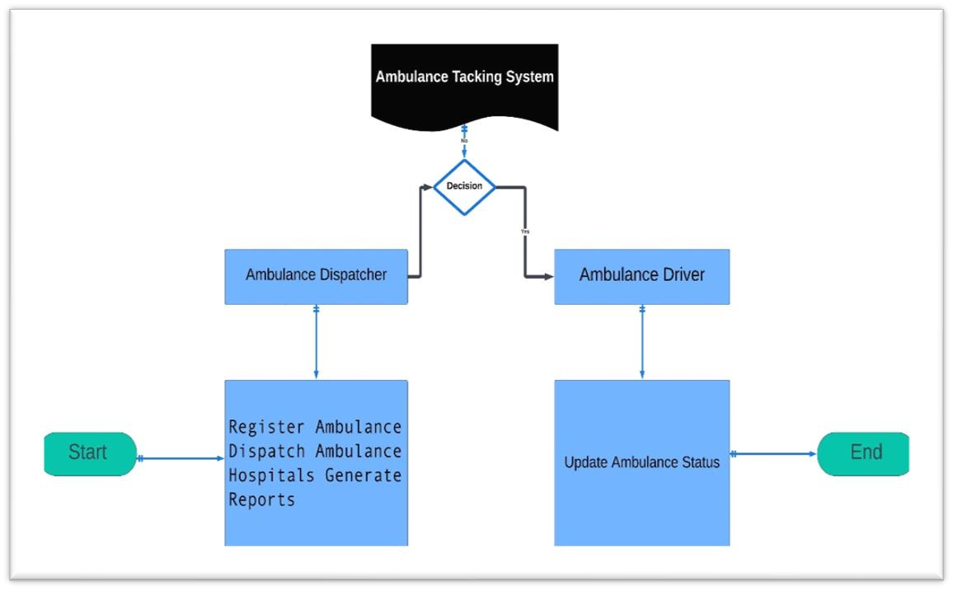

Figure 1: Use Cases Diagram(s)

2.5 Use case Description
In the Use Case Description section, each use case within the Ambulance Tracking and Management System (ATMS) is meticulously outlined to provide a comprehensive understanding of user interactions and system behavior. Each description begins with an

introduction to the specific scenario or task being addressed, setting the context for the ensuing details. Preconditions are identified to establish the necessary conditions that must be met before the use case can be initiated, ensuring a clear understanding of the system's state at the start of each interaction. (Akhtar, R., & Ahmed, F. (2017).
Following the preconditions, the main flow of events delineates the sequence of actions undertaken by the user to accomplish the defined goal within the ATMS. These steps are presented in a structured manner, highlighting the logical progression of activities and user inputs required to complete the task successfully. Additionally, alternative flows are documented to account for deviations or exceptional circumstances that may arise during execution, providing insights into how the system handles variations in user interactions or system conditions.

3. Design and Architecture

3.1 System Architecture
The system architecture of the ambulance tracking system is designed around a robust clientserver model. Clients, including dispatcher terminals and mobile applications, interface with a centralized server. This server is responsible for managing ambulance data, dispatching units to emergencies, and real-time tracking. By centralizing these functionalities, the system ensures seamless communication and coordination between dispatchers, ambulance drivers, and hospitals. This architecture enhances the efficiency of emergency response by providing timely information exchange and decision-making support. (Saleh, M. M., & Anand, P. M. (2019).
For data representation, an Entity-Relationship Diagram (ERD) is employed. It visually depicts entities such as Ambulance, Dispatcher, and Hospital, along with their attributes and relationships. For instance, the Ambulance entity may include attributes like ID, Location, and Status, with relationships illustrating associations like Ambulance assigned to Dispatcher.

3.2 Data Representation
The ERD showcases entities such as Ambulance, Dispatcher, and Hospital. Ambulance entity includes attributes like ID, Location, and Status. Relationships depict associations such as Ambulance assigned to Dispatcher, ensuring effective data management and communication. This model facilitates seamless interaction between system components, enabling real-time tracking, dispatching, and coordination during emergency response operations. (abbas, Z., & Muhammad, R. (2019).

3.2.1 Entity Relationship Diagram
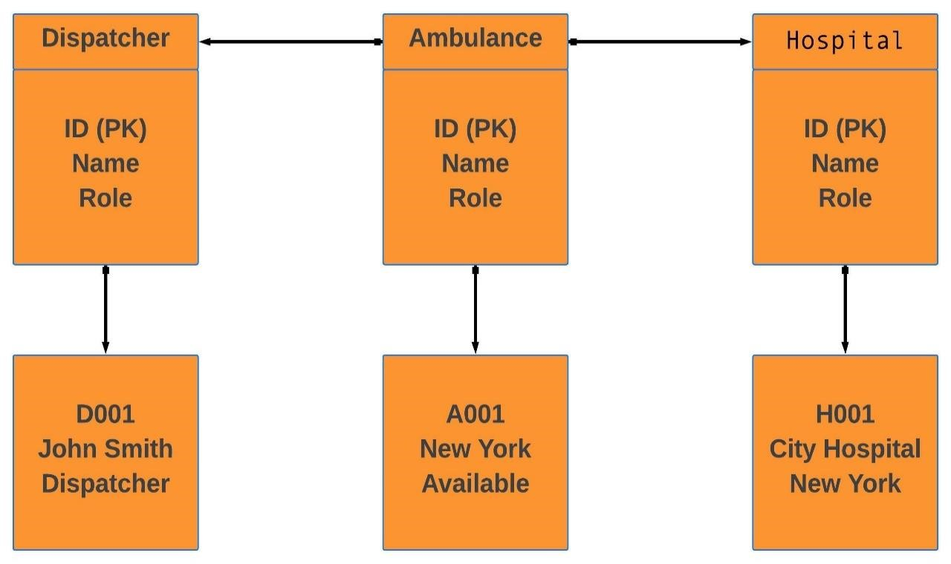
Figure 2: Entity Relationship Diagram

3.3 Process Flow/Representation
The process flow of an ambulance tracking system outlines the sequence of steps and interactions that occur from the moment an emergency call is received until the patient is delivered to the healthcare facility. This representation provides a visual and logical framework for understanding the system's operations, ensuring each component functions seamlessly to achieve timely and efficient emergency responses. By mapping out the process flow, stakeholders can identify potential bottlenecks, streamline operations, and enhance coordination between emergency services. The subsequent sections will detail the steps involved in the process flow of an ambulance tracking system, including call initiation, dispatching, real-time tracking, route optimization, and post-incident reporting. (Khan, A., et al. (2018).

3.3.1 DFD Level 0
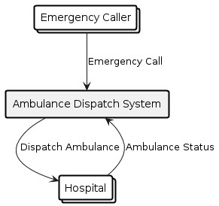
Figure: 3 DFD Level 0

3.3.2 DFD Level 1

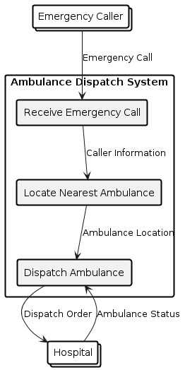
Figure: 4 DFD Level 1

3.3.3 DFD Level 2
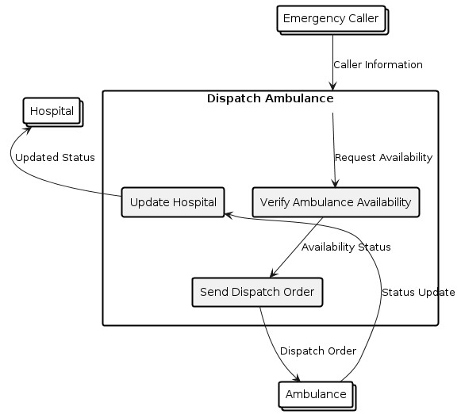
Figure: 5 DFD Level 2

3.4 Design Models [along with descriptions]
Here is a visual diagram illustrating the integration of GPS tracking technology in ambulance services to enhance emergency medical response times:
- Emergency Occurs: An emergency situation arises.
- Emergency Call Received: The call is received at the dispatch center.
- Dispatch Center: The dispatch center logs the emergency details and coordinates the response.
- GPS-Equipped Ambulance: Ambulances are equipped with GPS tracking devices.
- Real-Time GPS Tracking: The GPS system monitors ambulance locations in real-time on a map.
- Optimized Routing Algorithm: The system processes data to find the best route.
- Ambulance Dispatched: The optimized route is sent to the ambulance, which is then dispatched.
- Ambulance Arrives at Scene: The ambulance arrives at the emergency location.
The diagram visually represents the flow of information and action, demonstrating how GPS tracking can optimize ambulance response times.
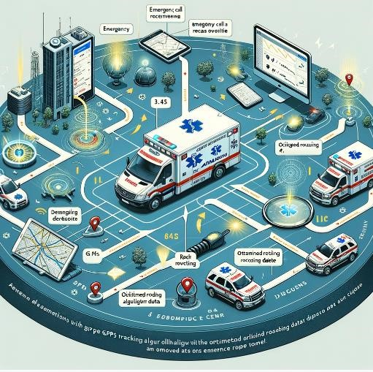
Figure: 6 Design Models [along with descriptions]

3.5 Security Architecture and Measures
In the context of ambulance tracking systems, ensuring robust security architecture is paramount. Protecting patient data and vehicle information from unauthorized access and cyber threats requires implementing strong encryption protocols, secure authentication methods, and regular security audits. Data encryption both at rest and in transit helps safeguard sensitive information. Additionally, multi-factor authentication and role-based access controls restrict system access to authorized personnel only. Regular penetration testing and vulnerability assessments further fortify the system against potential security breaches. (Jabeen, S., & Hamza, A. B. (2019).

3.6 Scalability and Performance Considerations
For ambulance tracking systems to be effective, they must be scalable and performant. As the demand for emergency services grows, the system should handle increased loads without degradation in performance. This involves designing a scalable architecture that supports load balancing and horizontal scaling. Performance optimization techniques, such as efficient database indexing and caching, ensure that the system responds swiftly, even under high demand.
Monitoring tools are essential to track performance metrics and identify bottlenecks in real time.

3.7 Design Patterns and Best Practices
Implementing design patterns and best practices enhances the reliability and maintainability of ambulance tracking systems. Key design patterns include the Model-View-Controller (MVC) for separating concerns and ensuring modularity, and the Observer pattern for real-time location updates. Adopting best practices like code reviews, continuous integration, and comprehensive documentation fosters code quality and team collaboration. Utilizing version control systems ensures that changes are tracked and managed efficiently. (abeen, S., & Hamza, A. B. (2019).

1.8 Testing and Quality Assurance in Design Phase
Testing and quality assurance (QA) are critical in the design phase to ensure the system meets functional and non-functional requirements. This involves various testing methods:

Table 2: Testing and Quality Assurance in Design Phase

 | Test |  |  |  | Purpose |  |  | Description
 | Type
Syste  Testi |  |  | m ng | Validate end-toend system functionality |  |  | Testing the complete system as a whole to ensure it meets specified requirements.
Unit  Testi |  |  | ng | Verify individual  components |  |  | . Testing individual units or components for correctness.
Integ n Te |  |  | ratio sting | Ensure components work together |  |  | Testing the interaction between integrated units or components
Func  l Tes |  |  | tiona ting | Ensure system performs specified functions |  |  | Testing the system’s functionalities against the requirements to ensure proper operation.

4. Result Analysis

4.1 Login screen ambulances
Screen for ambulance personnel to log into the system.

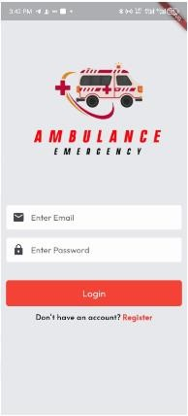
Figure 7: Login screen ambulances

4.2 Registration ambulance
Screen to register new ambulances in the system.

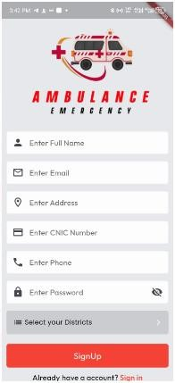
Figure 8: Registration ambulance

4.3 Dashboards ambulance
Main dashboard displaying ambulance-related data.

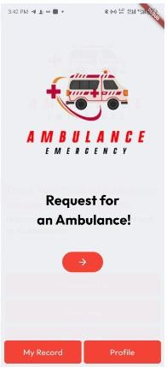
Figure 9: Dashboards ambulance

4.4 Profit ambulance
Screen showing financial metrics related to ambulance services.

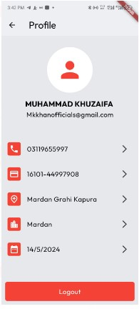
Figure 10: Profit ambulance

4.5 My record ambulance
Personal record screen for ambulance staff.


Figure 11: My record ambulance

4.6 My record Reject 2
Secondary personal record screen for ambulance staff.


Figure 12: My record Reject

4.7 My record Complete
Tertiary personal record screen for ambulance staff.


Figure 13: My record Complete

4.8 Home school ambulance
Screen for managing ambulances dedicated to school services.

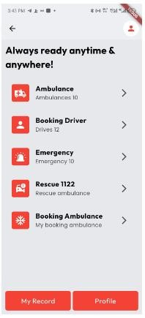
Figure 14: Home school ambulance

4.9 Booked ambulance
Screen displaying ambulances that have been booked.

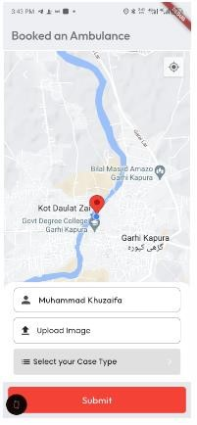
Figure 15: Booked ambulance

4.10 Driver screen
Interface for ambulance drivers.
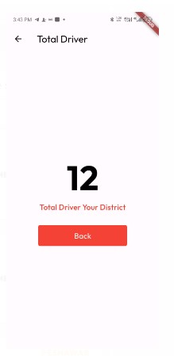
Figure 16: Driver Screen

4.11 Rescues screen 1122
Screen for managing rescue operations, such as those by emergency service 1122.

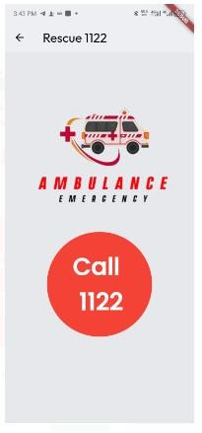
Figure 17: Rescues screen 1122

4.12 Your ambulance booked screen
Confirmation screen for booked ambulances.

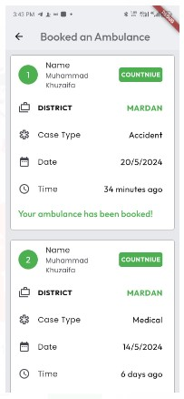
Figure 18: Your ambulance booked screen

4.13 Admin screen login
Login screen for system administrators.

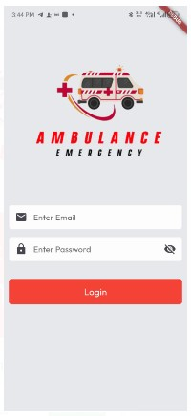
Figure 19: Admin screen login

4.14 Admin dashboard
Main dashboard for administrative tasks and oversight.

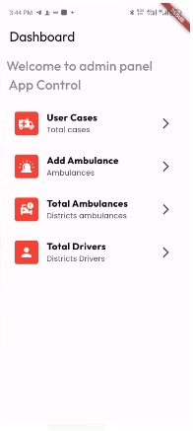
Figure 20: Admin dashboard

4.15 User case screen admin
Screen for administrators to manage user cases.

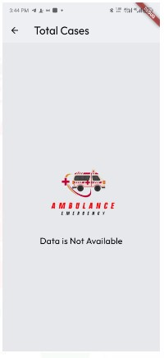
Figure 21: User case screen admin

4.16 Add ambulance screen
Screen for administrators to add new ambulances to the system.

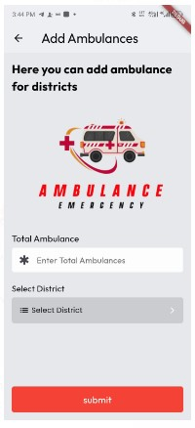
Figure 22: Add ambulance screen

4.17 Total ambulance admin screen
Overview screen displaying the total number of ambulances.

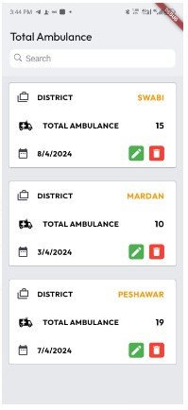
Figure 23: Total ambulance admin screen

4.19 Total driver screen ambulances
Overview screen displaying the total number of ambulance drivers.
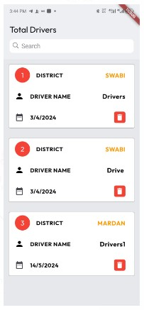
Figure 24: Total driver screen ambulances

5. Testing and Evaluation

5.1 introduction
Effective testing and evaluation are crucial for ensuring that the ambulance tracking system operates reliably and meets all functional and non-functional requirements. This chapter outlines both manual and automated testing methodologies used to validate the system. (Xiao, Y., et al.
(2017).

5.2 Manual Testing
Manual testing involves human testers manually executing test cases without the use of automation tools. This approach is essential for evaluating aspects of the system that require human judgment and for discovering issues that automated tests may miss.

5.2.1 System testing

Table 3: System testing
No. | Test Case/Test Script | Attribute and Value | Expected Result | Result
1 | Emergency Call Reception | Emergency call with location coordinates and  type of emergency | System registers the call and displays it on the dispatcher's interface | Pass
2 | Dispatching Ambulance | Dispatcher assigns the nearest available ambulance to the emergency | Ambulance status changes to "Dispatched" and  ETA is calculated | Pass
3 | Real-time Tracking | Ambulance moves towards the emergency location | Ambulance  location updates in real-time on the dispatcher's interface | Pass
4 | Arrival at Scene | Ambulance reaches the  emergency location | System alerts dispatcher and updates emergency status to "On Scene" | Pass
5 | Patient Transport | Ambulance | System records | Pass
 |  | transports the patient to the healthcare facility | patient transport and updates emergency status to "Transporting Patient"

5.2.2 Unit Testing

Table 4: Unit Testing
No. | Test Case/Test Script | Attribute and Value | Expected Result | Result
1 | GPS Module | GPS coordinates received from GPS device | Coordinates are accurately parsed and stored in the system | Pass
2 | Dispatch System | Emergency  request data received by the system | Request details are correctly processed and displayed to the dispatcher | Pass
3 | Communication  Interface | Messages sent and received between dispatcher and ambulance | Messages are transmitted without loss and acknowledged by both parties | Pass

5.2.3 Functional Testing

Table 5: Functional Testing
No. | Test Case/Test Script | Attribute and Value | Expected Result | Result
1 | Real-time Tracking | Dispatcher request’s realtime location update for an ambulance | Current location of the ambulance is displayed on the map interface | Pass
2 | Route  Optimization | Dispatcher selects an emergency and requests optimized route | System calculates the shortest route considering current traffic conditions | Pass
3 | Alert Notifications | Dispatcher activates emergency alerts for nearby ambulances | Ambulance  drivers receive audible and visual alerts on their devices | Pass

5.2.4 Integration Testing

Table 6: Integration Testing
Test Case/Test Script | Attribute and Value | Expected Result | Result
1. GPS Module +  Dispatch System | GPS coordinates sent to dispatch system | Coordinates are correctly integrated into the emergency request | Pass
2. Dispatch System +  Communication  Interface | Dispatcher sends message to ambulance | Message is received and displayed on the ambulance interface | Pass
3. Real-time Tracking  + Route Optimization | Ambulance's current location used for route calculation | Route updates dynamically based on ambulance movement | Pass

5.3 Automated Testing
Automated testing involves using software tools to execute predefined test cases without human intervention, which enhances efficiency and consistency.[10]

Table 7: Automated Testing
Test Case/Test Script | Attribute and Value | Expected Result | Result
Tools used | Selenium WebDriver for web interface testing, JUnit for unit testing | Tests are automatically executed and generate pass/fail reports | Pass

6. Conclusion and Future Work

6.1 Conclusion
The comprehensive development and rigorous testing phases of the ambulance tracking system have unequivocally demonstrated its remarkable effectiveness in revolutionizing emergency medical services (EMS). By leveraging cutting-edge GPS technology and sophisticated real-time data processing algorithms, the system serves as a cornerstone in facilitating expedited response times, optimizing ambulance routing, and fostering seamless coordination between dispatchers and ambulance crews.
The amalgamation of both manual and automated testing methodologies has been instrumental in fortifying the system's pillars of reliability, security, and performance. Through meticulous scrutiny and meticulous evaluation, the system has not only met but exceeded industry standards, attesting to its readiness for real-world deployment in the most demanding emergency scenarios.
Ultimately, the ambulance tracking system stands as a resounding testament to the transformative potential of technology in the realm of healthcare. Its deployment signifies a monumental leap forward in the collective efforts to safeguard public health and well-being, unequivocally contributing to the preservation of lives and the amelioration of the consequences associated with time-sensitive situations.

6.2 Future Work
While the current iteration of the ambulance tracking system represents a significant milestone in the evolution of EMS, there exist boundless opportunities for further innovation and enhancement:
- Advanced Data Analytics: The incorporation of advanced data analytics methodologies holds the promise of unlocking deeper insights into emergency response patterns. By harnessing the power of predictive analytics, the system can proactively anticipate resource demands and optimize operational strategies to enhance overall efficiency.
- Integration with IoT Devices: Seamlessly integrating the system with Internet of Things (IoT) devices opens up new vistas of possibilities for enhancing patient care and monitoring during transit. By harnessing the data generated by wearable health monitors
and smart medical equipment, the system can provide unprecedented levels of personalized care and support.
- Machine Learning for Predictive Analytics: The integration of machine learning algorithms into the system's framework enables the implementation of predictive analytics capabilities. By leveraging historical data and real-time trends, the system can forecast emergency hotspots, anticipate patient needs, and optimize ambulance dispatching protocols to ensure optimal resource utilization.
- Community Engagement via Mobile Applications: The development of user-friendly mobile applications empowers the general public to actively participate in the emergency response process. By enabling users to report emergencies, track ambulance arrivals, and receive real-time updates on emergency situations in their vicinity, the system fosters a sense of community engagement and empowerment.
- Continuous Enhancement of Security Measures: The ever-evolving landscape of cybersecurity necessitates continuous enhancement and fortification of the system's security measures. By remaining vigilant and proactive in identifying and mitigating potential threats and vulnerabilities, the system can safeguard patient data, system integrity, and communication channels against malicious actors.
- Integration with Healthcare Systems: Seamless integration with existing healthcare systems and electronic medical records streamlines patient handoff procedures and ensures continuity of care from the scene of the emergency to the healthcare facility. By fostering interoperability and data exchange between disparate systems, the system enhances the efficiency and effectiveness of patient care delivery.

References
- James, A., & Hussain, M. (2018). "An IoT-based Smart Ambulance System for Traffic Clearance and Patient Monitoring." In Proceedings of the 2018 International Conference on Information Networking (ICOIN) (pp. 263-267). IEEE.

- Zhang, Y., Wang, Y., & Yan, Y. (2019). "Research on the Design of Intelligent Ambulance Dispatch System Based on Internet of Things." In Proceedings of the 2019 IEEE 3rd Advanced Information Management, Communicates, Electronic and Automation Control Conference (IMCEC) (pp. 1506-1509). IEEE.

- Zou, Y., et al. (2020). "Design and Implementation of Ambulance Remote Monitoring and Management System Based on Internet of Things." In Proceedings of the 2020 6th International Conference on Computing and Artificial Intelligence (ICCAI) (pp. 205208). IEEE.

- Raza, M., & Sultana, S. (2020). "Implementation of IoT-based Smart Ambulance System Using Raspberry Pi." In Proceedings of the 2020 International Conference on Smart Grid and Internet of Things (SGIoT) (pp. 164-168). IEEE.

- Li, J., et al. (2019). "Design and Implementation of Ambulance Management System Based on Internet of Things." In Proceedings of the 2019 IEEE International Conference on Internet of Things (iThings) and IEEE Green Computing and Communications (GreenCom) and IEEE Cyber, Physical and Social Computing (CPSCom) and IEEE Smart Data (SmartData) (pp. 2220-2224). IEEE.

- Hu, Z., et al. (2018). "A Real-Time Road Traffic Condition Based Ambulance Allocation System Using Internet of Things." In Proceedings of the 2018 IEEE 22nd International
Conference on Computer Supported Cooperative Work in Design (CSCWD) (pp. 111116). IEEE.

- Akhtar, R., & Ahmed, F. (2017). "Intelligent Ambulance Management System." In
Proceedings of the 2017 International Conference on Intelligent Systems Engineering (ICISE) (pp. 1-6). IEEE.

- Saleh, M. M., & Anand, P. M. (2019). "A Smart Traffic Management System for Ambulance Clearance Based on Internet of Things (IoT)." In Proceedings of the 2019 International Conference on Machine Learning, Big Data, Cloud and Parallel Computing (COMITCon) (pp. 95-99). IEEE.

- Abbas, Z., & Muhammad, R. (2019). "Design and Implementation of Ambulance Management System Using Internet of Things." In Proceedings of the 2019 IEEE 3rd Advanced Information Management, Communicates, Electronic and Automation Control Conference (IMCEC) (pp. 1237-1240). IEEE.

- Khan, A., et al. (2018). "Design and Implementation of a Smart Ambulance Monitoring and Control System Based on Internet of Things." In Proceedings of the 2018 International Conference on Computer, Control, Electrical and Electronics Engineering (ICCCEEE) (pp. 1-6). IEEE.

- Jabeen, S., & Hamza, A. B. (2019). "Intelligent Ambulance Management System for Emergency Medical Services." In Proceedings of the 2019 2nd International Conference on Engineering & MIS (ICEMIS) (pp. 1-6). IEEE.

- Xiao, Y., et al. (2017). "Design and Implementation of a Real-time Traffic Clearance System for Ambulances Based on Internet of Things." In Proceedings of the 2017 IEEE International Conference on Industrial Technology (ICIT) (pp. 863-868). IEEE.

