**Assignment 2.1**

**Task 1**

For checking whether /user/acadgild exist or not

Used this command : **hadoop fs –ls /user/acadgild**

For creating Directory /user/acadgild/Hadoop

Used this command : **hadoop fs –mkdir /user/acadgild/Hadoop**

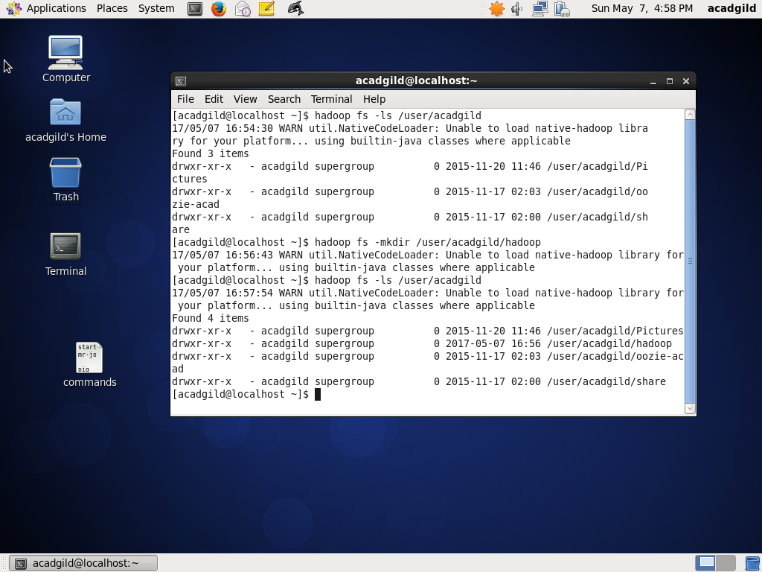

**Task 2**

For creating a file under this directory :

Used this command: **hadoop fs – touchz /user/casdgild/hadoop/word-count.txt**

For appending in a file:

Used this command: **hadoop fs –appendToFile - /user/acadgild/hadoop/word-count.txt**

