**Assignment 1.1**

**Step 1:** Import Appliance

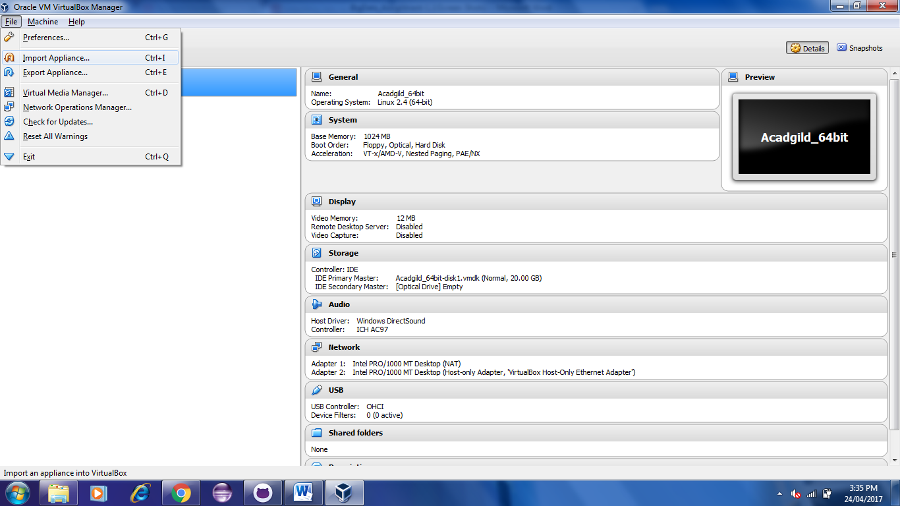

**Step 2:** Select the Appliance to Import

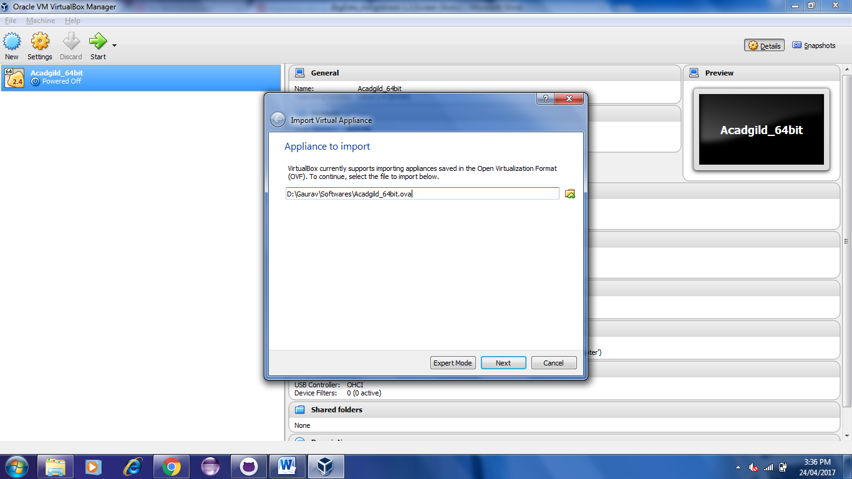

**Step 3:** Click on Import Button to start importing Acadgild VM

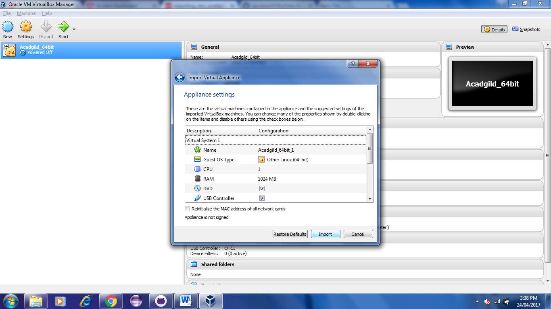

**Step 4:** Click the Start Button to initiate the Acadgild VM

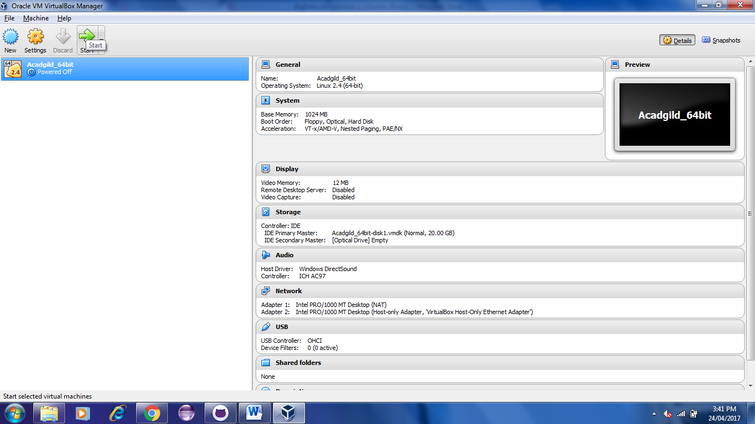

**Step 5**: Give the Password as Acadgild

