Matformer: a unified any-to-any autoregressive and diffusion model

This is not the readme of the “matformer” library. That is still missing (but, read “note_ _codice.md”), this is a draft presentation of a new architecture that should be built using the matformer library.

Disclaimer: this is not an academic paper!
This document is only a presentation of the project to the team. Even though the style of sentences may appear academic, there are many missing contents and references. Moreover only a small part of the experiments is executed to date. The architecture could (and will!) still drastically change and the following text may contain incorrect assertions.
The name “Matformer” must be changed: “Matteo” is my name but, if and as soon at this work will become a team-work, we need to find a new nice name.
Fundamental works for the comprehension of this draft, such as BLT or Coconut, are not yet introduced so the invite is to refer to the original papers.
Consider it a bit more than a blog post but less than an arXiv draft.

Introduction
Matformer is a novel transformer-based architecture grounded on a fundamental assumption, that is, the development of abstract representations in the latents of the models’ middle layers.
Mechanistic Interpretability studies showed in several occasions [1],[2] that the Large Language Models have a tendency to dedicate the lower layers to convert tokens into a more abstract representational space (de-tokenization), perform the actual computations into the middle layers and then convert back these representations into tokens at the final layers.
As can be for example observed in [3], initial as well as final layers tend to work in a subspace affine to the embedding/unembedding matrixes, in contrast with the middle layer. Again, [4] studies about multilingual capabilities of LLMs, in particular in big models, have demonstrated the existence of neurons independent from the input language and, consequently, they can be considered as conceptual neurons because they perform abstractions from the specific language the model is considering (but, see [3]).
Regarding multi-modality, works such as [5][6] strengthen the idea that such conceptual latent-space representations may also be amodal, that is, independent not just from the specific input language but also from the specific modality (text, audio, video, data...) vehicolating them.
Taking those findings into consideration, the main idea of “matformer” consists to design a model less bound to the specific input modality but capable to work on latent-space representations generated by smaller model aligned to the bigger model that works as adapters for each particular modality. This could mean to have a model potentially more aligned to some findings coming from cognitive neuroscience that applies to the way in which human brain works; moreover, it could mean to have a model that produces representations not bound to a specific input/output space, a characteristic that could improve generalisation performance of the model and performances in retrieval, memorisation and reasoning.
Another speculation that we would like to test with such a “latent representations transformer” is that this way of representing information may help the model to work with its own latents in a recurrent or semi-recurrent fashion (see: [7],[8]). Adding some form of recurrency, that has to be carefully managed in order not to lose the performance gain given by the parallerizability typical of Transformers models, may disclose new dimensions to improve the models’ performances in scenarios such as long-context inputs or to move toward a neural-fashioned RAG in which useful information are directly injected into the model in the form of latents instead of being just added to the prompt, an expensive operation due to the high computational costs of Attention.
Moreover, proposed improvement to the Transformer base model such as Coconut [9] fit well into this kind of design: instead of using all the layers of the model, reasoning in latent space could be performed only by the middle layers of the models, saving compute and reducing noise given by the tokenization and detokenization processes.

Modalities integration
To enable the latent representations transformer to process textual information we decided to closely follow the idea of the Byte Latent Transformer [10] but proposing a new implementation slightly different in some technical details. We believe that an architecture such as BLT is a natural choice for this kind of model, despite being a new and experimental model: the design choice of BLT to separate textual encoder and decoder as well as its working principle of feeding a global transformer with patch derived directly from text’s characters are well suited to fit in a model such as Matformer, being its core architectures a transformer capable to work directly on lesser modality-constrained patches.

Regarding audio and visual data, we decided to follow the approach of the contemporary state-of-the-art image and audio generative models to create patch representations starting from a Variational Autoencoder rather than directly from raw data. Being matformer a wannabe amodal and any-to-any model, it is necessary to find a strategy not just for multimedial comprehension but also to generate data in these modalities using the same, shared, central model thus avoiding approaches based on placing separate models side by side and creating more or less artificial communication channels between these models.
We decided to don’t follow the path of generating image and audio data using autoregressive approaches, that are commonly employed in generative large language models: instead, we choose denoising diffusion as first choice for the generation of multimedia contents.

Verifying if the same transformer model is able to learn at the same time distinct training objective such as autoregression (for text) and denoising diffusion (audio, image, eventually video) is a rather new path, not much explored in the literature. The point is to avoid negative interferences but at the same time promote the formation of positive interferences, aiming at reaching a real modality unification. We believe that several techniques developed in the field of Mechanistic Interpretability could be applied to such architecture to detect the nature of these interference. Future experiments may try to test the performance of this hybrid model employing text diffusion (as in Llada) or text-block diffusion also for text generation in order to unify the handling of different modalities, even though text diffusion works in a rather different way than diffusion employed for multimedia content.
The flexibility of this conceptual model allows, at least hypotethically, the integration into this architecture of any possible data representable in the form of patches-splittable tensors, such as raw data of various nature (scientific data, robotic data...) or, as we plan to test in future work, trying to represent in a way understandable for a neural network the “motion vectors” employed in video codecs such as MPEG. This could open up scenarios in which video can be efficiently generated avoiding the generation of each frame but limiting only to generating key frames and the motion vector between them.
Finally, the concept of “entropy” that we borrowed from Meta’s BLT paper and applied in the text encoder could be explored also to integrate other modality to avoid the model to spend the same amount of computation for low-informative parts of an input (as an example extreme case, black pixels in image, background noise in the audio or headers of a PDF) and high informative parts.

Implementation
Realising in practice such an hybrid model requires first of all a way to address the transformers’ residual stream into the correct direction. A possibility consists into integrating into the global model a small “router” model, that can be as simple as a linear probe, choosing each time where to address the residual stream. In this way, the training objective of the Matformer becomes double: on the one hand, to produce the patch with the correct information, on the other, to correctly route the flow toward the correct modality processor. The router can generate special tokens that will influence the behaviour of the model guiding the inference process toward the correct generation modality. Having such a router integrated into the model can help to integrate into the Matformer the promising “Coconut” architecture proposed by Meta: by generating a special <recurrent> token, a situation that will be better analysed in the following section.
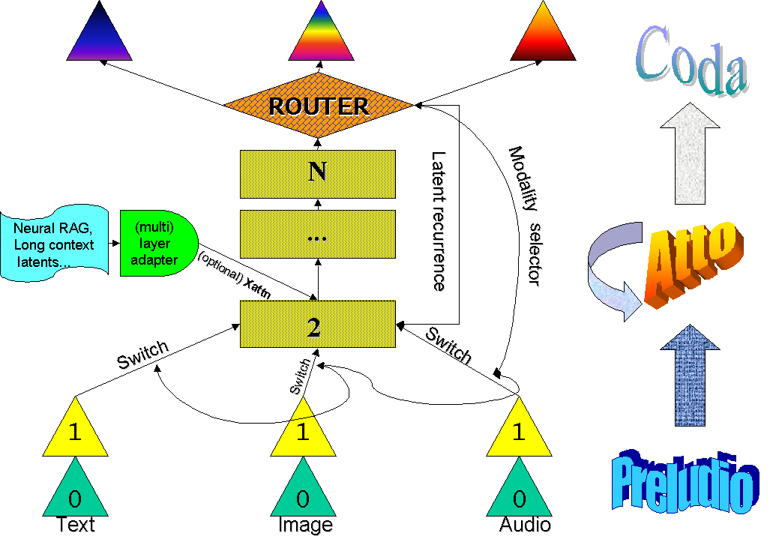

Enabling recurrence, neural RAG and, potentially, memory
At this stage of experimentation, this part is still far to be actually defined and implemented but we still want to describe a potential paradigm that may increase the interest in an architecture such as Matformer. We borrowed the very nice “Preludio, Atto and Coda” names from [9].
Regarding recurrence, that will be always optional both in training a new model but also during inference, Matformer is easily compatible with at least two different paradigms already explored in literature:
- Coconut: the router can decide to directly send the next token into the Atto, avoiding its passage trough the Preludio of any specific modality. To skip Preludio and Coda layers means that the additional computation/reasoning caused by the recurrence is not forced to belong to any specific modality, thus amodal reasoning is encouraged and computation is saved because the stream doesn’t have to pass through modality-specific layers. This behaviour could be teached to the model employing RL techniques.
- Standard RNN, such as [...]: a cross-attention layer can be easily added in the first(s) layers of the Atto, rendering the architecture ready to receive information coming from a precedent execution of the model. The excessive cost of BPTT can be attenuated by freezing all the copies of the main model and training only the adapter layers. During training this procedure can be parallelized with a careful batch preparation: if a long document is split into sequences, the model can be trained on the first batch of segments and at the next step receive the second segments as well as the pre-computed latents coming from the previous execution of the model. Unfortunately, giving to the model the entire sequence of latents may be too computational expensive due to the exponential costs of attention with increased sequence length. Because the information is already converted into a latent space by the previous execution of the model, interesting direction of experimentation could find ways to compress these latent tensor without losing the information relevant to lower the loss on the next part of the sequences. Autoencoders, Convolutions or Pooling could be tried to condense, for example, a number of latents originally as long as the original sequence to much shorter sequences ready to be injected in the cross-attention layer.

We believe that teaching the model to be able to work not only with latents coming from encoder models but also with its own latents may enable new scaling direction for the architecture. The model will no longer be constrained to reason or retrieve information in an expensive and limited “token” space, where for example specific grammatical constraints must be satisfied and multiple path of thinking are more difficult to represent [as shown in coconut]. A model capable to work with its own latent is a model in a sense more “self-aware” of its own internal mechanisms and that can be in principle more efficient: for example, it will no longer required for RAG to inject long pieces of information directly into the textual context, a very expensive operation in terms of memory and computations. Instead, a neural memory (such a QKV memory, or a Modern Hopfield Network) could directly search into a cache of pre-computed latents, potentially in superposition regime, and return to the model a latent similar to the prompt. We believe that a model organised in such a way can also be more easily adaptable to approaches such as Fast Weight or Test Time Training [...], approaches that definitely should be tested in the direction of solving one of the biggest lack of current architecture: continual learning.
Finally, similar to what is shown in [7][11] we expect a recurrence-enabled model to perform very well on potentially infinite sequence length without causing memory issues.

Bonus
Good results obtained by others in model stitching may suggest that, instead of initializing this model with random weights, weights from other models (ex. merging together a LLM and a Diffusion model) could be adapted. The BLT paper, for example, shows that Llama 3 can be easily converted to work with a BLT layers instead of the standard tokenization process.

Necessary ablation studies
- Using BLT-Like scheme for text instead of standard tokenization based approach
- Diffusion for text
- Understand the best strategy for diffusion conditioning, that is, mainly integration of timestep information
- [...]

Very Partial References
[1] Missing, but many of works on M.I. such as Neel Nanda’s
[2] Missing, but many of works on M.I. such as Neel Nanda’s
[3] Wendler, Veselovsky, Monea, West “Do Llamas Work in English? On the Latent Language of Multilingual Transformers”, ACL Proceedings, 2024
[4] Lindsey et al. On the Biology of a Large Language Model, Transformer Circuit Thread, Anthropic 2025
[5] Huh, Cheung, Wang, Isola “The Platonic Representation Hypothesis”, arXiv:2405.07987 2024
[6] Missing but easy to find
[7] Bulatov, Kuratov, Burtsev “Recurrent Memory Transformer”, arXiv: 2207.06881, 2022
[8] Nguyen, Lin “Intra-Layer Recurrence in Transformer for Language Modeling”, arXiv:2505.01855, 2025
[9] Hao et al, “Training Large Language Models to Reason in a Continuous Latent Space”, Meta, 2024
[10] Pagnoni et al “Byte Latent Transformer: Patches Scale Better than Tokens”, Meta, 2024
[11] Sun et al “Learning to (Learn at Test Time): RNNs with Expressive Hidden States”, arXiv:2407.04620, 2024

Simple Scheme of BLT Architecture:
