**Screenshot of the Database list**

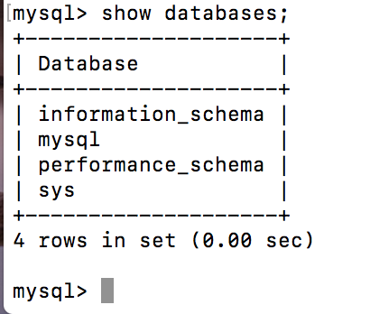

**Screenshot of the user list**

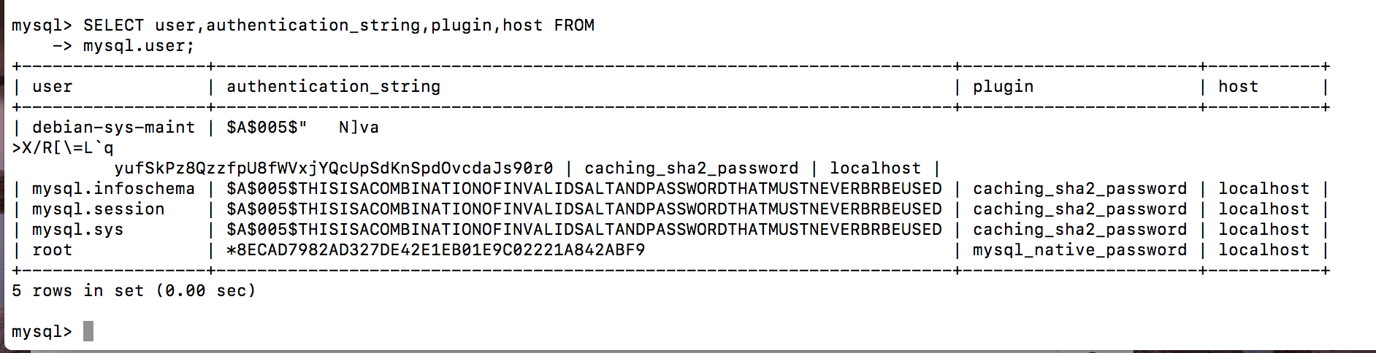

**Screenshot of Apache2 ubuntu Default page**

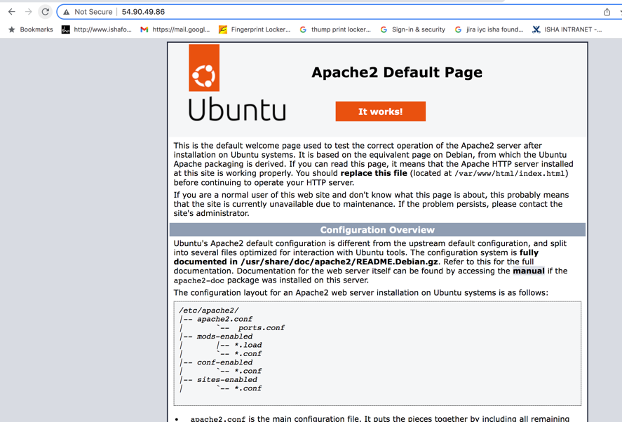

**Screenshot of the results of the last select command in phpMyAdmin**

