**ROLL NUMBER:2320030309**

**NAME: MRINALINI BANALA**

**Lab-1: Introduction to the Laboratory and the Tool Used: Cisco Packet Tracer**

**Objective**

The objective of this lab is to familiarize students with the laboratory environment and introduce the Cisco Packet Tracer software. The lab focuses on understanding the basics of the tool, creating a simple network topology, and verifying connectivity using basic networking commands.

**Procedure**

**Step 1: Introduction to Cisco Packet Tracer**

1. Launch the Cisco Packet Tracer application on your system.  
2. Familiarize yourself with the interface, including the workspace, device list, and toolbar.  
3. Understand the use of various tools and icons present in the application.

**Step 2: Setting Up a Basic Network Topology**

1. Add devices:  
 - Drag and drop two PCs from the device list onto the workspace.  
 - Drag and drop a Cisco switch (e.g., 2960) onto the workspace.  
2. Connect devices:  
 - Use the Copper Straight-Through cable to connect each PC to the switch (e.g., PC0 to FastEthernet0/1, PC1 to FastEthernet0/2).

**Step 3: Configuring the Network**

1. Assign IP addresses to the PCs:  
 - Click on each PC and go to the Desktop tab.  
 - Open IP Configuration and assign the following:  
 - PC0: IP Address: 192.168.1.2, Subnet Mask: 255.255.255.0  
 - PC1: IP Address: 192.168.1.3, Subnet Mask: 255.255.255.0  
2. Verify the configuration by checking the assigned IP addresses on each PC.

**Step 4: Testing Connectivity**

1. Open the Command Prompt on PC0 (Desktop tab -> Command Prompt).  
2. Test connectivity to PC1 using the ping command:  
 - Type: ping 192.168.1.3  
 - Observe the results for successful communication.  
3. Repeat the ping command from PC1 to PC0 (ping 192.168.1.2).

**Real-Time Mode and Simulation Mode in Cisco Packet Tracer**

Cisco Packet Tracer provides two primary modes for configuring and testing networks: Real-Time Mode and Simulation Mode. These modes are designed to help users understand network behavior and troubleshoot effectively.

**1. Real-Time Mode**

In Real-Time Mode, the network behaves as it would in a real-world scenario. All configurations, data transmissions, and network interactions happen instantly, allowing users to observe real-time network behavior. This mode is ideal for setting up and testing straightforward network topologies and configurations.

**2. Simulation Mode**

Simulation Mode allows users to slow down and analyze network operations step-by-step. In this mode, users can view the process of data packets being transmitted, traced, and processed within the network. It is particularly useful for troubleshooting, studying complex protocols, and understanding how devices communicate at different layers of the OSI model.

In Simulation Mode, users can:   
- Capture and analyze packet flow.  
- Observe the working of protocols like TCP/IP, ARP, and DNS.  
- Test specific scenarios by pausing and modifying the network mid-simulation.

**Results**

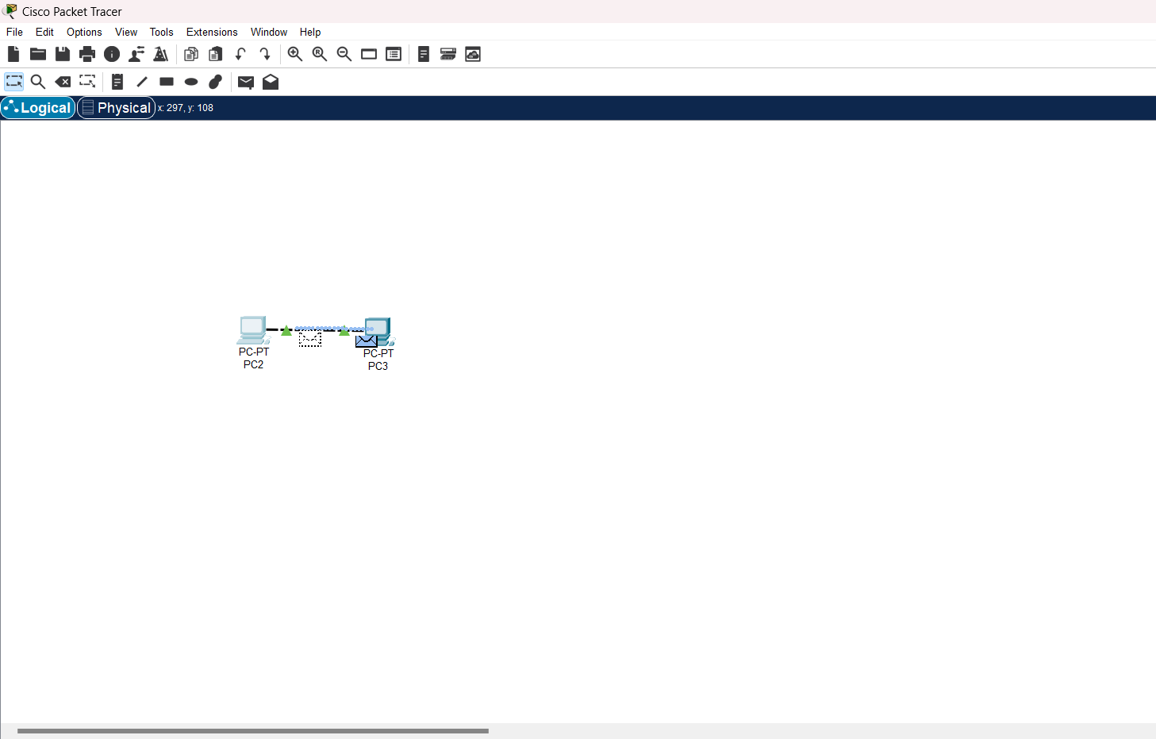

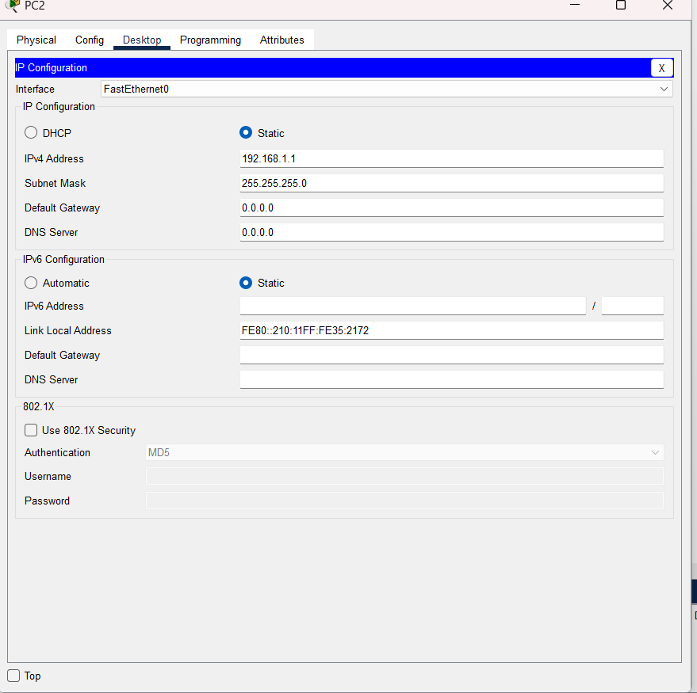

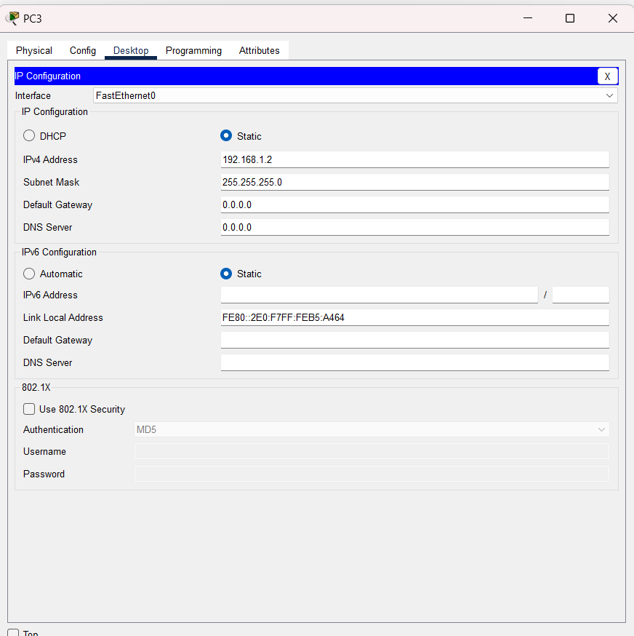

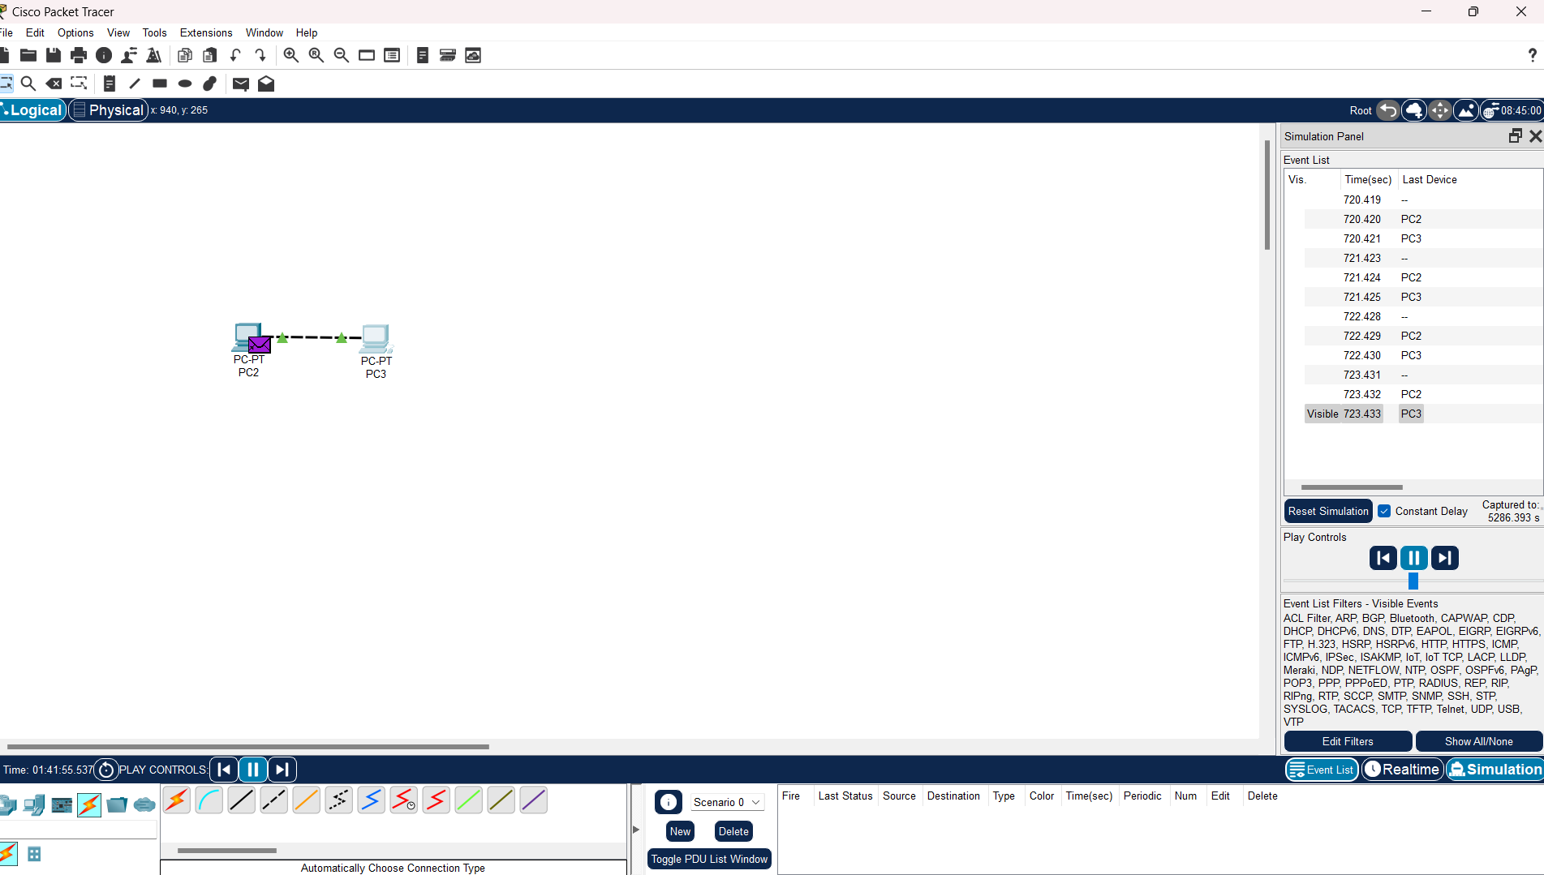

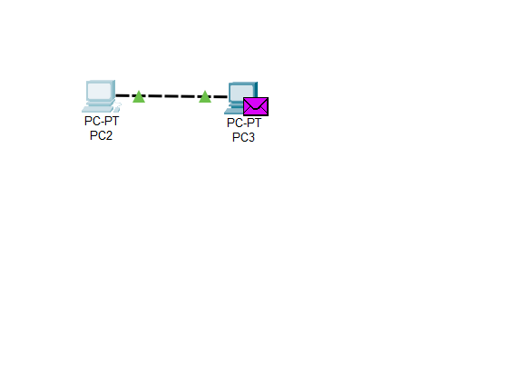

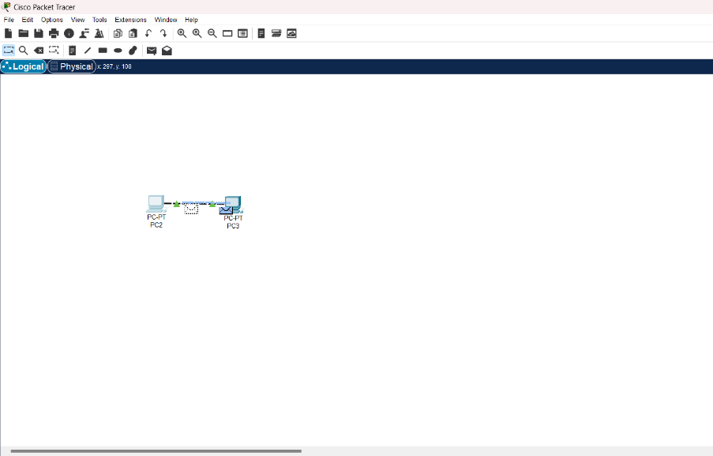

**Conclusion**

This lab introduced the Cisco Packet Tracer tool and demonstrated its use in setting up and testing a simple network topology. The activity enhanced understanding of basic networking concepts and the importance of IP address configuration.