**ROLL NUMBER: 2320030309**

**NAME: MRINALINI BANALA**

**Session 4: Construction of Different VLANS and TRUNKING using cisco packet tracer.**

**Objective**

The objective of this session is to:

1. Construct a network topology with multiple VLANs using Cisco Packet Tracer.
2. Configure VLANs to segment the network logically.
3. Enable trunking between switches to allow communication between VLANs across switches.
4. Verify VLAN functionality and connectivity within VLANs.
5. Test the inability of devices in different VLANs to communicate without a Layer 3 device (router).

**Procedure**

**Step 1: Setting Up the Network Topology**

1. Open Cisco Packet Tracer.
2. Drag and drop two switches (**S1** and **S2**) into the workspace.
3. Add eight PCs and connect them to the switches as follows:
   * **PC1 and PC2** to S1 (assigned to VLAN 10).
   * **PC3 and PC4** to S1 (assigned to VLAN 20).
   * **PC5 and PC6** to S2 (assigned to VLAN 10).
   * **PC7 and PC8** to S2 (assigned to VLAN 20).
4. Use **copper straight-through cables** to connect PCs to switches.
5. Use a **crossover cable** to connect **fa0/24** of S1 to **fa0/24** of S2.

**Step 2: Configure VLANs on Switch S1**

1. Enter global configuration mode:
2. Switch>enable
3. Switch#configure terminal
4. Create VLANs:
5. Switch(config)#vlan 10
6. Switch(config-vlan)#name VLAN10
7. Switch(config-vlan)#exit
8. Switch(config)#vlan 20
9. Switch(config-vlan)#name VLAN20
10. Switch(config-vlan)#exit
11. Assign Ports to VLAN 10 and VLAN 20:
12. Switch(config)#interface range fa0/1 - 4
13. Switch(config-if-range)#switchport mode access
14. Switch(config-if-range)#switchport access vlan 10
15. Switch(config-if-range)#exit
16. Switch(config)#interface range fa0/5 - 8
17. Switch(config-if-range)#switchport mode access
18. Switch(config-if-range)#switchport access vlan 20
19. Switch(config-if-range)#exit
20. Configure **fa0/24** as a trunk port:
21. Switch(config)#interface fa0/24
22. Switch(config-if)#switchport mode trunk
23. Switch(config-if)#exit

**Step 3: Configure VLANs on Switch S2**

1. Repeat the same VLAN configuration as in **Step 2**, ensuring **VLAN 10** and **VLAN 20** are created and assigned to the appropriate ports.
2. Configure **fa0/24** on **S2** as a trunk port.

**Step 4: Configure End Devices**

1. Assign the following IP addresses to the PCs:
   * **VLAN 10**:
     + PC1: 192.168.10.1/24
     + PC2: 192.168.10.2/24
     + PC5: 192.168.10.3/24
     + PC6: 192.168.10.4/24
   * **VLAN 20**:
     + PC3: 192.168.20.1/24
     + PC4: 192.168.20.2/24
     + PC7: 192.168.20.3/24
     + PC8: 192.168.20.4/24
2. Configure the IP settings in Packet Tracer for each PC.

**Step 5: Verify Connectivity**

1. Use the following commands on the switches:
   * **Check VLAN Configuration:**
   * Switch#show vlan brief
   * **Check Trunk Configuration:**
   * Switch#show interfaces trunk
2. Test connectivity:
   * **Within VLANs:**
     + Ping from **PC1** to **PC2** (VLAN 10, same switch).
     + Ping from **PC5** to **PC1** (VLAN 10, across switches).
     + Ping from **PC3** to **PC4** (VLAN 20, same switch).
     + Ping from **PC7** to **PC3** (VLAN 20, across switches).
   * **Between VLANs (Should Fail):**
     + Ping from **PC1** (VLAN 10) to **PC3** (VLAN 20).

**Results**

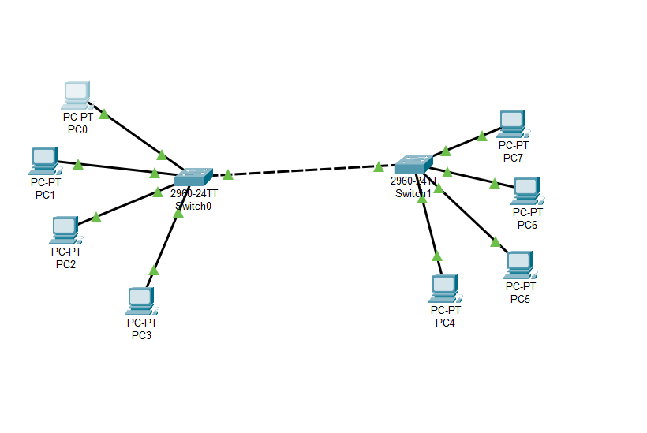

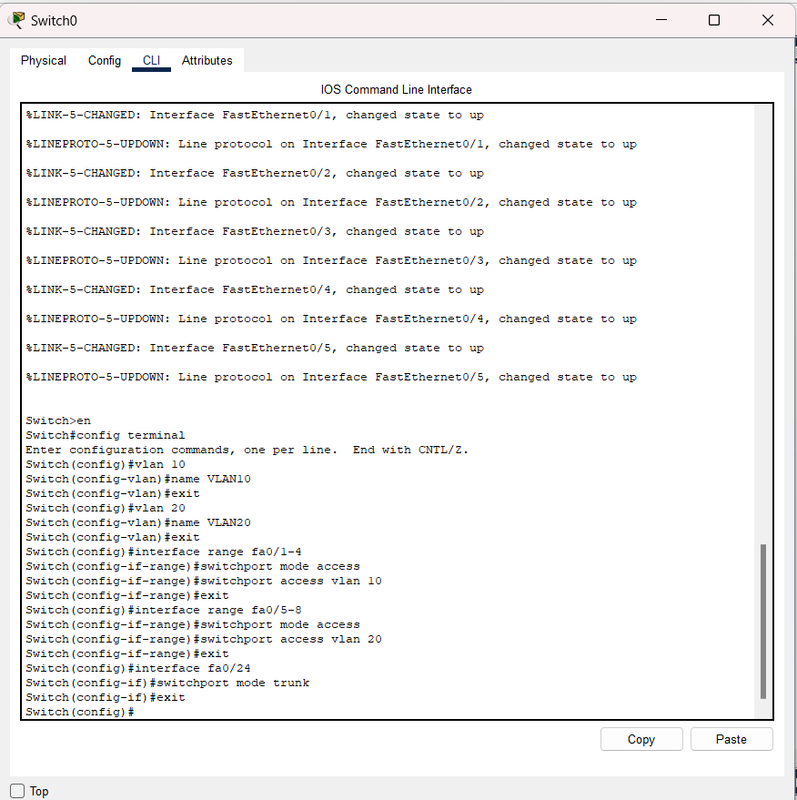

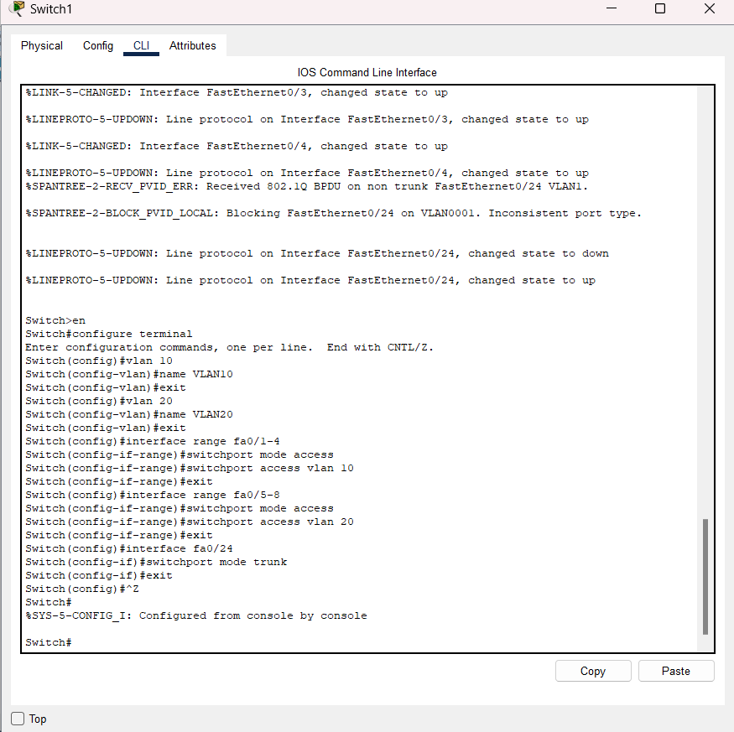

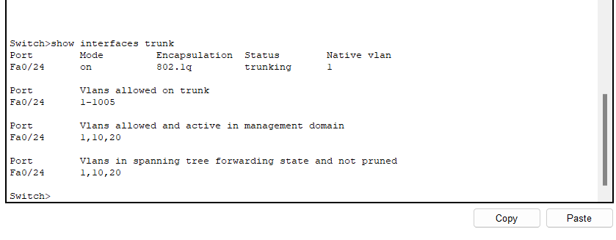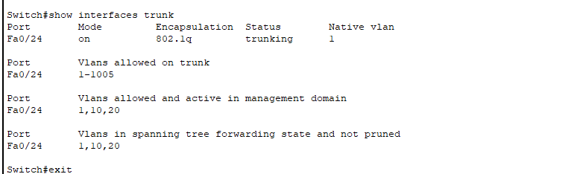

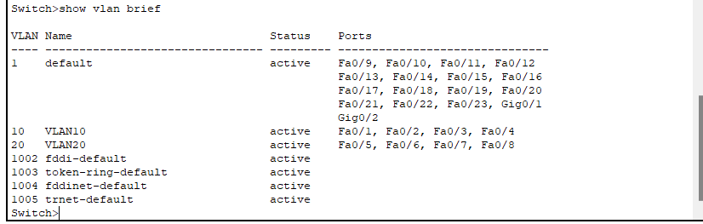

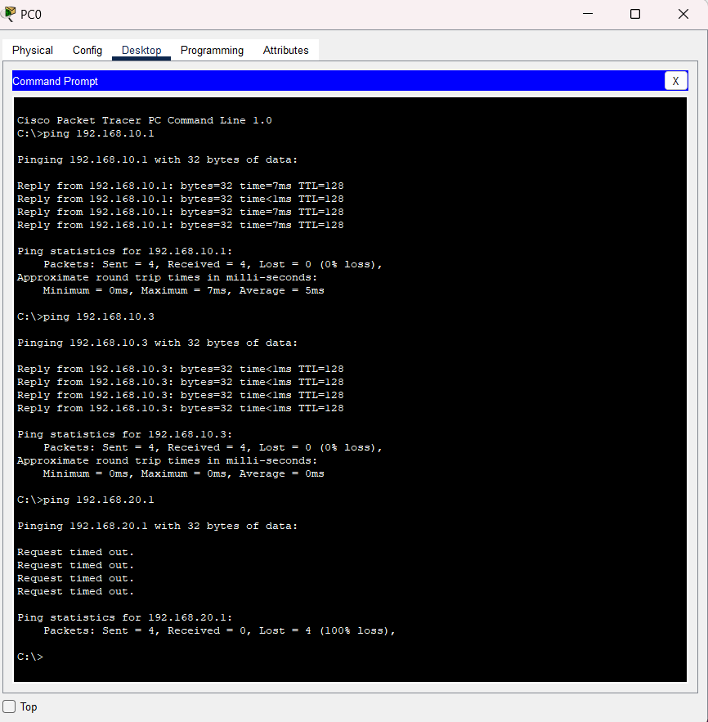

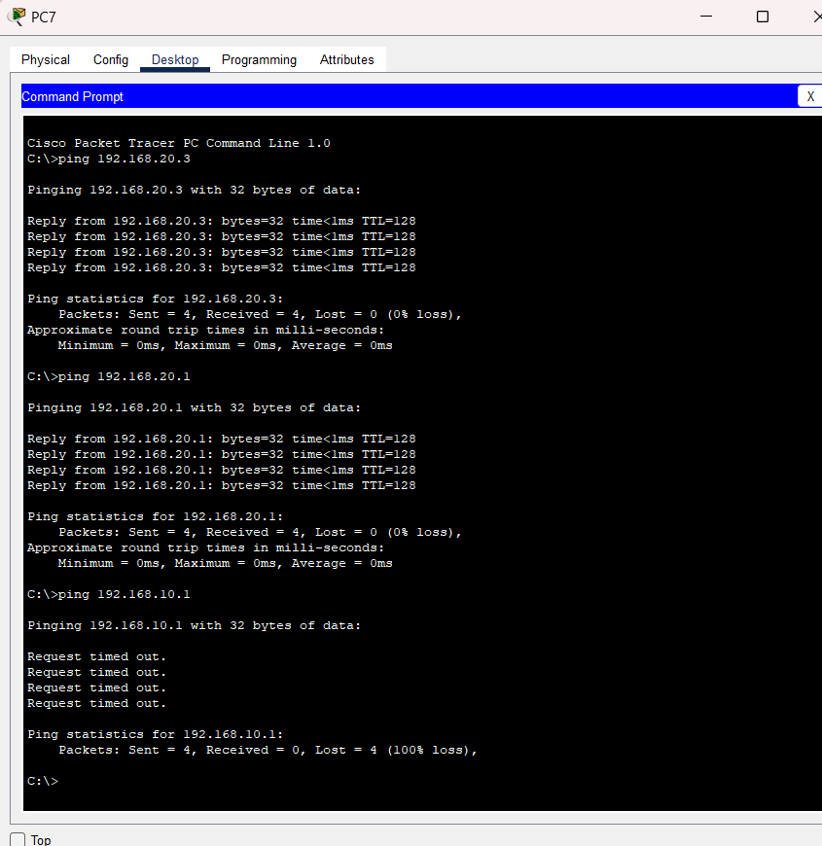

**Conclusion**

1. VLANs effectively segregate traffic into logical segments, improving network performance and security.
2. Trunking allows VLANs to span multiple switches, ensuring network scalability and proper segmentation across the network.
3. Communication between VLANs requires a Layer 3 device, such as a router, to route traffic between different IP subnets.