Comprehensive Analysis Report
Revisiting Hall-Petch strengthening in FCC multi-principal element alloys: best practices for building and auditing machine-learning strength models
Companion report to the manuscript in paper/. Every value below is read from results/ or recomputed from data/derived at build time; see docs/reproducing.md for the run order.

1. Dataset
The dataset contains 94 FCC alloy conditions in the Al-Co-Cr-Cu-Fe-Mn-Ni-V system: 93 with yield strength and 94 with Vickers hardness. These represent 82 unique compositions (81 within the YS subset). 9 chemistries recur across 21 records, and 1 composition appears in more than one batch, so leave-one-batch-out reduces but does not remove exact-composition overlap.
Mean grain size spans 14.66-211.75 um, yield strength 151.5-544.5 MPa and hardness 57.6-227.5 HV. Mean grain size and its within-map standard deviation are strongly correlated (r = 0.801), so SD_grain is treated as an exploratory measure of distribution width rather than an independent mechanism.
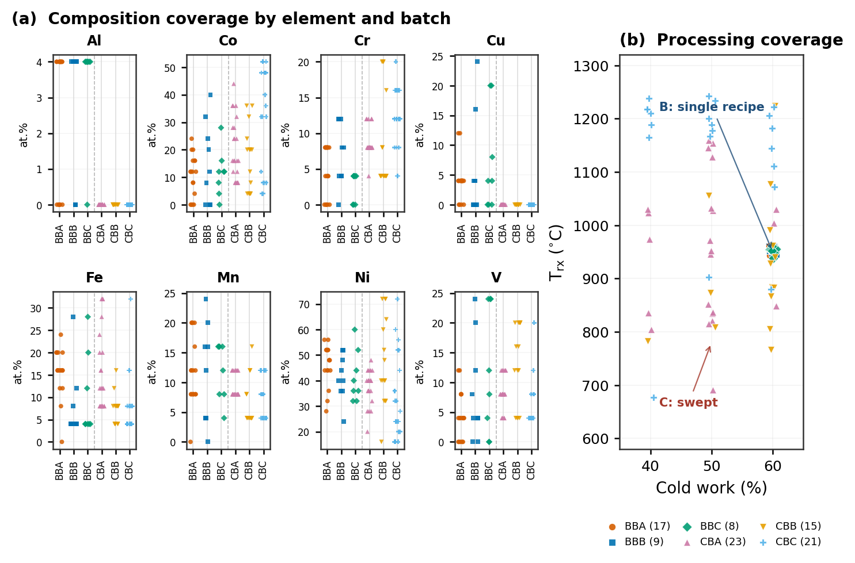
Composition and processing coverage by batch.

2. Validation protocol
Three internal protocols ask progressively harder questions. All predictions from held-out records are pooled before scoring, so the reported R-squared is a single pooled Q-squared and not the mean of fold-specific values.
- Shuffled 5-fold cross-validation (seed 42): interpolation within the pooled dataset.
- Leave-one-out: record-level interpolation. A record with the same composition can remain in the training set, so LOO is not a test on unseen compositions.
- Leave-one-batch-out across the six BO batches: transfer to an unseen experimental iteration. This is the primary grouped transfer test.
A heterogeneous literature set provides an external stress test, and every closed form is checked for poles, sign changes and non-finite values over the observed and literature ranges.
Table 1. Pooled out-of-fold R-squared across the three internal protocols.
Target | Model | 5-fold | LOO | LOBO
HV | F1 classical Hall-Petch | 0.086 | 0.136 | -0.077
HV | F4 LightGBM S1 | 0.195 | 0.323 | 0.112
HV | F5 HV fixed form | 0.725 | 0.727 | 0.636
YS | F1 classical Hall-Petch | 0.405 | 0.406 | 0.373
YS | F2 PCA-OLS | 0.462 | 0.480 | 0.362
YS | F3 M15 SD-grain interaction | 0.731 | 0.694 | 0.694
YS | F3 M3 | 0.666 | 0.652 | 0.625
YS | F4 Lasso S2 | 0.683 | 0.674 | 0.621
YS | F4 LightGBM S2 | 0.632 | 0.574 | 0.615

3. Family 1: classical Hall-Petch
Yield strength: 5-fold 0.405, LOO 0.406, LOBO 0.373.
Vickers hardness: 5-fold 0.086, LOO 0.136, LOBO -0.077.
Grain size is a useful, reproducible baseline for yield strength and a poor one for hardness, where the batch-held-out score is negative. Nine pre-specified scaling laws were compared; five two-parameter monotonic forms fall within delta-BIC < 2 of the classical exponent, so the data support d^-1/2 as a parsimonious baseline rather than as a uniquely identified exponent.
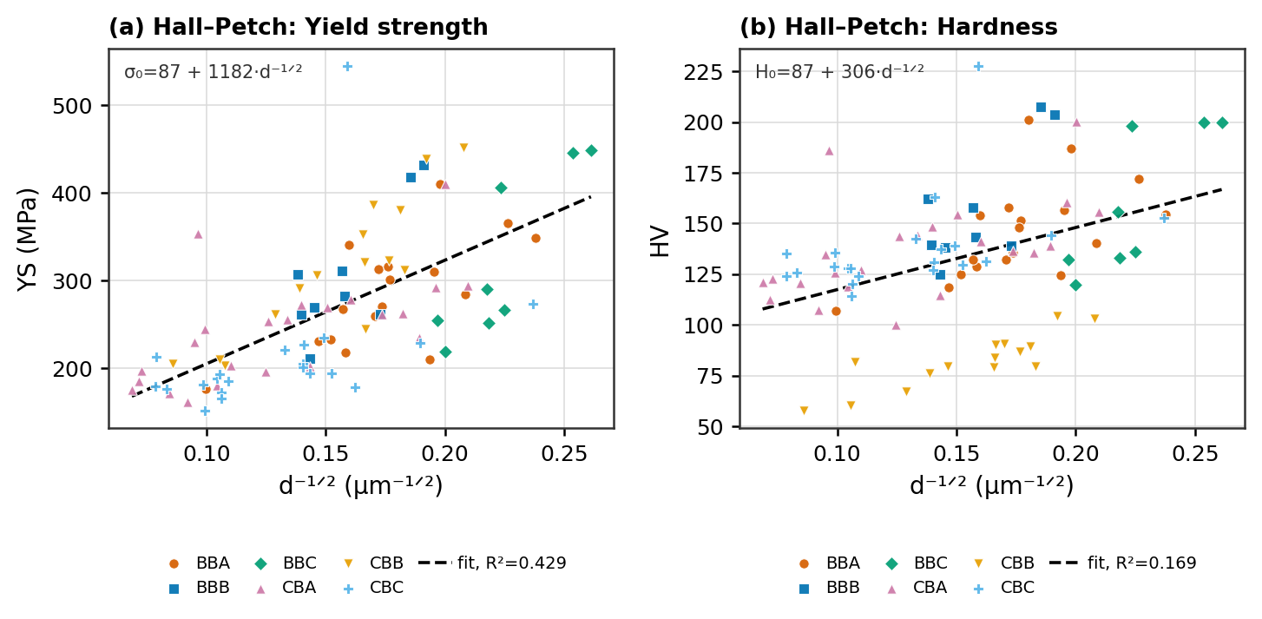
Classical Hall-Petch fits for YS and HV, coloured by batch.
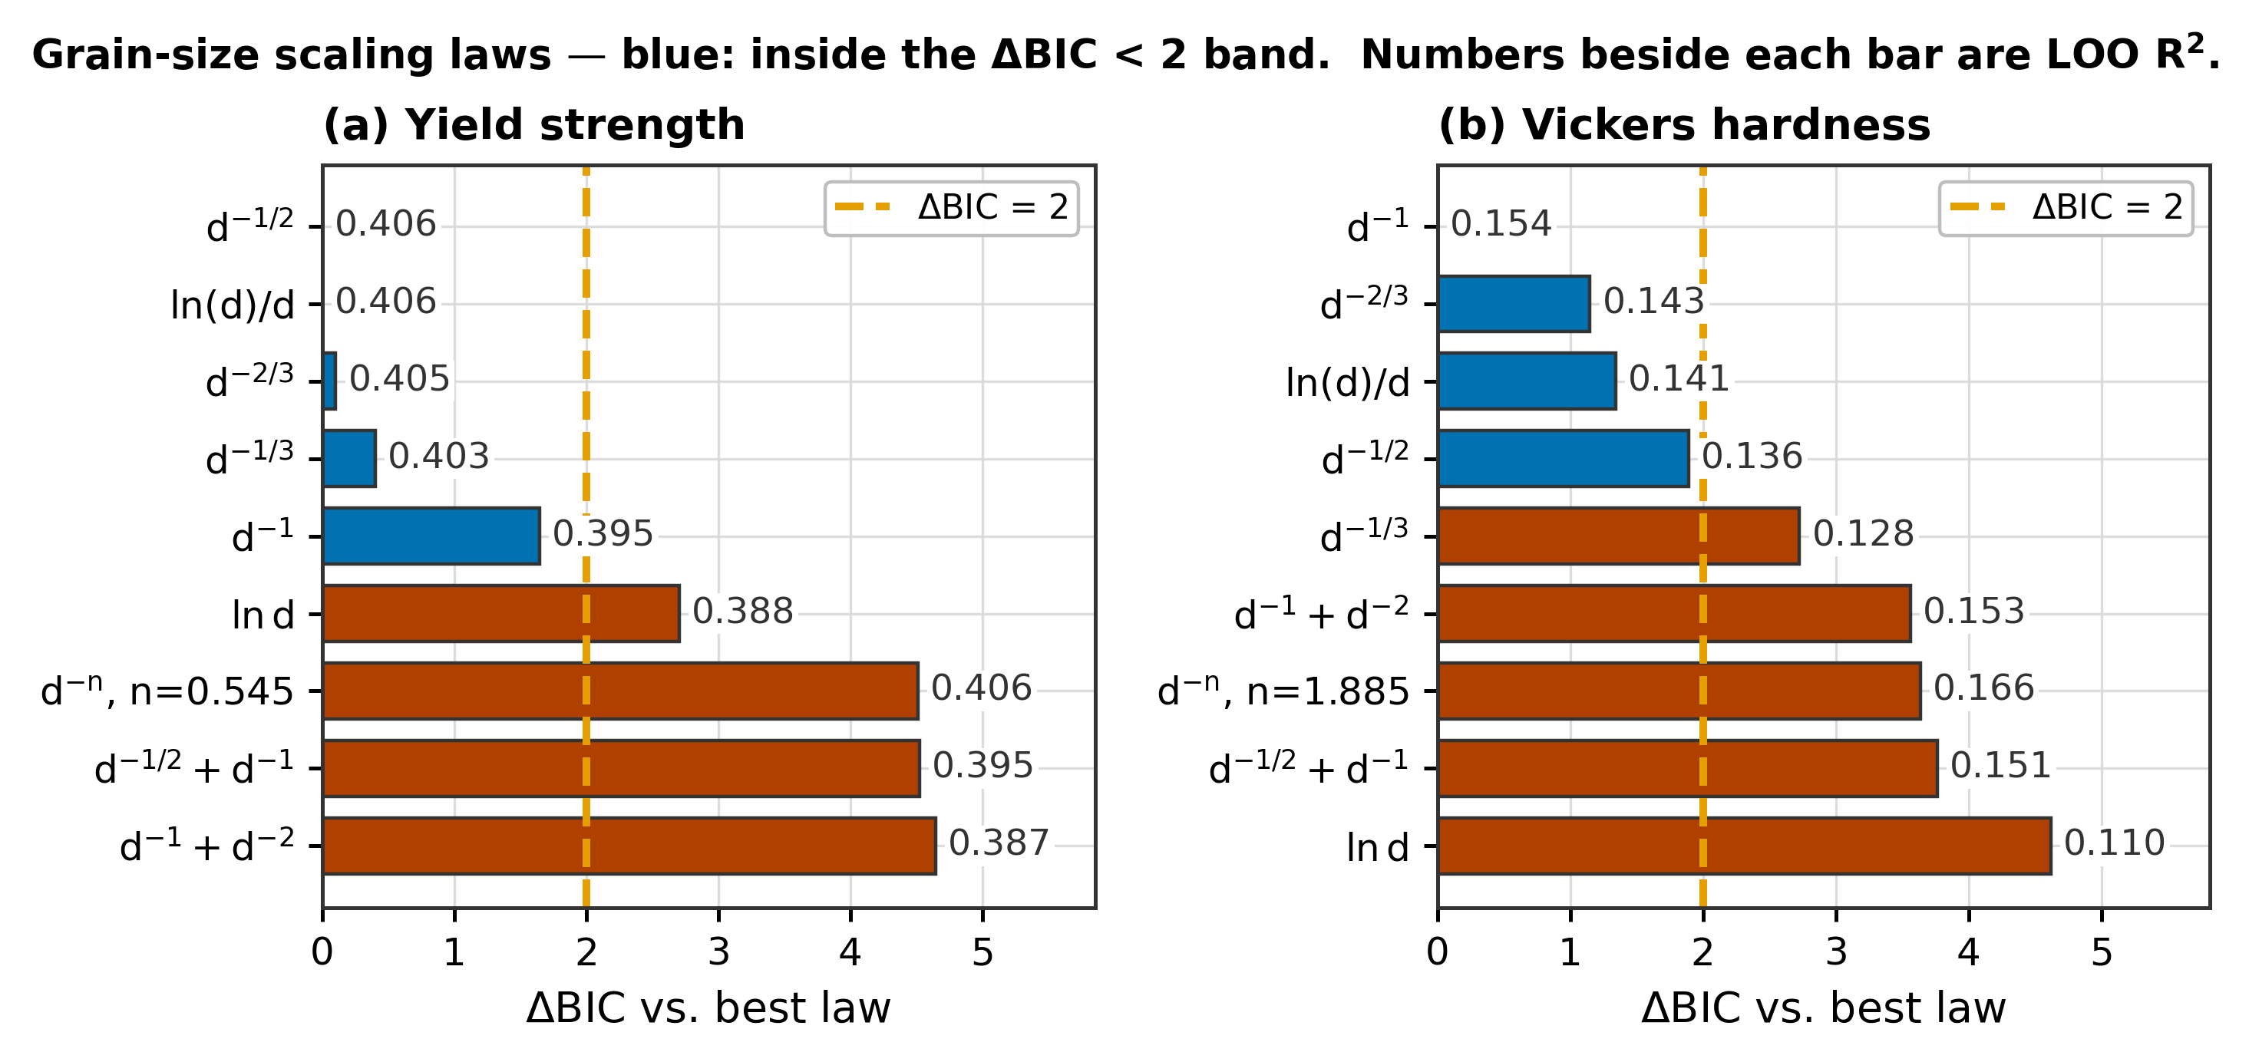
Information-criterion comparison of the nine grain-size scaling laws.

4. Family 2: physics-derived descriptors
Three solid-solution-strengthening models (Varvenne-Leyson-Curtin, a weighted Labusch extension, and Toda-Caraballo) were implemented from their source papers using Vegard-law volumes and rule-of-mixtures elastic constants. Each was scored on three separate axes: standalone accuracy, marginal value alongside Hall-Petch, and information content beyond raw composition.
The decisive test is redundancy. All three formulas are deterministic functions of composition, so any model given the elemental fractions can encode whatever transformation they express. Appending an SSS estimate to a composition model changes LOO R-squared by at most 0.002, and every partial correlation after removing composition is below 0.10 in magnitude.
Fold-contained PCA-OLS gives 5-fold 0.462, LOO 0.480, LOBO 0.362. Fitting the scaler and PCA on all records before splitting had produced 0.525 / 0.516 / 0.441, so even unsupervised preprocessing inflates held-out scores when it precedes the split.
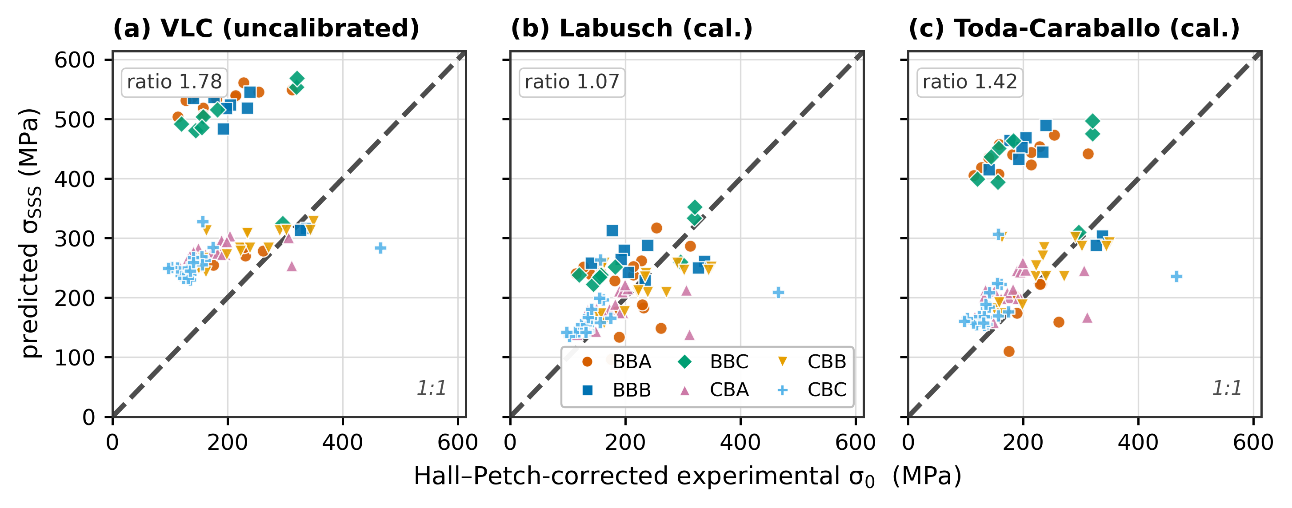
SSS predictions against Hall-Petch-corrected experimental friction stress.

5. Family 3: composition and processing
Table 2. The M-model hierarchy, recomputed at build time.
Model | p | 5-fold | LOO | LOBO | dBIC vs M3
M0: baseline Hall-Petch | 2.000 | 0.405 | 0.406 | 0.373 | 36.524
M1: sigma_0(V) | 3.000 | 0.609 | 0.605 | 0.584 | 1.444
M3: sigma_0(all 7 elements) | 9.000 | 0.666 | 0.652 | 0.625 | 0.000
M4: k(V) | 3.000 | 0.602 | 0.598 | 0.557 | 3.212
M6: k(all 7 elements) | 9.000 | 0.638 | 0.622 | 0.537 | 5.524
M10: sigma_0 + k (all) | 16.000 | 0.641 | 0.650 | 0.587 | 17.255
M11: sigma_0(delta) | 3.000 | 0.452 | 0.456 | 0.392 | 31.313
M13: M3 + SD_grain | 10.000 | 0.658 | 0.668 | 0.595 | -2.340
M15: M3 + SD_grain + SD*d^-1/2 | 11.000 | 0.731 | 0.694 | 0.694 | -20.067

Making the friction stress composition-dependent produces the largest single gain for yield strength: M3 reaches LOO 0.652 and LOBO 0.625 against 0.406 / 0.373 for the grain-only baseline.
Grain-distribution width helps only in a specific form. Adding SD_grain as an independent additive term (M13) raises LOO to 0.668 but lowers LOBO to 0.595. Allowing it to modify the Hall-Petch term (M15) gives 0.731 / 0.694 / 0.694 with delta-BIC -20.1 relative to M3. The additive control shows the gain cannot be credited to measuring grain width alone; because SD_grain is correlated with mean grain size and with processing, the term is read as a predictive interaction rather than as proof that distribution width changes the Hall-Petch slope.
Table 3. M3 coefficients relative to Ni, with 95% intervals.
coefficient | value | lo95 | hi95
intercept (sigma_00) | 229.600 | 152.400 | 306.700
alpha_Al | -201.300 | -955.400 | 552.800
alpha_Co | -187.200 | -268.100 | -106.300
alpha_Cr | -307.700 | -588.500 | -26.900
alpha_Cu | -334.000 | -651.900 | -16.200
alpha_Fe | -360.400 | -520.100 | -200.600
alpha_Mn | 82.300 | -117.600 | 282.200
alpha_V | 291.300 | 41.000 | 541.500
k_HP | 765.800 | 501.500 | 1030.000

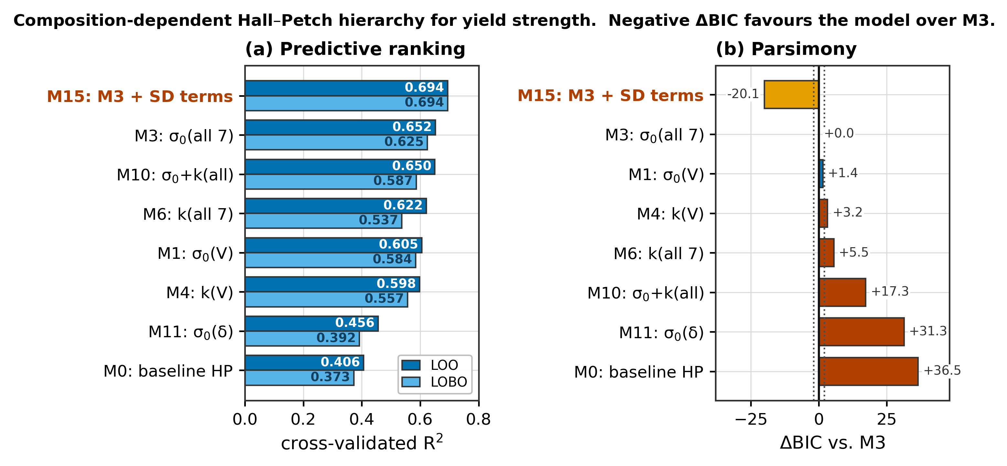
Family 3 hierarchy: predictive ranking and parsimony.

6. Family 4: non-linear machine learning at matched inputs
Linear controls and non-linear estimators were run on identical S1-S4 input matrices and identical splits, at declared fixed settings with no data-driven hyperparameter search, so that any difference reflects the model class rather than the tuning budget.
Table 4. Matched-input comparison.
model | 5-fold | LOO | LOBO
F4 Lasso S2 | 0.683 | 0.674 | 0.621
F4 LightGBM S1 | 0.195 | 0.323 | 0.112
F4 LightGBM S2 | 0.632 | 0.574 | 0.615

At matched inputs the linear control and the gradient-boosted model give nearly identical batch-held-out scores, with overlapping batch-bootstrap intervals. There is no evidence that non-linearity improves transfer to an unseen batch on this dataset.
One comparison needs care: the Family 1 baseline uses d^-1/2 alone, while the S1 matrix also contains SD_grain. Part of any S1-versus-baseline gap is therefore the extra feature and not the estimator.
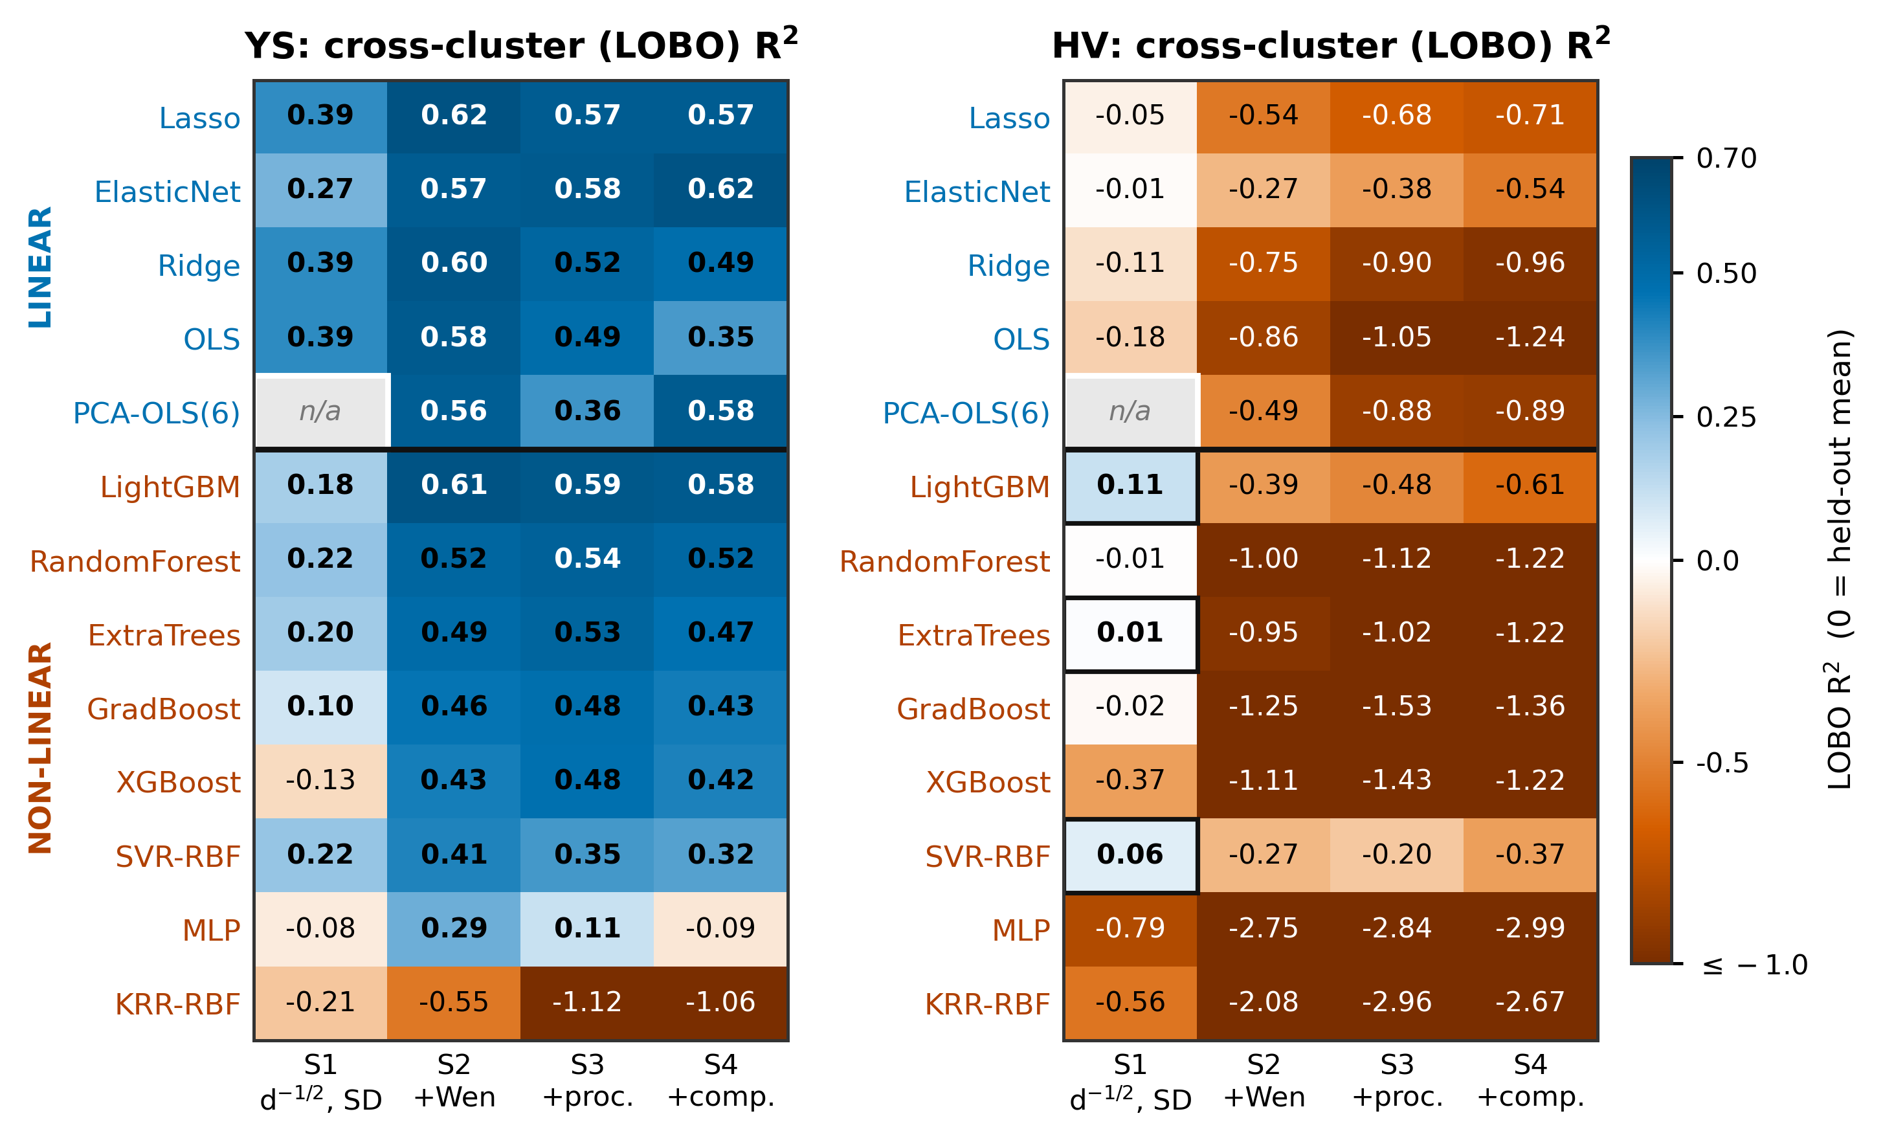
Batch-held-out R-squared across the feature ladder for YS and HV.

7. Family 5: symbolic regression
PySR and SISSO searched for compact closed forms. In the stored workflow the equation structures were selected after viewing complete-data search fronts and only their constants were refit inside the folds, so these are post-selection fixed-form scores and not unbiased estimates of symbolic discovery. They are reported as such and are not ranked against the pre-specified linear models.
The refit hardness form is HV = 222.3 + 84.5(6.93 - d)/SD_grain + -1.005 dH_mix / t_hold^2, with full-data R-squared 0.744 and RMSE 16.90 HV.
With the structure fixed and constants refit per fold: 5-fold 0.725, LOO 0.727, LOBO 0.636.
Two safety findings belong with these equations. SISSO Full places a shear-modulus difference in a denominator and becomes unstable when the constituent moduli are similar; removing that term lowers the aggregate literature RMSE substantially. Separately, one descriptor-based PySR equation contains a protected square root whose argument approaches zero just below the observed range, so it stays real but diverges outside the sampled envelope.
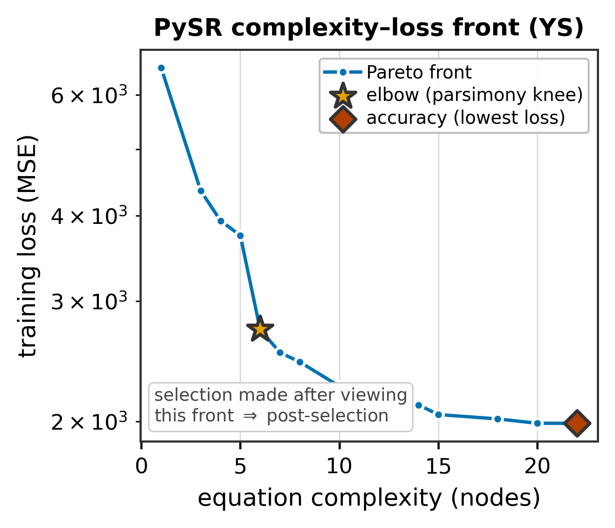
PySR complexity-loss front for yield strength.

8. Literature stress test and hardness-yield correspondence
Table 5. Direct-measurement literature records (evidence class E1).
label | R2 | RMSE | bias | n
Tier 1 (measured YS) / SISSO | -5.080 | 300.310 | 49.960 | 54.000
Tier 1 (measured YS) / SISSO Robust | -0.730 | 159.970 | -61.270 | 54.000
Tier 1 (measured YS) / M3 | -0.510 | 149.510 | -76.580 | 54.000

Every evaluated model is worse than predicting the mean of the literature set. The compilation mixes sources and test modes and was filtered using outcomes, so it is reported as a stress test that exposes domain sensitivity and unsafe equations, not as an unbiased external benchmark.
Across the 93 paired records the effective Tabor ratio is 5.13 +/- 1.36, well above the classical value of 3. Hardness and strength rank together within a batch but the association weakens once batches are pooled, so a single conversion cannot be transferred across composition and processing domains.
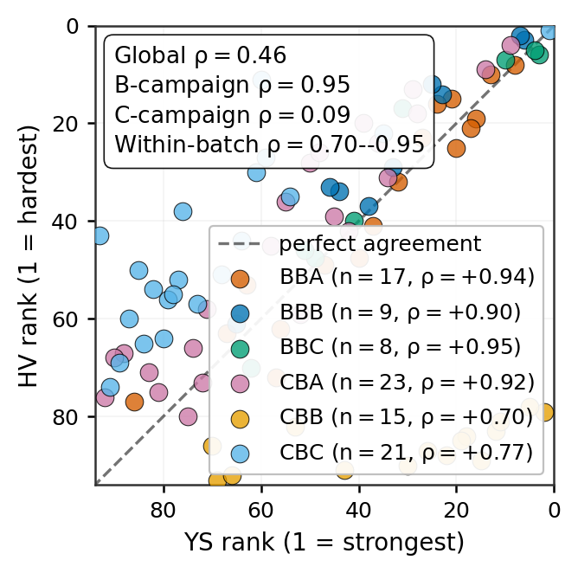
Hardness rank against strength rank, by batch.

9. What the analysis supports
- A physically interpretable grain-size baseline is worth establishing first; it calibrates expectations and exposes where the remaining variance lives.
- Physics-derived descriptors must be shown to add information beyond the measured inputs they are computed from, not merely to be physically motivated.
- Measured composition and processing should be exhausted before estimator complexity is increased.
- Grain-distribution width helps yield strength through an interaction with the Hall-Petch term, not as an additive contribution; the additive control is what makes that distinction visible.
- Validation groups must match the intended decision. Record-level interpolation, batch-level transfer and external deployment are different questions with different answers.
- Closed forms need a domain audit, including poles hidden inside protected operators, before any deployment claim.
The coefficients reported here belong to this alloy system and these campaigns. The workflow does not.

