1. What is the concept of human learning? Please give two examples.

Learning is the process of acquiring new understanding, knowledge, behaviors, skills, values, attitudes, and preferences.

Learning to drive a motor-car, typewriting, singing or memorizing a poem or a mathematical table, and music etc. need exercise and repetition of various movements and actions many times.

2. What different forms of human learning are there? Are there any machine learning equivalents?

Three Major Types of human Learning:

Learning through association - Classical Conditioning.

Learning through consequences – Operant Conditioning.

Learning through observation – Modeling/Observational Learning.

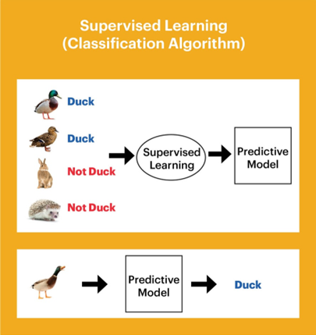Supervised Learning:

In supervised learning, a computer program is given a training dataset that is labelled with corresponding output values, and a function will be determined based on this dataset (Kotsiantis et al., 2007) [3]. This function, or algorithm, will then be used for classifying new data to predict their corresponding output values, with the assumption that the new data conforms to the rules of the function being used. Linear regression, decision trees, random forest and support vector machines are some commonly used techniques that are actually examples of supervised learning.

Human Learning Theory Equivalent:

Supervised learning is similar to concept learning (Bruner & Austin, 1986), where a person is required to classify new objects into existing categories, by matching the features of the new objects to examples in the categories

Unsupervised Learning

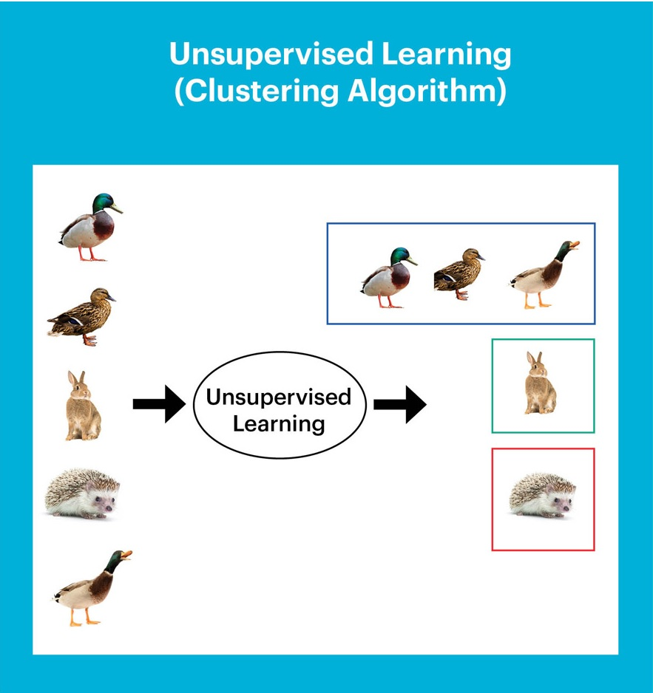

In unsupervised learning, the training dataset does not have any labelled corresponding output values (Hastie et al., 2009) [5]. Since there are no “correct answers” to learn from, the objective of the algorithm is to uncover any interesting patterns that it can find in the data, and new data will help to confirm or disconfirm these patterns that it finds. Some of the well-known examples of unsupervised learning include k-means clustering, principal component analysis and artificial neural networks.

Human Learning Theory Equivalent

Artificial neural networks follow the neuronal principle of Hebbian learning, where the algorithm centres on inputs with similar properties, just like how neurons that activate simultaneously strengthen the synaptic link between each other (Sanger, 1989)

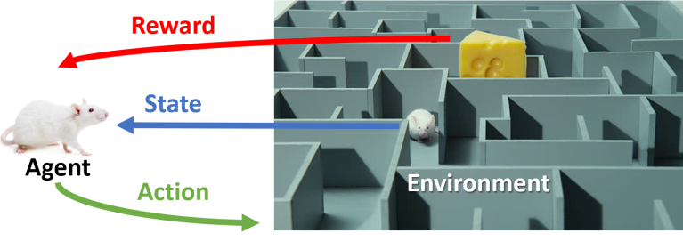Reinforcement Learning

In reinforcement learning, there are “correct answers” but the input data is not paired with the desired outputs. The “correct answers” contain numerical rewards, which the algorithm needs to maximise by choosing the correct actions to take. This is very much similar to a mouse navigating through a maze looking for food, where wrong moves result in the punishment of hunger, and right moves get it to the food more quickly.

Essentially, reinforcement learning is figuring out the right balance between exploration and exploitation, where exploitation gives certainty in the amount of reward, but exploration opens the possibility of finding higher rewards, or risks getting no reward at all. The successful development of artificial intelligence for abstract games such as checkers and Go was based on the concept of reinforcement learning.

Human Learning Theory Equivalent

Reinforcement learning is inspired by the reward system of operant conditioning (Sutton & Barto, 1998) [7]. Operant conditioning was established by B. F. Skinner (1938) [8], after Edward Thorndike (1927) observed how cats learn to escape a puzzle box more quickly after a repeated number of trials [9]. Thorndike noted that behaviours that helped the cats to escape were repeated more frequently over time compared to behaviours that did not, and he termed this the law of effect.

Skinner similarly created a chamber for rats and pigeons, where one lever delivered a reward while another administered a shock. He found that when the animals started to identify what each lever did, pressing of the reward lever was reinforced and frequency of the behaviour increased. Conversely, punishment resulted in decrease of the shock lever being pressed.

3. What is machine learning, and how does it work? What are the key responsibilities of machine learning?

Machine learning is a subfield of artificial intelligence, which is broadly defined as the capability of a machine to imitate intelligent human behavior. Artificial intelligence systems are used to perform complex tasks in a way that is similar to how humans solve problems.

Machine learning is the process of making systems that learn and improve by themselves, by being specifically programmed.

The ultimate goal of machine learning is to design algorithms that automatically help a system gather data and use that data to learn more. Systems are expected to look for patterns in the data collected and use them to make vital decisions for themselves.

In general, machine learning is getting systems to think and act like humans, show human-like intelligence, and give them a brain. In the real world, there are existing machine learning models capable of tasks like :

* Separating spam from actual emails, as seen in Gmail
* Correcting grammar and spelling mistakes, as seen in autocorrect

Thanks to machine learning, the world has also seen design systems capable of exhibiting uncanny human-like thinking, which performs tasks like:

* Object and image recognition
* Detecting fake news
* Understanding written or spoken words
* Bots on websites that interact with humans, like humans
* Self-driven cars

Machine Learning Steps:

The task of imparting intelligence to machines seems daunting and impossible. But it is actually really easy. It can be broken down into 7 major steps :

1. Collecting Data:

As you know, machines initially learn from the data that you give them. It is of the utmost importance to collect reliable data so that your machine learning model can find the correct patterns. The quality of the data that you feed to the machine will determine how accurate your model is. If you have incorrect or outdated data, you will have wrong outcomes or predictions which are not relevant.

Make sure you use data from a reliable source, as it will directly affect the outcome of your model. Good data is relevant, contains very few missing and repeated values, and has a good representation of the various subcategories/classes present.

2. Preparing the Data:

After you have your data, you have to prepare it. You can do this by :

* Putting together all the data you have and randomizing it. This helps make sure that data is evenly distributed, and the ordering does not affect the learning process.
* Cleaning the data to remove unwanted data, missing values, rows, and columns, duplicate values, data type conversion, etc. You might even have to restructure the dataset and change the rows and columns or index of rows and columns.
* Visualize the data to understand how it is structured and understand the relationship between various variables and classes present.
* Splitting the cleaned data into two sets - a training set and a testing set. The training set is the set your model learns from. A testing set is used to check the accuracy of your model after training.

3. Choosing a Model:

A machine learning model determines the output you get after running a machine learning algorithm on the collected data. It is important to choose a model which is relevant to the task at hand. Over the years, scientists and engineers developed various models suited for different tasks like speech recognition, image recognition, prediction, etc. Apart from this, you also have to see if your model is suited for numerical or categorical data and choose accordingly.

4. Training the Model:

Training is the most important step in machine learning. In training, you pass the prepared data to your machine learning model to find patterns and make predictions. It results in the model learning from the data so that it can accomplish the task set. Over time, with training, the model gets better at predicting.

5. Evaluating the Model:

After training your model, you have to check to see how it’s performing. This is done by testing the performance of the model on previously unseen data. The unseen data used is the testing set that you split our data into earlier. If testing was done on the same data which is used for training, you will not get an accurate measure, as the model is already used to the data, and finds the same patterns in it, as it previously did. This will give you disproportionately high accuracy.

When used on testing data, you get an accurate measure of how your model will perform and its speed.

6. Parameter Tuning:

Once you have created and evaluated your model, see if its accuracy can be improved in any way. This is done by tuning the parameters present in your model. Parameters are the variables in the model that the programmer generally decides. At a particular value of your parameter, the accuracy will be the maximum. Parameter tuning refers to finding these values.

7. Making Predictions

In the end, you can use your model on unseen data to make predictions accurately.

4. Define the terms "penalty" and "reward" in the context of reinforcement learning.

Reinforcement learning is all about gamifying the learning process. This type of machine learning uses a reward-penalty method to teach an AI system. If it makes the right move, it gets rewarded. If it makes a mistake, it receives a penalty.

In other words, reinforcement learning forces a system to learn and adapt quickly, or it otherwise loses serious numerical rewards. It's a feedback-based machine learning method in which the AI agent learns to (rightly) behave in an environment by taking actions and seeing those actions' results.

In short, the agent learns from experience without any pre-programming and doesn't require any human supervision.

Reinforcement learning lets a machine learn from its mistakes, similar to how humans do. It's a type of machine learning in which the machine learns to solve a problem using trial and error. Also, the machine learns from its actions, unlike supervised learning, where historical data plays a critical role.

The AI system that undergoes the learning process is called the agent or the learner. The learning system explores and observes the environment around it, just like us. If the agent performs the right action, it receives positive feedback or a positive reward. If it takes an adverse action, it receives negative feedback or a negative reward.

5. Explain the term "learning as a search"?

Concept Learning As Search

Concept learning can be viewed as the task of searching through a large space of hypotheses implicitly defined by the hypothesis representation. The goal of this search is to find the hypothesis that best fits the training examples.

Learning can be viewed as a search through the space of all sentences in a concept description language for a sentence that best describes the data. Alternatively, it can be viewed as a search through all hypotheses in a hypothesis space.

6. What are the various goals of machine learning? What is the relationship between these and human learning?

(1) To make the computers smarter, more intelligent. The more direct objective in this aspect is to develop systems (programs) for specific practical learning tasks in application domains. (2) To dev elop computational models of human learning process and perform computer simulations.

Humans acquire knowledge through experience either directly or shared by others. Machines acquire knowledge through experience shared in the form of past data. We have the terms, Knowledge, Skill, and Memory being used to define intelligence. Just because you have good memory, that does not mean you are intelligent. And just because you are intelligent, it does not mean you should have a good memory. However, there are exceptions to these rules. Humans begin learning by memorizing. After few years, he realizes that mere capability to memorize is not intelligence. Then he practices on transforming the data stored in memory to knowledge and applies them to develop skills to solve problems faced in real life. A person with good memory and more knowledge without the required skills cannot be considered intelligent. Search engines replaces human memory and these days the focus is on acquiring intelligence by making use of data available on the web. In humans, learning speed depends on individuals and in machines, learning speed depends on the algorithm selected and the volume of examples exposed to it.

Skill is a manifestation of intelligence possessed by humans. And intelligence is the ability to apply knowledge. Human intelligence sustains, but his knowledge fades as new technologies emerge. Humans without knowledge in particular subjects can apply their intelligence to solve problems in new domains. But machines can solve new problems only if their intelligence has been updated with retraining on data acquired from the changed scenarios. This is a fundamental difference between human intelligence and machine intelligence.

Both humans and machines make mistakes in applying their intelligence in solving problems. In ML, overfitting memorizes all examples and an overfitted model lacks generalization and it fails to work on never seen before examples. In most of the Asian countries, the education system does overfitting of students by over coaching and tuitions on technical subjects enabling them to solve only example problems. These example problems are answered in examinations without need for applying any intelligence. These students can solve the problems which they have already seen and only the problems seen by them in the past. They are not able to handle general problems properly with accuracy because their intelligence is not generalized. This is the major reason for missing skill levels among university recruits. In short, vast majority of students become overfitted learning models and their employability is in question.

In ML, Transfer Learning is a technique that reuses a model that was created by machine learning experts and that has already been trained on a large dataset. Transfer learning leverages information extracted from one set of distributions. In humans, transfer of knowledge to students is often done by teachers and tuition providers. This may not make the students intelligent. But in the case of machine learning, transfer learning makes the transferee as intelligent as the transferor. In the case of humans, transfer learning only transfers the knowledge and it depends on the inherent intelligence of the transferee to enhance his/her problem solving skills.

To summarize, overfitting is a curse to humans and machine learning systems. Machine intelligence is limited to the areas in which they are trained. But human intelligence is independent of his domain of training. An intelligent human being will be able to solve problems related to unforeseen domains, whereas a machine will not be able to do that.

7. Illustrate the various elements of machine learning using a real-life illustration.

There are three main elements to every machine learning algorithm, and they include:

* Representation: what the model looks like; how knowledge is represented.
* Evaluation: how good models are differentiated; how programs are evaluated.
* Optimization: the process for finding good models; how programs are generated.

8. Provide an example of the abstraction method.

abstraction: constructing new terms from existing ones. Propositionalization: constructing a single relational term and reformulating it in a propositional representation.

Abstraction is a technique of hiding unnecessary details from the user. The user is only given access to the details that are relevant. Vehicle operations or ATM operations are classic examples of abstractions in the real world.

Abstraction separates ideas from specific instances of those ideas. An abstract method is declared, but contains no implementation. Abstract classes cannot be instantiated, and require subclasses to provide implementations for the abstract methods.

# Import the python abstract base class.

import abc

ABC = abc.ABCMeta('ABC', (object,), {'__slots__': ()})

# Define an abstract class which must contain at least one abstract method.

class AbstractPlane(ABC):

__metaclass__ = abc.ABCMeta

@abc.abstractmethod

def takeoff(self):

''' data '''

@abc.abstractmethod

def land(self):

''' data '''

# Define a concrete class using an abstract class.

class Transport(AbstractPlane):

def fly(self):

print('flying')

def takeoff(self):

print('taking off')

def land(self):

print('landing')

# Instantiate and use an object.

transport1 = Transport()

transport1.takeoff()

transport1.fly()

transport1.land()

9. What is the concept of generalization? What function does it play in the machine learning process?

Generalization refers to your model's ability to adapt properly to new, previously unseen data, drawn from the same distribution as the one used to create the model.

In machine learning, generalization is a definition to demonstrate how well is a trained model to classify or forecast unseen data. Training a generalized machine learning model means, in general, it works for all subset of unseen data. An example is when we train a model to classify between dogs and cats.

What is classification, exactly? What are the main distinctions between classification and regression?

In machine learning, classification is a predictive modeling problem where the class label is anticipated for a specific example of input data. For example, in determining handwriting characters, identifying spam, and so on, the classification requires training data with a large number of datasets of input and output.

The main difference between Regression and Classification algorithms that Regression algorithms are used to predict the continuous values such as price, salary, age, etc. and Classification algorithms are used to predict/Classify the discrete values such as Male or Female, True or False, Spam or Not Spam, etc.

11. What is regression, and how does it work? Give an example of a real-world problem that was solved using regression.

Machine Learning Regression is a technique for investigating the relationship between independent variables or features and a dependent variable or outcome. It's used as a method for predictive modelling in machine learning, in which an algorithm is used to predict continuous outcomes.

Some real-world examples for regression analysis include predicting the price of a house given house features, predicting the impact of SAT/GRE scores on college admissions, predicting the sales based on input parameters, predicting the weather, etc.

Regression analysis is a statistical method to model the relationship between a dependent (target) and independent (predictor) variables with one or more independent variables. More specifically, Regression analysis helps us to understand how the value of the dependent variable is changing corresponding to an independent variable when other independent variables are held fixed. It predicts continuous/real values such as temperature, age, salary, price, etc.

Regression is a supervised learning technique which helps in finding the correlation between variables and enables us to predict the continuous output variable based on the one or more predictor variables. It is mainly used for prediction, forecasting, time series modeling, and determining the causal-effect relationship between variables.

In Regression, we plot a graph between the variables which best fits the given datapoints, using this plot, the machine learning model can make predictions about the data. In simple words, "Regression shows a line or curve that passes through all the datapoints on target-predictor graph in such a way that the vertical distance between the datapoints and the regression line is minimum." The distance between datapoints and line tells whether a model has captured a strong relationship or not.

Some examples of regression can be as:

* Prediction of rain using temperature and other factors
* Determining Market trends
* Prediction of road accidents due to rash driving.

So for such case we need Regression analysis which is a statistical method and used in machine learning and data science. Below are some other reasons for using Regression analysis:

* Regression estimates the relationship between the target and the independent variable.
* It is used to find the trends in data.
* It helps to predict real/continuous values.
* By performing the regression, we can confidently determine the most important factor, the least important factor, and how each factor is affecting the other factors.

12. Describe the clustering mechanism in detail.

Clustering is the act of organizing similar objects into groups within a machine learning algorithm. Assigning related objects into clusters is beneficial for AI models. Clustering has many uses in data science, like image processing, knowledge discovery in data, unsupervised learning, and various other applications.

13. Make brief observations on two of the following topics:

i. Machine learning algorithms are used

Machine learning algorithms are a combination of math and logic that adjust themselves to perform more progressively once the input data varies. Being a general-purpose, easy to learn and understand language, Python can be used for a large variety of development tasks.

5 most used machine learning algorithms:

* Linear regression
* Decision tree
* Logistic regression
* Support Vector Machines (SVM)
* Naive Bayes

1. Linear regression

It is one of the most popular Supervised Machine Learning algorithms in Python that maintains an observation of continuous features and based on it, predicts an outcome. It establishes a relationship between dependent and independent variables by fitting a best line. This best fit line is represented by a linear equation Y=a*X+b, commonly called the regression line.

In this equation,

Y – Dependent variable

a- Slope

X – Independent variable

b- Intercept

The regression line is the line that fits best in the equation to supply a relationship between the dependent and independent variables. When it runs on a single variable or feature, we call it simple linear regression and when it runs on different variables, we call it multiple linear regression. This is often used to estimate the cost of houses, total sales or total number of calls based on continuous variables.

2. Decision Trees

A decision tree is built by repeatedly asking questions to the partition data. The aim of the decision tree algorithm is to increase the predictiveness at each level of partitioning so that the model is always updated with information about the dataset.

Even though it is a Supervised Machine Learning algorithm, it is used mainly for classification rather than regression. In a nutshell, the model takes a particular instance, traverses the decision tree by comparing important features with a conditional statement. As it descends to the left child branch or right child branch of the tree, depending on the result, the features that are more important are closer to the root. The good part about this machine learning algorithm is that it works on both continuous dependent and categorical variables.

3. Logistic regression

A supervised machine learning algorithm in Python that is used in estimating discrete values in binary, e.g: 0/1, yes/no, true/false. This is based on a set of independent variables. This algorithm is used to predict the probability of an event’s occurrence by fitting that data into a logistic curve or logistic function. This is why it is also called logistic regression.

Logistic regression, also called as Sigmoid function, takes in any real valued number and then maps it to a value that falls between 0 and 1. This algorithm finds its use in finding spam emails, website or ad click predictions and customer churn. Check out this Prediction project using python.

Sigmoid Function is defined as,

f(x) = L / 1+e^(-x)

x: domain of real numbers

L: curve’s max value

4. Support Vector Machines (SVM)

This is one of the most important machine learning algorithms in Python which is mainly used for classification but can also be used for regression tasks. In this algorithm, each data item is plotted as a point in n-dimensional space, where n denotes the number of features you have, with the value of each feature as the value of a particular coordinate.

SVM does the distinction of these classes by a decision boundary. For e.g: If length and width are used to classify different cells, their observations are plotted in a 2D space and a line serves the purpose of a decision boundary. If you use 3 features, your decision boundary is a plane in a 3D space. SVM is highly effective in cases where the number of dimensions exceeds the number of samples.

5. Naive Bayes

Naive Bayes is a supervised machine learning algorithm used for classification tasks. This is one of the reasons it is also called a Naive Bayes Classifier. It assumes that features are independent of one another and there exists no correlation between them. But as these assumptions hold no truth in real life, this algorithm is called ‘naive’.

This algorithm works on Bayes’ theorem which is:

p(A|B) = p(A) . p(B|A) / p(B)

In this,

p(A): Probability of event A

p(B): Probability of event B

p(A|B): Probability of event A given event B has already occurred

p(B|A): Probability of event B given event A has already occurred

The Naive bayes classifier calculates the probability of a class in a given set of features, p( yi I x1, x2, x3,…xn). As this is put into the Bayes’ theorem, we get :

p( yi I x1, x2…xn)= p(x1,x2,…xn I yi). p(yi) / p(x1, x2….xn)

As the Naive Bayes’ algorithm assumes that features are independent, p( x1, x2…xn I yi) can be written as :

p(x1, x2,….xn I yi) = p(x1 I yi) . p(x2 I yi)…p(xn I yi)

p(x1 I yi) is the conditional probability for a single feature and can be easily estimated from the data. Let’s say there are 5 classes and 10 features, 50 probability distributions need to be stored. Adding all these, it becomes easier to calculate the probability to observe a class given the values of features (p(yi I x1,x2,…xn)).

ii. Studying under supervision

Supervised learning is the types of machine learning in which machines are trained using well "labelled" training data, and on basis of that data, machines predict the output. The labelled data means some input data is already tagged with the correct output.

In supervised learning, the training data provided to the machines work as the supervisor that teaches the machines to predict the output correctly. It applies the same concept as a student learns in the supervision of the teacher.

Supervised learning is a process of providing input data as well as correct output data to the machine learning model. The aim of a supervised learning algorithm is to find a mapping function to map the input variable(x) with the output variable(y).

In the real-world, supervised learning can be used for Risk Assessment, Image classification, Fraud Detection, spam filtering, etc.

iii. Studying without supervision

As the name suggests, unsupervised learning is a machine learning technique in which models are not supervised using training dataset. Instead, models itself find the hidden patterns and insights from the given data. It can be compared to learning which takes place in the human brain while learning new things. It can be defined as:

Unsupervised learning is a type of machine learning in which models are trained using unlabeled dataset and are allowed to act on that data without any supervision.

Unsupervised learning cannot be directly applied to a regression or classification problem because unlike supervised learning, we have the input data but no corresponding output data. The goal of unsupervised learning is to find the underlying structure of dataset, group that data according to similarities, and represent that dataset in a compressed format.

iv. Reinforcement learning is a form of learning based on positive reinforcement.

Reinforcement Learning is a feedback-based Machine learning technique in which an agent learns to behave in an environment by performing the actions and seeing the results of actions. For each good action, the agent gets positive feedback, and for each bad action, the agent gets negative feedback or penalty.

In Reinforcement Learning, the agent learns automatically using feedbacks without any labeled data, unlike supervised learning.

Since there is no labeled data, so the agent is bound to learn by its experience only.

RL solves a specific type of problem where decision making is sequential, and the goal is long-term, such as game-playing, robotics, etc.

The agent interacts with the environment and explores it by itself. The primary goal of an agent in reinforcement learning is to improve the performance by getting the maximum positive rewards.

The agent learns with the process of hit and trial, and based on the experience, it learns to perform the task in a better way. Hence, we can say that "Reinforcement learning is a type of machine learning method where an intelligent agent (computer program) interacts with the environment and learns to act within that." How a Robotic dog learns the movement of his arms is an example of Reinforcement learning.

It is a core part of Artificial intelligence, and all AI agent works on the concept of reinforcement learning. Here we do not need to pre-program the agent, as it learns from its own experience without any human intervention.

Example: Suppose there is an AI agent present within a maze environment, and his goal is to find the diamond. The agent interacts with the environment by performing some actions, and based on those actions, the state of the agent gets changed, and it also receives a reward or penalty as feedback.

The agent continues doing these three things (take action, change state/remain in the same state, and get feedback), and by doing these actions, he learns and explores the environment.

The agent learns that what actions lead to positive feedback or rewards and what actions lead to negative feedback penalty. As a positive reward, the agent gets a positive point, and as a penalty, it gets a negative point.