1.How many seconds are in an hour? Use the interactive interpreter as a calculator and multiply the number of seconds in a minute (60) by the number of minutes in an hour (also 60).

sol. 60

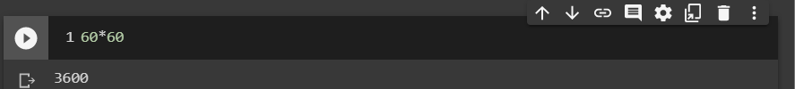

2. Assign the result from the previous task (seconds in an hour) to a variable called seconds_per_hour.

seconds_per_hour = 60 * 60

seconds_per_hour

3. How many seconds do you think there are in a day? Make use of the variables seconds per hour and minutes per hour.

seconds_per_hour = 60 * 60

hours_in_one_day = 24

second_in_a_day = hours_in_one_day * seconds_per_hour

second_in_a_day

4. Calculate seconds per day again, but this time save the result in a variable called seconds_per_day

seconds_per_hour = 60 * 60

hours_in_one_day = 24

seconds_per_day = hours_in_one_day * seconds_per_hour

seconds_per_day

5. Divide seconds_per_day by seconds_per_hour. Use floating-point (/) division.

seconds_per_day/seconds_per_hour

6. Divide seconds_per_day by seconds_per_hour, using integer (//) division. Did this number agree with the floating-point value from the previous question, aside from the final .0?

seconds_per_day // seconds_per_hour

Yes the number agrees.

7. Write a generator, genPrimes, that returns the sequence of prime numbers on successive calls to its next() method: 2, 3, 5, 7, 11, ...

def genPrimes():

n = 2

primes = []

while True:

for p in primes:

if n % p == 0:

break

else:

primes.append(n)

yield n

n += 1