**CREATION OF TABLES:**

CUSTOMER

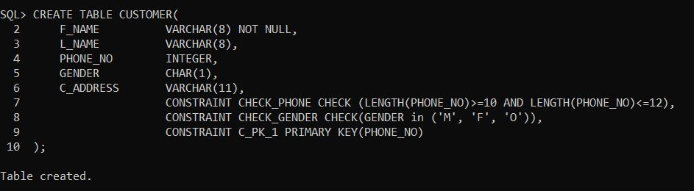

EMPLOYEE

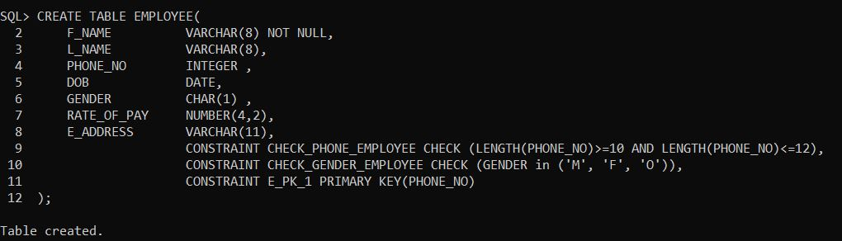

APPOINTMENT

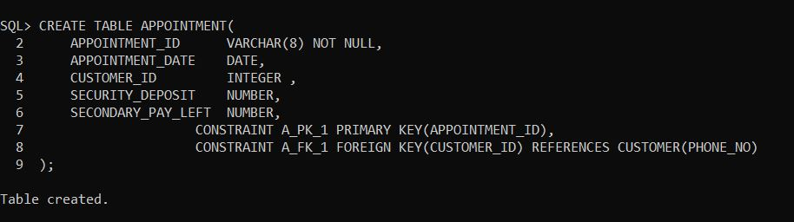

SERVICES

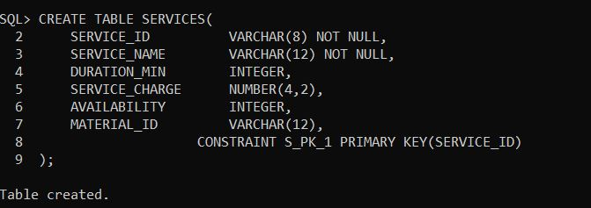

MATERIAL

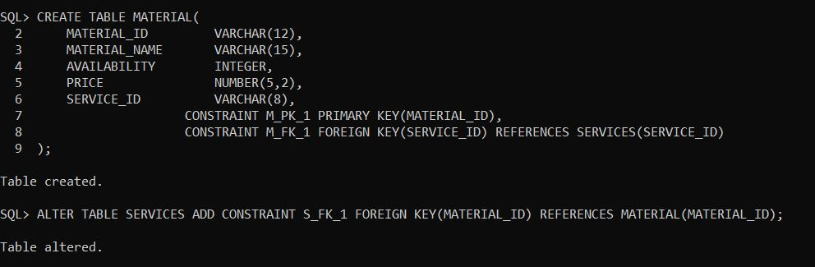

SERVICE_RENDERED

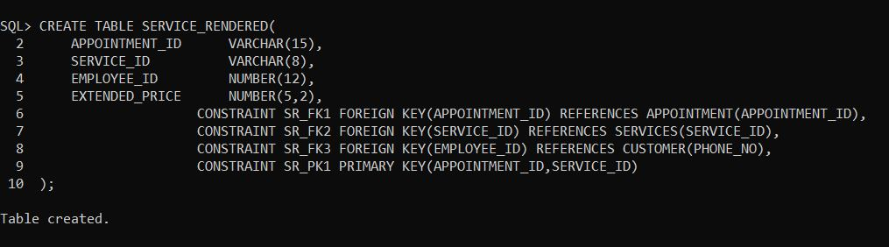

BILLINGS

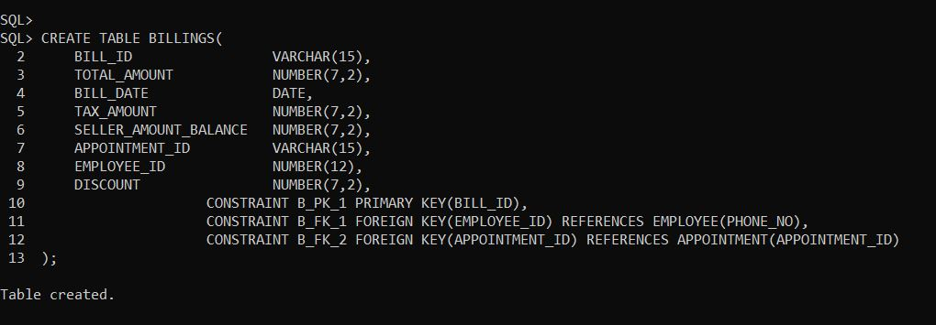

ALL TABLES

