

C++ PROJECT REPORT

STUDENT CART

SUBMITTED BY:

VISHESH KUMAR CHAURASIA (205119109)

MRINAL SATYAWANSHI (205119057)

**CONCEPTS USED**

* CLASSES
* ACCESS MODIFIERS
* DATA ENCAPSULATION
* FUNCTIONS
* INHERITANCE
* PREPROCESSORS
* OPERATOR OVERLOADING
* FILE HANDLING
* EXCEPTION HANDLING
* USAGE OF UNICODE CHARACTERS
* SELF DEFINED HEADER FILES

**INTRODUCTION**

This project is all about student cart. The project helps students with the difficulty of finding essential resources in low prices. Basically, this is the e commerce based project by sing which students can deal among them themselves for buying and selling the second hand goods like bicycle, mattresses, laptops, and many other useful things.

The project works simply as a system where it stores all the information about the buyers, sellers, and the things on which the dealing has to be done. In this, you will get all the information about the product which you want to buy with its all specifications like how old it is and what will be its expected cost by the seller. If you like that product you will get the contact of the seller so that you can contact him/her directly.

**DEPENDENCY GRAPH**

fmainmenu.cpp

Database.h

.data.txt

flogin.h

fsell.h

fpurchase.h

fcycles.h

fmatress.h

flaptops.h

fbucket.h

felectronis.h

**DISCRIPTION OF PROJECT**

**Account menu:**

It shows you the menu where you can get navigation to the different account reacted services like login, create, forget password, and exit.

**Screenshot:**

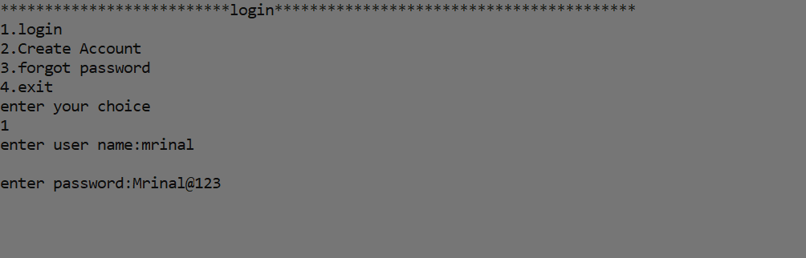

**Creating new account:**

In this section you will get the service to create your account if you haven’t yet. If you will create account with the same user name again it will show error also there is a password constraint that you have to use alphanumeric password including atleast one: -

special symbol

upper case character

lower case character

digit

if your password doesn’t have any of the above mentioned character it will not accept it. Also for convenience of users there is confirm password input so that privacy can be kept.

**Screenshot:**

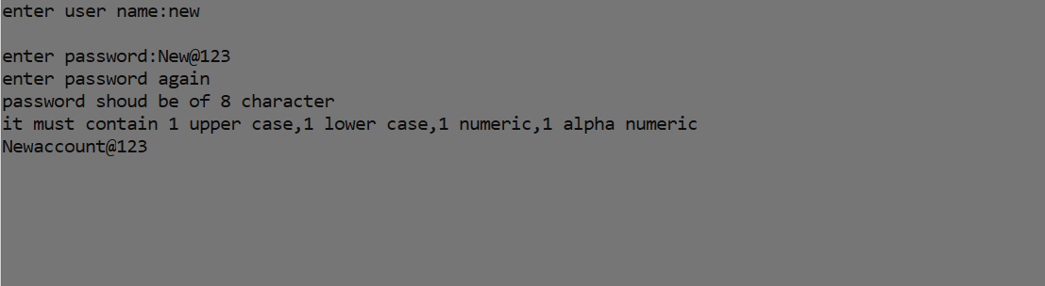

**Login menu:**

This screen will appear when you will logged in into your account. It will work as a terminal to take you to the cart or to exit for now. But in future it can show multiple features like your rating related to your products sold, reviews which is provided by the buyers, dealing history and their whole information etc.

**Screenshot:**

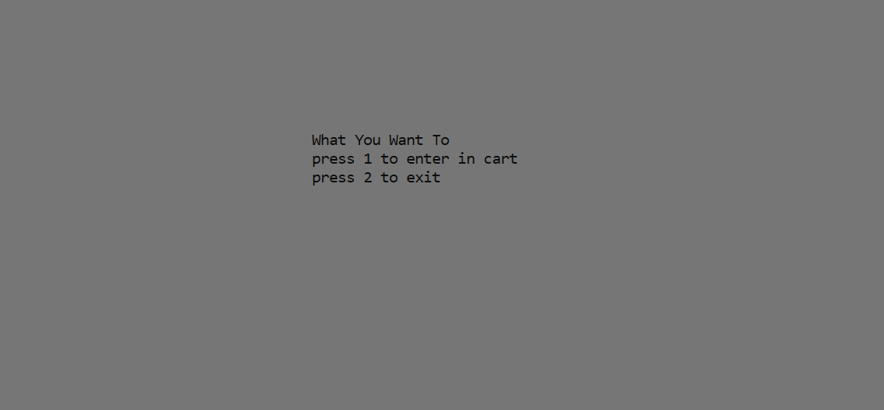

**Main menu:**

This is the screen of main menu which appears after the cart selection. As shown that it is going to navigate you to the purchase and sell menu. Choose the option whatever you want to do

**Screenshot:**

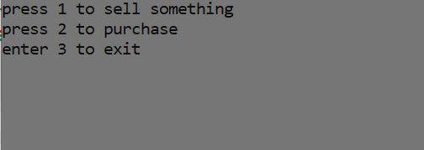

**Purchase menu:**

It takes you to the main menu of purchasing feature where you can opt the kind of product you want to purchase like cycles, laptops, buckets, mattresses etc.

On choosing the option you will get the list of the products with the details of product and contact of the seller if you want to purchase then you have to enter the required details of that product from the provided list.

**Screenshot:**

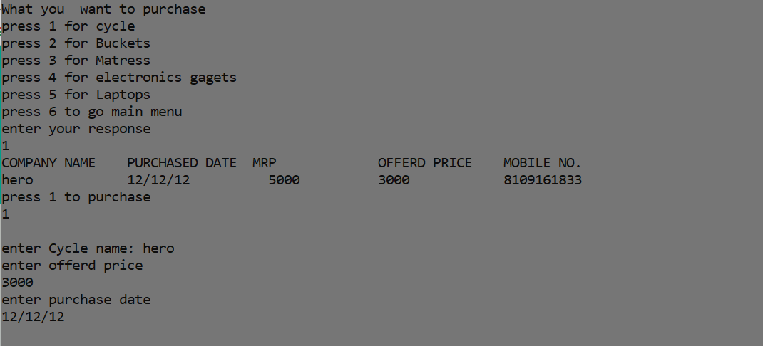

**Sell menu:**

As the name tells, now you are on main selling menu through which you can add your items to the data which you want to sell all you have to do is to select the type of product which you are going to sell then enter the required details of the product like name, when did you bought that, price you expect, your contact, etc.

**Screenshot:**

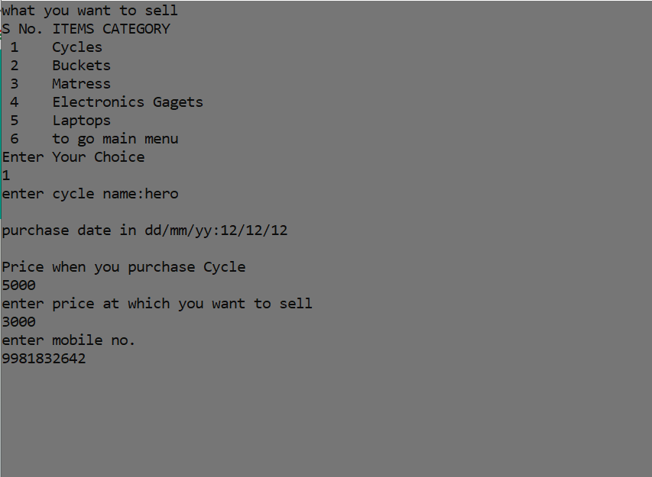

**Text files**

These are the text file which is created through the code and being used by the processes. Since the project is using File handling so data is stored in various text file to act as a database.

The various text files being used are shown below:

**Database:** it stores the information about the account details of the users

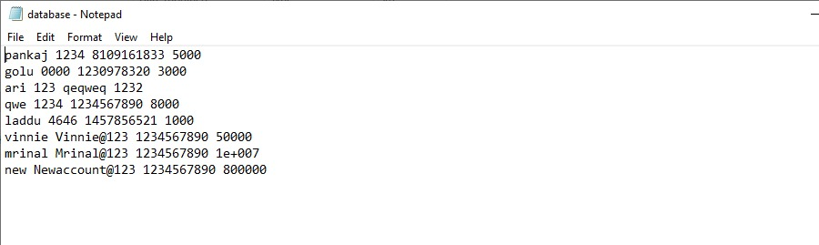

**Cycles.txt:** it stores the information about the cycle to be sold.

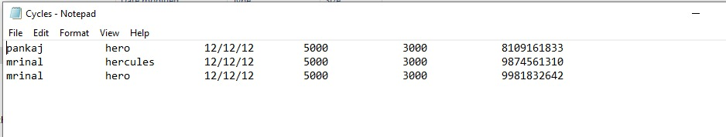

**Buckets.txt:** it stores the information of buckets to be sold

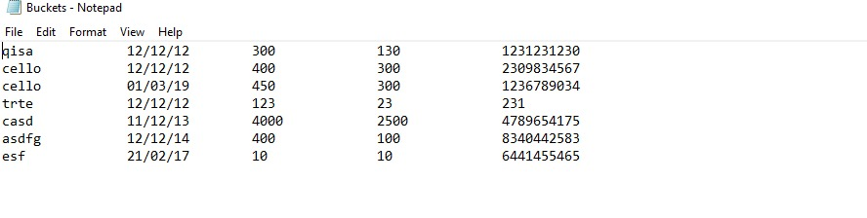

**Matress.txt:** it stores the information of the mattresses to be sold

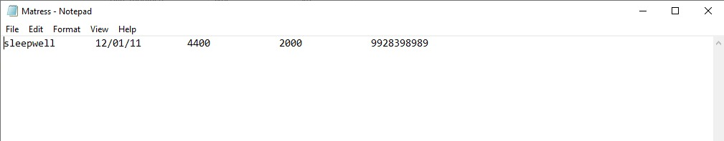

**Laptops.txt:** it stores the information about the laptops to be sold.

