Experiment No: 1

GRADIENT

Aim: To display a 256x256 image matrix where the intensity level of each line changes from 0 to 255.

Program:

A = ones(1,256);

B = [0:255];

C = (uint8(A'*B))';

imshow(C);



Result**:** The script was successfully executed.

Experiment No: 2

IMAGE QUANTIZATION AND SAMPING

Aim: To perform image quantization and sampling at different rates.

Program:

%Quantization

A=imread('exp 2.jpg');

B=rgb2gray(A);

subplot(2,2,1);

imshow(B);

title('Original Image');

C=B/2;

subplot(2,2,2);

imshow(C,[0,127]);

title('Quantized by 2');

D=B/8;

subplot(2,2,3);

imshow(D,[0,31]);

title('Quantized by 8');

E=B/64;

subplot(2,2,4);

imshow(E,[0,3]);

title('Quantized by 64');

%Sampling

A=imread('ex 2.jpg');

B=rgb2gray(A);

subplot(2,2,1);

imshow(B);

title('Original Image');

S1=imresize(B,[480 640]/4);

subplot(2,2,2);

imshow(S1);

title('Sampled by 2');

S2=imresize(B,[480 640]/8);

subplot(2,2,3);

imshow(S2);

title('Sampled by 8');

S3=imresize(C,[480 640]/64);

subplot(2,2,4);

imshow(S3);

title('Sampled by 64');

Observation:

Quantization

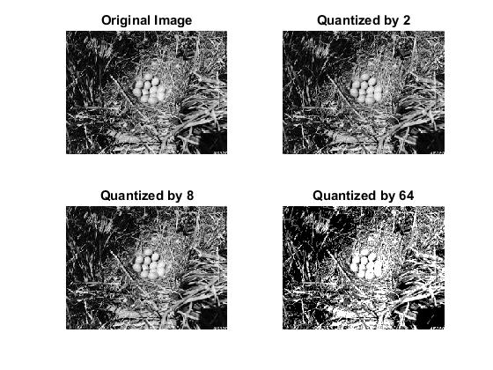

Sampling

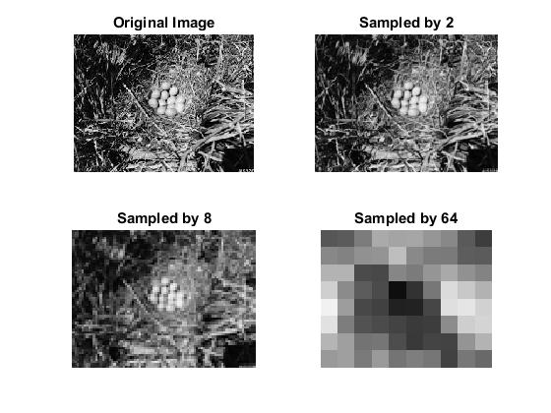

Result: It was observed that as the sampling value is increased the image becomes blurred and if quantization value is increased the amount of grey level available to represent the image decreases.

Experiment No: 3

HISTOGRAM EQUALISATION

Aim: To perform Histogram Equalisation on a low contrast image.

Program:

A=imread('histogram equalization.jpg');

B=rgb2gray(A);

C=histeq(B);

subplot(2,2,1);

imshow(B);

title('Original image');

subplot(2,2,2);

imshow(C);

title('Image after histogram equalization');

subplot(2,2,3);

imhist(B);

title('Histogram of original image');

subplot(2,2,4);

imhist(C);

title('Histogram after doing histogram equalization');

Observation:

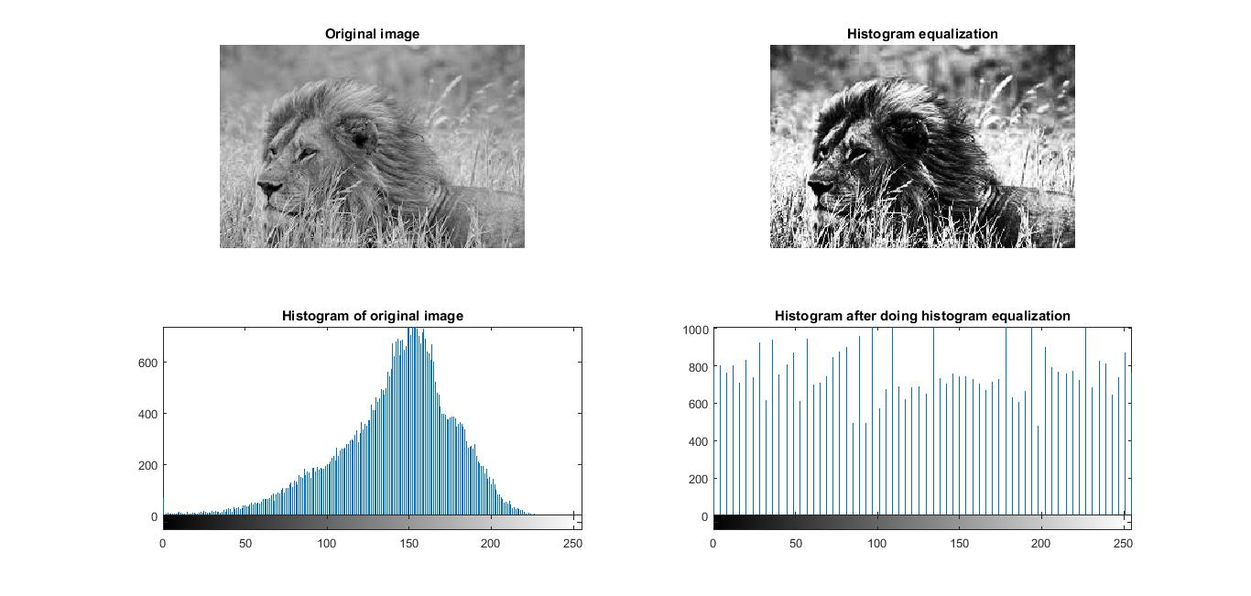

It was observed by comparing the histograms that the pixel values after equalization get uniformly distributed, thus increasing the dynamic range of the initially washed out image.

Result: Histogram equalization was performed on the image.

