Covid Data Dashboard made in Tableau

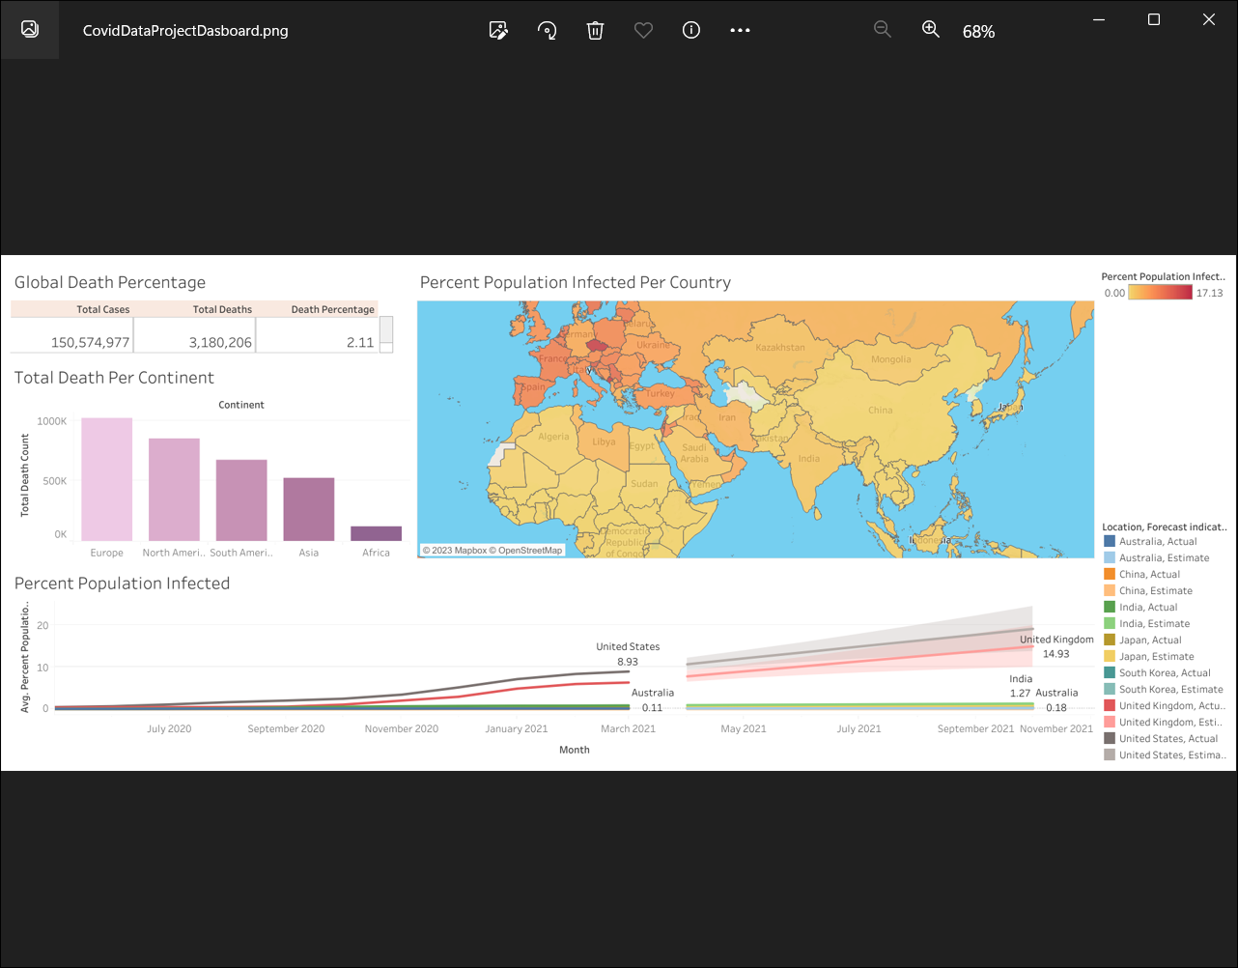

Road Accidents Dashboard made in PowerBI Desktop

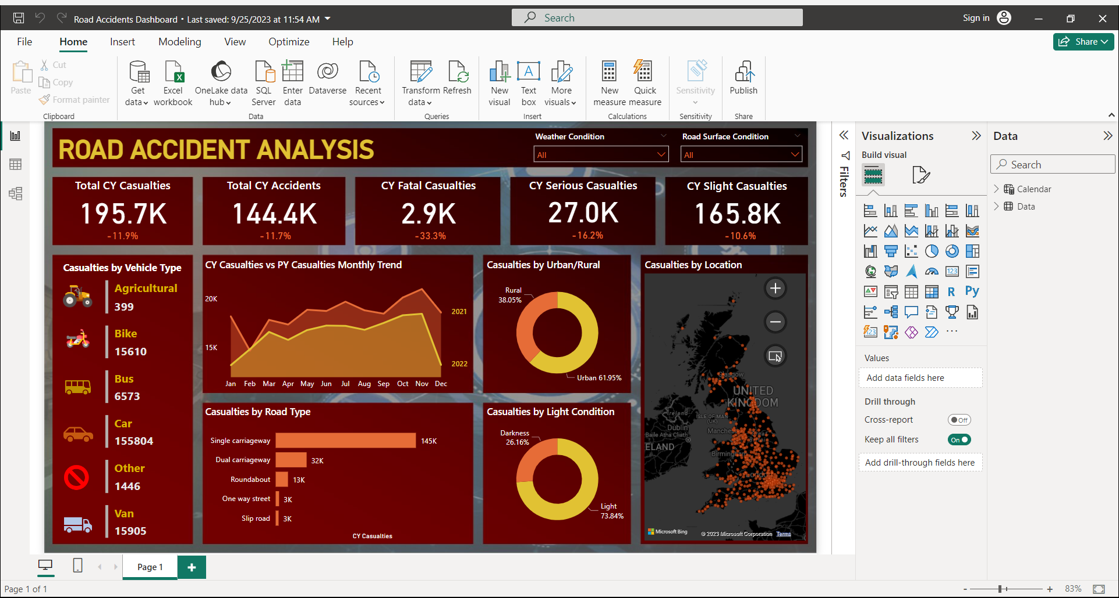

Hotel Revenue Dashboard made in PowerBI Desktop

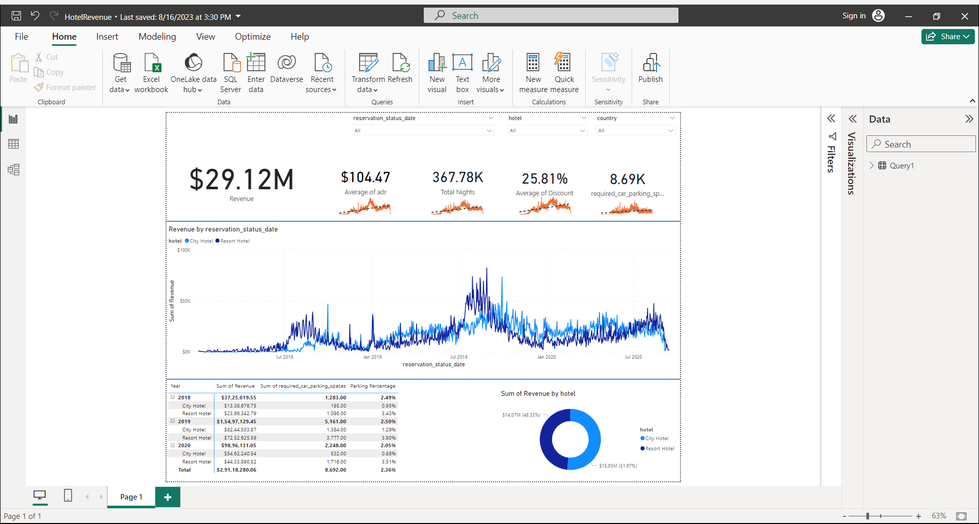

Road accidents dashboard on MS Excel

