# **Lecture 2**

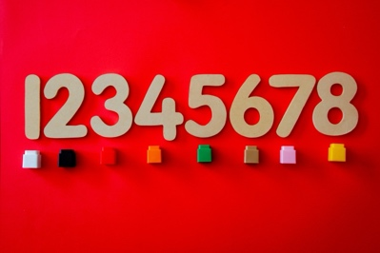

## **Integration By Parts**

Integrating by parts is a useful technique in calculus for integrating products of functions. The method is based on the product rule for differentiation and can be quite handy for various types of integrals. Here's a step-by-step explanation to help you understand and apply this method:

### **Process:**

#### Identify the functions u and dv

To start, you need to split the integral into two parts. Suppose you have an integral of the form ∫𝑢 𝑑𝑣. Your goal is to choose 𝑢 and 𝑑𝑣 such that 𝑢 is a function that becomes simpler when differentiated, and 𝑑𝑣 is a function that can be easily integrated.

#### Differentiate u and integrate dv

Once you've chosen 𝑢 and 𝑑𝑣, differentiate 𝑢 to get 𝑑𝑢, and integrate 𝑑𝑣 to get 𝑣:

#### Apply the integration by parts formula

The formula for integration by parts is derived from the product rule of differentiation and is given by:

This formula transforms the original integral into a new one, which is hopefully simpler to evaluate.

#### Evaluate the New Integral:

After applying the formula, you will have a new integral. You need to evaluate this integral to complete the process.