Realty Intel
Development report: P0 complete
SerpApi India Hackathon 2026 · Commerce & Market Intelligence track · Bengaluru
Covers 3 to 7 October 2026 · repository mrinesh/SerpAPI_Hack, main at e148478

1. Summary
Realty Intel turns an investor's brief (what to buy, where, for how much and why) into a short, explained list of Bengaluru properties. It searches the property portals and Google Maps through SerpApi, has DeepSeek check each candidate against the brief, adds evidence about each locality, computes yield and return in code, and ranks the result. Every figure on screen shows how sure the system is and links to the search result it came from.
All development work on the P0 (must-ship) list is finished and merged. The one P0 item left is the hackathon submission itself: making the repository public, recording the demo video and filling in the form, which the team does by hand. The first submission is due on 8 October; the final deadline is 10 October, 23:59 IST.

Measure | Value
P0 items done | All except the submission (SUB)
Features built | 11 P0 features plus quality flags (F-12) and CI (I-14)
Commits on main | 72, over 5 days
Automated tests | 390 backend (pytest) and 40 frontend (vitest), all passing
Continuous integration | GitHub Actions on every push; green on main
Design decisions recorded | 24 architecture decision records (ADRs)
Recorded provider responses | 40 SerpApi searches and 95 DeepSeek calls, all used
SerpApi account | 196 of 250 free searches left this month
Running the demo | make setup && make demo: no API keys, no searches spent

2. What the product does
One pipeline runs in the background while the run page shows each stage live:
- Profile. A three-step wizard: segment and property type, up to five localities, budget, goal (rental income, appreciation or balanced) and risk. It suggests a target return from sourced area data.
- Discover. Site-filtered Google searches of 99acres, MagicBricks and NoBroker, reading the prices their search pages quote, plus housing projects from Google Maps.
- Clean. Regex parsers read price, rate, size, BHK and status from each snippet; duplicates are merged; the locality is confirmed from the result's own words.
- Verify. DeepSeek fills only missing facts, from quoted evidence, and judges each candidate against the brief. Hard limits such as budget are enforced in code, and implausible prices or wrong localities are flagged.
- Enrich. Per locality: geocoded centre, nearest metro stations, schools and hospitals, price level, past-year price change, typical rent and recent news. Commercial briefs also get the same-category businesses nearby. Yield and total return are computed in code.
- Rank. A score computed in code from relevance, value, evidence, ROI and area access, with an AI-written reason, highlights and risks for the top five, whose every number is checked.

3. What has been built

Must-ship features (P0) and extras
ID | Item | Status | What it delivers
F-01 | Investor profile | Done | Wizard and profile API, validated against reference data; suggested target ROI
F-02 | Property discovery | Done | Portal search pages and Maps projects turned into priced candidates
F-03 | AI relevance check | Done | Grounded extraction and verification; rejects kept with reasons
F-04 | Ranked recommendations | Done | Code-computed score with breakdown; checked AI reasons for the top five
F-05 | Area intelligence | Done | Amenities, price level, growth, rent, news, summary; frozen per run
F-06 | Competitor analysis | Done | Businesses within 2 km for commercial briefs, read by property type
F-07 | Property detail page | Done | One property as one run judged it, with every source
F-09 | Investment metrics | Done | Price vs area, rent, yield, growth, total return vs target
F-11 | Sources and confidence | Done | Confidence badge, method and links on every figure
F-12 | Quality flags (P1) | Done | Too good to be true, missing data, location mismatch
F-19 | Results map | Done | Candidates, amenities and competitors on OpenStreetMap
F-20 | Live pipeline progress | Done | Stage-by-stage progress with searches and cache hits

Foundations
ID | Item | Notes
S-01 | Data coverage spike | What SerpApi returns for Bengaluru; shaped discovery (ADR 0011)
S-02 | Extraction accuracy spike | Regex vs DeepSeek on 20 labelled entries (section 6)
S-03 | Search cost model | About 10 searches for a fresh one-locality search; 0 on repeat
I-02 to I-04 | SerpApi gateway | Cache, record/replay fixtures, per-run and monthly budgets
I-06, I-07 | DeepSeek provider | Structured output, record/replay, model tiers
I-08 to I-10 | Database, orchestrator, UI shell | SQLite (WAL), background runs, typed API client
I-12 | Locality matching | Names, aliases and spelling variants; landmarks ignored
I-13 | Demo fixtures | Two recorded demo profiles seeded by make demo
I-14 | CI (P1) | Lint, tests, build and the fixture check on every push
D-01 | Documentation | README, product, architecture, pipeline, API, data model, 24 ADRs

4. The product on screen
Screenshots from the offline demo (make demo), which replays recorded searches and AI responses.
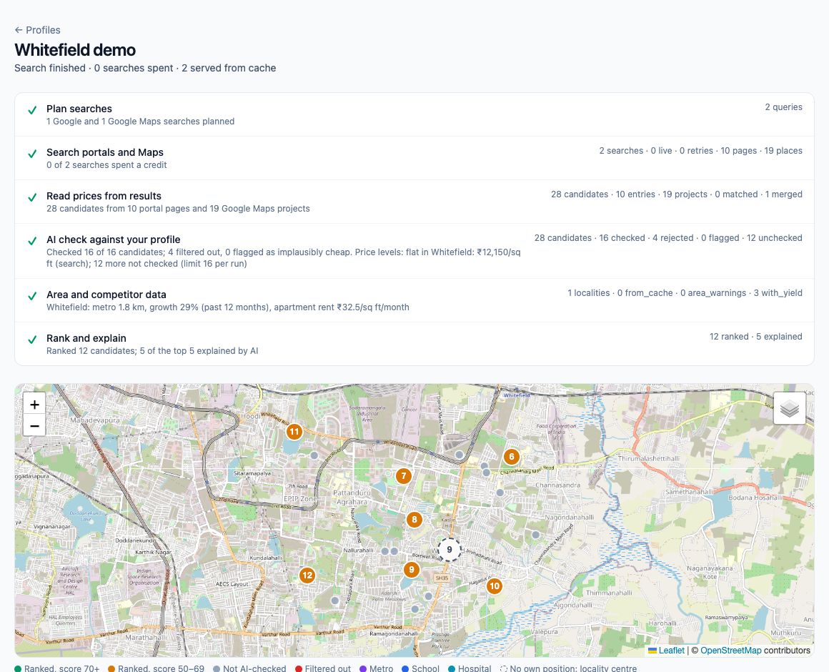
Figure 1. A residential search: live pipeline stages and the candidates on the map, ranked ones numbered and coloured by score.
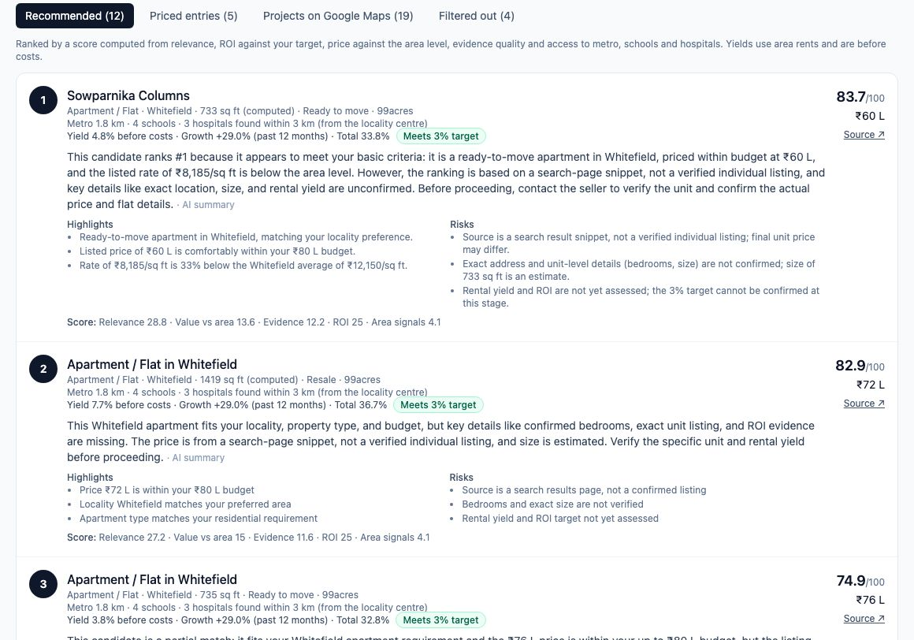
Figure 2. The ranked shortlist: score, AI reason with highlights and risks, yield against the target, and the score breakdown.
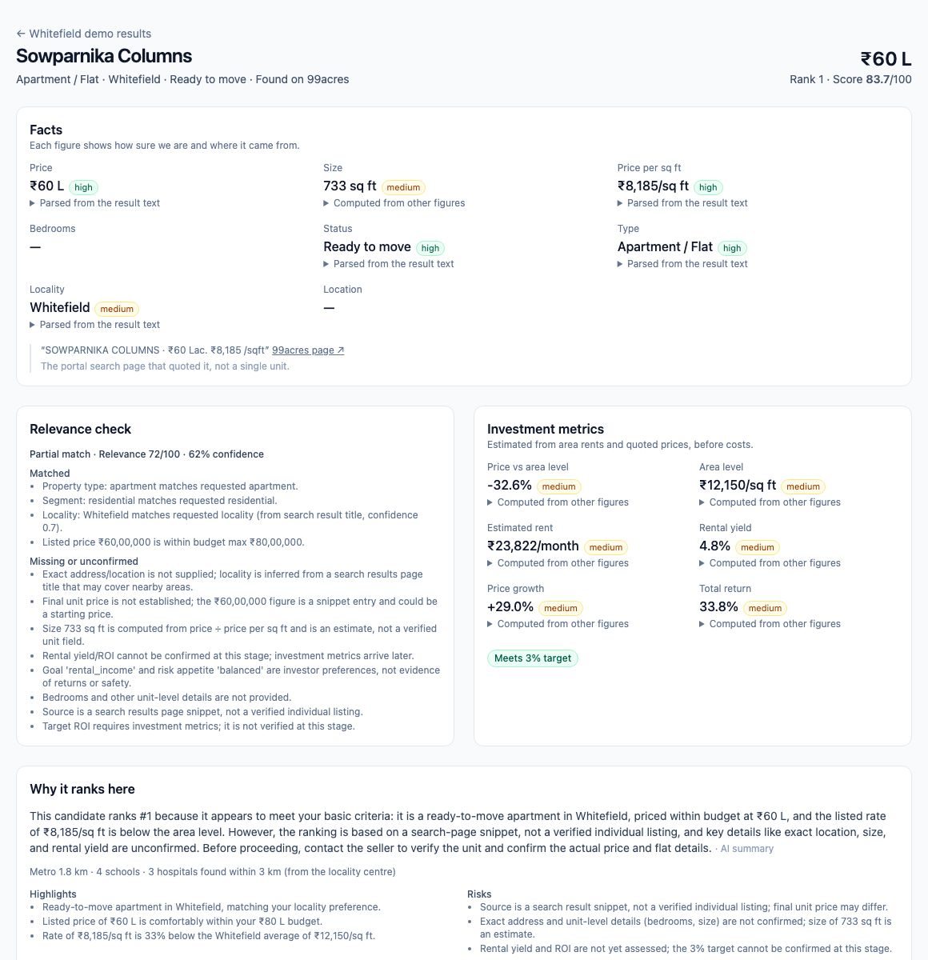
Figure 3. The property page: each fact with its confidence and how it was obtained, the relevance check and the metrics.
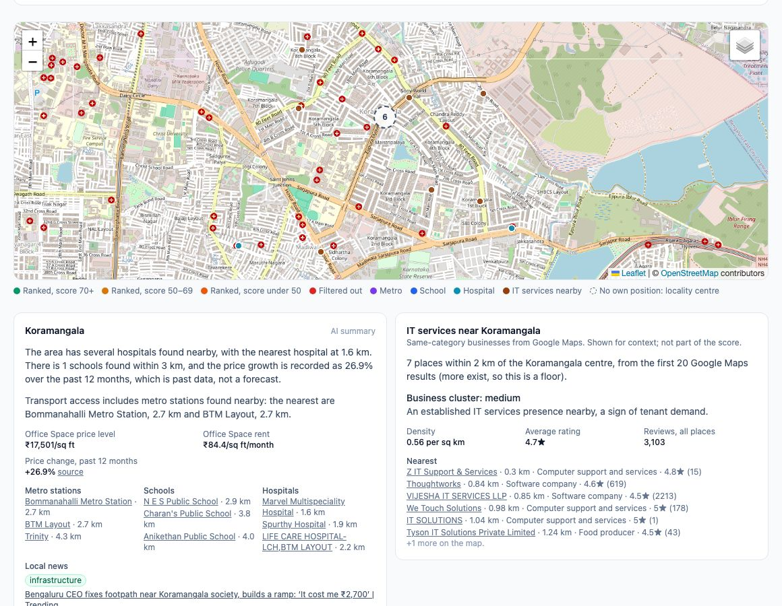
Figure 4. A commercial search for an IT services office in Koramangala: area card and the nearby-business card, with the map layer.

5. How it uses SerpApi and AI

SerpApi: the only data source
Engine | Role
google | Site-filtered portal searches (discovery); locality price level per sq ft; past-year price change; rent levels
google_maps | Housing projects with GPS; locality centres; nearest metro, schools and hospitals; same-category businesses
google_news | Recent locality news, labelled by topic and sentiment, shown but not scored
Account API | Searches left this month, shown in the app header (free)
Locations API | Fixed the location parameter to Bengaluru,Karnataka,India (free)

All calls go through one gateway (official serpapi SDK) with a database cache, a hard budget per run and per month, and record/replay fixtures. Development recorded 40 searches; the demo and the tests replay them without spending anything.

DeepSeek: extracts and explains, never decides the numbers
- Code computes scores, money, yield, return and every ranking. The model extracts facts and writes explanations (ADR 0008).
- Grounded extraction: a value is accepted only if the quoted text supports it; otherwise it stays missing (ADR 0013).
- Hard limits in code: budget, type, segment and locality are checked after the model's verdict, so a model mistake cannot pass a listing over budget.
- Checked explanations: every number in an AI-written reason or area summary must appear in the figures it was given, or the code-written text is shown instead.
- Visible failures: a failed search or AI call is shown and retried on the next run; it never silently becomes missing data (ADR 0019).

6. Quality and evidence
- 390 backend and 40 frontend tests, from pure functions to full demo runs replayed end to end.
- GitHub Actions runs lint, typecheck, tests, the production build and the fixture check on every push.
- make fixtures fails if any recorded AI response is unused, so superseded recordings cannot pile up; 52 were pruned after the latest re-recording.
- A fresh clone runs the full demo with no .env and no keys; the git history was scanned and contains no API keys.

Extraction accuracy spike (S-02)
20 snippet entries from the recorded searches were labelled by hand and read three ways. Correct out of 19 listings:
Field | Regex alone | DeepSeek alone | Shipped (regex, then AI for gaps)
Price | 19 | 15 (4 missed) | 19
Price per sq ft | 19 | not asked | computed in code
Size | 18 (1 wrong) | 14 (5 missed) | 18 (1 wrong)
Bedrooms | 19 | 19 | 19
Status | 18 (1 extra) | 19 | 18 (1 extra)

DeepSeek was never wrong, but it refuses figures that need arithmetic, so regex stays first and the AI fills gaps. The three parser problems found are tracked as F-22. The labels were written by Claude Code and still need the product owner's review.

7. Key decisions
Each choice someone could question is recorded as an ADR in docs/decisions/. The ones that shape the product most:
ADR | Decision
0002 | SerpApi is the only listing source; portals are linked, never scraped
0003 | Record/replay providers and a hard search budget
0004 | Every investor-facing fact carries its source and confidence
0006 | Enrich per locality, not per property, to stay within the search budget
0008 | Code computes scores and money; the LLM extracts and explains
0011 | Discovery reads portal search-page snippets and Google Maps projects
0012 | DeepSeek V4 Pro replaces Gemini; thinking on for reasoning, off for extraction
0013 | Evidence-grounded extraction, hard constraints, per-run snapshots
0015 | Composite ranking in code; grounded AI explanations for the top five
0021 | The property page shows a property as one run judged it
0022 | Map positions only from SerpApi; nothing is placed at an invented point
0023 | Competitors read as competition for shops and as a cluster for offices
0024 | Locality confirmed from the result's own words; mismatches flagged

8. Timeline
Date | Commits | Main work
Sat 3 Oct | 23 | Repository, tooling and docs; scaffolds; investor profile (F-01)
Sun 4 Oct | 10 | SerpApi gateway; data coverage spike (S-01); discovery and live progress (F-02, F-20)
Mon 5 Oct | 2 | DeepSeek provider and the first relevance-check work (with gscode007)
Tue 6 Oct | 12 | Relevance check (F-03), ranking (F-04), area intelligence (F-05), metrics (F-09), quality flags (F-12), suggested target
Wed 7 Oct | 25 | Hardening and news; property page (F-07), map (F-19), competitors (F-06); submission prep; fixture check, locality matching, S-02, CI, close-out

Ideas from gscode007's parallel branches (visible failures, validated caches, locality news, frozen per-run areas) were adopted, with credit in ADRs 0019 and 0020.

9. What is left

To submit (by hand, first submission by 8 October)
- Make the GitHub repository public; it is private today.
- Record the demo video (under 3 minutes, running locally); the plan is in docs/SUBMISSION.md.
- Paste the drafted description and SerpApi explanation into the form; confirm the project name, disclosures, community source and teammates; check the links in an incognito window.
- Review the S-02 labels in backend/fixtures/spikes/s02_labels.json.

Should-ship (P1), not built
ID | Item | Notes
F-08 | Saved properties and compare | API scaffolded (returns 501); placeholder page in the app
F-10 | Alerts | New matches and price drops between runs; scheduler hook ready (I-11)
F-22 | Parser fixes from S-02 | Size ranges, status from page filters, description phrases
F-06b | Competitor review gaps | Reviews of top competitors; about 3 searches per locality
F-05 P1 | Rental demand from Google Trends | Deferred; costs searches

Next phase: the live website
Today the app runs on a laptop and the demo replays recordings. The next phase is a hosted site that runs real searches and AI calls for each user's brief: live mode with the existing budgets and caches, hosting for the backend and frontend, API keys kept as server secrets, rate limits and a guard on the shared search budget.

