hw3
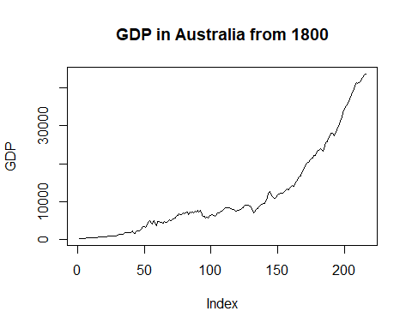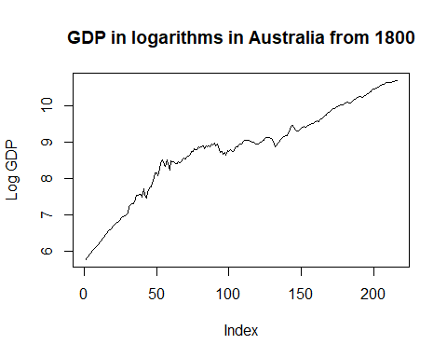
It can be seen that time series is nonstationary.
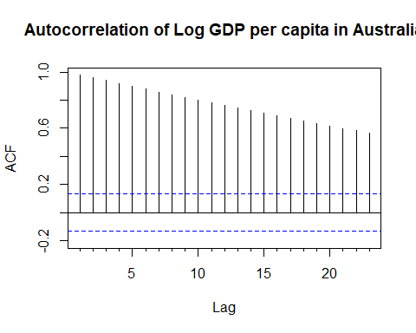
ACF slowly decreases, it is in favour of nonstationarity of series.
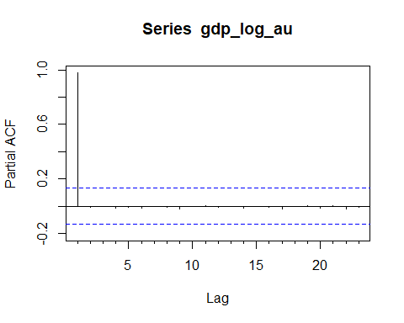
It can be seen that only first lag is significant.

Checking of stationarity.

1.1. Stationarity of Australia’s GDP in logarithms

Dickey, Fuller test
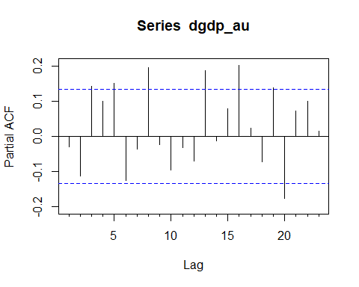
For Dickey Fuller test I will choose 5 lags (3rd is less significant and 8 lags is far enough).
##
## ###############################################
## # Augmented Dickey-Fuller Test Unit Root Test #
## ###############################################
##
## Test regression drift
##
##
## Call:
## lm(formula = z.diff ~ z.lag.1 + 1 + z.diff.lag)
##
## Residuals:
## Min 1Q Median 3Q Max
## -0.193004 -0.025645 0.004582 0.024315 0.196532
##
## Coefficients:
## Estimate Std. Error t value Pr(>|t|)
## (Intercept) 0.096846 0.033644 2.879 0.00442 **
## z.lag.1 -0.008723 0.003614 -2.413 0.01669 *
## z.diff.lag1 -0.073455 0.069020 -1.064 0.28848
## z.diff.lag2 -0.149111 0.068946 -2.163 0.03173 *
## z.diff.lag3 0.122711 0.069101 1.776 0.07726 .
## z.diff.lag4 0.077032 0.068959 1.117 0.26528
## z.diff.lag5 0.127373 0.069021 1.845 0.06643 .
## ---
## Signif. codes: 0 '***' 0.001 '**' 0.01 '*' 0.05 '.' 0.1 ' ' 1
##
## Residual standard error: 0.05681 on 203 degrees of freedom
## Multiple R-squared: 0.09199, Adjusted R-squared: 0.06515
## F-statistic: 3.428 on 6 and 203 DF, p-value: 0.003029
##
##
## Value of test-statistic is: -2.4134 7.9432
##
## Critical values for test statistics:
## 1pct 5pct 10pct
## tau2 -3.46 -2.88 -2.57
## phi1 6.52 4.63 3.81
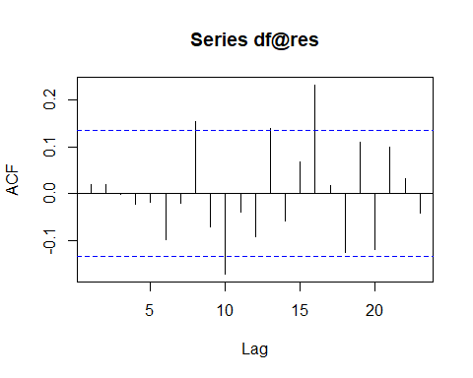
##
## Box-Ljung test
##
## data: df@res
## X-squared = 2.4719, df = 1, p-value = 0.1159
Residuals for 5 lags are not correlated.
T-statistics for z.lag.1 is greater than critical value, therefore the null hypothesis about non-stationarity around constant can not be rejected.
##
## ###############################################
## # Augmented Dickey-Fuller Test Unit Root Test #
## ###############################################
##
## Test regression trend
##
##
## Call:
## lm(formula = z.diff ~ z.lag.1 + 1 + tt + z.diff.lag)
##
## Residuals:
## Min 1Q Median 3Q Max
## -0.181748 -0.023873 0.000824 0.021907 0.207818
##
## Coefficients:
## Estimate Std. Error t value Pr(>|t|)
## (Intercept) 0.2543561 0.0815337 3.120 0.00208 **
## z.lag.1 -0.0324810 0.0117800 -2.757 0.00636 **
## tt 0.0004737 0.0002238 2.117 0.03547 *
## z.diff.lag1 -0.0707581 0.0684476 -1.034 0.30249
## z.diff.lag2 -0.1477328 0.0683651 -2.161 0.03188 *
## z.diff.lag3 0.1213378 0.0685186 1.771 0.07809 .
## z.diff.lag4 0.0776471 0.0683752 1.136 0.25747
## z.diff.lag5 0.1292744 0.0684421 1.889 0.06035 .
## ---
## Signif. codes: 0 '***' 0.001 '**' 0.01 '*' 0.05 '.' 0.1 ' ' 1
##
## Residual standard error: 0.05632 on 202 degrees of freedom
## Multiple R-squared: 0.1117, Adjusted R-squared: 0.08092
## F-statistic: 3.629 on 7 and 202 DF, p-value: 0.001043
##
##
## Value of test-statistic is: -2.7573 6.8805 5.2033
##
## Critical values for test statistics:
## 1pct 5pct 10pct
## tau3 -3.99 -3.43 -3.13
## phi2 6.22 4.75 4.07
## phi3 8.43 6.49 5.47
The null hypothesis of nonstationarity around the trend also can not be rejected.
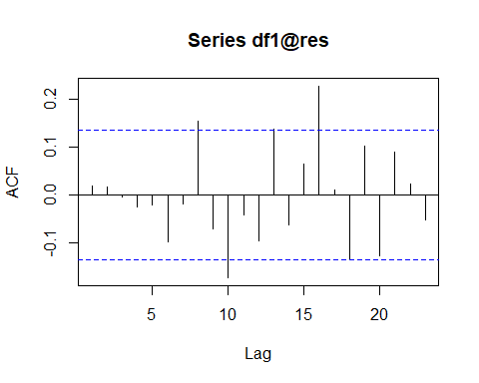
##
## Box-Ljung test
##
## data: df1@res
## X-squared = 7.78, df = 3, p-value = 0.05078
## Phillips-Perron Unit Root Test
## alternative: stationary
##
## Type 1: no drift no trend
## lag Z_rho p.value
## 4 0.51 0.804
## -----
## Type 2: with drift no trend
## lag Z_rho p.value
## 4 -2.02 0.765
## -----
## Type 3: with drift and trend
## lag Z_rho p.value
## 4 -6.09 0.723
## ---------------
## Note: p-value = 0.01 means p.value <= 0.01
The null hypothesis about non-stationary of the series can not be rejected in PP-test.
## Warning in kpss.test(gdp_log_au, null = "Level"): p-value smaller than printed
## p-value
##
## KPSS Test for Level Stationarity
##
## data: gdp_log_au
## KPSS Level = 3.9521, Truncation lag parameter = 4, p-value = 0.01
## Warning in kpss.test(gdp_log_au, null = "Trend"): p-value smaller than printed
## p-value
##
## KPSS Test for Trend Stationarity
##
## data: gdp_log_au
## KPSS Trend = 0.66576, Truncation lag parameter = 4, p-value = 0.01
There the null hypothesis is reverse. The null hypothesis about stationarity can not be accepted.

1.2. Stationarity of Australia’s GDP growth rate in logarithms
As series of Log GDP in Australia is nonstationary, I will transform it in a form of its first differences (and will get growth rate of GDP in logarithms).
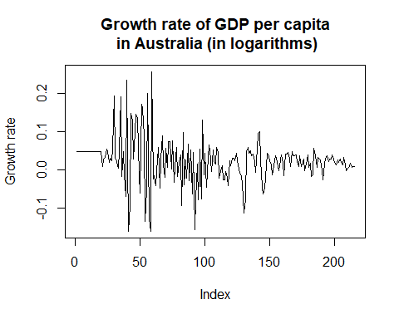
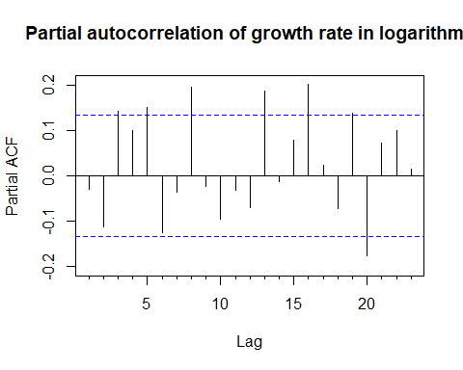
##
## ###############################################
## # Augmented Dickey-Fuller Test Unit Root Test #
## ###############################################
##
## Test regression drift
##
##
## Call:
## lm(formula = z.diff ~ z.lag.1 + 1 + z.diff.lag)
##
## Residuals:
## Min 1Q Median 3Q Max
## -0.198654 -0.021704 0.001141 0.022922 0.217895
##
## Coefficients:
## Estimate Std. Error t value Pr(>|t|)
## (Intercept) 0.018822 0.005433 3.464 0.000649 ***
## z.lag.1 -0.855904 0.163197 -5.245 0.000000394 ***
## z.diff.lag1 -0.176692 0.155233 -1.138 0.256370
## z.diff.lag2 -0.286575 0.143192 -2.001 0.046695 *
## z.diff.lag3 -0.110979 0.127950 -0.867 0.386772
## z.diff.lag4 -0.021504 0.100353 -0.214 0.830544
## z.diff.lag5 0.123879 0.069673 1.778 0.076908 .
## ---
## Signif. codes: 0 '***' 0.001 '**' 0.01 '*' 0.05 '.' 0.1 ' ' 1
##
## Residual standard error: 0.05729 on 202 degrees of freedom
## Multiple R-squared: 0.5556, Adjusted R-squared: 0.5424
## F-statistic: 42.08 on 6 and 202 DF, p-value: < 0.00000000000000022
##
##
## Value of test-statistic is: -5.2446 13.7671
##
## Critical values for test statistics:
## 1pct 5pct 10pct
## tau2 -3.46 -2.88 -2.57
## phi1 6.52 4.63 3.81
T-statistics for z.lag.1 is less than crictical value, therefore, the null hypothesis about nonstationarity around drift can be rejected.
##
## KPSS Test for Level Stationarity
##
## data: dgdp_au
## KPSS Level = 0.70157, Truncation lag parameter = 4, p-value = 0.0134
## Warning in pp.test(dgdp_au): p-value smaller than printed p-value
##
## Phillips-Perron Unit Root Test
##
## data: dgdp_au
## Dickey-Fuller Z(alpha) = -221.81, Truncation lag parameter = 4, p-value
## = 0.01
## alternative hypothesis: stationary
All tests indicate stationarity of the series, as p-values are less than 0.01.

Estimation of AR(p) model.
It can be seen that there are many significant lags. I will build AR(3).
##
## z test of coefficients:
##
## Estimate Std. Error z value Pr(>|z|)
## ar1 -0.0168302 0.0674295 -0.2496 0.80290
## ar2 -0.1071118 0.0668766 -1.6016 0.10924
## ar3 0.1407449 0.0671486 2.0960 0.03608 *
## intercept 0.0228757 0.0039563 5.7821 0.000000007376 ***
## ---
## Signif. codes: 0 '***' 0.001 '**' 0.01 '*' 0.05 '.' 0.1 ' ' 1

$$Y_{t}=0.0229-0.0168Y_{t-1}-0.1071Y_{t-2}+0.1407Y_{t-3}+ε_{t}$$
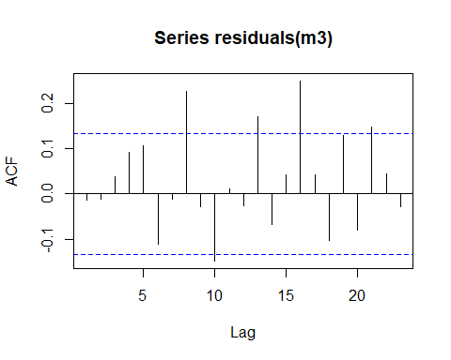
##
## Box-Ljung test
##
## data: residuals(m3)
## X-squared = 4.8284, df = 2, p-value = 0.08944
ACF and Ljung-Box test show that hypothesis of absence of the residuals’ autocorrelation for 10 lags can not be rejected for AR(3).

DJA
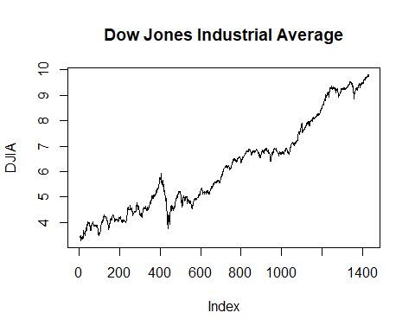
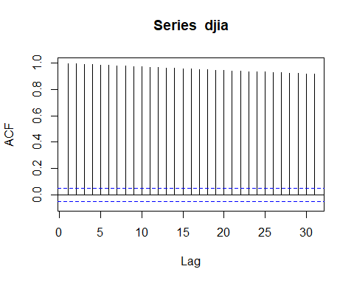 Acf slowly decreases.
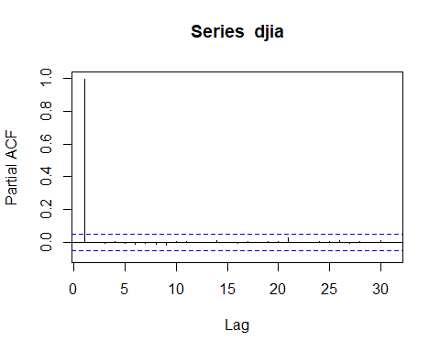
Only first lag is significant.
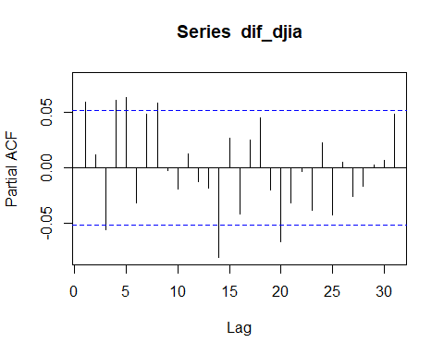 I will chose lag 8, 14th lag is greatly significant, but too far.
##
## ###############################################
## # Augmented Dickey-Fuller Test Unit Root Test #
## ###############################################
##
## Test regression drift
##
##
## Call:
## lm(formula = z.diff ~ z.lag.1 + 1 + z.diff.lag)
##
## Residuals:
## Min 1Q Median 3Q Max
## -0.35144 -0.02472 0.00265 0.03055 0.31485
##
## Coefficients:
## Estimate Std. Error t value Pr(>|t|)
## (Intercept) 0.0045672 0.0050158 0.911 0.36268
## z.lag.1 -0.0001430 0.0007813 -0.183 0.85485
## z.diff.lag1 0.0575878 0.0265839 2.166 0.03046 *
## z.diff.lag2 0.0176515 0.0265823 0.664 0.50678
## z.diff.lag3 -0.0682606 0.0265616 -2.570 0.01027 *
## z.diff.lag4 0.0569884 0.0265627 2.145 0.03209 *
## z.diff.lag5 0.0688350 0.0265626 2.591 0.00966 **
## z.diff.lag6 -0.0346607 0.0265606 -1.305 0.19212
## z.diff.lag7 0.0450337 0.0265751 1.695 0.09037 .
## z.diff.lag8 0.0589223 0.0265542 2.219 0.02665 *
## ---
## Signif. codes: 0 '***' 0.001 '**' 0.01 '*' 0.05 '.' 0.1 ' ' 1
##
## Residual standard error: 0.053 on 1412 degrees of freedom
## Multiple R-squared: 0.0209, Adjusted R-squared: 0.01466
## F-statistic: 3.35 on 9 and 1412 DF, p-value: 0.0004557
##
##
## Value of test-statistic is: -0.183 3.3033
##
## Critical values for test statistics:
## 1pct 5pct 10pct
## tau2 -3.43 -2.86 -2.57
## phi1 6.43 4.59 3.78
T-statistics is greater than critical value, therefore, the null hypthosesis about nonstationarity around constant can not be rejected.
##
## ###############################################
## # Augmented Dickey-Fuller Test Unit Root Test #
## ###############################################
##
## Test regression trend
##
##
## Call:
## lm(formula = z.diff ~ z.lag.1 + 1 + tt + z.diff.lag)
##
## Residuals:
## Min 1Q Median 3Q Max
## -0.34939 -0.02574 0.00276 0.02920 0.30626
##
## Coefficients:
## Estimate Std. Error t value Pr(>|t|)
## (Intercept) 0.03043048 0.01057529 2.878 0.00407 **
## z.lag.1 -0.00907858 0.00328501 -2.764 0.00579 **
## tt 0.00004057 0.00001441 2.816 0.00493 **
## z.diff.lag1 0.06142163 0.02658988 2.310 0.02103 *
## z.diff.lag2 0.02362753 0.02660846 0.888 0.37471
## z.diff.lag3 -0.06313654 0.02656462 -2.377 0.01760 *
## z.diff.lag4 0.06137493 0.02659109 2.308 0.02114 *
## z.diff.lag5 0.07283755 0.02658427 2.740 0.00622 **
## z.diff.lag6 -0.02943537 0.02662088 -1.106 0.26903
## z.diff.lag7 0.04920607 0.02656052 1.853 0.06415 .
## z.diff.lag8 0.06317771 0.02659380 2.376 0.01765 *
## z.diff.lag9 0.00318645 0.02660647 0.120 0.90469
## ---
## Signif. codes: 0 '***' 0.001 '**' 0.01 '*' 0.05 '.' 0.1 ' ' 1
##
## Residual standard error: 0.05286 on 1409 degrees of freedom
## Multiple R-squared: 0.02629, Adjusted R-squared: 0.01869
## F-statistic: 3.459 on 11 and 1409 DF, p-value: 0.00008923
##
##
## Value of test-statistic is: -2.7636 4.7692 3.9714
##
## Critical values for test statistics:
## 1pct 5pct 10pct
## tau3 -3.96 -3.41 -3.12
## phi2 6.09 4.68 4.03
## phi3 8.27 6.25 5.34
T-statistics is greater than critical value, therefore, the null hypthosesis about nonstationarity around trend can not be rejected.
## Augmented Dickey-Fuller Test
## alternative: stationary
##
## Type 1: no drift no trend
## lag ADF p.value
## [1,] 0 3.10 0.99
## [2,] 1 2.88 0.99
## [3,] 2 2.83 0.99
## [4,] 3 3.01 0.99
## [5,] 4 2.79 0.99
## [6,] 5 2.60 0.99
## [7,] 6 2.70 0.99
## [8,] 7 2.57 0.99
## Type 2: with drift no trend
## lag ADF p.value
## [1,] 0 0.2059 0.972
## [2,] 1 0.1548 0.968
## [3,] 2 0.1455 0.967
## [4,] 3 0.2028 0.972
## [5,] 4 0.1431 0.967
## [6,] 5 0.0374 0.959
## [7,] 6 0.0382 0.959
## [8,] 7 -0.0946 0.947
## Type 3: with drift and trend
## lag ADF p.value
## [1,] 0 -2.17 0.504
## [2,] 1 -2.33 0.436
## [3,] 2 -2.37 0.421
## [4,] 3 -2.22 0.483
## [5,] 4 -2.39 0.411
## [6,] 5 -2.56 0.342
## [7,] 6 -2.46 0.384
## [8,] 7 -2.57 0.336
## ----
## Note: in fact, p.value = 0.01 means p.value <= 0.01
The null hypothesis about nonstationary can not be rejected.
## Warning in kpss.test(djia, null = "Level"): p-value smaller than printed
## p-value
##
## KPSS Test for Level Stationarity
##
## data: djia
## KPSS Level = 17.009, Truncation lag parameter = 7, p-value = 0.01
The null hypothesis about stationary can be rejected.
##
## Phillips-Perron Unit Root Test
##
## data: djia
## Dickey-Fuller Z(alpha) = -12.015, Truncation lag parameter = 7, p-value
## = 0.4395
## alternative hypothesis: stationary
The null hypothesis about nonstationary can not be rejected.
All tests show that series is nonstationary.
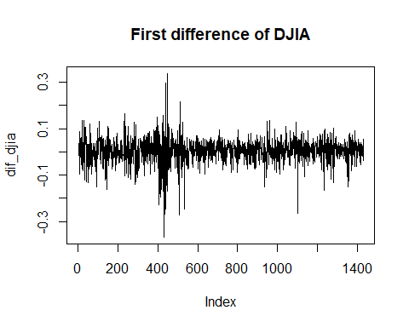
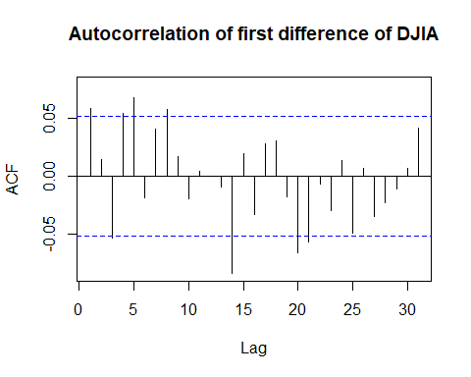
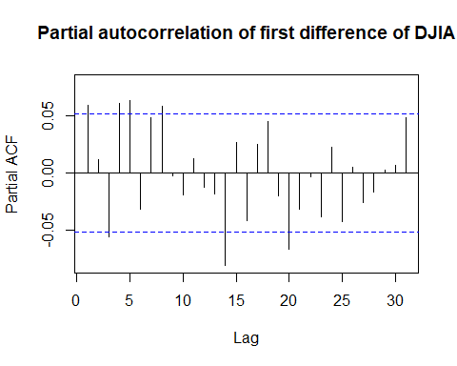
##
## ###############################################
## # Augmented Dickey-Fuller Test Unit Root Test #
## ###############################################
##
## Test regression drift
##
##
## Call:
## lm(formula = z.diff ~ z.lag.1 + 1 + z.diff.lag)
##
## Residuals:
## Min 1Q Median 3Q Max
## -0.35094 -0.02444 0.00244 0.03041 0.31550
##
## Coefficients:
## Estimate Std. Error t value Pr(>|t|)
## (Intercept) 0.003679 0.001446 2.544 0.01106 *
## z.lag.1 -0.813668 0.075259 -10.812 < 0.0000000000000002 ***
## z.diff.lag1 -0.128939 0.072389 -1.781 0.07510 .
## z.diff.lag2 -0.108177 0.069299 -1.561 0.11874
## z.diff.lag3 -0.174268 0.065520 -2.660 0.00791 **
## z.diff.lag4 -0.117145 0.061193 -1.914 0.05578 .
## z.diff.lag5 -0.047218 0.056823 -0.831 0.40613
## z.diff.lag6 -0.080843 0.051145 -1.581 0.11418
## z.diff.lag7 -0.037461 0.043927 -0.853 0.39391
## z.diff.lag8 0.021050 0.036487 0.577 0.56410
## z.diff.lag9 0.019571 0.026586 0.736 0.46176
## ---
## Signif. codes: 0 '***' 0.001 '**' 0.01 '*' 0.05 '.' 0.1 ' ' 1
##
## Residual standard error: 0.053 on 1409 degrees of freedom
## Multiple R-squared: 0.4807, Adjusted R-squared: 0.4771
## F-statistic: 130.4 on 10 and 1409 DF, p-value: < 0.00000000000000022
##
##
## Value of test-statistic is: -10.8116 58.4455
##
## Critical values for test statistics:
## 1pct 5pct 10pct
## tau2 -3.43 -2.86 -2.57
## phi1 6.43 4.59 3.78
T-statistics is less than critical value, then the null hypothesis about nonstationarity around constant can be rejected.
## Augmented Dickey-Fuller Test
## alternative: stationary
##
## Type 1: no drift no trend
## lag ADF p.value
## [1,] 0 -35.4 0.01
## [2,] 1 -25.4 0.01
## [3,] 2 -22.1 0.01
## [4,] 3 -17.8 0.01
## [5,] 4 -15.0 0.01
## [6,] 5 -14.3 0.01
## [7,] 6 -12.7 0.01
## [8,] 7 -11.3 0.01
## Type 2: with drift no trend
## lag ADF p.value
## [1,] 0 -35.6 0.01
## [2,] 1 -25.6 0.01
## [3,] 2 -22.4 0.01
## [4,] 3 -18.1 0.01
## [5,] 4 -15.3 0.01
## [6,] 5 -14.6 0.01
## [7,] 6 -13.0 0.01
## [8,] 7 -11.6 0.01
## Type 3: with drift and trend
## lag ADF p.value
## [1,] 0 -35.6 0.01
## [2,] 1 -25.6 0.01
## [3,] 2 -22.4 0.01
## [4,] 3 -18.1 0.01
## [5,] 4 -15.3 0.01
## [6,] 5 -14.6 0.01
## [7,] 6 -13.0 0.01
## [8,] 7 -11.6 0.01
## ----
## Note: in fact, p.value = 0.01 means p.value <= 0.01
All p_value is less than 0.01, then series is stationary.
## Warning in kpss.test(dif_djia, null = "Level"): p-value greater than printed
## p-value
##
## KPSS Test for Level Stationarity
##
## data: dif_djia
## KPSS Level = 0.081805, Truncation lag parameter = 7, p-value = 0.1
The null hypthosesis about stationarity can not be rejected.
## Warning in pp.test(dif_djia): p-value smaller than printed p-value
##
## Phillips-Perron Unit Root Test
##
## data: dif_djia
## Dickey-Fuller Z(alpha) = -1379.1, Truncation lag parameter = 7, p-value
## = 0.01
## alternative hypothesis: stationary
All tests show that series with difference of DJIA is stationary.

Build ARMA model
## AR/MA
## 0 1 2 3 4 5 6 7 8 9 10 11 12 13
## 0 x o x x x o o x o o o o o x
## 1 x o o o x o o o o o o o o x
## 2 x x o o x o o o o o o o o x
## 3 x x x o o o o o o o o o o x
## 4 x x x x o o x o o o o o o x
## 5 x x x x x o o o o o o o o x
## 6 x x x x x x o o o o o o o x
## 7 x x x o x x x o o o o o o x
##
## z test of coefficients:
##
## Estimate Std. Error z value Pr(>|z|)
## ar1 -0.4446410 0.0849899 -5.2317 0.00000016796732 ***
## ar2 -0.7892614 0.0648380 -12.1728 < 0.00000000000000022 ***
## ma1 0.5199380 0.0787492 6.6025 0.00000000004044 ***
## ma2 0.8407339 0.0536572 15.6686 < 0.00000000000000022 ***
## intercept 0.0044796 0.0014770 3.0328 0.002423 **
## ---
## Signif. codes: 0 '***' 0.001 '**' 0.01 '*' 0.05 '.' 0.1 ' ' 1
$$Y_{t}=0.0045-0.4446Y_{t-1}-0.7893Y_{t-2}+0.5199ε_{t-1}+0.8407ε_{t-2}+ε_{t}$$
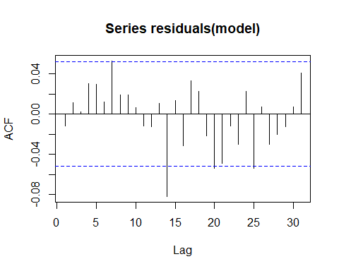
##
## Box-Ljung test
##
## data: residuals(model)
## X-squared = 8.6829, df = 3, p-value = 0.03382
First lags for residuals autocorrelation are not correlated.

