**MATLAB CODE:**

%% max_dist_K_mean_test.m

% author: mrinmoy sarkar

% email:msarkar@aggies.ncat.edu

clear;

close all;

% data

x = [0 0 5 5 4 1;

0 1 4 5 5 0];

%% plot data

figure;

plot(x(1,:),x(2,:),'or');

xlabel('x1');

ylabel('x2');

axis([-1 6 -1 6])

title('visualize of data points')

%% Maximum-Distance algorithm

[z,L] = maximumDistanceAlgorithm(x);

figure

noOfClass = size(z,2);

classes = cell(1,noOfClass);

indicator={'g>','b<'};

for i=1:noOfClass

index = find(L==i);

data = x(:,index);

classes{1,i} = data;

%plot different cluster member with different color

hold on;

plot(data(1,:),data(2,:),indicator{i},'MarkerSize',10);

end

%indicate cluster centre

plot(z(1,:),z(2,:),'ko','MarkerSize',15);

axis([-1 6 -1 6])

xlabel('x1');

ylabel('x2');

legend('cluster 1','cluster 2','cluster center');

title('clustering using Maximum-Distance Algorithms')

%% K-Means Algorithm

k = 2;

[z, classes] = kmeanAlgorithm(x,k);

figure

for i=1:k

data = classes{1,i};

%plot different cluster member with different color

hold on;

plot(data(1,:),data(2,:),indicator{i},'MarkerSize',10);

end

%indicate cluster centre

plot(z(1,:),z(2,:),'k*','MarkerSize',15);

axis([-1 6 -1 6])

xlabel('x1');

ylabel('x2');

legend('cluster 1','cluster 2','cluster center');

title('clustering using K-Means Algorithms')

**For 3.6:**

function [z,L] = maximumDistanceAlgorithm(x)

z = x(:,1);

dist = 0;

xx=x;

x=x(:,2:end);

while 1

n = size(x,2);

distances = zeros(1,n);

for i=1:n

c = size(z,2);

p = ones(size(z,1),c).*x(:,i);

d = z - p;

d = sum(d.^2);

d = sqrt(d);

distances(i) = min(d);

end

[dn, dni] = max(distances);

if dist ~= 0 && dn > dist

temp = ones(size(z)).*x(:,dni);

dist =.5 * mean(sqrt(sum((z-temp).^2)));

z = [z x(:,dni)];

if size(x,2) == 1

break;

elseif dni == 1

x=x(:,2:end);

elseif dni == size(x,2)

x=x(:,1:dni-1);

else

x=[x(:,1:dni-1) x(:,dni+1:end)];

end

elseif dist ~= 0 && dn < dist

break;

else

z = [z x(:,dni)];

dist = sqrt(sum((z(:,2) - z(:,1)).^2))/2;

if size(x,2) == 1

break;

elseif dni == 1

x=x(:,2:end);

elseif dni == size(x,2)

x=x(:,1:dni-1);

else

x=[x(:,1:dni-1) x(:,dni+1:end)];

end

end

end

L = zeros(1,size(xx,2));

for i= 1:size(xx,2)

temp = ones(size(z)).*xx(:,i);

[mi, L(i)] = min(sqrt(sum((z-temp).^2)));

end

end

**For 3.7:**

function [z,classes] = kmeanAlgorithm(x,k)

classes = cell(1,k);

z=zeros(size(x,1),k);

for i=1:k

z(:,i) = x(:,i);

classes{1,i}=[];

end

while 1

for i=1:size(x,2)

temp = ones(size(z)).*x(:,i);

[m mi] = min(sqrt(sum((z-temp).^2)));

classes{1,mi} = [classes{1,mi} x(:,i)];

end

zNew = zeros(size(z));

for i=1:k

temp = classes{1,i};

zNew(:,i) = (1/size(temp,2))*sum(temp,2);

end

if sum(sum(z-zNew)) == 0

break;

else

z=zNew;

end

for i=1:k

classes{1,i}=[];

end

end

end

**PLOT:**

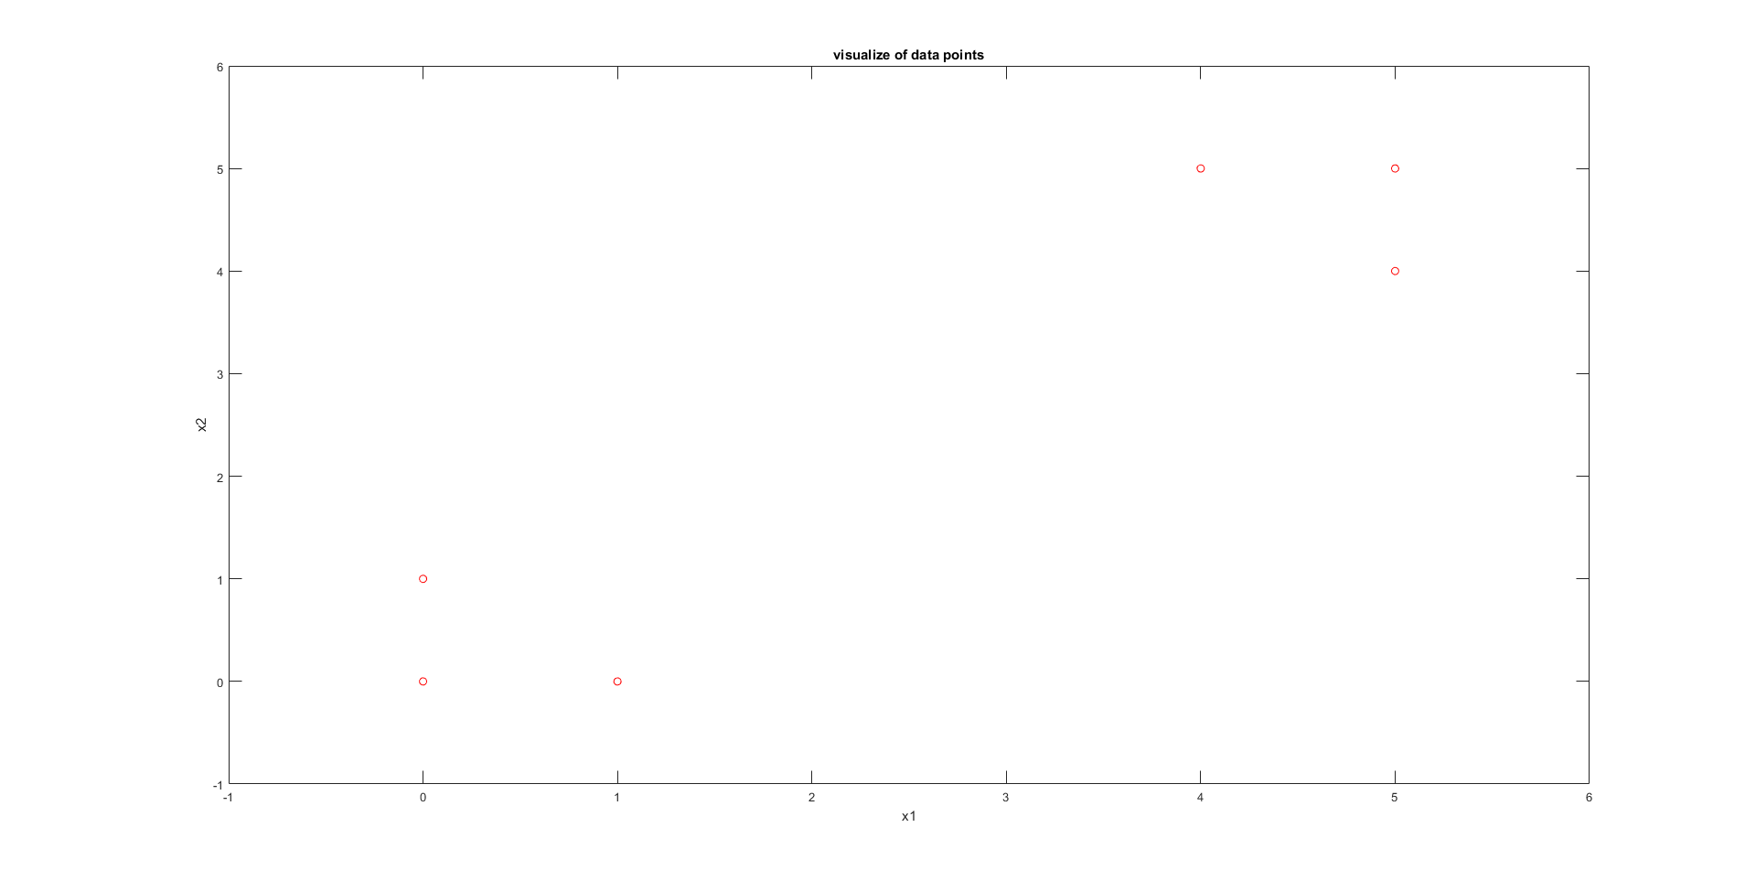

**Figure 1: Data visualization**

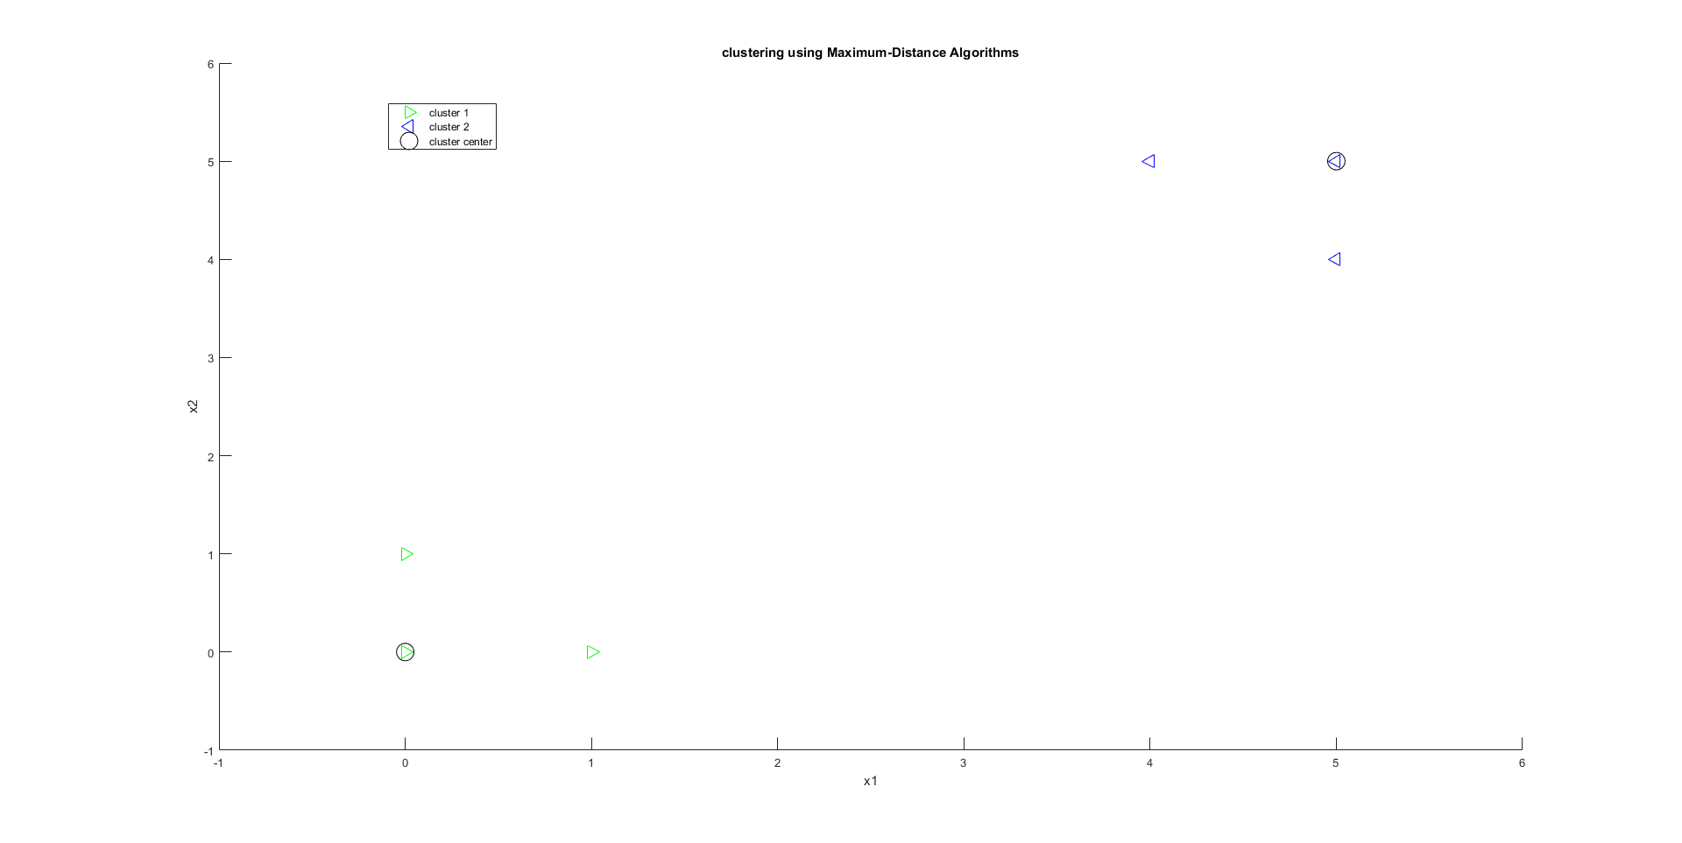

**Figure 2: Clustering Using Maximum Distance Algorithms**

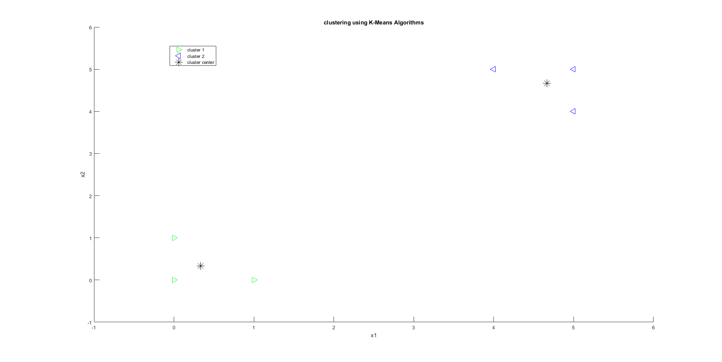

**Figure 3: Clustering Using K-Means Algorithms**