**Name: Mrinmoy Sarkar**

**Banner Id: 950-363-260**

**Project 1: Data creation and display**

**Results:** (1) 2-d plot of the Fisher’s Iris data with petal width versus sepal length

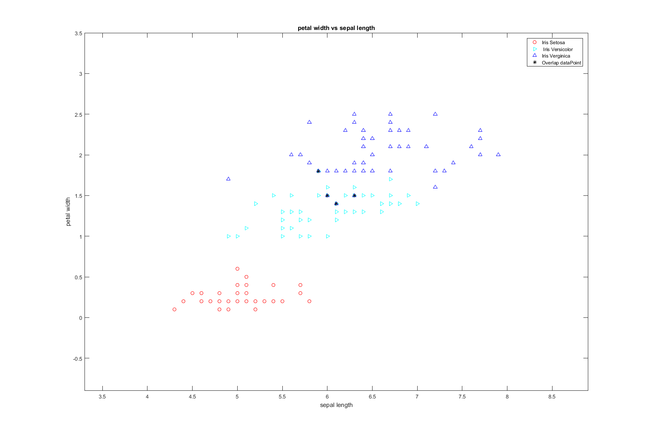

Figure 1: 2-d plot of the Fisher’s Iris data with petal width versus sepal length

# Total overlapping data points for petal width vs sepal length is: 4

(2) 2-d plot of the Fisher’s Iris data with petal length versus sepal width

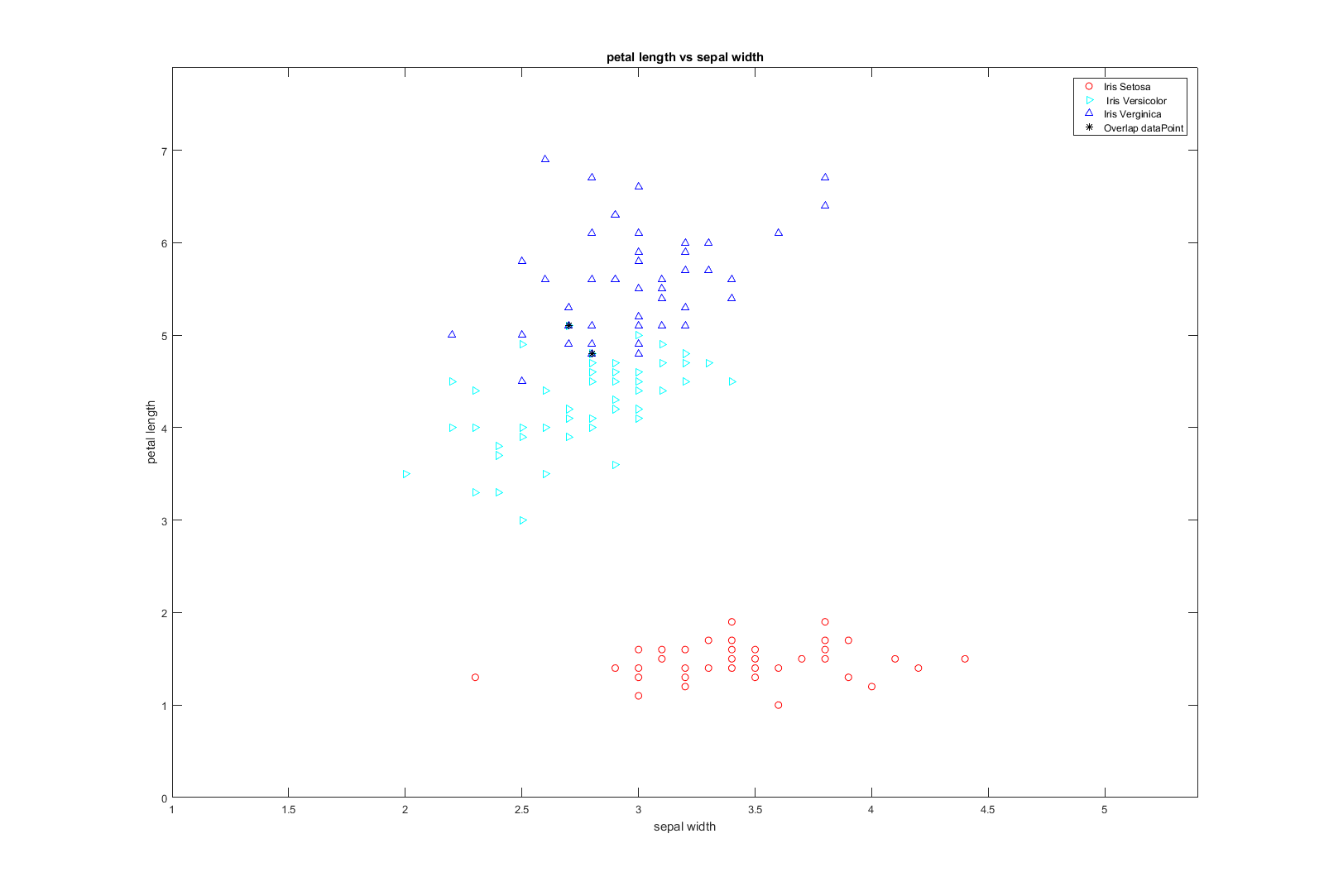

Figure 2: 2-d plot of the Fisher’s Iris data with petal length versus sepal width

# Total overlapping data points for petal length vs sepal width is: 2

**MATLAB Code:**

%% file name dataCreationAndDisplay.m

% author: Mrinmoy Sarkar

% email: msarkar@aggies.ncat.edu

% date: 9/2/2017

clear;

close all;

% load data to a veriable

data = importdata('iris.txt');

% no. of class is 3 named Iris-setosa, Iris-versicolor and Iris-verginica

% there are 4 attributes named sepal-length, sepal-width, petal-length,

% petal-width

% there are 50 plants for each species

irisSetosa = zeros(50,4);

irisVersicolor = zeros(50,4);

irisVerginica = zeros(50,4);

n = size(data,1);

indxSeto = 1;

indxVers = 1;

indxVerg = 1;

for i=2:n

x = strsplit(cell2mat(data(i)));

if strcmp(x(5), 'Iris-setosa')

for j=1:4

irisSetosa(indxSeto,j) = str2double(cell2mat(x(j)));

end

indxSeto = indxSeto + 1;

elseif strcmp(x(5), 'Iris-versicolor')

for j=1:4

irisVersicolor(indxVers,j) = str2double(cell2mat(x(j)));

end

indxVers = indxVers + 1;

elseif strcmp(x(5), 'Iris-virginica')

for j=1:4

irisVerginica(indxVerg,j) = str2double(cell2mat(x(j)));

end

indxVerg = indxVerg + 1;

end

end

%% plot Fisher's Iris data with petal width versus sepal length

figure;

plot(irisSetosa(:,1), irisSetosa(:,4), 'or'); hold on;

plot(irisVersicolor(:,1), irisVersicolor(:,4), '>c'); hold on;

plot(irisVerginica(:,1), irisVerginica(:,4), '^b'); hold on;

axis([min([min(irisSetosa(:,1)),min(irisVersicolor(:,1)),min(irisVerginica(:,1))])-1 ...

max([max(irisSetosa(:,1)),max(irisVersicolor(:,1)),max(irisVerginica(:,1))])+1 ...

min([min(irisSetosa(:,4)),min(irisVersicolor(:,4)),min(irisVerginica(:,4))])-1 ...

max([max(irisSetosa(:,4)), max(irisVersicolor(:,4)),max(irisVerginica(:,4))])+1]);

title('petal width vs sepal length');

xlabel('sepal length');

ylabel('petal width');

legend('Iris Setosa', ' Iris Versicolor', 'Iris Verginica','AutoUpdate','off');

%% plot overlap symbol (*)

x1 = table(irisSetosa(:,1),irisSetosa(:,4));

x2 = table(irisVersicolor(:,1),irisVersicolor(:,4));

x3 = table(irisVerginica(:,1),irisVerginica(:,4));

temp1 = union(intersect(x1,x2),intersect(x1,x3));

overlapingPoints = union(temp1, intersect(x2,x3));

disp(['Total overlapping data points for petal width vs sepal length is : ' num2str(size(overlapingPoints,1))])

plot(overlapingPoints.Var1, overlapingPoints.Var2, '*k');

legend('Iris Setosa', ' Iris Versicolor', 'Iris Verginica', 'Overlap dataPoint')

%% plot Fisher's Iris data with petal length versus sepal width

figure;

plot(irisSetosa(:,2), irisSetosa(:,3), 'or'); hold on;

plot(irisVersicolor(:,2), irisVersicolor(:,3), '>c'); hold on;

plot(irisVerginica(:,2), irisVerginica(:,3), '^b'); hold on;

axis([min([min(irisSetosa(:,2)),min(irisVersicolor(:,2)),min(irisVerginica(:,2))])-1 ...

max([max(irisSetosa(:,2)),max(irisVersicolor(:,2)),max(irisVerginica(:,2))])+1 ...

min([min(irisSetosa(:,3)),min(irisVersicolor(:,3)),min(irisVerginica(:,3))])-1 ...

max([max(irisSetosa(:,3)), max(irisVersicolor(:,3)),max(irisVerginica(:,3))])+1]);

title('petal length vs sepal width');

xlabel('sepal width');

ylabel('petal length');

legend('Iris Setosa', ' Iris Versicolor', 'Iris Verginica','AutoUpdate','off');

%% plot overlap symbol (*)

x1 = table(irisSetosa(:,2),irisSetosa(:,3));

x2 = table(irisVersicolor(:,2),irisVersicolor(:,3));

x3 = table(irisVerginica(:,2),irisVerginica(:,3));

temp1 = union(intersect(x1,x2),intersect(x1,x3));

overlapingPoints = union(temp1, intersect(x2,x3));

disp(['Total overlapping data points for petal length vs sepal width is : ' num2str(size(overlapingPoints,1))])

plot(overlapingPoints.Var1, overlapingPoints.Var2, '*k');

legend('Iris Setosa', ' Iris Versicolor', 'Iris Verginica', 'Overlap dataPoint')

**Summary of the results:**

**(1)**

* For petal width vs sepal length, Iris Setosa is linearly separable from Irsi Vesicolor and Iris Verginica
* There are 4 overlapping points between Irsi Vesicolor and Iris Verginica
* Because of the overlapping points, Irsi Vesicolor and Iris Verginica are not linearly separable

**(2)**

* For petal length vs sepal width, Iris Setosa is linearly separable from Irsi Vesicolor and Iris Verginica
* There are 2 overlapping points between Irsi Vesicolor and Iris Verginica
* Because of the overlapping points, Irsi Vesicolor and Iris Verginica are not linearly separable
* There are some points in Irsi Vesicolor and Iris Verginica that are enclosed in one another region