HW#3

Name: Mrinmoy Sarkar
Dept.:ECE
Course: ECEN-621

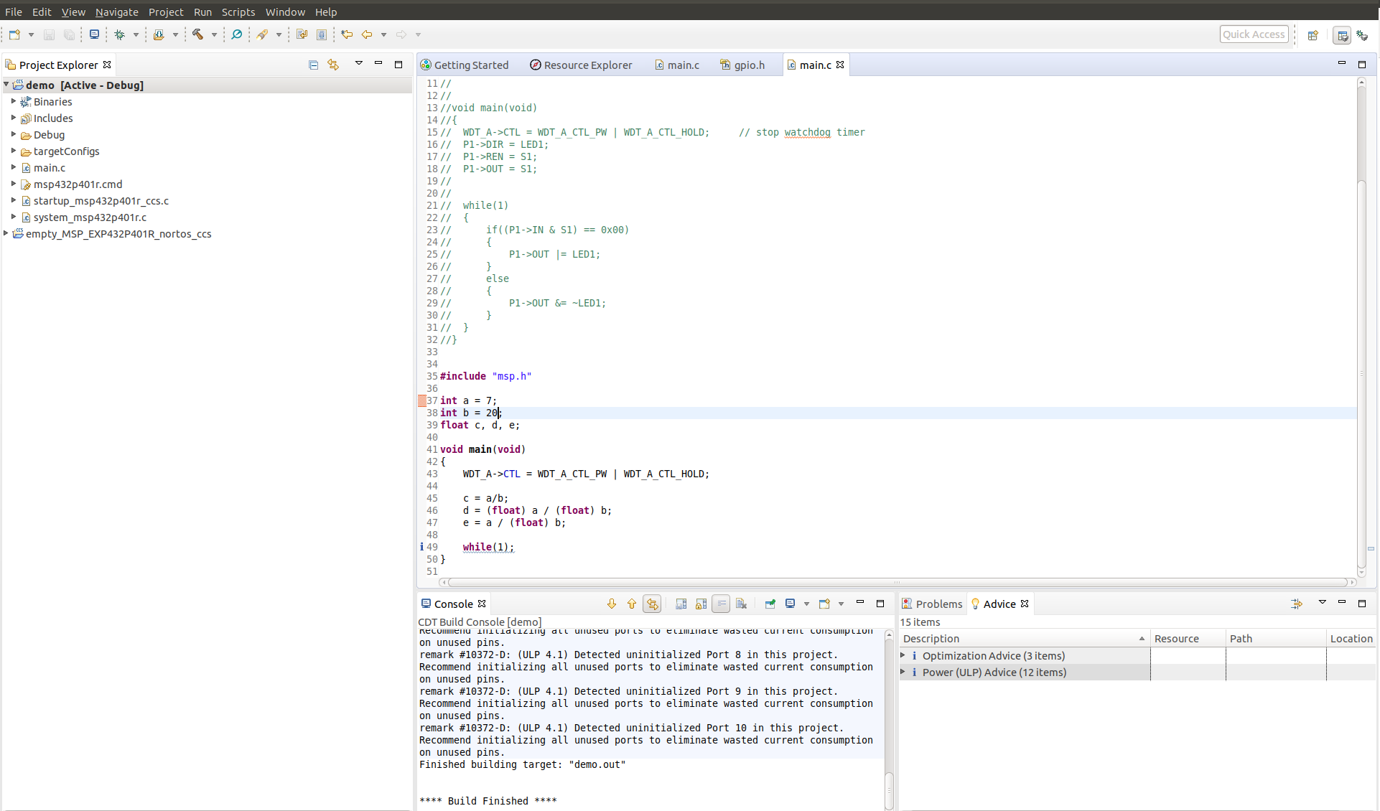
C Code
Input & Output Data
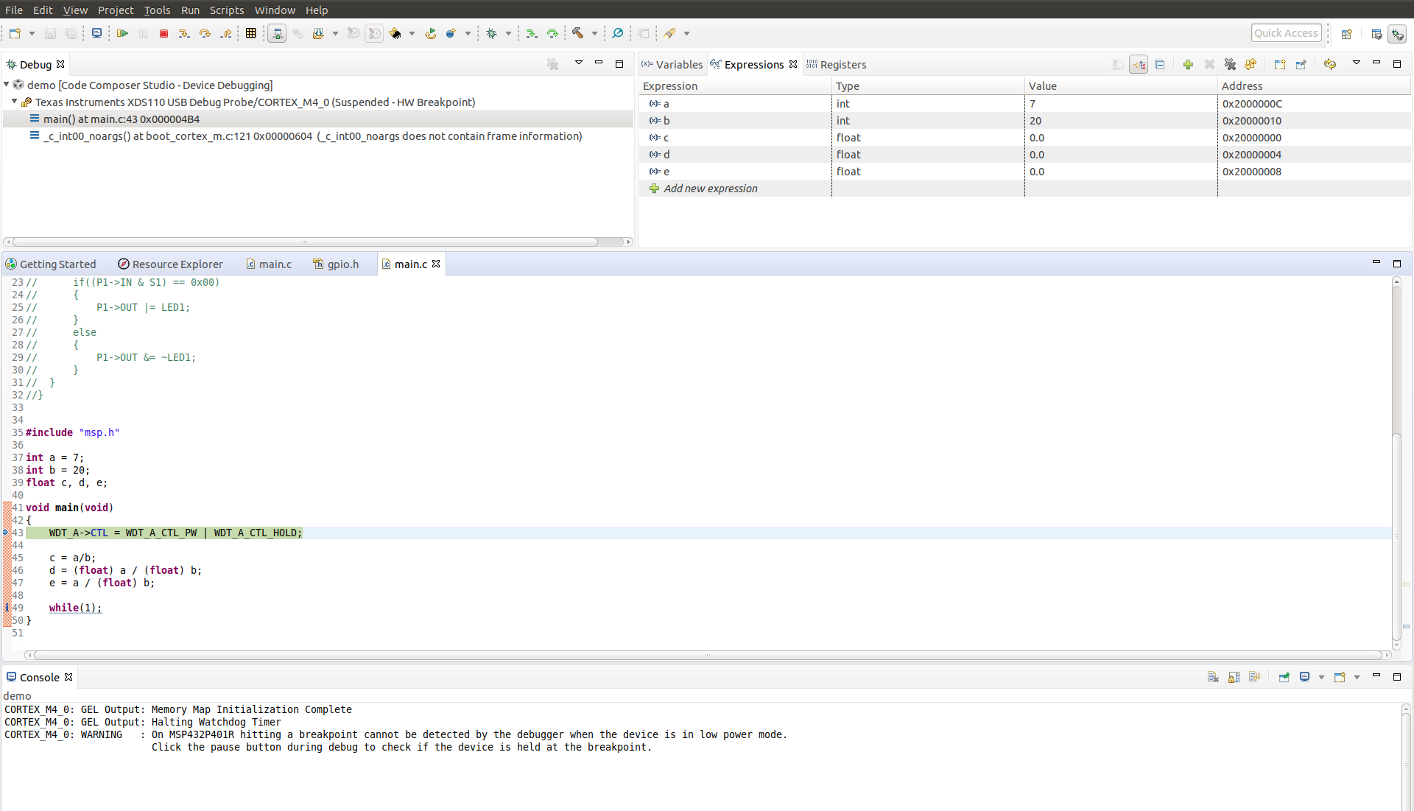

Assembly Code

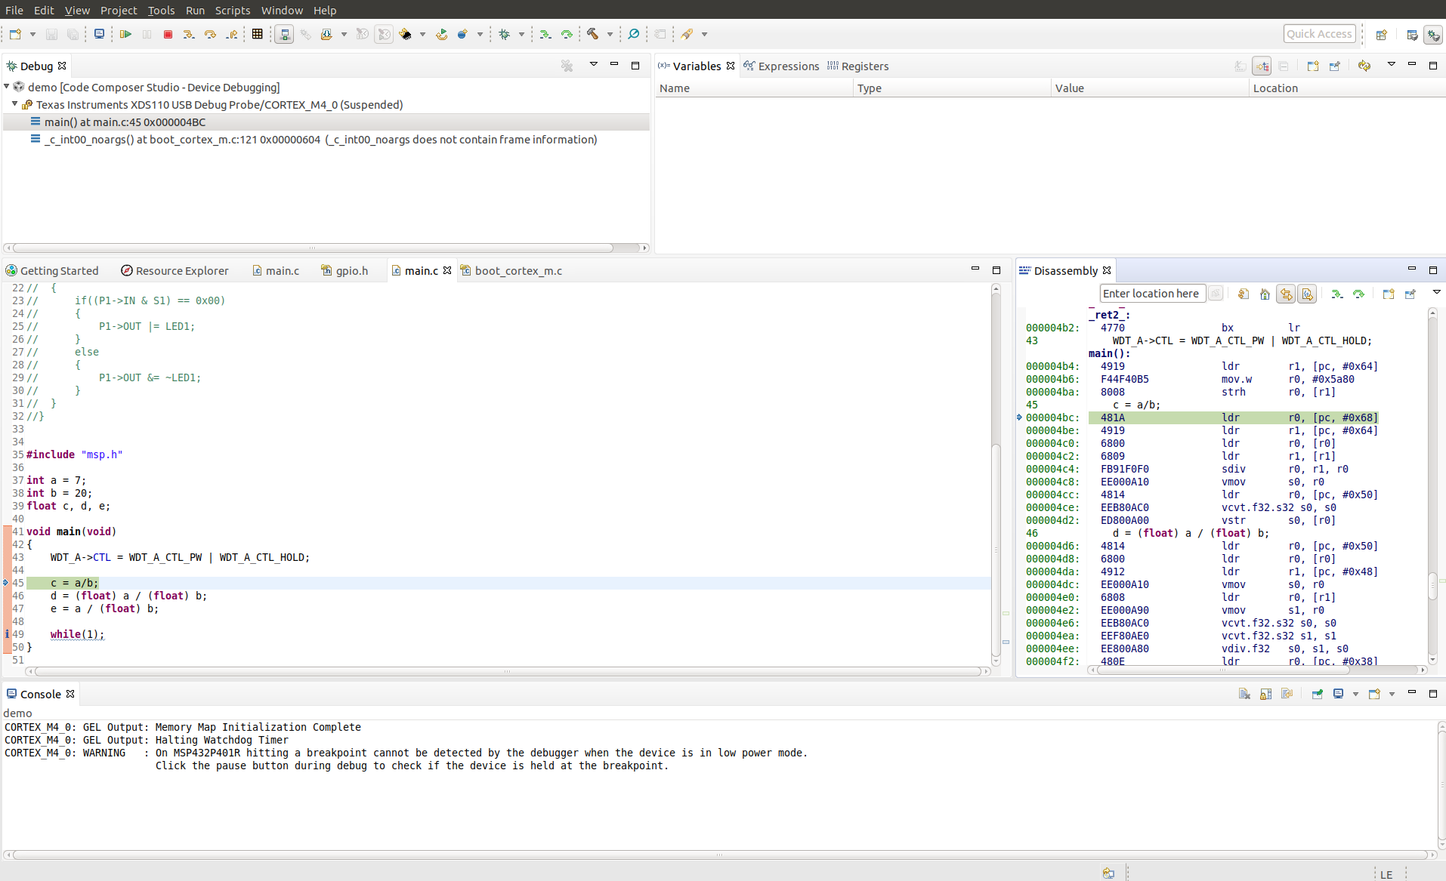
Break point utilization: I use break point in the beginning of the main function so that I can see how all the C statements execute one after another and how the variables change their values and stored in the memory of the micro-controller.

