HW#4

Name: Mrinmoy Sarkar
Dept.:ECE
Course: ECEN-621

C code for sequential programming approach :
#include "msp.h"

/**
* main.c
*/

#define LED_GREEN BIT1
#define S1 BIT1
#define DELAY 500

void main(void)
{
int i;
WDT_A->CTL = WDT_A_CTL_PW | WDT_A_CTL_HOLD; // stop watchdog timer
P1->DIR &= ~S1;
P1->REN = S1;
P1->OUT = S1;
P2->DIR = LED_GREEN;
P2->OUT = 0x00;

while(1)
{
if((P1->IN & S1) == 0x00)
{
for(i=0;i<DELAY;i++);
if((P1->IN & S1) == 0x00)
{
P2->OUT ^= LED_GREEN;
while((P1->IN & S1) == 0x00);
}
}
}

}

C code for state machine programming approach :
#include "msp.h"

/**
* main.c
*/

#define LED_GREEN BIT1
#define S1 BIT1
#define DELAY 500
int i;
enum Toggle_states {init_state, Unlit1_state, Unlit2_state, Lit1_state, Lit2_state} toggle_states;

void TicFct_Toggle_Led()
{
switch(toggle_states)
{
case init_state:
toggle_states = Unlit1_state;
break;
case Unlit1_state:
if((P1->IN & S1) == 0x00)
{
for(i=0;i<DELAY;i++);
if((P1->IN & S1) == 0x00)
{
toggle_states = Lit1_state;
}
}
break;
case Lit1_state:
if((P1->IN & S1) != 0x00)
{
for(i=0;i<DELAY;i++);
if((P1->IN & S1) != 0x00)
{
toggle_states = Lit2_state;
}
}
break;
case Lit2_state:
if((P1->IN & S1) == 0x00)
{
for(i=0;i<DELAY;i++);
if((P1->IN & S1) == 0x00)
{
toggle_states = Unlit2_state;
}
}
break;
case Unlit2_state:
if((P1->IN & S1) != 0x00)
{
for(i=0;i<DELAY;i++);
if((P1->IN & S1) != 0x00)
{
toggle_states = Unlit1_state;
}
}
break;
}
switch(toggle_states)
{
case Unlit1_state:
case Unlit2_state:
P2->OUT &= ~LED_GREEN;
break;
case Lit1_state:
case Lit2_state:
P2->OUT |= LED_GREEN;
break;
}
}

void main(void)
{
toggle_states = init_state;

WDT_A->CTL = WDT_A_CTL_PW | WDT_A_CTL_HOLD; // stop watchdog timer
P1->DIR &= ~S1;
P1->REN = S1;
P1->OUT = S1;
P2->DIR = LED_GREEN;
P2->OUT = 0x00;

while(1)
{
TicFct_Toggle_Led();
}
}

Flowchart of Sequential program:
START
S1==0?
END
LED = !LED;
Power Off?
LED = 0;
YES
NO
YES
NO

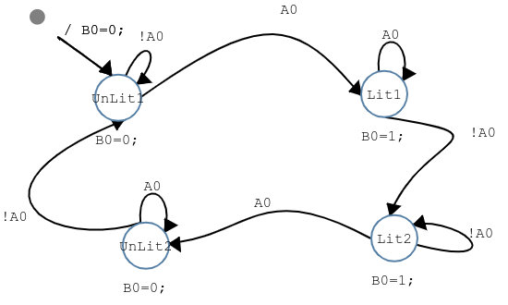
RIBS model for the SM program:

Delay in for loop:
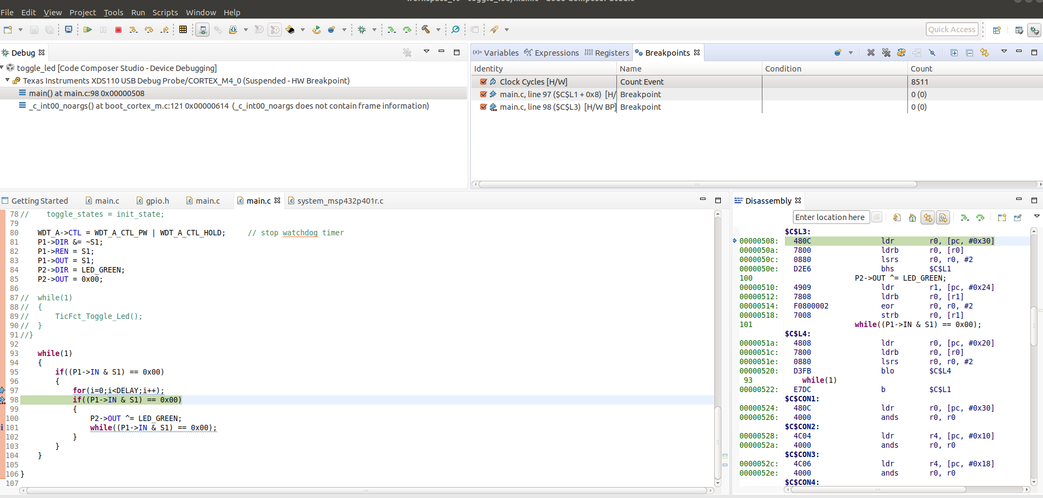
#define __SYSTEM_CLOCK 3000000

The actual delay = 8511/3000000 = 0.002837 sec = 2.837 ms

