MATLAB Assignment #3

Name: Mrinmoy Sarkar

Banner ID: 95036-3260

Class: Digital Image Processing(ECEN-657)

Semester: Spring 2018

Date of Submission: 04/12/2018

**MATLAB program:**

|  |
| --- |
| %% Matlab Assignment #3  % author : Mrinmoy Sarkar  % email : msarkar@aggies.ncat.edu  % date : 3/26/2018  %%  clear all; close all;    %% form f(x,y)  X=1:251;  Y=1:251;  [xx,yy]=meshgrid(Y,X);  f = zeros(251,251,'logical');  f(120:130,120:130)=1;  %% form g(x,y)  g = zeros(251,251,'logical');  for i=1:251  for j=1:251  dx = i-125;  dy = j-125;  if ((dx^2+dy^2)^0.5) <= 5  g(i,j) = 1;  end  end  end  %% plot and image show f(x,y) and g(x,y)  figure(1)  subplot(231)  plot(f)  title('f(x,y) 2D')  subplot(232)  mesh(xx,yy,f);  title('f(x,y) 3D')  subplot(233)  imshow(f)  title('f(x,y)')  subplot(234)  plot(g)  title('g(x,y) 2D')  subplot(235)  mesh(xx,yy,g)  title('g(x,y) 3D')  subplot(236)  imshow(g)  title('g(x,y)')  % cicular shift in spatial domain  f = circshift(f,[125,125]);  g = circshift(g,[125,125]);  %% plot and image show f(x,y) and g(x,y) after circular shift  figure(2)  subplot(231)  plot(f)  title('f(x,y) after circular shift in spatial domain 2D')  subplot(232)  mesh(xx,yy,f);  title('f(x,y) after circular shift in spatial domain 3D')  subplot(233)  imshow(f)  title('f(x,y) after circular shift in spatial domain')  subplot(234)  plot(g)  title('g(x,y) after circular shift in spatial domain 2D')  subplot(235)  mesh(xx,yy,g)  title('g(x,y) after circular shift in spatial domain 3D')  subplot(236)  imshow(g)  title('g(x,y) after circular shift in spatial domain')  %% find F(u,v) and G(u,v)  F = fft2(f);  G = fft2(g);    %% plot and image show |F(u,v)| and |G(u,v)|  figure(3)  subplot(231)  plot(abs(F))  title('|F(u,v)| 2D')  subplot(232)  mesh(xx,yy,abs(F));  title('|F(u,v)| 3D')  subplot(233)  imshow(abs(F))  title('|F(u,v)|')  subplot(234)  plot(abs(G))  title('|G(u,v)| 2D')  subplot(235)  mesh(xx,yy,abs(G))  title('|G(u,v)| 3D')  subplot(236)  imshow(abs(G))  title('|G(u,v)|')    %% plot and image show phase(F(u,v)) and phase(G(u,v))  figure(4)  subplot(231)  plot(angle(F));  title('phase(F(u,v)) 2D')  subplot(232)  mesh(xx,yy,angle(F));  title('phase(F(u,v)) 3D')  subplot(233)  imshow(angle(F))  title('phase(F(u,v))')  subplot(234)  plot(angle(G))  title('phase(G(u,v)) 2D')  subplot(235)  mesh(xx,yy,angle(G))  title('phase(G(u,v)) 3D')  subplot(236)  imshow(angle(G))  title('phase(G(u,v))')    %% plot and image show circular shift of |F(u,v)| and |G(u,v)|  figure(5)  subplot(231)  plot(abs(fftshift(F)));  title('circular shifted |F(u,v)| 2D')  subplot(232)  mesh(xx,yy,abs(fftshift(F)));  title('circular shifted |F(u,v)| 3D')  subplot(233)  imshow(abs(fftshift(F)))  title('circular shifted |F(u,v)|')  subplot(234)  plot(abs(fftshift(G)))  title('circular shifted |G(u,v)| 2D')  subplot(235)  mesh(xx,yy,abs(fftshift(G)))  title('circular shifted |G(u,v)| 3D')  subplot(236)  imshow(abs(fftshift(G)))  title('circular shifted |G(u,v)|')    %% plot and image show circular shift of phase(F(u,v)) and phase(G(u,v))  figure(6)  subplot(231)  plot(angle(fftshift(F)));  title('circular shifted phase(F(u,v)) 2D')  subplot(232)  mesh(xx,yy,angle(fftshift(F)));  title('circular shifted phase(F(u,v)) 3D')  subplot(233)  imshow(angle(fftshift(F)))  title('circular shifted phase(F(u,v))')  subplot(234)  plot(angle(fftshift(G)))  title('circular shifted phase(G(u,v)) 2D')  subplot(235)  mesh(xx,yy,angle(fftshift(G)))  title('circular shifted phase(G(u,v)) 3D')  subplot(236)  imshow(angle(fftshift(G)))  title('circular shifted phase(G(u,v))') |

**Figures:**

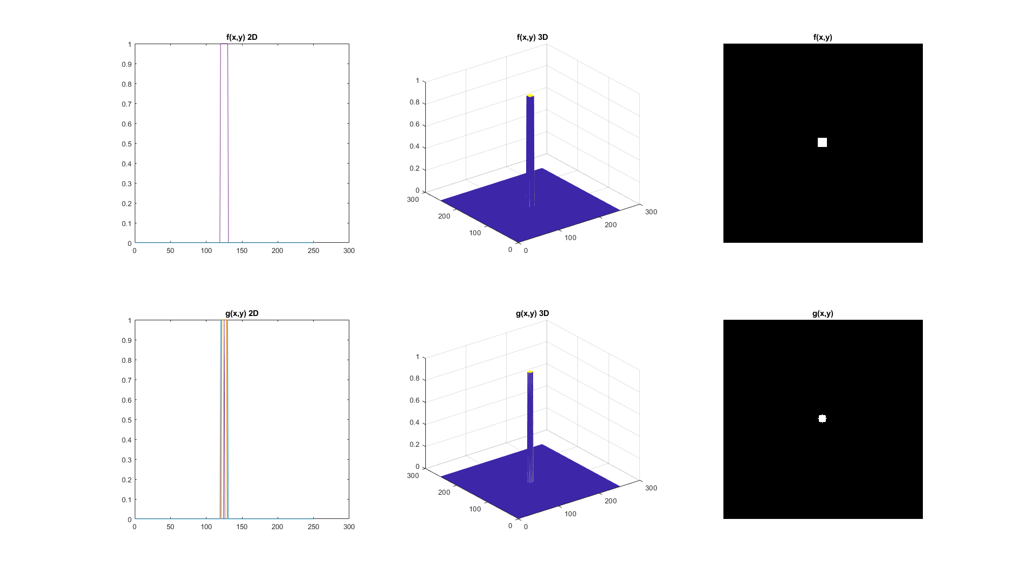

Figure 1: f(x,y) and g(x,y)

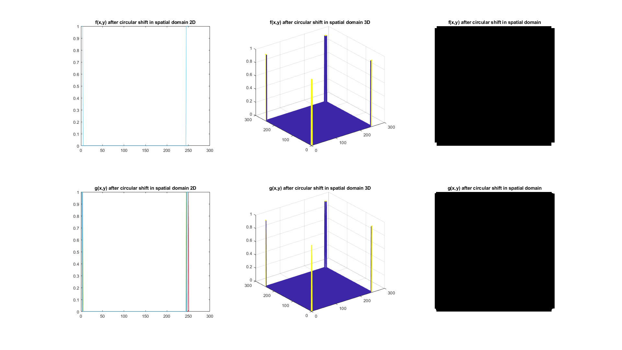

Figure 2: f(x,y) and g(x,y) circular sgifted in spatial domain

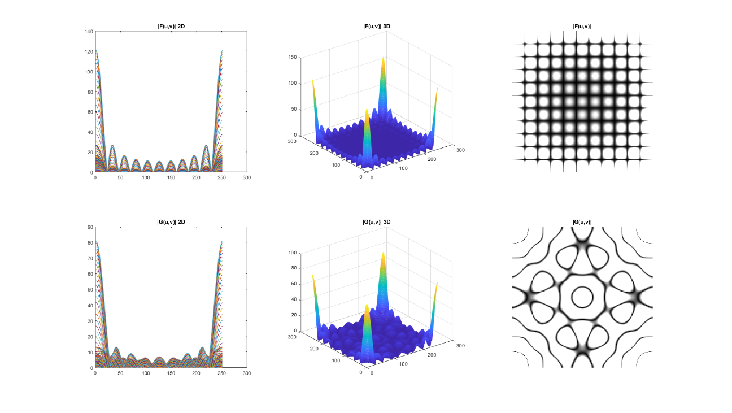

Figure 3: |F(u,v)| and |G(u,v)|

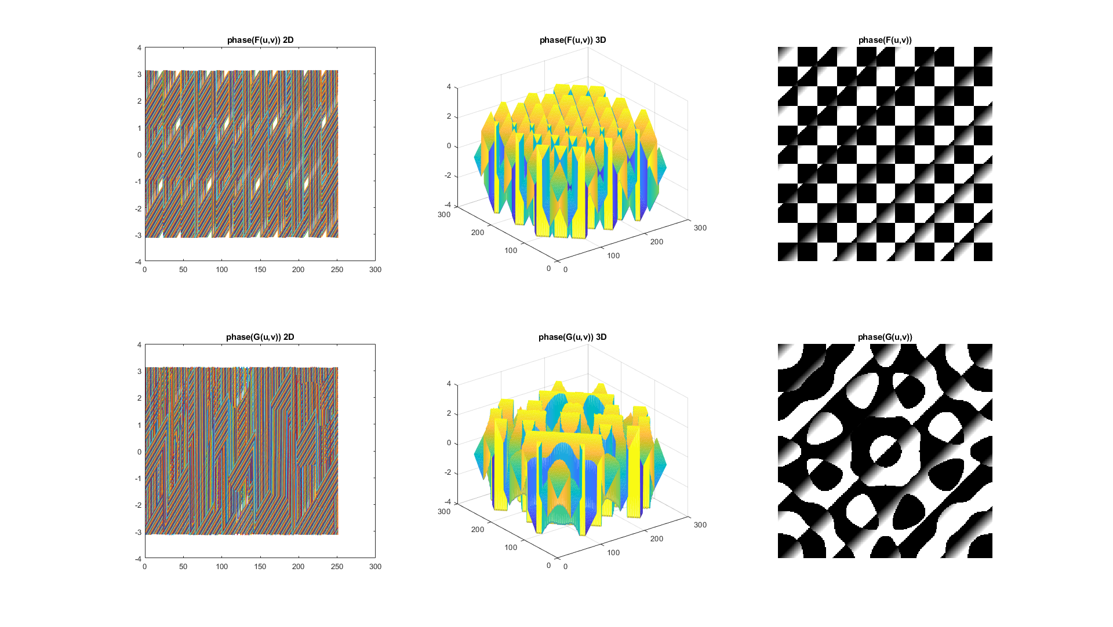

Figure 4: phase(F(u,v)) and phase(G(u,v))

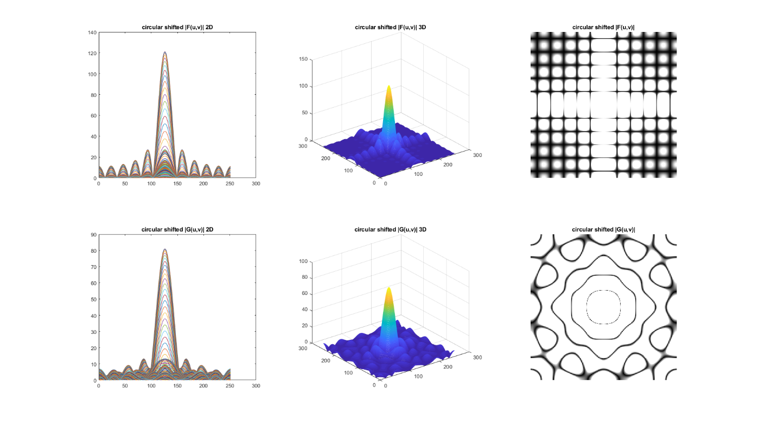

Figure 5: circular shifted |F(u,v)| and |G(u,v)|

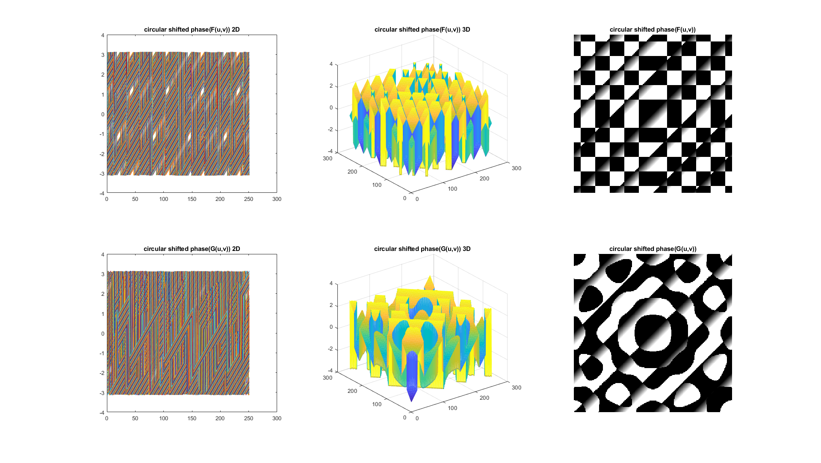

Figure 6: circular shifted phase(F(u,v)) and phase(G(u,v))

************************** The End **************************