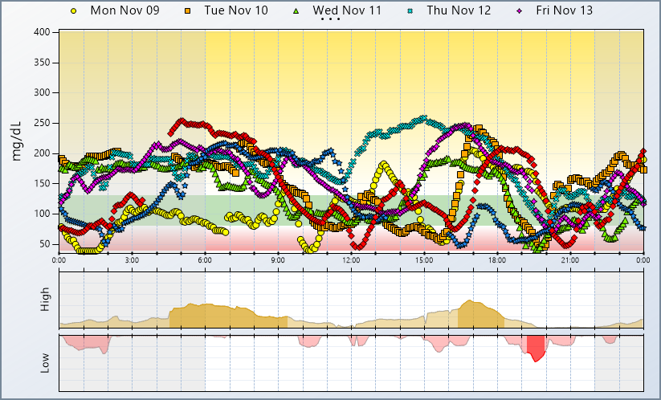 |  |  |  | Statistics
 |  |  |  | Average Glucose |  |  | 142 mg/dL
 |  |  |  | Sensor Usage |  |  | 7 of 7 Days
 |  |  |  | Calibrations / day |  |  | 2.9
 |  |  |  | Standard Deviation |  |  | ± 52 mg/dL
 |  |  |  | 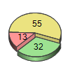 |  |  | 55 % High
 |  |  |  |  |  |  | 32 % Target
 |  |  |  |  |  |  | 13 % Low
 |  |  |  | Target Range |  |  |  | 80 - 130 mg/dL
 |  |  |  | Nighttime | 22:00 - 6:00
 |  |  |  | Interpretation
Note: See above graph for other patterns as well as review any individualized considerations.
Pattern Insights Summary |  | Some Possible Considerations
Nighttime Lows  (0 Found) | No significant patterns detected
Daytime Lows  (1 Found) | Most significant pattern of lows found between 19:10 and 20:00 | - Adjustment to basal insulin  - Adjustment to meal-time or correction insulin  - Review carbohydrate counting  - Effects of exercise, alcohol, and/or food choices
Nighttime Highs  (1 Found) | Most significant pattern of highs found between 4:30 and 9:25 | - Adjustment to basal, dinner, or snack insulin  - Delayed absorption of high fat/protein dinner meal  - High bedtime glucose range; fear of overnight hypo
Daytime Highs  (1 Found) | Most significant pattern of highs found between 16:20 and 18:20 | - Adjustment to the timing of insulin delivery  - Adjustment to meal-time insulin or correction dose  - Effects of exercise, alcohol, and/or food choices

