* **Detailed explanation**:

All changes related to the new instruction are tagged with comment: *// ADDIUPC* in the soft-core. We must perform the following actions:

* Inhibit “*Reserved Instruction Exception*”:

Change:

*assign maj_ri_e = … (mpc_ir_e[31:28] == 4'b011_0) ||*

For:

*assign maj_ri_e = ...*

*((mpc_ir_e[31:28] == 4'b011_0) && (mpc_ir_e[27:26] != 2'b00)) || // ADDIUPC*

* Change signals:
  + - * ***alu_sel_e***: This signal is registered to the next stage through the Main Pipeline Registers. Then, at m14k_edp, when it is 1, it selects the ALU for output at the M-Stage.

Set this signal to 1 when an addiupc is found:

*((mpc_ir_e[31:26] == 6'o30)) || // ADDIUPC*

* + - * ***maj_vd_e***: This signal controls the RF write strobe at A/W-Stage. Set to 1 when addiupc found:

*((mpc_ir_e[31:26] == 6'o30)) || // ADDIUPC*

* New signal:
  + - * ***addiupc_instr***: Set to 1 when addiupc found:

*assign addiupc_instr = (mpc_ir_e[31:26] == 6'o30);*

* Change signal ***dest_e***based on the new signal: We must select Rs as Destination Register:

*assign dest_e [5:0] = addiupc_instr ? { 1'b0, mpc_ir_e[25:21] } : ((special_e | spec2_e | mpc_cnvt_e | rwpgpr_e | dest_cnvt_dsp_e | lx_e) ? { rwpgpr_e & ~rdpgpr_e, pdest_e } : ((lnk31_e) ? 6'h1f : { 1'b0, src_b_e[4:0] })); // ADDIUPC*

* Incorporate new functionality:
  + - * We must insert the new operands as an input to the “*m14k_edp_add_simple*” adder. ***aop_e*** and ***bop_e*** are the inputs to the adder:
        1. ***aop_e***: Incorporate the PC as an input. The PC is already available at E-Stage in signal ***iva_e***.

*assign* ***aop_e*** *[31:0] = addiupc_instr ? iva_e : (icc_pcrel_e ? (iva_e & ~{30'b0, {2{icc_pcrel_e}}}) : edp_abus_e); // ADDIUPC*

* + - * 1. ***bop_e***: Incorporate the SignExt(Imm<<2) as an input.

*assign* ***bop_e*** *[31:0] = addiupc_instr ? { {11{mpc_ir_e[18]}}, mpc_ir_e[18:0], 2'b0} : {32{mpc_subtract_e}} ^ bbus_imm_e; // ADDIUPC*

* **EXAMPLE - SIMULATION**:

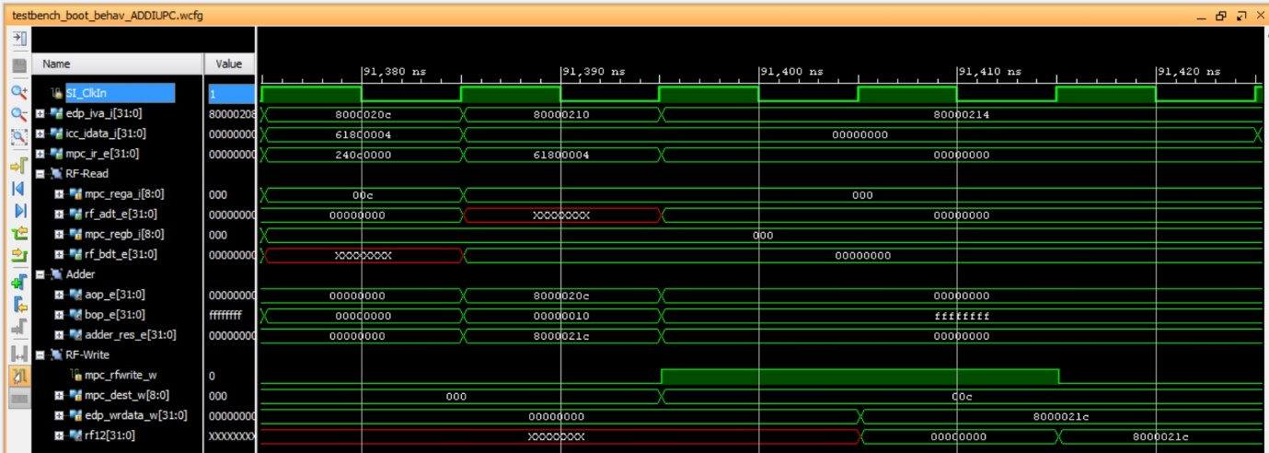

Observe that in the 5th cycle rf12($t4)=0x800002ac.

* **EXAMPLE – EXECUTION ON THE BOARD**:

When the program is downloaded on the board, you should see on the 7-seg displays:

* 7-seg displays=$t4, which in our example is 0x8000021c

Then, when you debug the program following the steps stated in the document, you should observe the following:

