* **EXPLANATION**:
* **m14k_mpc_dec:**
  + Disable exception for the funct field that we will use (*funct* = *011100*).

assign spec_ri_e = special_e && ((mpc_ir_e[5:0] == 6'o05) ||

(mpc_ir_e[5:0] == 6'o16) ||

(mpc_ir_e[5:2] == 4'b010_1) ||

(mpc_ir_e[5:0] == 6'b011_101) || // LWI

(mpc_ir_e[5:1] == 5'b011_11) || // LWI

(mpc_ir_e[5:1] == 5'b101_00) ||

(mpc_ir_e[5:2] == 4'b101_1) ||

(mpc_ir_e[0] && mpc_ir_e[5:2] == 4'b110_1) ||

((mpc_ir_e[5:3] == 3'o2) & ~edp_dsp_present_xx &

(mpc_ir_e[0] ? (mpc_ir_e[12:11] != 2'b00) : // 11, 13 (HI/LO 1-3)

(mpc_ir_e[22:21] != 2'b00))) ||

(mpc_ir_e[5:3] == 3'o7));

* + Control signals:
    - **load_e**:

assign load_e = !(mpc_ldst_e & ~(mpc_ir_e[31:26] == 6'o23) ? (mpc_ir_e[29] || mpc_atomic_m) :

(mpc_ir_e[31:26] == 6'o23) ? mpc_ir_e[3] :

(mpc_ir_e[23:21] == 3'b011) ? mpc_ir_e[9] : mpc_ir_e[23]) ||

mpc_lxs_e || lx_e || cop_e || synci_e || mpc_atomic_e || lwi_instr_e; // LWI

* + - **mpc_ldst_e**:

assign mpc_ldst_e = lwi_instr_e || mpc_lxs_e || mpc_ir_e[31] || (regimm_e && (mpc_ir_e[20:16] == 5'o07)) || lx_e || (mpc_ir_e[31:26] == 6'o23) && !mpc_ir_e[5];

* + - **lwi_instr_e**:

assign lwi_instr_e = special_e && (mpc_ir_e[5:0] == 6'b011_100); // LWI

* **m14k_edp:**
  + Select register for lwi instruction:

assign dva_offset_e[31:0] = lwi_instr_e ? edp_bbus_e : !mpc_selimm_e ? bbusis_e

: (mpc_atomic_e || mpc_atomic_m) ? {{20{mpc_imsgn_e}}, mpc_ir_e[11:0]}

: {{16{mpc_imsgn_e}}, mpc_ir_e[15:0]};

* **EXAMPLE - SIMULATION**:

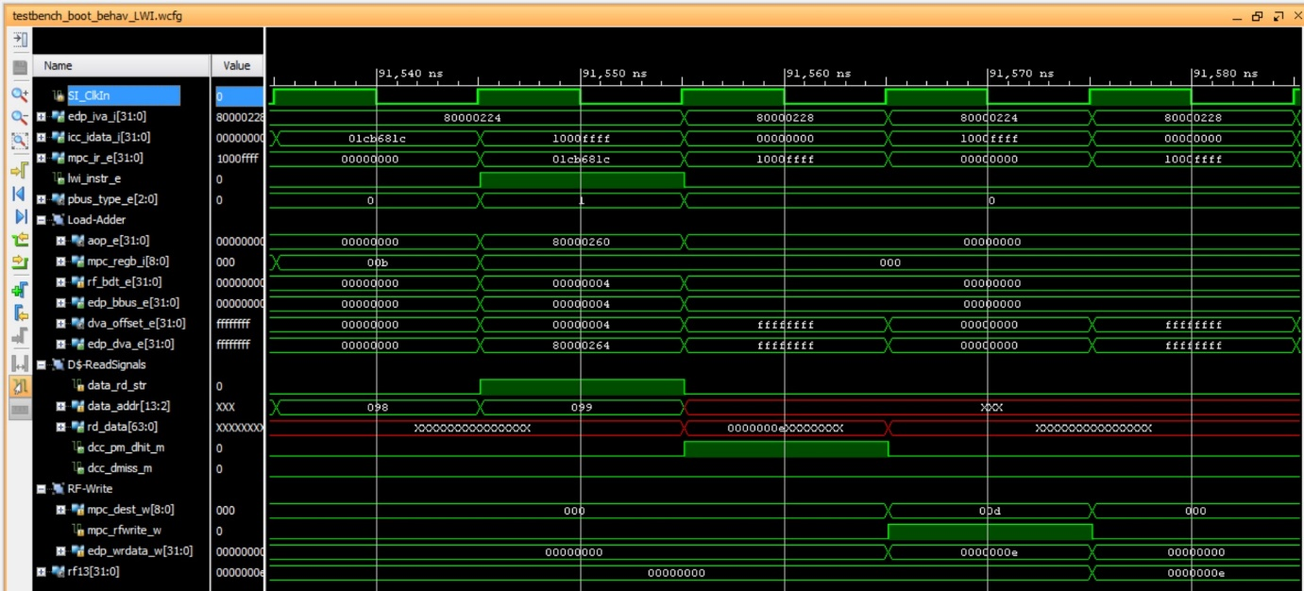

Observe that in the fifth cycle rf13=0xe, as this is the value read from the D$.

* **EXECUTION ON THE BOARD**:

When the program is downloaded on the board, you should see on the 7-seg displays:

* 7-seg displays=$t5, which in our example is 0x0000000e

Then, when you debug the program following the steps stated in the document, you should observe the following:

