* **EXPLANATION**:

Detailed explanation: All changes related to the new instruction are tagged with comment: *// LWPC* in the soft-core. We must perform the following actions:

* Inhibit “*Reserved Instruction Exception*”:

Comment:

*assign maj_ri_e = … (mpc_ir_e[31:26] == 6'o47) ||*

* New signal:
  + - * ***lwpc_instr***: Set to 1 when lwpc found:

*assign lwpc_instr = (mpc_ir_e[31:26] == 6'o47);*

* Incorporate new functionality:
  1. We must insert the new operands as an input to the *lw* adder. ***aop_e*** and ***dva_offset_e*** are the inputs to the adder that calculates the Effective Address:
  2. ***aop_e***: Incorporate the PC as an input. The PC is already available at E-Stage in signal ***iva_e***.

*assign* ***aop_e****[31:0] = lwpc_instr ? iva_e : (icc_pcrel_e ? (iva_e & ~{30'b0, {2{icc_pcrel_e}}}) : edp_abus_e); // LWPC*

* 1. ***dva_offset_e***: Incorporate the SignExt(Imm<<2) as an input.

*assign* ***dva_offset_e****[31:0] = lwpc_instr ? { {11{mpc_ir_e[18]}}, mpc_ir_e[18:0], 2'b0} : {32{mpc_subtract_e}} ^ bbus_imm_e; // LWPC*

* We must select Rs as Destination Register:

*assign dest_e [5:0] = lwpc_instr ? { 1'b0, mpc_ir_e[25:21] } : ((special_e | spec2_e | mpc_cnvt_e | rwpgpr_e | dest_cnvt_dsp_e | lx_e) ? { rwpgpr_e & ~rdpgpr_e, pdest_e } : ((lnk31_e) ? 6'h1f : { 1'b0, src_b_e[4:0] })); // LWPC*

* **EXAMPLE - SIMULATION**:

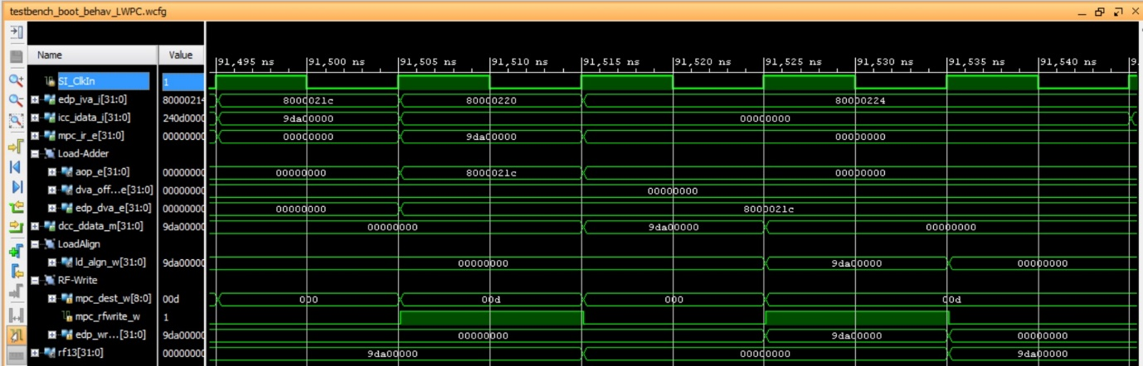

Observe that in the fifth cycle rf13 is written to 0x9da00000, which corresponds to the opcode of the instruction stored at PC=0x8000021c.

* **EXECUTION ON THE BOARD**:

When the program is downloaded on the board, you should see on the 7-seg displays:

* 7-seg displays=$t5, which in our example is 0x9da00000

Then, when you debug the program following the steps stated in the document, you should observe the following:

