* **EXPLANATION**:
  1. All changes related to the new instruction are tagged with comment: *// BEQC* in the soft-core. We must perform the following actions:
     + Annul the DS when the branch is not taken: There is a specific signal (***annul_ds_i***) which annuls the DS. For Branch Likely instructions, the DS is annulled when the condition for the branch is not met (!***mpc_eqcond_e***). For Branch Compact instructions, the DS is annulled when the condition for the branch is met (***mpc_eqcond_e***). Note that we only change the functionality of the BEQL instruction.

Change:

*assign annul_ds_i = (br_likely_e && mpc_irval_e && !mpc_eqcond_e) ||*

For:

*assign annul_ds_i = ((br_likely_e && mpc_ir_e[27:26]!=2'b00) && mpc_irval_e && !mpc_eqcond_e) || // BranchCompact*

*((br_likely_e && mpc_ir_e[27:26]==2'b00) && mpc_irval_e && mpc_eqcond_e) || // BranchCompact*

* **EXAMPLE - SIMULATION**:

**Results of the simulation on the original core (BEQL instruction):**

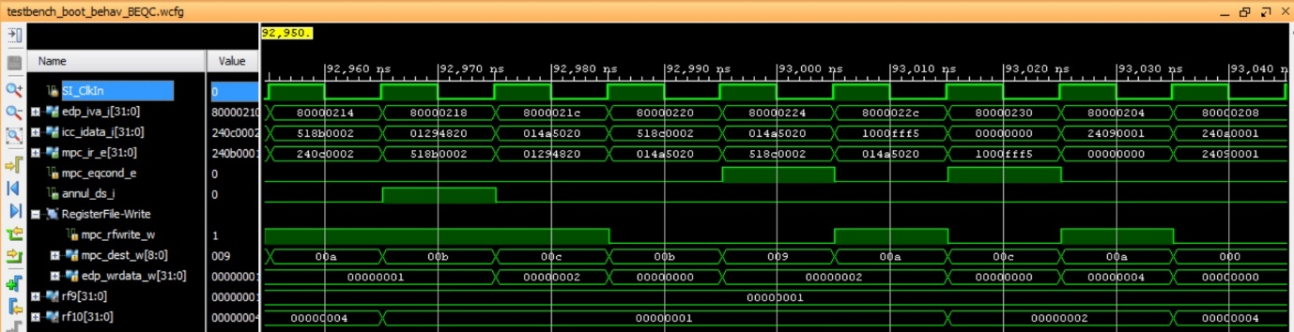

In the second cycle, the first beql is executed. The condition is not met (mpc_eqcond_e=0), thus the branch is not taken. In this case, the instruction in the branch delay slot must not be executed (annul_ds_i=1). Observe that, in cycle 5, the register file is not written.

In the fifth cycle, the second beql is executed. The condition is met (mpc_eqcond_e=1), thus the branch is taken. In this case, the instruction in the branch delay slot must be executed (annul_ds_i=0). Observe that, in the eighth cycle, the register file is written with the result of the instruction in the delay slot.

The result in registers $t1 and $t2 is:

* $t1(rf9)=1
* $t2(rf10)=4

**Results of the simulation on the modified core (BEQC instruction):**

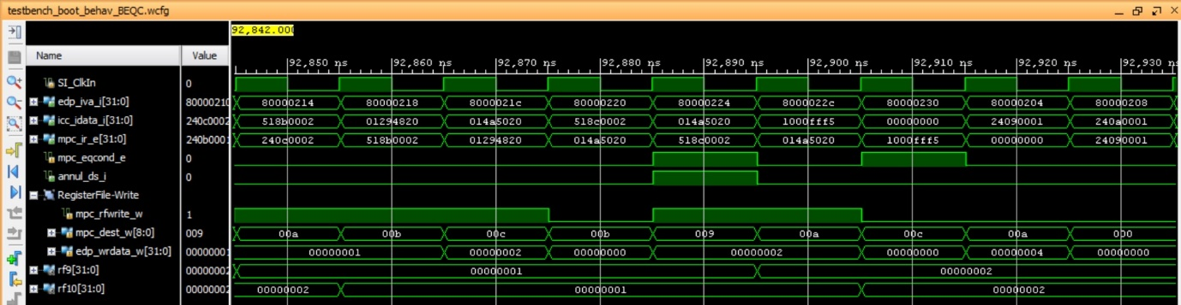

In the second cycle, the first beql is executed. The condition is not met (mpc_eqcond_e=0), thus the branch is not taken. In this case, differently to the previous case, the instruction in the branch delay slot must be executed (annul_ds_i=0). Observe that, in cycle 5, the register file is written.

In the fifth cycle, the second beql is executed. The condition is met (mpc_eqcond_e=1), thus the branch is taken. In this case, differently to the previous case, the instruction in the branch delay slot must not be executed (annul_ds_i=1). Observe that, in the eighth cycle, the register file is not written.

The result in registers $t1 and $t2 is:

* $t1(rf9)=2
* $t2(rf10)=2
* **EXECUTION ON BOARD**:

**Results of the execution on the original core (BEQL instruction):**

When the program is downloaded on the board, you should see on the 7-seg displays:

* Switches=0 🡪 7-seg displays=$t1, which in our example is 0x1
* Switches=1 🡪 7-seg displays=$t2, which in our example is 0x4

**Results of the execution on the modified core (BEQC instruction):**

When the program is downloaded on the board, you should see on the 7-seg displays:

* Switches=0 🡪 7-seg displays=$t1, which in our example is 0x2
* Switches=1 🡪 7-seg displays=$t2, which in our example is 0x2

**Debug of the modified core:**

