# Simulation

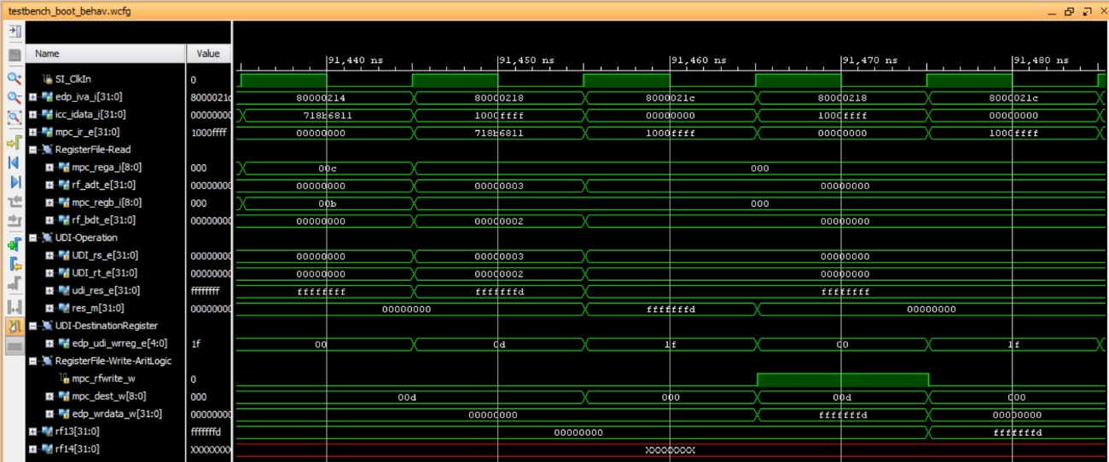

# Implementation on the board

You should see the result of the NAND operation (i.e. 0xfffffffd), stored in $t5, on the 7 Segment Displays.

When using the debugger:

