# Simulation

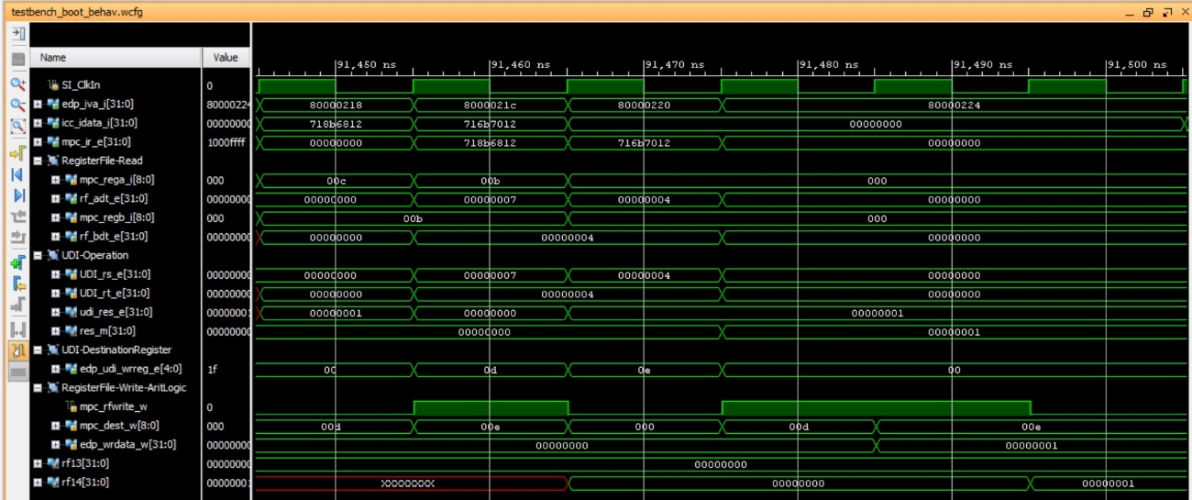

# Implementation on the board

When the program is downloaded on the board, you should see on the 7-seg displays:

* Switches=0 🡪 7-seg displays=$t5, which in our example is 0x0
* Switches=1 🡪 7-seg displays=$t6 which in our example is 0x1
* Any other value for the switches 🡪 7-seg displays=0x0

Then, when you debug the program following the steps stated in the document, you should observe the following:

