### Simulation:

**1) Simulation without ISPRAM:**

We next show the execution of the initial instructions of the FP algorithm:

8000023c: 3c0f3fa0 lui t7,0x3fa0

80000240: 3c184020 lui t8,0x4020

80000244 <flpadd>:

80000244: 3c0c007f lui t4,0x7f

80000248: 358cffff ori t4,t4,0xffff

8000024c: 01ec4024 and t0,t7,t4

80000250: 030c4824 and t1,t8,t4

…

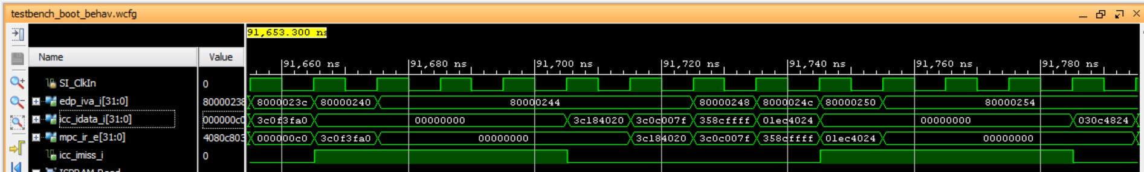

You can see that every 4 instructions there is an I$ miss.

**2) Simulation with ISPRAM:**

We first show the simulation of the cache instruction that initializes the first instruction in the ISPRAM (instruction addiu $t7,$a0,0 (0x248f0000)):

80000230: 3c0b248f lui t3,0x248f

80000234: 408be001 mtc0 t3,c0_datalo

**80000238: bc080000 cache 0x8,0(zero)**

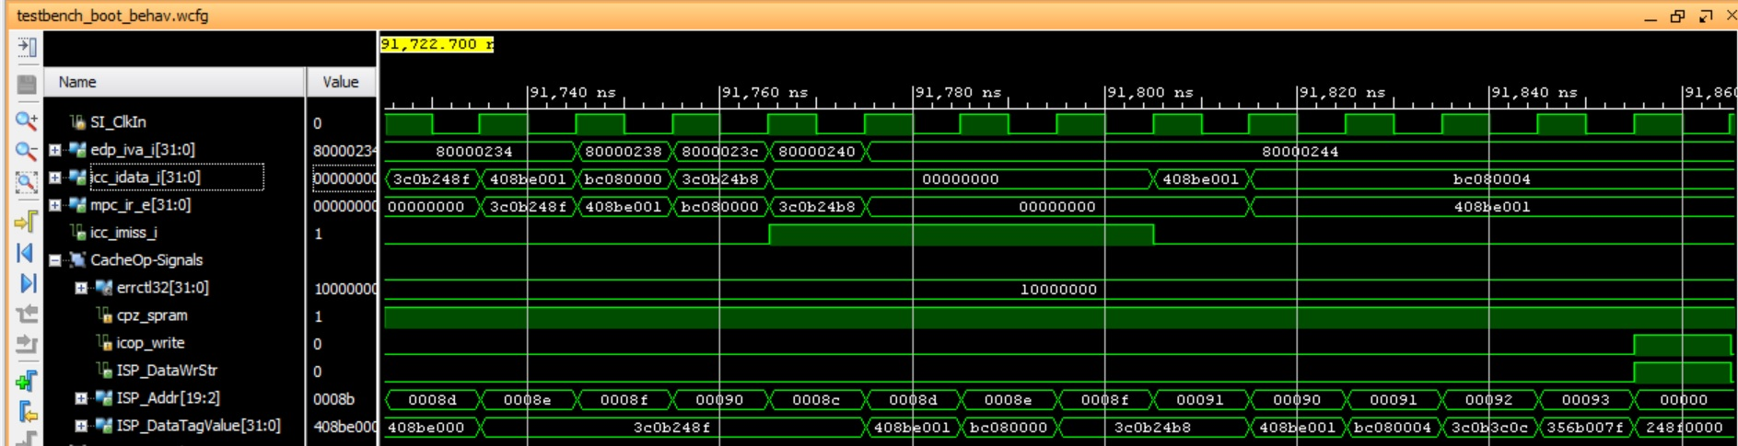

Observe that the first cache instruction (0xbc080000) is fetched in the third cycle. Then, in the last cycle, the ISPRAM is written with the first instruction (addiu $t7,$a0,0 (0x248f0000)).

We next show the execution of the initial instructions of the FP algorithm:

80040000: 248f0000 addiu $t7,$a0,0

80040004: 24b80000 addiu $t8,$a1,0

80040008 <flpadd>:

80040008: 3c0c007f lui t4,0x7f

8004000c: 358cffff ori t4,t4,0xffff

80040010: 01ec4024 and t0,t7,t4

80040014: 030c4824 and t1,t8,t4

…

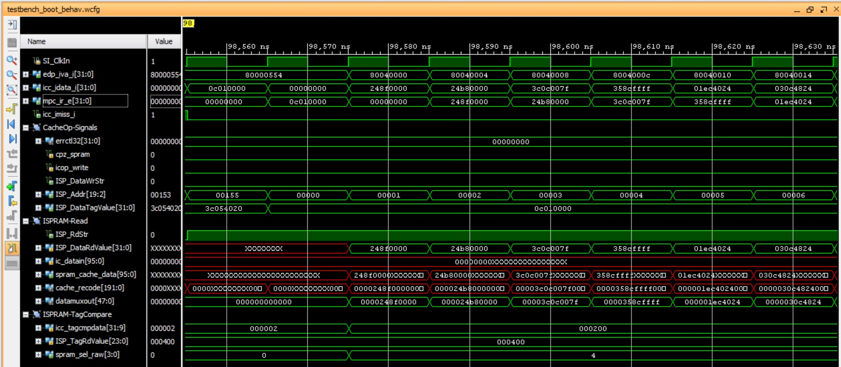

In this case there are no misses at all, as the algorithm is being fetched from the ISPRAM.

### Execution on the board:

* *SimulationSources_WithoutISPRAM*:
  + Switches=0 🡪 91 cycles
  + Switches=1 🡪 43 instructions

CPI = 91/43 ≈ 2.12

* + Switches=2 🡪 Result: $t9=0x40700000, which corresponds to the result of adding 1.25+2.5
* *SimulationSources_ISPRAM*:
  + Switches=0 🡪 65 cycles
  + Switches=1 🡪 56 instructions

CPI = 65/56 ≈ 1.16

* + Switches=2 🡪 Result: $t9=0x40700000, which corresponds to the result of adding 1.25+2.5

The difference is that instructions are always found in the ISPRAM, whereas 1 every 4 instructions fetched from the I$ miss (note that if the program was not sequential, it would be even worse), adding a miss penalty of around 4 cycles.