**SPEEDTEST MODULE**

# CONTENTS

## This module has the following files:

1. MODULE_SPEEDTEST.doc
2. MODULE_SPEEDTEST_MEDIA.zip

## A. Messenger

Draw 2 screen mockups for a messenger app with size 360x640.

1. screen - a list of dialogs (avatar, full name, message preview).
2. screen - chat with the user (avatar, full name, menu (three points), messages, text field, send button)

All elements should exist.

## B1. Loading Animation

We want to create the following CSS loading animation.

## B2. Digital Timer

Create a digital timer, time format is: 3 digit of seconds passed, and centiseconds following it. Its max value is: “999:59”. “Start timer“ button starts, “Stop timer” button stops, “Reset timer” button stops and resets to 0 the timer.A picture containing tableware

| 020:01 |
| --- |

## C1. Canvas Animation

Draw a circular figure in a container of 320px height and 400px width using canvas. When the browser window reloads, the circular object must move from left to right continuously.





## C2. Transition

You are given a picture that you need to cut into N cards after “Split Image” button is clicked, with dinamic input X and Y. Each card should disappear with animation when the card is clicked. Example X is 5 and Y is 3.

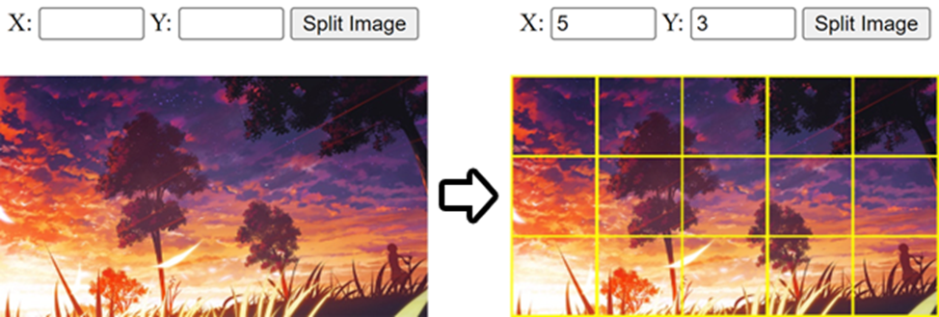

## D. PHP Calendar

1. You can create index.php using index.html

2. When you open the index.php, in the top area of calendar, current month and current year should be shown and today's date should be highlighted like index.html

3. If you click the left arrow button the previous month calendar should be shown.

4. If you click the right arrow button the next month's calendar should be shown.

## E. XML2JSON Converter

Create a simple xml to json convertor using pure PHP(See the example.xml).

Screen shot:

