Artificial Neural Network (ANN) - Classification 1

Rafiq Islam

2025-03-25

Table of contents

**Incomplete**

## Binary Classification

Say we have a dataset like this

import torch  
import numpy as np  
import matplotlib.pyplot as plt  
from mywebstyle import plot_style  
plot_style('#f4f4f4')  
  
np.random.seed(0)  
  
cl1 = np.random.randn(100,2)+np.array([0,-2])  
cl2 = np.random.randn(100,2)+np.array([2,2])  
  
l1 = np.zeros((100,1))  
l2 = np.ones((100,1))  
  
d1 = np.hstack((cl1,l1))  
d2 = np.hstack((cl2,l2))  
  
data_np = np.vstack((d1,d2))  
np.random.shuffle(data_np)  
plt.scatter(  
 data_np[data_np[:,2]==0][:,0],  
 data_np[data_np[:,2]==0][:,1],  
 color='red',  
 label = 'class 1'  
)  
plt.scatter(  
 data_np[data_np[:,2]==1][:,0],  
 data_np[data_np[:,2]==1][:,1],  
 color='blue',  
 label = 'class 2'  
)  
plt.legend()  
plt.xlabel('Feature 1')  
plt.ylabel('Feature 2')  
plt.show()  
  
data = torch.tensor(data_np, dtype=torch.float32)

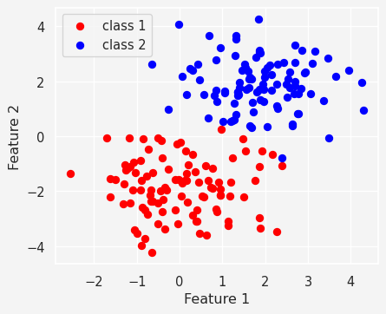

and we want to make an ANN classifier model with this data. So, we consider a two layer neural network

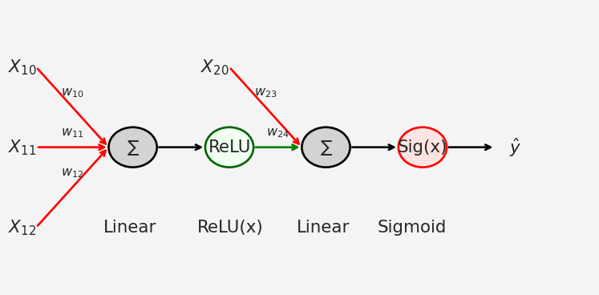

So our model

import torch.nn as nn  
  
ANN_classifier = nn.Sequential(  
 nn.Linear(2,1), # Input layer mapping R^2--> R  
 nn.ReLU(), # Activation function in layer 1  
 nn.Linear(1,1), # Output layer  
 nn.Sigmoid() # Activation function in layer 2  
)

Now let’s train the model and

X = data[:,:-1] # X all rows, all columns except the last one  
y = data[:, -1] # y all rows, only the last column  
y = y.view(-1,1)  
lr = 0.01 # Learning Rate  
loss_function = nn.BCELoss() # Binary Cross Entropy Loss  
optimizer = torch.optim.SGD( # Stochastic Gradient Descent Optimizer  
 ANN_classifier.parameters(),  
 lr=lr  
)  
num_epochs = 1000 # Number of Epochs  
  
# Define losses to store the loss from each epoch  
losses = torch.zeros(num_epochs)  
for epoch in range(num_epochs):  
 # Forward Pass  
 pred = ANN_classifier(X)  
  
 # Compute loss  
 loss = loss_function(pred, y)  
 losses[epoch] = loss   
  
 # Backpropagation  
 optimizer.zero_grad()  
 loss.backward()  
 optimizer.step()  
  
plt.plot(losses.detach())  
plt.xlabel('Epoch')  
plt.ylabel('Loss')  
plt.show()

