Model Fine Tuning: Bias-Variance Trade Off

Rafiq Islam

2024-09-23

Table of contents

## Introduction

The bias-variance tradeoff is a fundamental concept in machine learning that helps us understand the balance between underfitting and overfitting. It describes how different sources of error contribute to a model’s overall prediction error and how we can optimize model complexity for better generalization. To understand the bias-variance tradeoff, let’s first define **bias** and **variance** in the context of machine learning models: **Bias** is the error introduced by approximating a real-world problem (often complex) by a simplified model. High bias occurs when a model is too simple and can’t capture the underlying patterns, leading to underfitting. **Variance** is the model’s sensitivity to small fluctuations in the training data. High variance indicates that the model is too complex, fitting the noise in the training data rather than the actual signal, leading to overfitting. The goal is to strike a balance between bias and variance to minimize the overall error, often called the **expected prediction error**.

## Mathematical Derivation

The expected mean squared error (MSE) between the true function $f\left(x\right)$ and the model’s predictions $\hat{f}\left(x\right)$ is given by:

Where:

* $f\left(x\right)$ is the true function.
* $\hat{f}\left(x\right)$ is the estimated function (the model).

The third term, $2E\left[\left(f\left(x\right)−E\left[\hat{f}\left(x\right)\right]\right)\left(E\left[\hat{f}\left(x\right)\right]−\hat{f}\left(x\right)\right)\right]$, **vanishes** because the errors $f\left(x\right)−E\left[\hat{f}\left(x\right)\right]$ and $E\left[\hat{f}\left(x\right)\right]−\hat{f}\left(x\right)$ are independent. This is a key step in the decomposition.

* $f\left(x\right)−E\left[\hat{f}\left(x\right)\right]$ is the bias-related error.
* $E\left[\hat{f}\left(x\right)\right]−\hat{f}\left(x\right)$ is the variance-related error.

Since these two terms are uncorrelated, their cross-product expectation equals zero:

$$2E\left[\left(f\left(x\right)−E\left[\hat{f}\left(x\right)\right]\right)\left(E\left[\hat{f}\left(x\right)\right]−\hat{f}\left(x\right)\right)\right]=0$$

**What is $σ^{2}$?**

Now, $σ^{2}$, the irreducible error, is the variance of the noise in the data:

$$σ^{2}=E\left[{\left(y−f\left(x\right)\right)}^{2}\right]=E\left[ϵ^{2}\right]$$

where $y=f\left(x\right)+ϵ$, and $ϵ$ is the noise term with variance $σ^{2}$. This noise is independent of both the bias and variance components and does not interact with them in the decomposition. It is the part of the error that remains no matter how good the model is.

$$\text{MSE}\left(x\right)={\left(\text{Bias}\left[\hat{f}\left(x\right)\right]\right)}^{2}+\text{Variance}\left[\hat{f}\left(x\right)\right]+σ^{2}$$

## Bias-Variance Tradeoff Intuition

* A **high bias** model makes strong assumptions about the data and fails to capture the underlying patterns, resulting in underfitting.

import numpy as np  
import matplotlib.pyplot as plt  
np.random.seed(0)  
X = np.linspace(-3,3,100)  
y = X**2 + np.random.randn(100)*2  
from sklearn.linear_model import LinearRegression  
model = LinearRegression()  
model.fit(X.reshape(-1,1),y)  
y_pred = model.predict(X.reshape(-1,1))  
  
plt.scatter(X,y, color='blue', label = 'Data Points')  
plt.plot(X,y_pred, color='red', label='High Bias Model (linear)')  
plt.xlabel('X')  
plt.ylabel('y')  
plt.title('High Bias Model Overfitting the Data')  
plt.legend()  
plt.gca().set_facecolor('#f4f4f4')   
plt.gcf().patch.set_facecolor('#f4f4f4')  
plt.show()

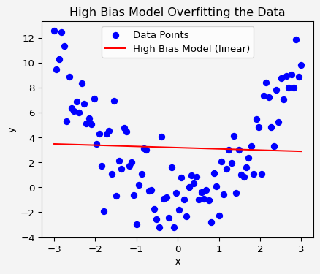

* A **high variance** model is highly flexible, capturing not only the signal but also the noise in the data, leading to overfitting.

from sklearn.tree import DecisionTreeRegressor  
  
model2 = DecisionTreeRegressor(max_depth=10)  
model2.fit(X.reshape(-1,1),y)  
y_pred = model2.predict(X.reshape(-1,1))  
  
plt.scatter(X,y, color='blue', label = 'Data Points')  
plt.plot(X,y_pred, color='red', label='High Variance Model (linear)')  
plt.xlabel('X')  
plt.ylabel('y')  
plt.title('High Variance Model Overfitting the Data')  
plt.legend()  
plt.gca().set_facecolor('#f4f4f4')   
plt.gcf().patch.set_facecolor('#f4f4f4')  
plt.show()

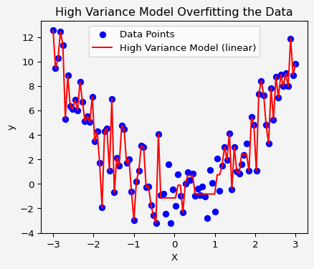

* The tradeoff arises because increasing model complexity reduces bias but increases variance, while simplifying the model reduces variance but increases bias.

The key is to find a sweet spot where the model has low enough bias and variance to generalize well to unseen data.

## More Visualization of Bias-Variance Tradeoff

Now let’s use Python to visualize the bias-variance tradeoff by generating models of varying complexity on a synthetic dataset.

import numpy as np  
import matplotlib.pyplot as plt  
from sklearn.preprocessing import PolynomialFeatures  
from sklearn.linear_model import LinearRegression  
from sklearn.metrics import mean_squared_error  
from sklearn.model_selection import train_test_split  
  
# Generate synthetic data  
np.random.seed(0)  
n_samples = 100  
X = np.random.rand(n_samples, 1) * 10  
y = np.sin(X).ravel() + np.random.randn(n_samples) * 0.5  
  
# Function to plot the results  
def plot_bias_variance(X, y, degrees):  
 X_plot = np.linspace(0, 10, 100).reshape(-1, 1)  
 fig, axs = plt.subplots(2,2, figsize=(8.2,5.5))  
 fig.patch.set_facecolor('#f4f4f4')  
  
 for i, degree in enumerate(degrees):  
 poly = PolynomialFeatures(degree)  
 X_poly = poly.fit_transform(X)  
 X_plot_poly = poly.transform(X_plot)  
   
 # Train a linear regression model  
 model = LinearRegression()  
 model.fit(X_poly, y)  
   
 # Predict on the plot points  
 y_plot_pred = model.predict(X_plot_poly)  
   
 ax = axs[i//2, i%2]  
 ax.set_facecolor('#f4f4f4')  
 ax.scatter(X,y, color='red', label='Data')  
 ax.plot(X_plot, y_plot_pred, label=f'Polynomial degree {degree}')  
 ax.set_title(f'Polynomial Degree {degree}')  
 ax.legend()  
   
 # Calculate and display training error  
 y_pred = model.predict(X_poly)  
 mse = mean_squared_error(y, y_pred)  
 ax.text(0, -1.5, f'MSE: {mse:.2f}', fontsize=12)  
  
 plt.tight_layout()  
 plt.savefig('bv.png')  
 plt.show()  
  
# Visualize bias-variance tradeoff  
degrees = [1, 3, 5, 9]  
plot_bias_variance(X, y, degrees)

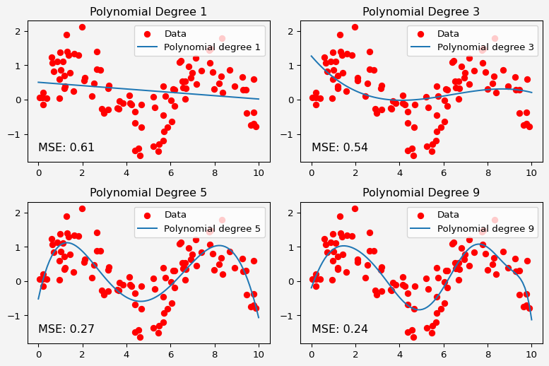

We create a synthetic dataset where $y=sin\left(x\right)$ with added Gaussian noise.

* For **low-degree polynomials** (e.g., degree 1), the model has high bias. It is too simple to capture the nonlinear relationship in the data, leading to underfitting.
* For **high-degree polynomials** (e.g., degree 9), the model has high variance. It fits the training data too closely, even capturing the noise, leading to overfitting.
* A **moderate-degree polynomial** (e.g., degree 3 or 5) balances bias and variance, achieving the lowest error on unseen data.

The bias-variance tradeoff is a crucial concept for building machine learning models that generalize well. By understanding how bias and variance contribute to the total error, we can make informed decisions about model complexity. In practice, techniques like cross-validation and regularization are often used to find the optimal balance between bias and variance. Understanding and visualizing this tradeoff helps machine learning practitioners fine-tune their models to achieve the best possible performance.

## References

1. **Hastie, T., Tibshirani, R., & Friedman, J.** (2009). *The Elements of Statistical Learning: Data Mining, Inference, and Prediction*. Springer.
2. **Bishop, C. M.** (2006). *Pattern Recognition and Machine Learning*. Springer.
3. **Géron, A.** (2019). *Hands-On Machine Learning with Scikit-Learn, Keras, and TensorFlow*. O’Reilly Media.
4. **Kohavi, R. & Wolpert, D.** (1996). Bias plus variance decomposition for zero-one loss functions. *Proceedings of the 13th International Conference on Machine Learning*.
5. **James, G., Witten, D., Hastie, T., & Tibshirani, R.** (2013). *An Introduction to Statistical Learning with Applications in R*. Springer.

**Share on**

**You may also like**