Exploratory Data Analysis (EDA) and Data Visualization

Rafiq Islam

2024-11-08

Table of contents

In this Exploratory Data Analysis and Visualization notebook, we want to explore the [911 call data from Kaggle.com](https://www.kaggle.com/datasets/mchirico/montcoalert)

## The Dataset

import pandas as pd  
import numpy as np  
import seaborn as sns  
import matplotlib.pyplot as plt  
df = pd.read_csv('911.csv')

## Discriptive Statistics

We first check the data information to see the number of observations, datatype, memory usages etc.

df.info()

<class 'pandas.core.frame.DataFrame'>  
RangeIndex: 105957 entries, 0 to 105956  
Data columns (total 9 columns):  
 # Column Non-Null Count Dtype   
--- ------ -------------- -----   
 0 lat 105957 non-null float64  
 1 lng 105957 non-null float64  
 2 desc 105957 non-null object   
 3 zip 92735 non-null float64  
 4 title 105957 non-null object   
 5 timeStamp 105957 non-null object   
 6 twp 105924 non-null object   
 7 addr 105957 non-null object   
 8 e 105957 non-null int64   
dtypes: float64(3), int64(1), object(5)  
memory usage: 7.3+ MB

A first look of the data

df.head()

|  | lat | lng | desc | zip | title | timeStamp | twp | addr | e |
| --- | --- | --- | --- | --- | --- | --- | --- | --- | --- |
| 0 | 40.297876 | -75.581294 | REINDEER CT & DEAD END; NEW HANOVER; Station ... | 19525.0 | EMS: BACK PAINS/INJURY | 12/10/15 17:10 | NEW HANOVER | REINDEER CT & DEAD END | 1 |
| 1 | 40.258061 | -75.264680 | BRIAR PATH & WHITEMARSH LN; HATFIELD TOWNSHIP... | 19446.0 | EMS: DIABETIC EMERGENCY | 12/10/15 17:29 | HATFIELD TOWNSHIP | BRIAR PATH & WHITEMARSH LN | 1 |
| 2 | 40.121182 | -75.351975 | HAWS AVE; NORRISTOWN; 2015-12-10 @ 14:39:21-St... | 19401.0 | Fire: GAS-ODOR/LEAK | 12/10/15 14:39 | NORRISTOWN | HAWS AVE | 1 |
| 3 | 40.116153 | -75.343513 | AIRY ST & SWEDE ST; NORRISTOWN; Station 308A;... | 19401.0 | EMS: CARDIAC EMERGENCY | 12/10/15 16:47 | NORRISTOWN | AIRY ST & SWEDE ST | 1 |
| 4 | 40.251492 | -75.603350 | CHERRYWOOD CT & DEAD END; LOWER POTTSGROVE; S... | NaN | EMS: DIZZINESS | 12/10/15 16:56 | LOWER POTTSGROVE | CHERRYWOOD CT & DEAD END | 1 |

Some data related questions. For example,

* What are the top 10 zipcodes for 911 calls?
* df.zip.value_counts().head(10)
* zip  
  19401.0 7445  
  19464.0 7122  
  19403.0 5189  
  19446.0 5060  
  19406.0 3404  
  19002.0 3238  
  19468.0 3202  
  19454.0 2984  
  19090.0 2832  
  19046.0 2779  
  Name: count, dtype: int64
* What are the top 10 twonships for the 911 calls?
* df.twp.value_counts().head(10)
* twp  
  LOWER MERION 9069  
  ABINGTON 6403  
  NORRISTOWN 6265  
  UPPER MERION 5551  
  CHELTENHAM 4882  
  POTTSTOWN 4448  
  UPPER MORELAND 3658  
  LOWER PROVIDENCE 3435  
  PLYMOUTH 3371  
  HORSHAM 3142  
  Name: count, dtype: int64

## Feature Engineering

Sometimes creating new features from the existing features helps understand the data better. For example, for this dataset, we can create a new column called Reason for emergency 911 call.

df['reason'] = df.title.apply(lambda title: title.split(':')[0])  
df.head(3)

|  | lat | lng | desc | zip | title | timeStamp | twp | addr | e | reason |
| --- | --- | --- | --- | --- | --- | --- | --- | --- | --- | --- |
| 0 | 40.297876 | -75.581294 | REINDEER CT & DEAD END; NEW HANOVER; Station ... | 19525.0 | EMS: BACK PAINS/INJURY | 12/10/15 17:10 | NEW HANOVER | REINDEER CT & DEAD END | 1 | EMS |
| 1 | 40.258061 | -75.264680 | BRIAR PATH & WHITEMARSH LN; HATFIELD TOWNSHIP... | 19446.0 | EMS: DIABETIC EMERGENCY | 12/10/15 17:29 | HATFIELD TOWNSHIP | BRIAR PATH & WHITEMARSH LN | 1 | EMS |
| 2 | 40.121182 | -75.351975 | HAWS AVE; NORRISTOWN; 2015-12-10 @ 14:39:21-St... | 19401.0 | Fire: GAS-ODOR/LEAK | 12/10/15 14:39 | NORRISTOWN | HAWS AVE | 1 | Fire |

what are top reasons for the emergency calls?

df.reason.value_counts()

reason  
EMS 52515  
Traffic 37505  
Fire 15937  
Name: count, dtype: int64

visualization of the reason column

sns.countplot(x=df.reason, hue=df.reason, palette='viridis')

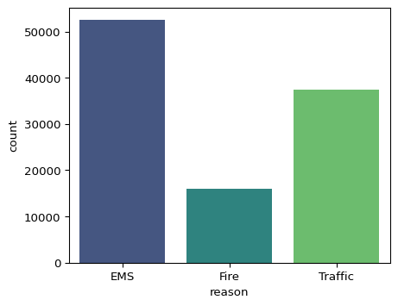

The timeStamp column contains time information year-month-day hour:minute:second format but in string value/object. So we can convert this column to obtain new features.

df['timeStamp'] = pd.to_datetime(df.timeStamp)  
time = df.timeStamp.iloc[0]

/tmp/ipykernel_3527/1994586768.py:1: UserWarning:  
  
Could not infer format, so each element will be parsed individually, falling back to `dateutil`. To ensure parsing is consistent and as-expected, please specify a format.

Let’s create new features called hour, month, and day of the calls.

df['hour'] = df.timeStamp.apply(lambda time: time.hour)  
df['month'] = df.timeStamp.apply(lambda time: time.month)  
df['day'] = df.timeStamp.apply(lambda time: time.dayofweek)  
days = {  
 0:'Monday', 1:'Tuesday', 2:'Wednesday',   
 3:'Thursday', 4:'Friday', 5:'Saturday',  
 6:'Sunday'  
 }  
df.day = df.day.map(days)  
df = df[  
 ['lat','lng','zip','twp','e','reason',  
 'month','day','hour','title','timeStamp',  
 'desc','addr']  
 ]  
df.head(3)

|  | lat | lng | zip | twp | e | reason | month | day | hour | title | timeStamp | desc | addr |
| --- | --- | --- | --- | --- | --- | --- | --- | --- | --- | --- | --- | --- | --- |
| 0 | 40.297876 | -75.581294 | 19525.0 | NEW HANOVER | 1 | EMS | 12 | Thursday | 17 | EMS: BACK PAINS/INJURY | 2015-12-10 17:10:00 | REINDEER CT & DEAD END; NEW HANOVER; Station ... | REINDEER CT & DEAD END |
| 1 | 40.258061 | -75.264680 | 19446.0 | HATFIELD TOWNSHIP | 1 | EMS | 12 | Thursday | 17 | EMS: DIABETIC EMERGENCY | 2015-12-10 17:29:00 | BRIAR PATH & WHITEMARSH LN; HATFIELD TOWNSHIP... | BRIAR PATH & WHITEMARSH LN |
| 2 | 40.121182 | -75.351975 | 19401.0 | NORRISTOWN | 1 | Fire | 12 | Thursday | 14 | Fire: GAS-ODOR/LEAK | 2015-12-10 14:39:00 | HAWS AVE; NORRISTOWN; 2015-12-10 @ 14:39:21-St... | HAWS AVE |

Now that we have almost a clean dataset, we can analyze the reason column based on the days of the week or months of a year.

sns.countplot(x='day', data= df, hue='reason', palette='viridis')  
plt.legend(bbox_to_anchor=(1.05,1), loc=2, borderaxespad=0.0)

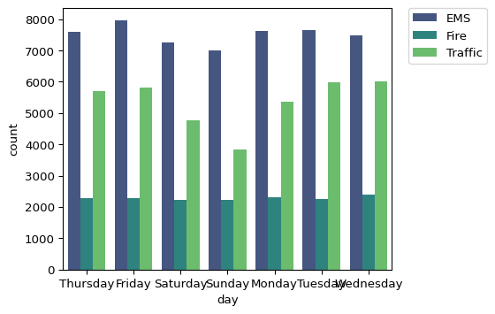

For the month column

sns.countplot(x='month', data= df, hue='reason', palette='viridis')  
plt.legend(bbox_to_anchor=(1.05,1), loc=2, borderaxespad=0.0)

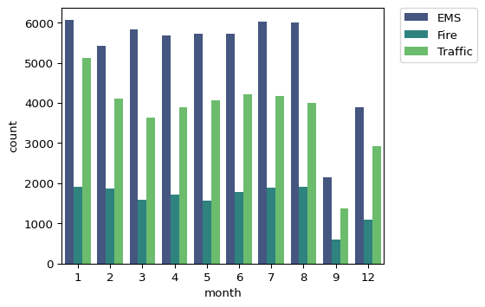

To create a time series data

df['date'] = df['timeStamp'].apply(lambda time: time.date())  
df.groupby('date').count()['twp'].plot()

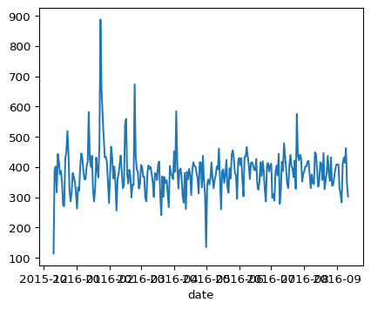

Now to see for each reason

start_date = pd.to_datetime('2019-01-01')  
  
  
df['date'] = pd.to_datetime(df['date'])  
  
  
fig = plt.figure(figsize=(7.9,6))  
  
ax1 = fig.add_subplot(311)  
df[(df['reason'] == 'Traffic') & (df['date'] >= start_date)].groupby('date').count()['twp'].plot(ax=ax1)  
  
ax2 = fig.add_subplot(312)  
df[(df['reason'] == 'Fire') & (df['date'] >= start_date)].groupby('date').count()['twp'].plot(ax=ax2)  
  
ax3 = fig.add_subplot(313)  
df[(df['reason'] == 'EMS') & (df['date'] >= start_date)].groupby('date').count()['twp'].plot(ax=ax3)  
  
plt.tight_layout()  
  
plt.show()

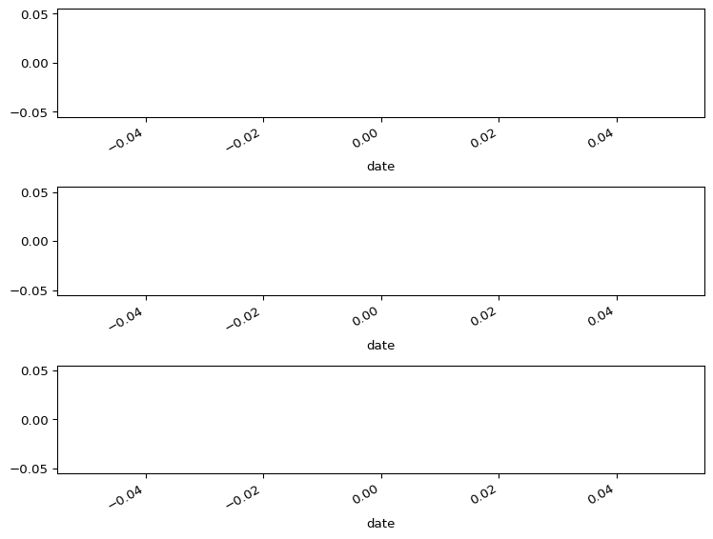

**Share on**

**You may also like**